**Supplementary Data**



**Figure S1: Fold induction of wild type and *sem-4* mutants by *brap-2(ok1492)*.** qPCR from the data presented in Fig 1C was re-graphed to quantify the requirement of SEM-4 for *brap-2(ok1492)* induction of *gst-4* mRNA. The *brap-2* mutant enhanced gst-4 expression in the wild type by 20x, in the *sem-4(n1378)* mutant by13x and in the *sem-3(n1971)* mutant by 10x.

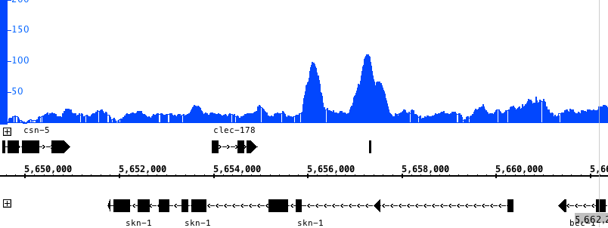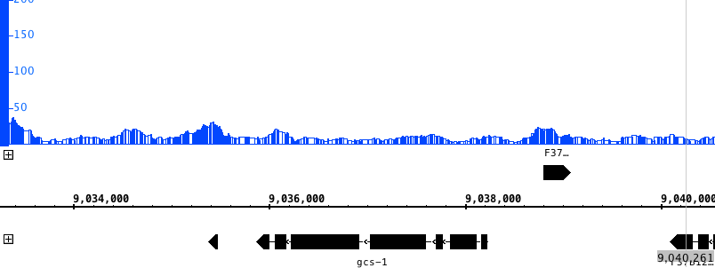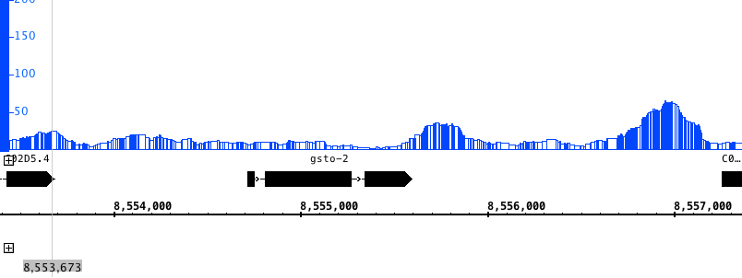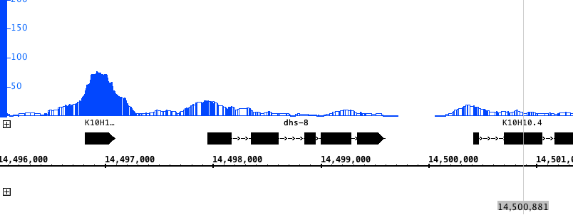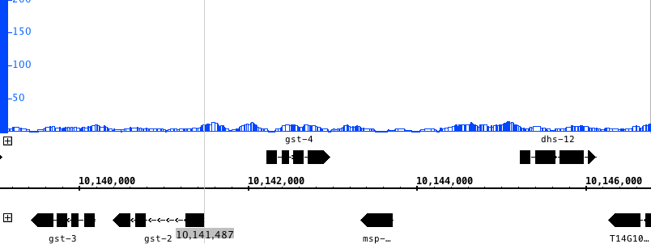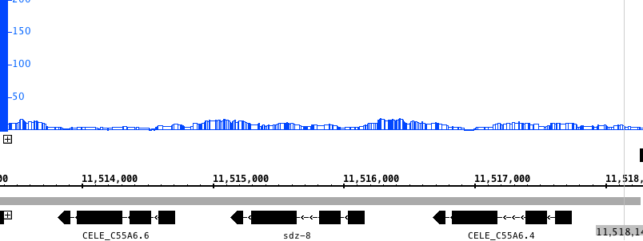

*gst-4*

*gcs-1*

*dhs-8*

*gsto-2*

*sdz-8*

*skn-1*

**Figure S2:** **Binding sites of SEM-4 on the promoters of phase II detoxification genes and *skn-1*.** ChIP-seq tracks for SEM-4 (blue) on the promoters of nine phase II detoxification genes. The x-axis corresponds to genomic location and the y-axis to normalized ChIP-seq signal density. Data taken from modEncode_3606 (L2 stage) signal data files and compiled using the Integrative Genome Browser.