Supplemental figures for

Genetic architecture modulates diet induced mRNA and miRNA expression profile in Diversity Outbred mouse
Excel Que^{1,2, †}, Kristen L. James^{2,†}, Alisha R. Coffey³, Tangi L. Smallwood³, Jody Albright⁴, M. Nazmul Huda^{1,2}, Daniel Pomp⁵, Praveen Sethupathy^{6,*}, and Brian J. Bennett^{1,2,*}

¹ Western Human Nutrition Research Center, Agricultural Research Service, USDA, Davis, California
² Department of Nutrition, University of California Davis, Davis, California
³ Curriculum in Genetics and Molecular Biology, University of North Carolina at Chapel Hill, Chapel Hill, North Carolina
⁴ Nutrition Research Institute, University of North Carolina at Chapel Hill, Kannapolis, North Carolina
⁵ Department of Genetics, University of North Carolina at Chapel Hill, Chapel Hill, North Carolina
⁶ Department of Biomedical Sciences, College of Veterinary Medicine, Cornell University, Ithaca, New York

†These authors contributed equally
*Corresponding authors

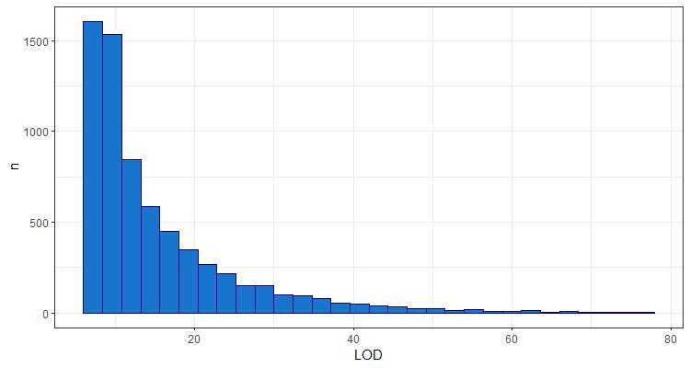
Supplemental Figure 1: Distribution of LOD scores significant at p < 0.05 in the genome scan with diet as an additive covariate, as determined by the null distribution of max LODs from 1,000 permuted genome scans.

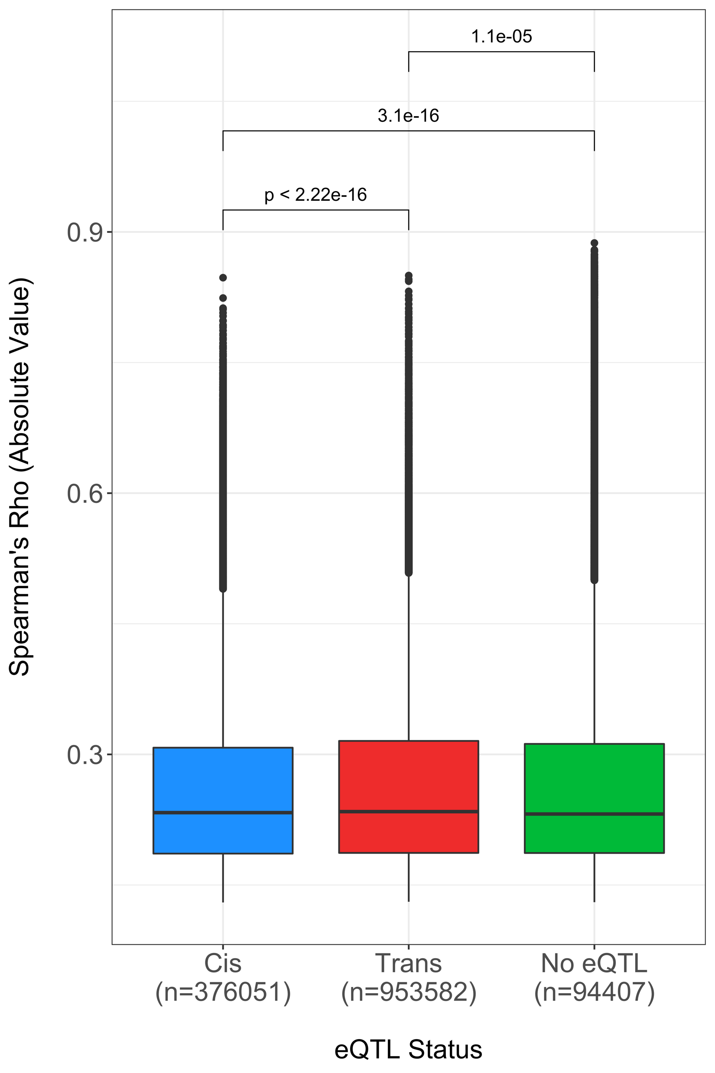
Supplemental Figure 2: Magnitude of correlation is greater in non-mapping miRNA-mRNA pairs than in those with mRNA with eQTL. Expression data was used to generate correlations between pairs of miRNA (n = 246) and mRNA (n = 24,004). The results were filtered for BH-corrected significance (α ≤ 0.05) and Spearman’s rho was plotted against the eQTL status of the mRNA from the additive genome scan. Wilcoxon rank sum test found a significant difference between the absolute correlations of cis and trans-mapping eQTL (p < 2.22 x 10⁻¹⁶) with the median of trans-eQTL being 0.234, whereas cis was 0.233. A less significant trend was observed that non-mapping mRNA had lower miRNA correlations than mapping mRNA (p < 1.1 x 10⁻⁵). The median value for no eQTL was 0.232.

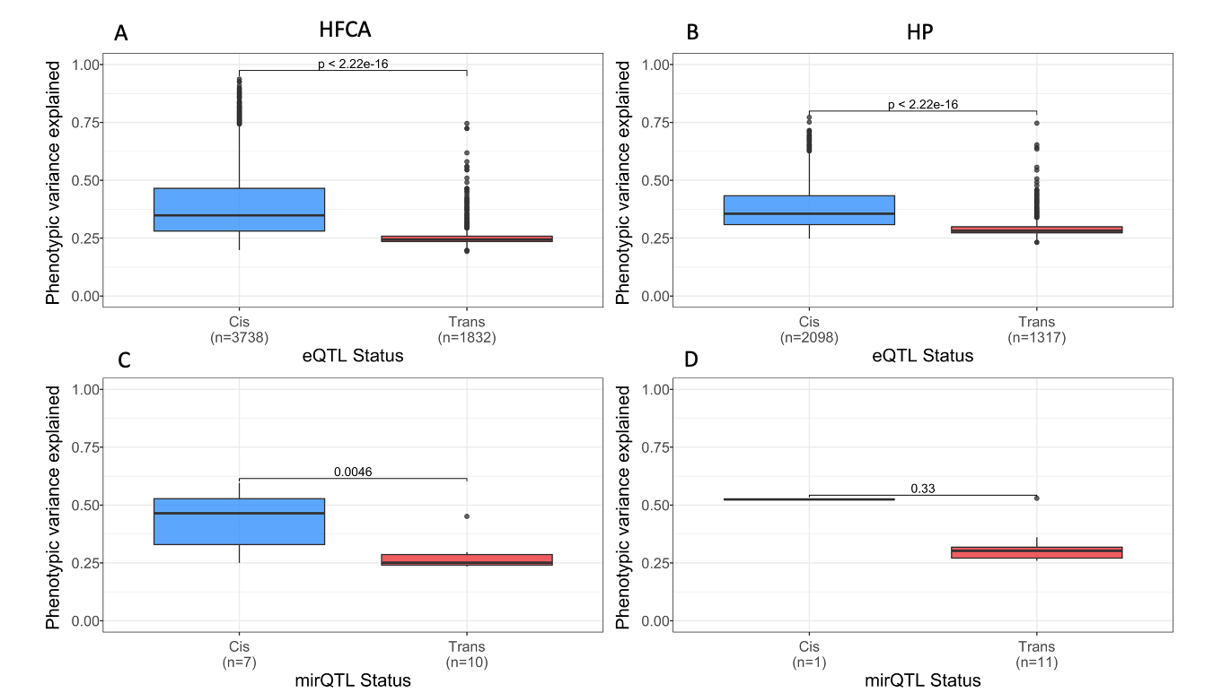
Supplemental Figure 3: eQTL and mirQTL have similar effect size in Diversity Outbred mice fed different diets (A, B) Wilcoxon rank sum tests reveal a significant difference in the phenotypic variance explained between cis and trans-eQTL of mice fed a HFCA diet or a HP diet. The median phenotypic variance explained by cis-eQTL in the HFCA is 0.349 whereas it is 0.244 in trans. Similarly, in the HP, the variance explained by cis-eQTL is 0.356 and 0.282 in trans. (C, D) Wilcoxon rank sum tests reveal a significant difference in the phenotypic variance explained between cis and trans-mirQTL and a similar but insignificant (p ≥ 0.05) difference in the phenotypic variance explained between the cis and trans-mirQTL of mice fed a HP diet. The median phenotypic variance explained by cis-mirQTL in the HFCA is 0.465 whereas it is 0.251 in trans. Similarly, in the HP, the variance explained by cis-mirQTL is 0.525 and 0.302 in trans.

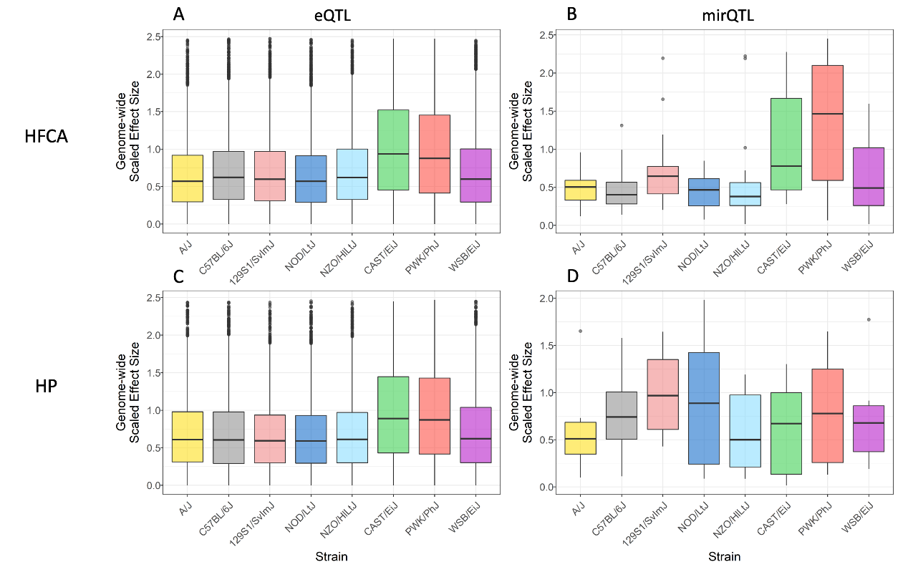
Supplemental Figure 4: Alleles from Wild Derived strains contribute to eQTL and mir-eQTL. (A) Boxplot representation of center-scaled BLUP coefficients from all significant eQTL in the HFCA-fed mice. Kruskal-Wallis rank sum test indicates significant differences (p < 2.2 x 10⁻¹⁶) among founder effects. Dunn's post-hoc test confirms significantly (BH-adjusted p < 1.0 x 10⁻⁴) larger effects from the CAST/EiJ and PWK/PhJ strains relative to all other strains. (B) Boxplot representation of center-scaled BLUP coefficients from all significant mirQTL in the HFCA-fed mice. Kruskal-Wallis rank sum test indicates no significant differences (p = 0.34) among founder effects. C) Boxplot of center-scaled BLUP coefficients from all significant eQTL in the HP-fed mice. Kruskal-Wallis rank sum test indicates significant differences (p < 2.2 x 10⁻¹⁶) among founder effects. Dunn's post-hoc test confirms significantly (p < 1.0 x 10⁻⁴, BH-adjusted) larger effects from the CAST/EiJ and PWK/PhJ strains relative to all other strains. (D) Boxplot of center-scaled BLUP coefficients from all significant mirQTL in the HP-fed mice. Kruskal-Wallis rank sum test does not indicate significant differences (p < 0.064) among founder effects.

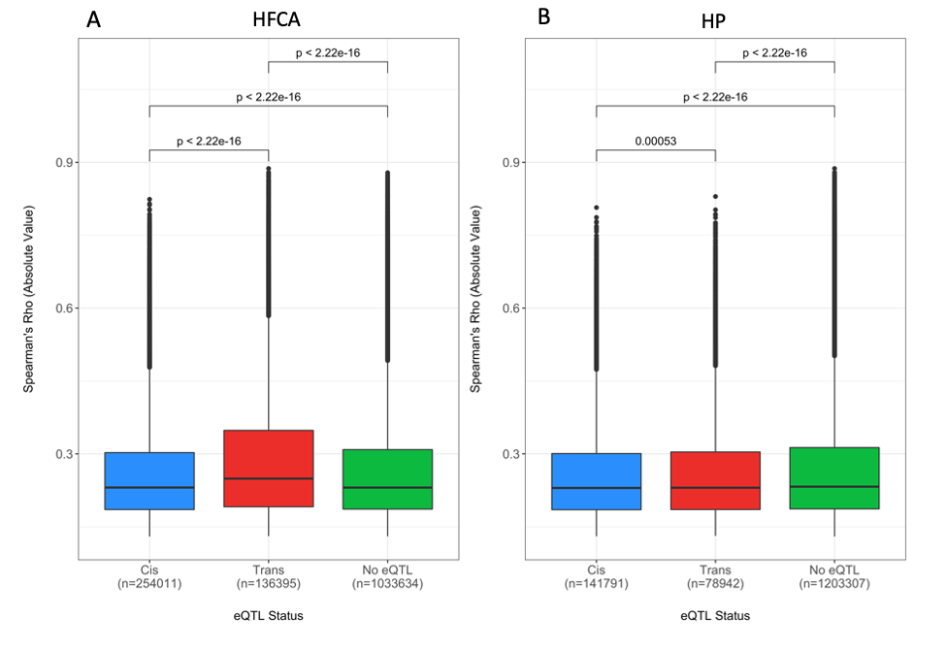
Supplemental Figure 5: Magnitude of correlation of miRNA-mRNA pairs with eQTL status differs by diet. Expression data was used to generate correlations between pairs of miRNA (n = 246) and mRNA (n = 24,004). The results were filtered for FDR-corrected significance (α ≤ 0.05) and Spearman’s rho was plotted against the eQTL status of the mRNA from the HFCA model (A) and the HP model (B). Wilcoxon rank sum test reveals a significant difference between the absolute correlations of cis and trans-mapping eQTL in the HFCA and HP model (HFCA, p < 2.2 x 10⁻¹⁶; HP, p < 0.0005).

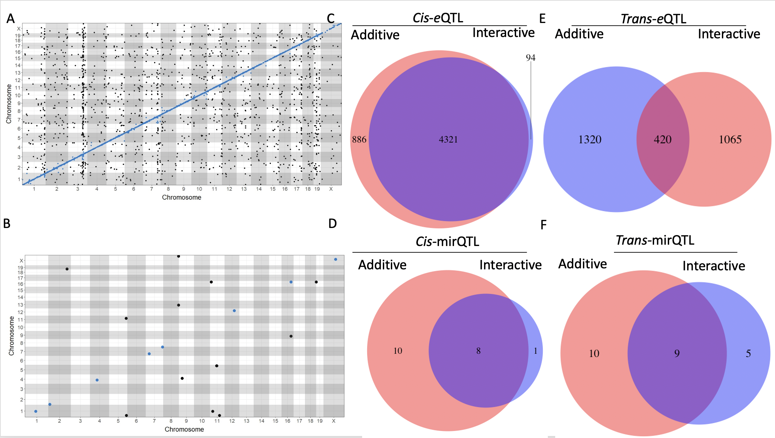
Supplemental Figure 6: Overlap between results of additive and interactive models revealed large architectural differences in trans-eQTLs compared to cis-eQTLs. Differences in the genetic architecture of eQTL and mirQTL in the additive and interactive QTL analyses. Global architecture of significant eQTL (A) and mirQTL (B) from the interactive scan. We observed larger overlaps between additive and interactive scans in cis-regulated QTL (C and D) and sparser overlaps between trans-regulated QTL (E and F).

