SUPPLEMENTAL FIGURE LEGENDS
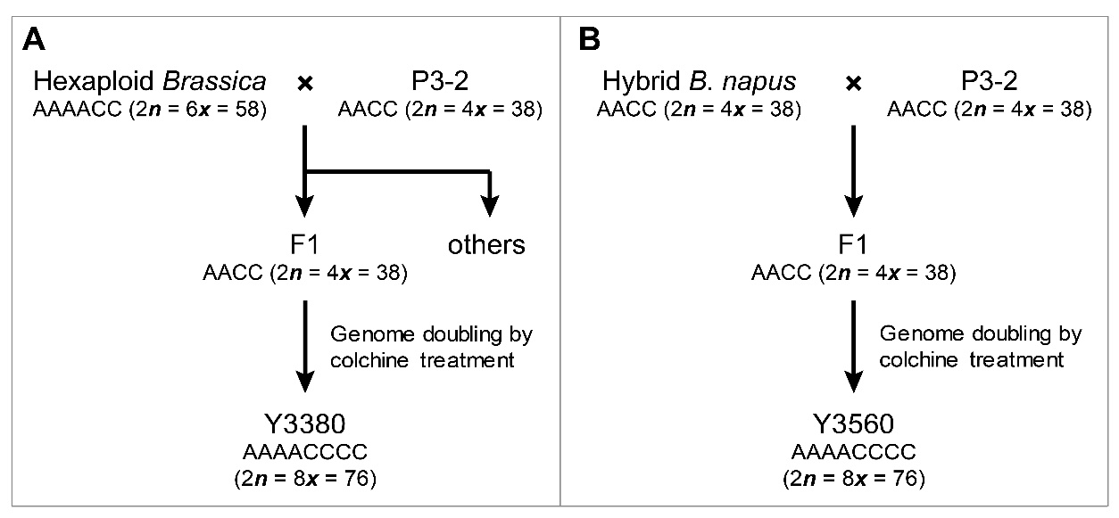

Figure S1 Generation of octoploid B. napus. (A) Cross hexaploid Brassica with P3-2, and then select tetraploid B. napus in the progeny for genome doubling to obtain octoploid Y3380. (B) Cross the heterozygous B. napus with P3-2, and treat the hybrid with colchicine to obtain octoploid Y3560.
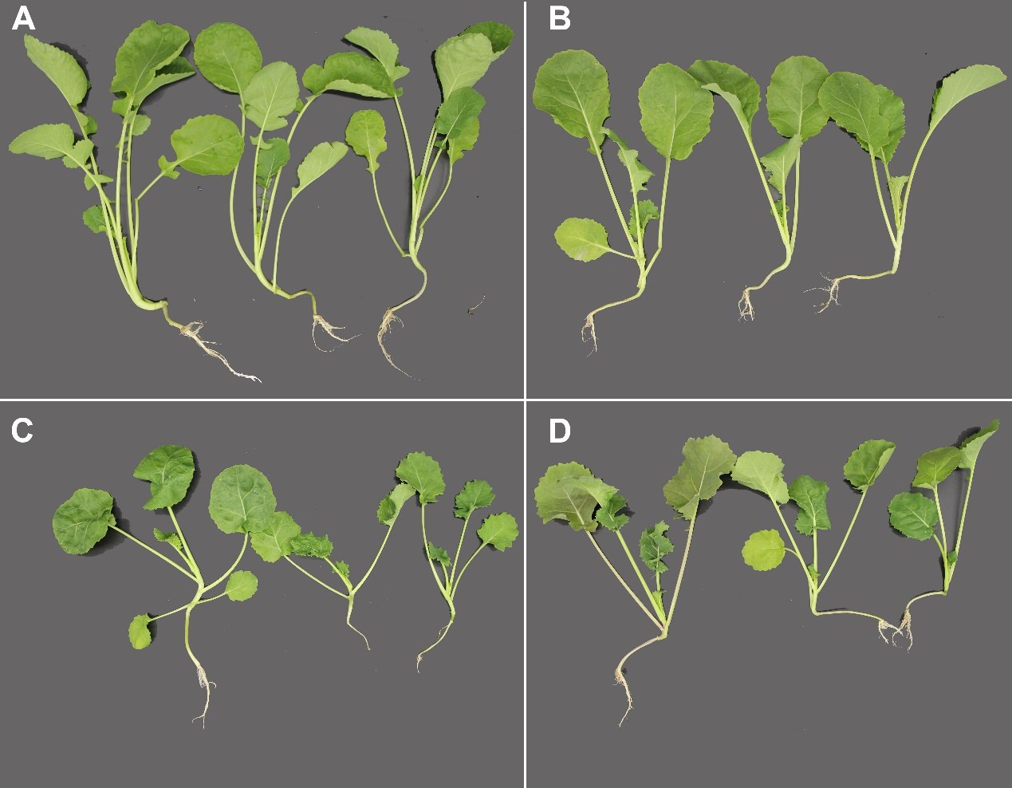

Figure S2 Seedlings of tetraploid and octoploid B. napus 63 days after sowing. (A) ZS11, tetraploid. (B) P3-2, tetraploid. (C) Y3380, octoploid. (D) Y3560, octoploid.

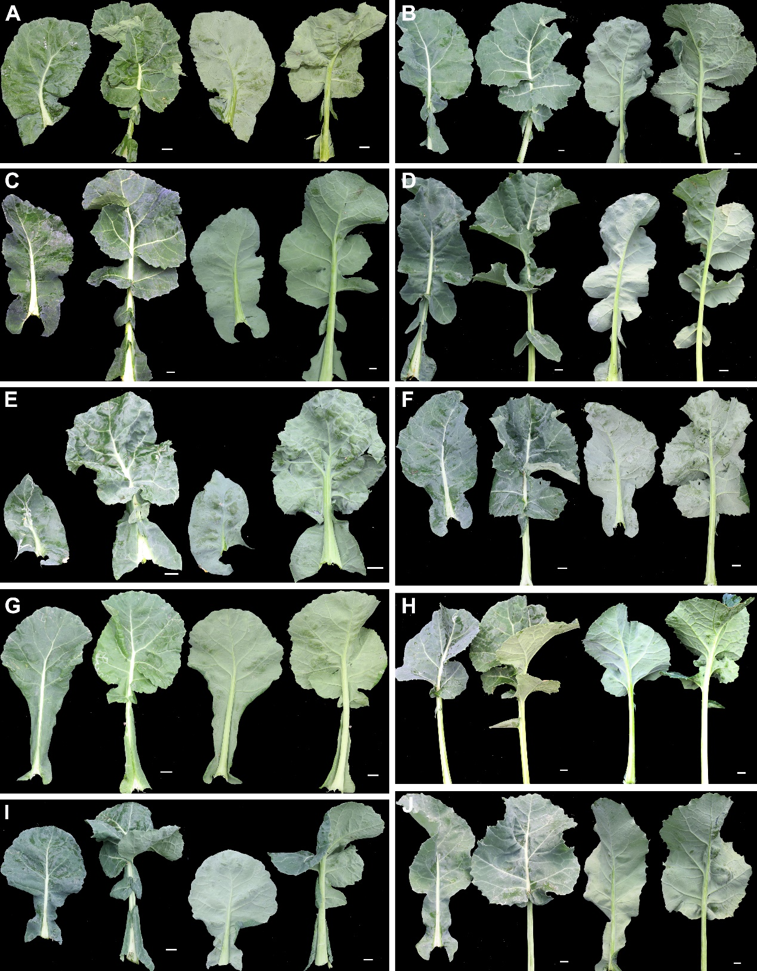

Figure S3 Leaf morphologies of octoploid Brassica. The third and eighth leaves (from bottom to top) of a plant were picked. Abaxial and adaxial surface of leaf were shown. (A-E) Leaves of Y3560 individuals. (F-J) Leaves of Y3380 individuals. Bar, 1 cm.
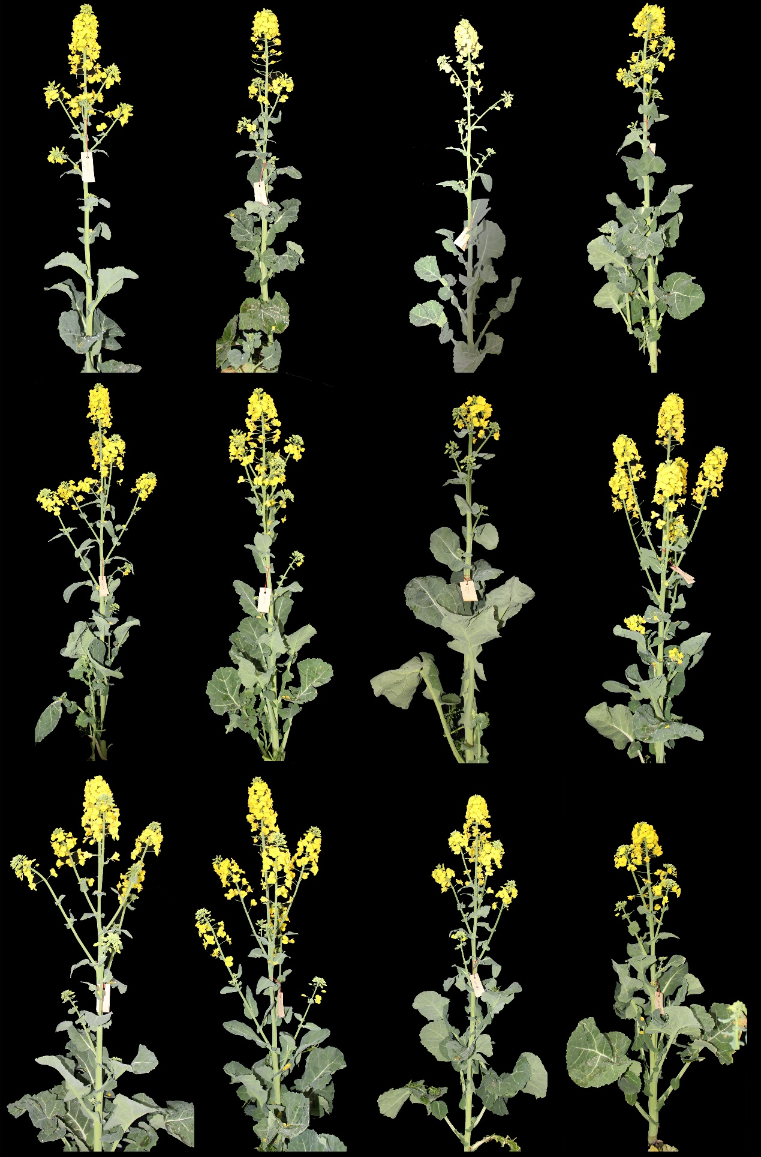

Figure S4 Whole plant morphology of octoploid B. napus at the flowering stage.
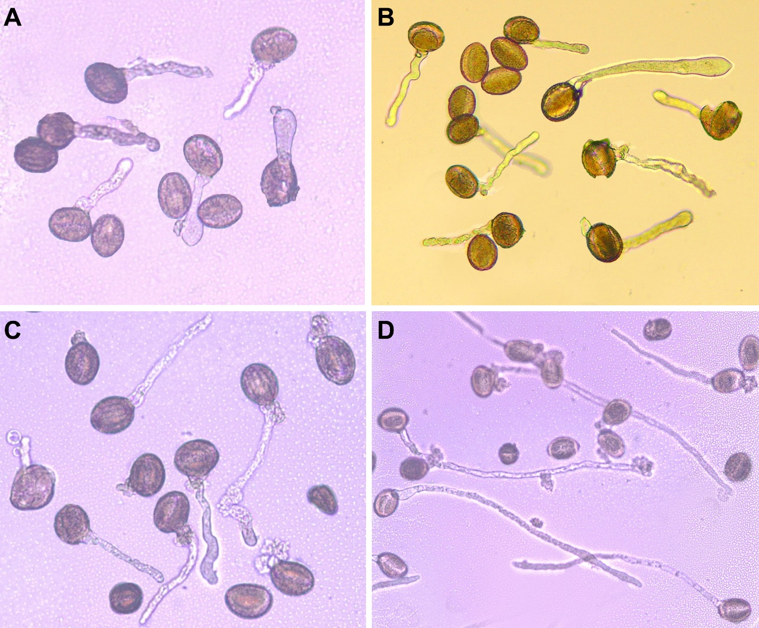

Figure S5 In vitro pollen germination for 3 h. (A) ZS11, tetraploid. (B) P3-2, tetraploid. (C) Y3380, octoploid. (D) Y3560, octoploid.
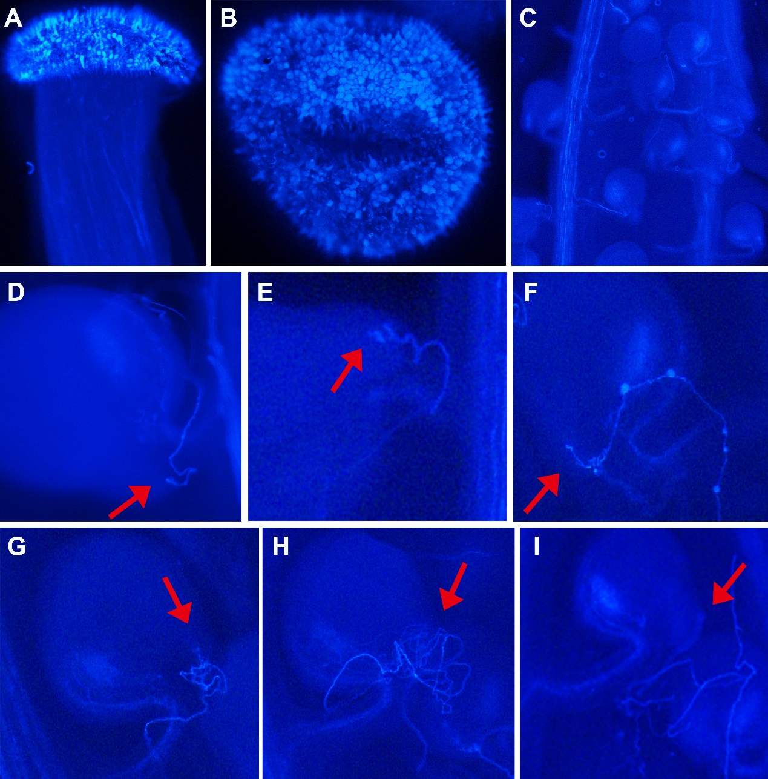

Figure S6 In vivo pollen grain germination and pollen tube growth in octoploid B. napus. (A-B) Pollen grain grew on stigma and germinated. (C) Pollen tube could pass through the style to ovary, but it could not reach the micropyle of many ovules. (D-E) Pollen tube successfully entered into the ovule. (F) Pollen tube continued its growth in embryo sac. (G-H) Excessively curved pollen tube. (I) Defective pollen tube-ovule recognition.
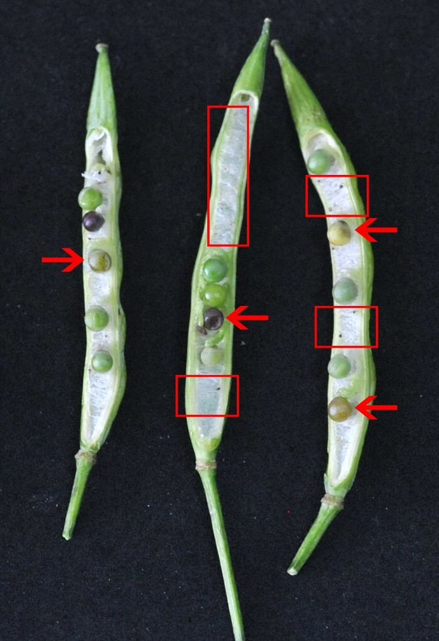

Figure S7 Self-pollinated siliques of octoploid B. napus. Arrows pointed to the aborting seeds, and the box represented unfertilized embryos.
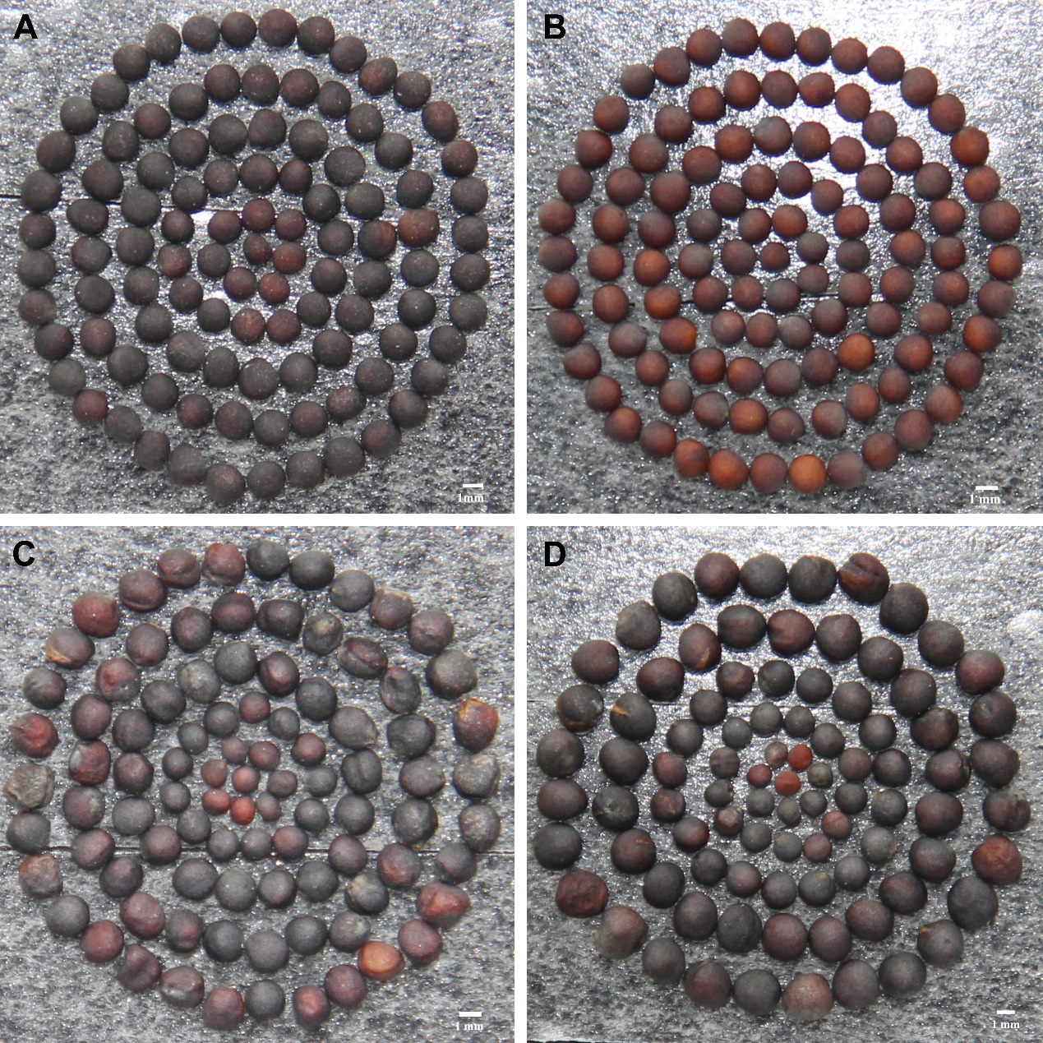

Figure S8 Seeds derived from self-pollination of rapeseed plants. (A) Self-pollinated seeds of ZS11. (B) Self-pollinated seeds of P3-2. (C) Self-pollinated seeds of Y3380. (D) Self-pollinated seeds of Y3560.
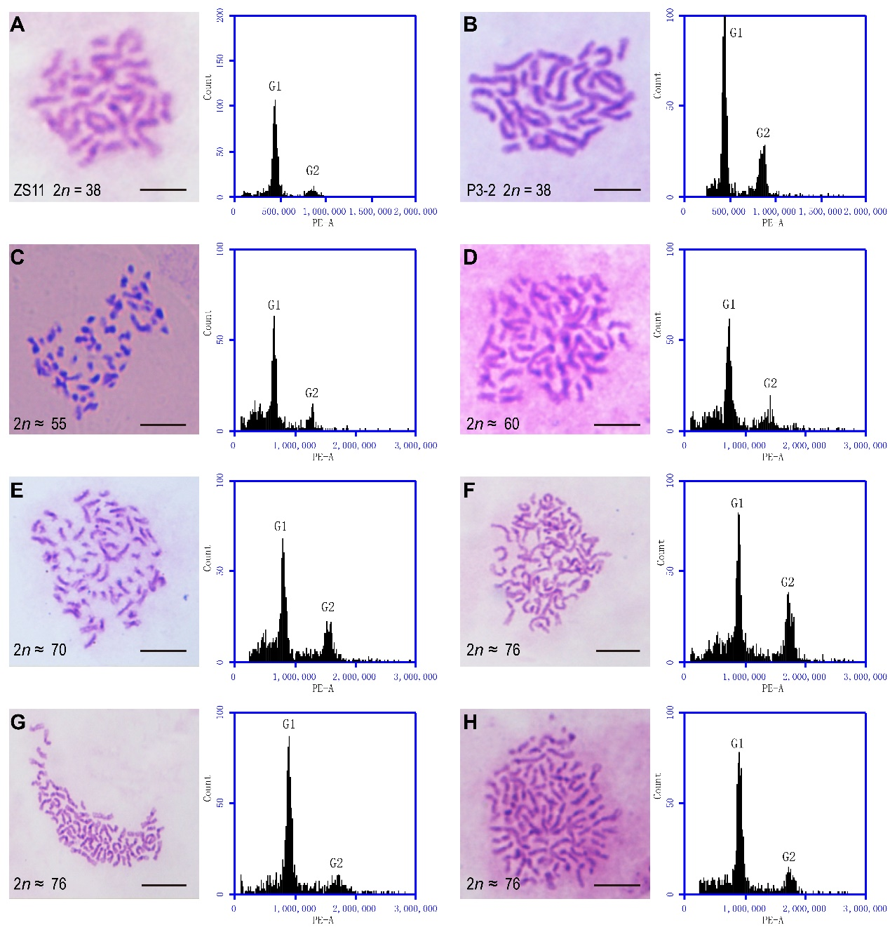

Figure S9 Somatic chromosome number of different ploidy Brassica plants and the corresponding result of flow cytometry. Abscissa axis of the flow chart was the value of fluorescence intensity. (A) ZS11, AACC, 2n = 38. The fluorescence intensity of its mitotic G1 phase was about 445K. (B) P3-2, AACC, 2n = 38. The G1 fluorescence intensity was about 434K. (C) Plant with 55 somatic chromosomes. The G1 fluorescence intensity was about 632K. (D) Plant with 60 somatic chromosomes. The G1 fluorescence intensity was about 700K. (E) Plant with 70 somatic chromosomes. The G1 fluorescence intensity was about 804K. (F-H) Plant with 76 somatic chromosomes. The G1 fluorescence intensity was approximately 890K. Correlation coefficient between chromosome number and fluorescence intensity of G1 phase was 0.98. Bar: 5μm.

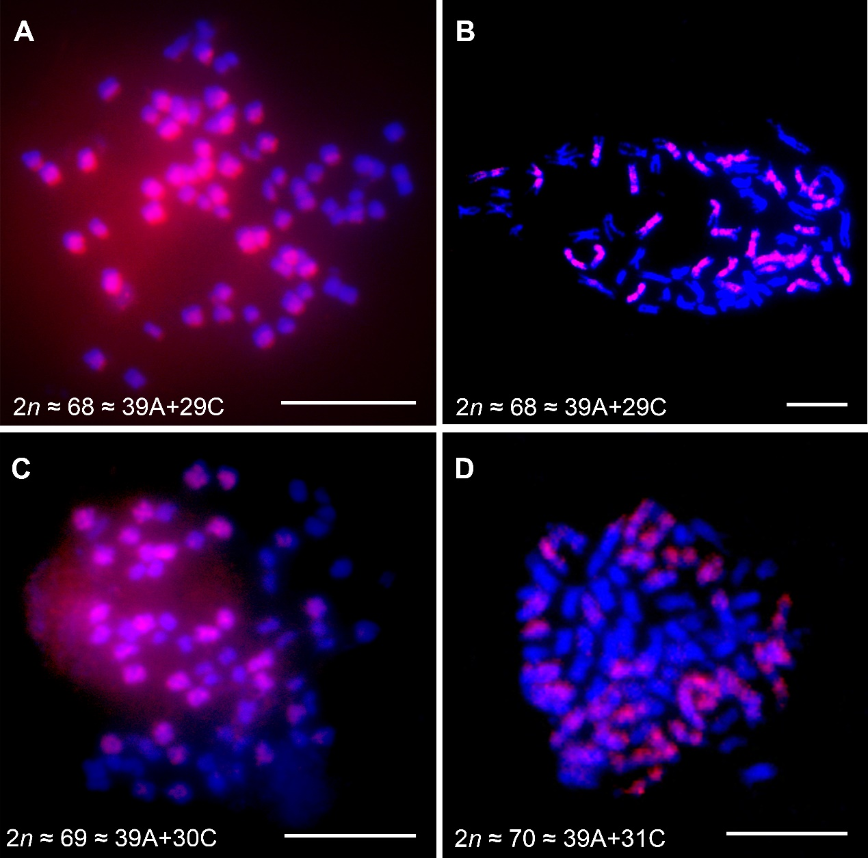

Figure S10 FISH analysis of the self-pollinated individuals derived from octoploid B. napus. Blue signals were from DAPI staining and red signals were from C-genome-specific probe (BAC BoB014O06). (A) An inbred offspring of Y3560, with 2n ≈ 68 (39A+29C). (B) An inbred offspring of Y3380, with 2n ≈ 68 (39A+29C). (C) An inbred offspring of Y3560, with 2n ≈ 69 (39A+30C). (D) An inbred offspring of Y3380, with 2n ≈ 70 (39A+31C). Bar: 5μm.
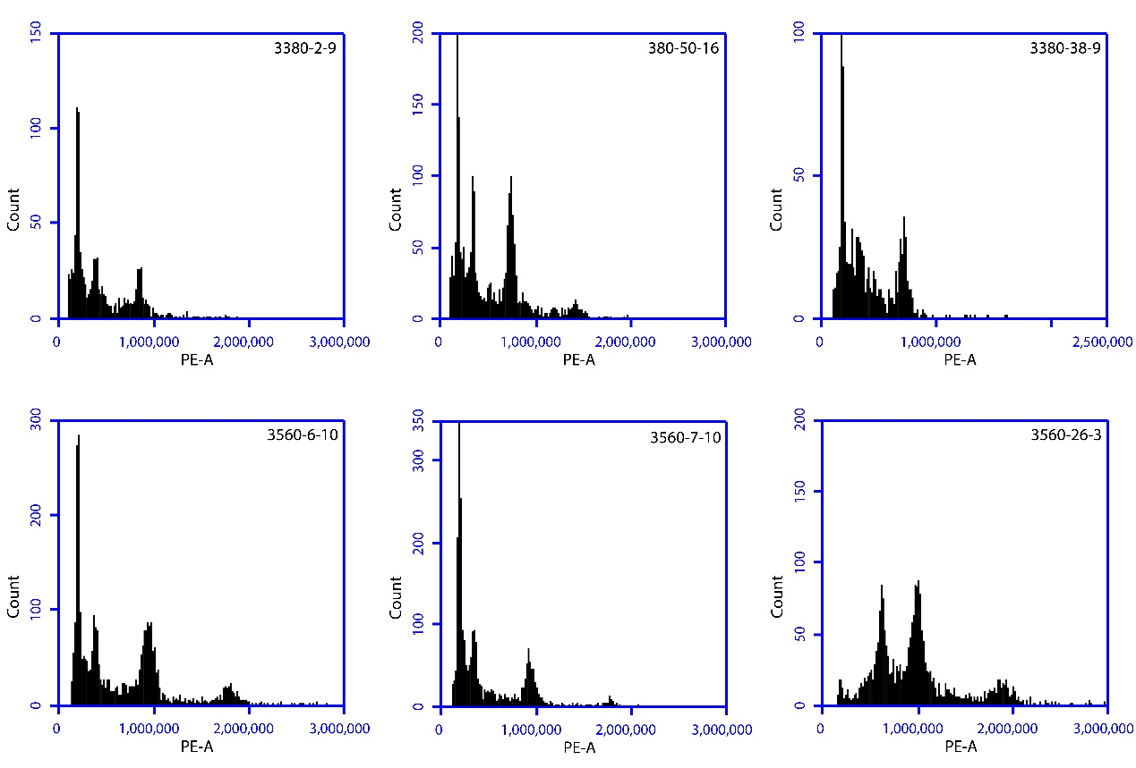

Figure S11 Flow cytometer analysis of mixed-ploidy individuals derived from self-pollination of octoploid B. napus.
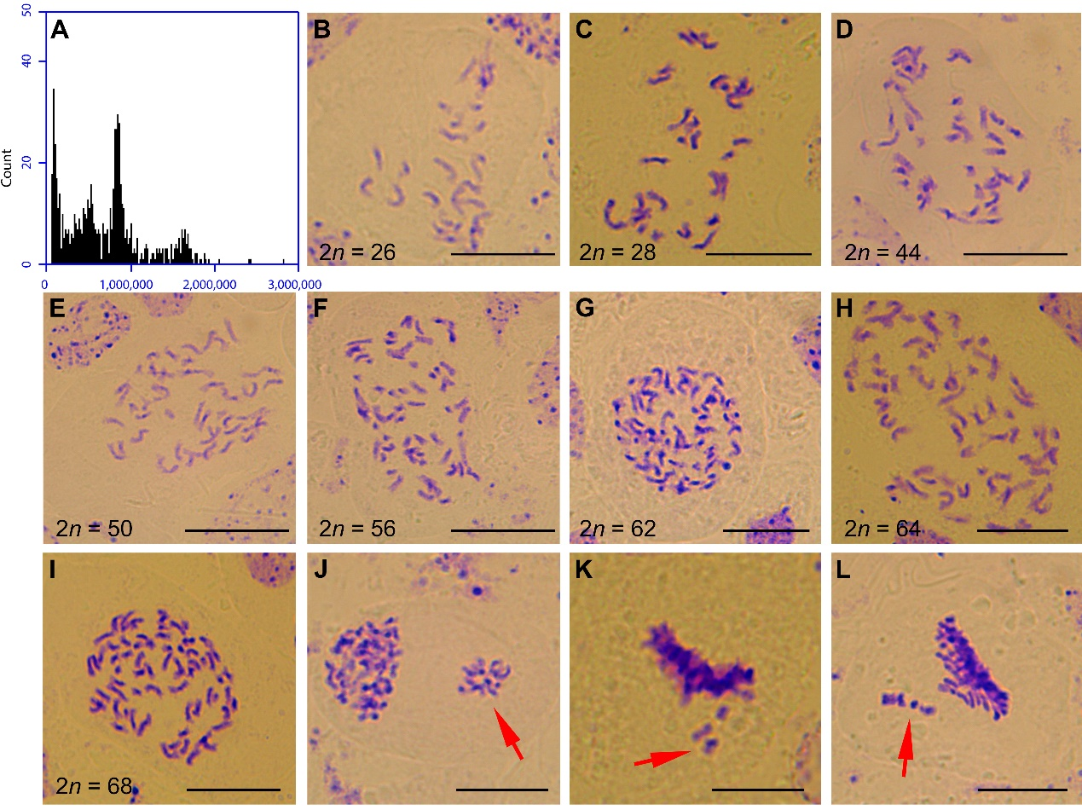

Figure S12 Flow cytometry analysis and somatic chromosome observation of a mixed-ploidy plant derived from octoploid B. napus. (A) Flow cytometry histogram. (B) One cell with 2n = 26. (C) One cell with 2n = 28. (D) One cell with 2n = 44. (E) One cell with 2n = 50. (F) One cell with 2n = 56. (G) One cell with 2n = 62. (H) One cell with 2n = 64. (I) one cell with 2n = 68. (J) One cell with unequal chromosome separation at telophase. (K-L) Chromosome lagging at metaphase. Bar: 10μm.

