Low oxygen stress during early development influences regulation of hypoxia-response genes in farmed Atlantic salmon (Salmo salar)

Tara Kelly*^{,co}, Hanne Johnsen^{†,‡,co}, Erik Burgerhout^{†,co}, Helge Tveiten†,§, Tina Thesslund†, Øivind Andersen †,**, Nicholas Robinson†,*

Supplementary Materials
A

B
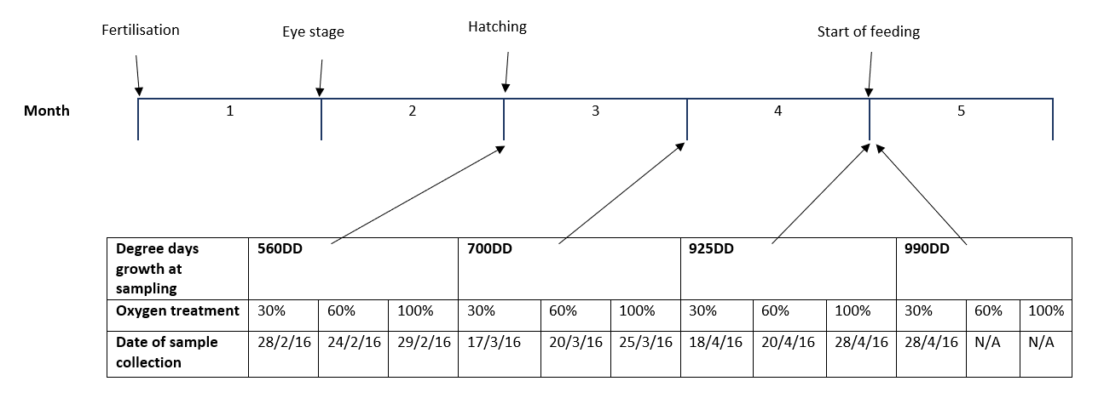
Figure S1. Outline of experimental set up, from egg fertilisation through to start-feeding at approximately 4 months showing the incubation temperatures for each treatment throughout the experiment (A) and dates/stages of development sampled (B).

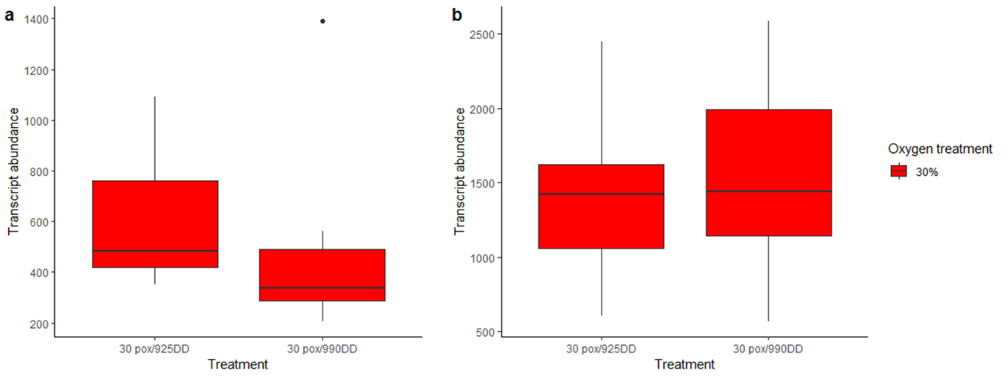
Figure S2. RNA-seq count data for egln3 (a) and hbae (b) in Atlantic salmon reared in 30% O₂ until 925DD and 990DD.

Table S1. Outline of primers used for qPCR
Gene | Direction | Sequence (5' -> 3') | Accession | Chromosome | Efficiency
egln1_L | Forward | CGAGCAACAGAATGACACAGC | XM_014131242.1 | 12 | 2.06
 | Reverse | GCAGGCGGATTTGAACGT
egln2 | Forward | CTGGGCTGCCGTTCTATAATG | NM_001165346.1 | 9 | 1.80
 | Reverse | ACTGTGGCTGCCCTCAATG
egln3 | Forward | GGACCGGATATGTGAAACATGTG | XM_014194431.1 | 1 | 1.96
 | Reverse | GCCTTCCAGTTCTTGTTCAGGTA
hbae | Forward | CGAGCTGCACGCCTTCA | NM_001140924.1 | 6 | 1.99
 | Reverse | GGATGTTGTGGTTGATGATCTTGA
Efficiency = (10^(-1/slope)

Table S2. Pyrosequencing assays. Outline of assays used for DNA methylation analysis.
Assay | Direction | Sequence (5' -> 3') | Position CpG site
1 | Forward PCR Primer | TGGTGTGAGTTTAGATTTGTTATAGAA | 4, 5
 | Reverse PCR Primer | CAATAATTCAACCTTTCTCACTCT
 | Sequencing Primer | ATAGAATAGAATAGAATTTTTGTGA
2 | Forward PCR Primer | TGTAGAGTGAGAAAGGTTGAATTAT | 6, 7, 8
 | Reverse PCR Primer | AAAACCAAACAATCAAATCCAAAACTAACC
 | Sequencing Primer | AGAAAGGTTGAATTATTGAAA

Table S3. Spearman’s correlation between relative expression and methylation at promoter CpG sites in egln3 (n=36).
CpG site | p-value | Correlation
6 | 0.002757 | -0.4974898
8 | 0.002189 | -0.4941665
6+8 | 0.000382 | -0.5600938
All sites (4-8) | 0.08201 | -0.2937858

Table S4. Top twenty enriched gene ontology terms associated with differentially expressed genes comparing: A) 30% O₂ 990DD with 100% O₂ 925DD, B) 30% O₂ 990DD with 60% O₂ 925DD, C) 60% O₂ 925DD with 100% O₂ 925DD, and D) 30% O₂ 990DD with 30% O₂ 925DD.
A
GO.ID |  | Term |  |  |  | Annotated |  | Significant | Expected | Fisher.classic
GO:0003735 |  | structural constituent of ribosome |  |  |  | 231 |  | 177 | 53.91 | < 1e-30
GO:0005198 |  | structural molecule activity |  |  |  | 564 |  | 246 | 131.62 | 2.30E-27
GO:0016675 |  | oxidoreductase activity, acting on a hem... |  |  |  | 38 |  | 33 | 8.87 | 1.80E-16
GO:0016676 |  | oxidoreductase activity, acting on a hem... |  |  |  | 38 |  | 33 | 8.87 | 1.80E-16
GO:0015002 |  | heme-copper terminal oxidase activity |  |  |  | 38 |  | 33 | 8.87 | 1.80E-16
GO:0004129 |  | cytochrome-c oxidase activity |  |  |  | 38 |  | 33 | 8.87 | 1.80E-16
GO:0015078 |  | proton transmembrane transporter activit... |  |  |  | 138 |  | 73 | 32.21 | 4.50E-14
GO:0009055 |  | electron transfer activity |  |  |  | 98 |  | 55 | 22.87 | 2.60E-12
GO:0016491 |  | oxidoreductase activity |  |  |  | 911 |  | 276 | 212.6 | 4.10E-07
GO:0016651 |  | oxidoreductase activity, acting on NAD(P... |  |  |  | 56 |  | 28 | 13.07 | 1.20E-05
GO:0051920 |  | peroxiredoxin activity |  |  |  | 10 |  | 8 | 2.33 | 0.00025
GO:0050136 |  | NADH dehydrogenase (quinone) activity |  |  |  | 17 |  | 11 | 3.97 | 0.00033
GO:0003954 |  | NADH dehydrogenase activity |  |  |  | 17 |  | 11 | 3.97 | 0.00033
GO:0016655 |  | oxidoreductase activity, acting on NAD(P... |  |  |  | 17 |  | 11 | 3.97 | 0.00033
GO:0008137 |  | NADH dehydrogenase (ubiquinone) activity |  |  |  | 17 |  | 11 | 3.97 | 0.00033
GO:0016706 |  | oxidoreductase activity, acting on paire... |  |  |  | 23 |  | 13 | 5.37 | 0.00061
GO:0003899 |  | DNA-directed 5'-3' RNA polymerase activi... |  |  |  | 43 |  | 20 | 10.04 | 0.00071
GO:0034062 |  | 5'-3' RNA polymerase activity |  |  |  | 43 |  | 20 | 10.04 | 0.00071
GO:0097747 |  | RNA polymerase activity |  |  |  | 43 |  | 20 | 10.04 | 0.00071
GO:0003723 |  | RNA binding |  |  |  | 635 |  | 181 | 148.19 | 0.00122
B
GO.ID |  | Term |  |  |  | Annotated |  | Significant | Expected | Fisher.classic
GO:0005506 |  | iron ion binding |  |  |  | 60 |  | 26 | 6.15 | 2.10E-11
GO:0048037 |  | cofactor binding |  |  |  | 123 |  | 39 | 12.61 | 2.10E-11
GO:0140104 |  | molecular carrier activity |  |  |  | 22 |  | 14 | 2.25 | 1.60E-09
GO:0005344 |  | oxygen carrier activity |  |  |  | 21 |  | 13 | 2.15 | 1.10E-08
GO:0019825 |  | oxygen binding |  |  |  | 21 |  | 13 | 2.15 | 1.10E-08
GO:0020037 |  | heme binding |  |  |  | 44 |  | 19 | 4.51 | 1.30E-08
GO:0046906 |  | tetrapyrrole binding |  |  |  | 45 |  | 19 | 4.61 | 2.00E-08
GO:0019842 |  | vitamin binding |  |  |  | 30 |  | 13 | 3.07 | 2.60E-06
GO:0016829 |  | lyase activity |  |  |  | 41 |  | 14 | 4.2 | 2.90E-05
GO:0005215 |  | transporter activity |  |  |  | 272 |  | 49 | 27.88 | 3.20E-05
GO:0050662 |  | coenzyme binding |  |  |  | 59 |  | 17 | 6.05 | 5.00E-05
GO:0031406 |  | carboxylic acid binding |  |  |  | 26 |  | 10 | 2.66 | 0.00013
GO:0043177 |  | organic acid binding |  |  |  | 26 |  | 10 | 2.66 | 0.00013
GO:0031418 |  | L-ascorbic acid binding |  |  |  | 10 |  | 6 | 1.02 | 0.00016
GO:0022857 |  | transmembrane transporter activity |  |  |  | 216 |  | 39 | 22.14 | 0.00021
GO:0016705 |  | oxidoreductase activity, acting on paire... |  |  |  | 38 |  | 12 | 3.89 | 0.00025
GO:0048029 |  | monosaccharide binding |  |  |  | 11 |  | 6 | 1.13 | 0.00033
GO:0016830 |  | carbon-carbon lyase activity |  |  |  | 15 |  | 7 | 1.54 | 0.00035
GO:0016491 |  | oxidoreductase activity |  |  |  | 225 |  | 39 | 23.06 | 0.00051
GO:0016675 |  | oxidoreductase activity, acting on a hem... |  |  |  | 14 |  | 6 | 1.43 | 0.00163
C
GO.ID |  | Term |  |  |  | Annotated |  | Significant | Expected | Fisher.classic
GO:0003735 |  | structural constituent of ribosome |  |  |  | 217 |  | 71 | 39.4 | 1.50E-07
GO:0016675 |  | oxidoreductase activity, acting on a hem... |  |  |  | 39 |  | 18 | 7.08 | 5.50E-05
GO:0016676 |  | oxidoreductase activity, acting on a hem... |  |  |  | 39 |  | 18 | 7.08 | 5.50E-05
GO:0015002 |  | heme-copper terminal oxidase activity |  |  |  | 39 |  | 18 | 7.08 | 5.50E-05
GO:0004129 |  | cytochrome-c oxidase activity |  |  |  | 39 |  | 18 | 7.08 | 5.50E-05
GO:0009055 |  | electron transfer activity |  |  |  | 91 |  | 30 | 16.52 | 0.00048
GO:0140110 |  | transcription regulator activity |  |  |  | 743 |  | 170 | 134.9 | 0.00049
GO:0003700 |  | DNA-binding transcription factor activit... |  |  |  | 695 |  | 158 | 126.19 | 0.00103
GO:0005198 |  | structural molecule activity |  |  |  | 508 |  | 118 | 92.23 | 0.00197
GO:0015370 |  | solute:sodium symporter activity |  |  |  | 58 |  | 20 | 10.53 | 0.0022
GO:0016772 |  | transferase activity, transferring phosp... |  |  |  | 1277 |  | 270 | 231.86 | 0.0024
GO:0015081 |  | sodium ion transmembrane transporter act... |  |  |  | 121 |  | 35 | 21.97 | 0.00243
GO:0016779 |  | nucleotidyltransferase activity |  |  |  | 105 |  | 31 | 19.06 | 0.00296
GO:0015291 |  | secondary active transmembrane transport... |  |  |  | 149 |  | 41 | 27.05 | 0.00304
GO:0016859 |  | cis-trans isomerase activity |  |  |  | 41 |  | 15 | 7.44 | 0.00401
GO:0005328 |  | neurotransmitter:sodium symporter activi... |  |  |  | 41 |  | 15 | 7.44 | 0.00401
GO:0003755 |  | peptidyl-prolyl cis-trans isomerase acti... |  |  |  | 41 |  | 15 | 7.44 | 0.00401
GO:0005326 |  | neurotransmitter transporter activity |  |  |  | 43 |  | 15 | 7.81 | 0.00668
GO:0015293 |  | symporter activity |  |  |  | 76 |  | 23 | 13.8 | 0.00697
GO:0015294 |  | solute:cation symporter activity |  |  |  | 76 |  | 23 | 13.8 | 0.00697
D
GO.ID |  | Term |  |  |  | Annotated |  | Significant | Expected | Fisher.classic
GO:0003824 |  | catalytic activity |  |  |  | 7117 |  | 1947 | 1752.42 | 8.20E-13
GO:0016853 |  | isomerase activity |  |  |  | 124 |  | 61 | 30.53 | 2.60E-09
GO:0140097 |  | catalytic activity, acting on DNA |  |  |  | 101 |  | 52 | 24.87 | 5.20E-09
GO:0048037 |  | cofactor binding |  |  |  | 527 |  | 186 | 129.76 | 1.70E-08
GO:0016491 |  | oxidoreductase activity |  |  |  | 915 |  | 288 | 225.3 | 8.30E-07
GO:0050662 |  | coenzyme binding |  |  |  | 293 |  | 108 | 72.15 | 1.70E-06
GO:0008135 |  | translation factor activity, RNA binding |  |  |  | 142 |  | 59 | 34.96 | 6.40E-06
GO:0019842 |  | vitamin binding |  |  |  | 125 |  | 51 | 30.78 | 4.70E-05
GO:0003678 |  | DNA helicase activity |  |  |  | 33 |  | 19 | 8.13 | 5.40E-05
GO:0016635 |  | oxidoreductase activity, acting on the C... |  |  |  | 7 |  | 7 | 1.72 | 5.50E-05
GO:0003743 |  | translation initiation factor activity |  |  |  | 101 |  | 43 | 24.87 | 5.50E-05
GO:0051540 |  | metal cluster binding |  |  |  | 68 |  | 31 | 16.74 | 0.00013
GO:0051536 |  | iron-sulfur cluster binding |  |  |  | 68 |  | 31 | 16.74 | 0.00013
GO:0008233 |  | peptidase activity |  |  |  | 805 |  | 243 | 198.22 | 0.00014
GO:0016787 |  | hydrolase activity |  |  |  | 2941 |  | 801 | 724.16 | 0.00018
GO:0070011 |  | peptidase activity, acting on L-amino ac... |  |  |  | 770 |  | 232 | 189.6 | 0.00022
GO:0003917 |  | DNA topoisomerase type I activity |  |  |  | 6 |  | 6 | 1.48 | 0.00022
GO:0008177 |  | succinate dehydrogenase (ubiquinone) act... |  |  |  | 6 |  | 6 | 1.48 | 0.00022
GO:0046923 |  | ER retention sequence binding |  |  |  | 6 |  | 6 | 1.48 | 0.00022
GO:0016645 |  | oxidoreductase activity, acting on the C... |  |  |  | 23 |  | 14 | 5.66 | 0.00024

