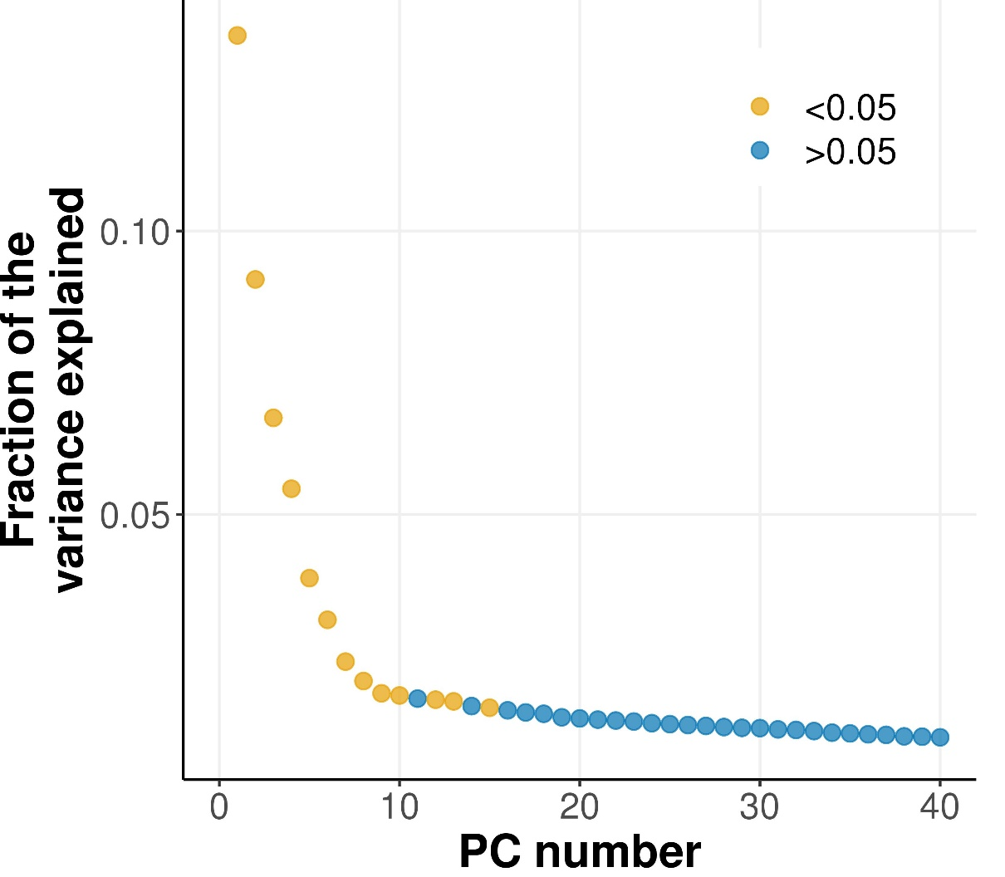
Figure S3. Fraction of the variance accounted for by the first 40 PCs derived from the genetic analysis of 125 individuals from different Nile tilapia strains / populations.

