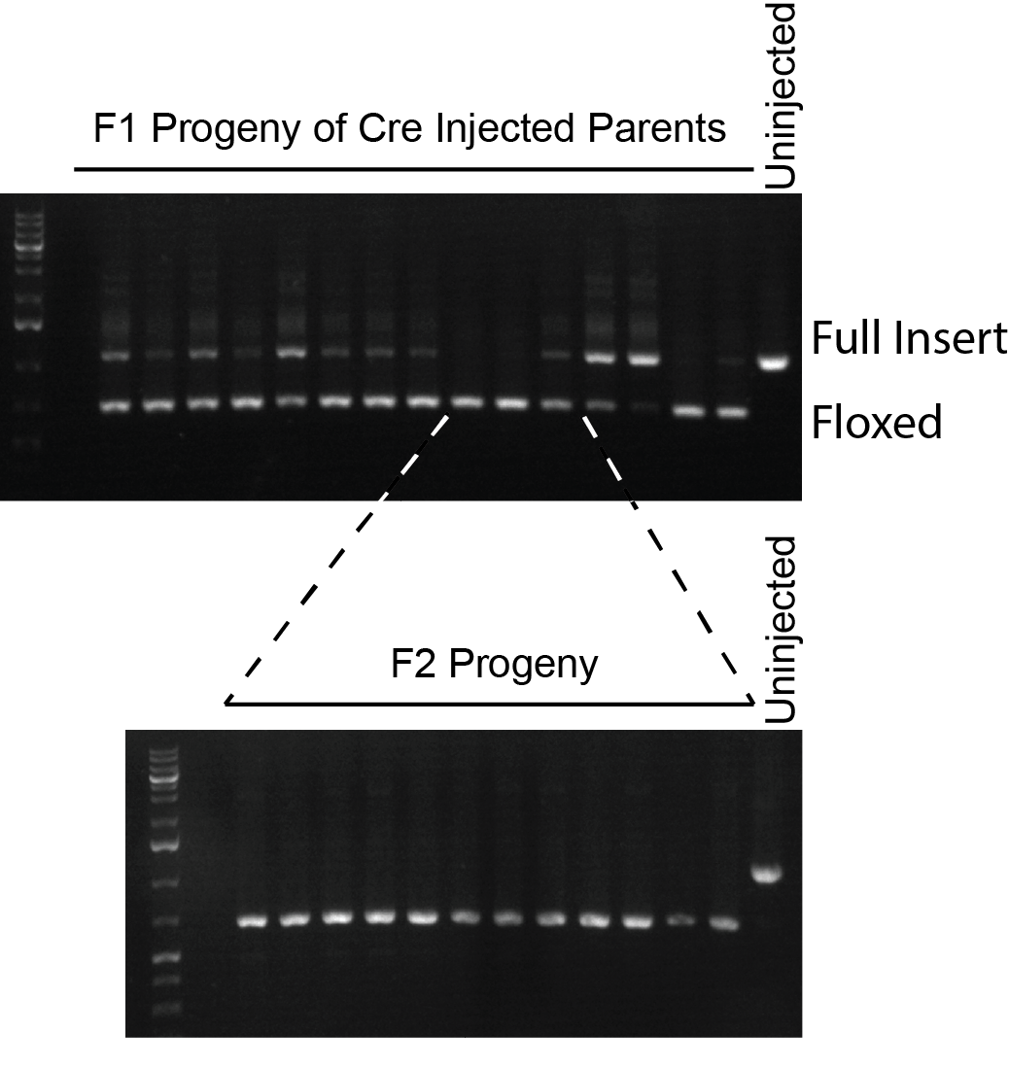
Figure S5. Injection of a Cre expressing plasmid results in the efficient removal of the hygromycin resistance marker gene. Co-injection marker expression marker positive F1 progeny (upper panel) were PCR screened for removal of the hygromycin resistance gene (“floxed” product). Four F2 progeny (lower panel) from three of the F1 broods with the weakest wild-type signal (“full insert” product), were then screened to confirm homozygous removal.

