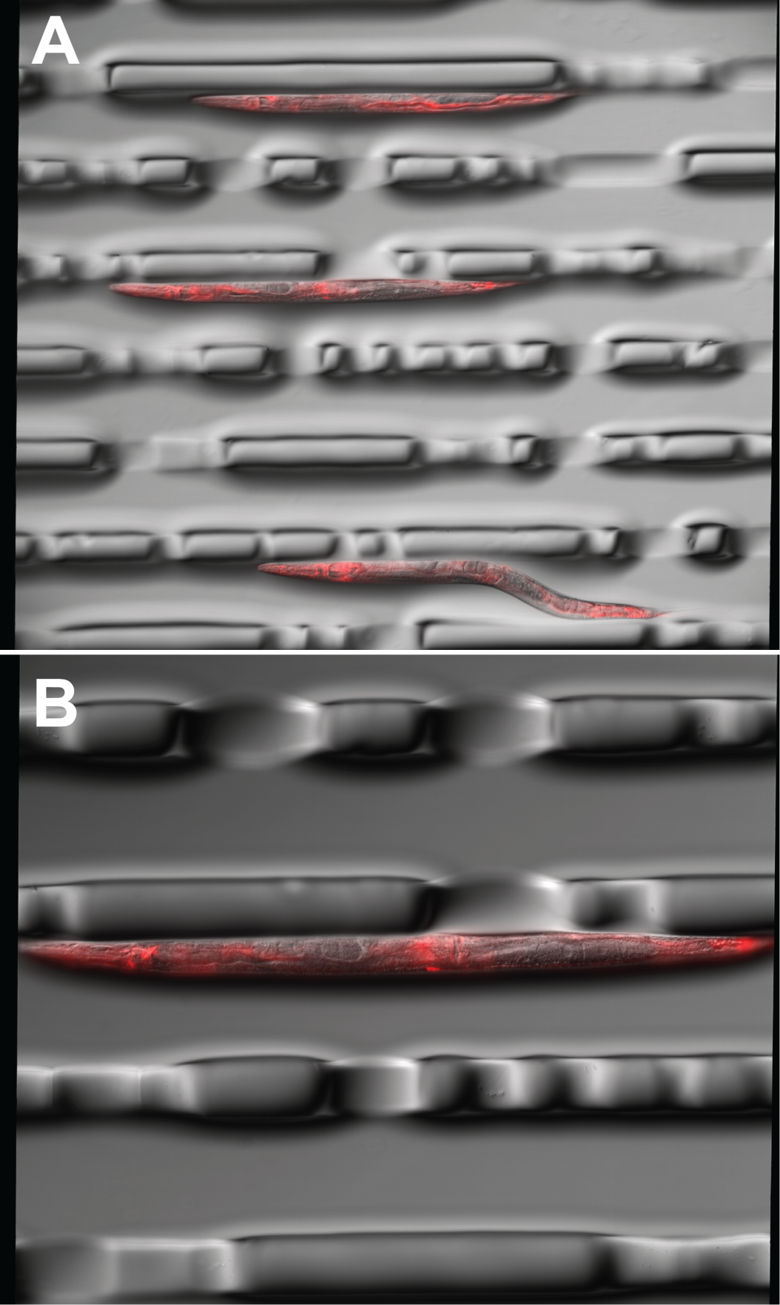
Figure S4. Representative images of eft-3p::wrmScarlet::tbb-2 3’UTR (pZCS16) array individuals. Synchronized young adults were injected with a mix containing 3 ng/µl pZCS16 91.25 ng/µl total DNA. A) Composite image of 30ms DIC and 40ms mCherry filter at 100x total magnification. B) Composite image 60ms DIC and mCherry filter at 200X total magnification.

