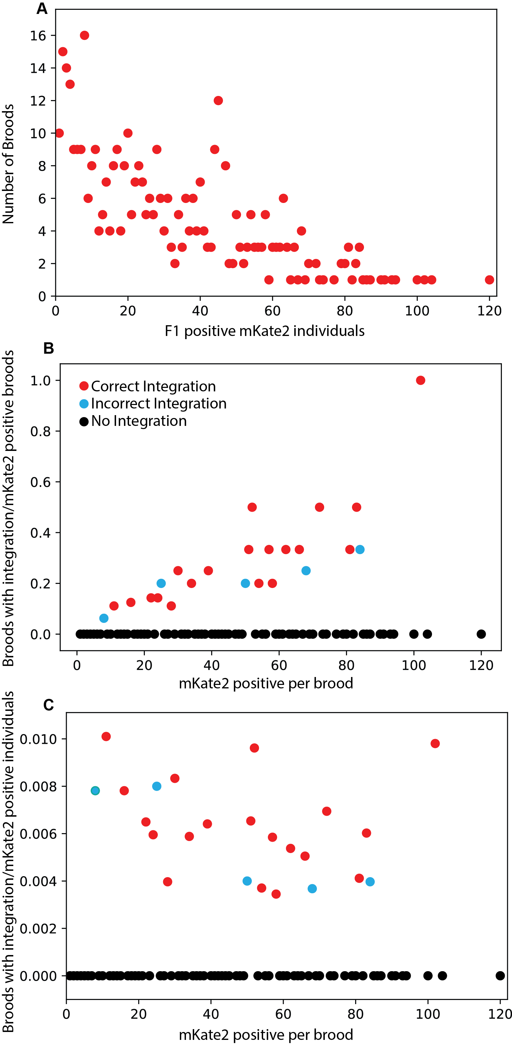
Figure S3. Comparison of integration broods. A) Distribution of co- injection marker (mKate2) positive broods based on the number of mKate2 positive F1 individuals per brood. Broods with a small number of positive individuals are most common; however, there are ‘jackpot’ injections showing large numbers of individuals. B) Broods with a large number of mKate2 positive F1 individuals are more likely to have integration events, both correct and incorrect. However, when controlling for the total number of mKate2 positive individuals, C) each brood with positive F1s is nearly equally likely to have integration events. Thus, while jackpot broods may have more transgenics, having more transgenics spread across several plates is similarly sufficient for identifying successful integration events.

