**Supplementary Material**

**Figure S1.** To compare the p-values, we looked at the proportional differences. These differences amounted to less than a 1% difference for all markers except for 115 (0.44% of data). The most significantly impacted proportions were in some of the most differentiated regions, where the p-value given by SAS and R respectively were 1.80E-07 and 1.73E-07 (3.9% difference). Given the small difference and the fact that in no case did any locus change from being statistically significant to not or vice versa, we conclude that these disagreements are unimportant.

**Figure S2.** Scatter plot of the single model results (-LogP) versus the matching multi-model results (line represents equality) for the MegaMUGA SNP chip data from Xu and Garland (2017) (A) and the WGS SNP data (B). No major differences were found for loci with small p-values (top right of graph).

The Following are in Separate Files:

**File S2.csv.** This table includes the raw allelic data for Mixed Model analyses.

Columns include: chromosome, base pair position (POS), base pair ID for that chromosome (marker), and two columns for each mouse representing alleles (columns 4 through 161).

**File S3.csv.** Mouse data for matching allelic data of Table S1.csv.

Columns include: row (id), mouse ID (mouse), test group with control as 0 and HR as 1 (pop), line (sub), and allele id within mouse (allele).

The rows are ordered such that transposing File S2.csv columns 4 through 161 lines up each mouse and allele with its proper data in File S3.csv. Likewise, transposing File S5.csv columns 9 through 166 will line each row of File S3.csv to its proper haplotype data.

**File S4.csv.** Mixed model analysis results for all WGS loci.

Columns include: chromosome, base pair position (POS), model associated with the best AICc (Model), and p-value generated with that model using 1, 6 degrees of freedom (P).

**File S5.csv.** Mouse haplotype data.

Columns include: chromosome (chr), block ID within chromosome (block), number of alleles determined to be present in the base population in generation 0 (n.hap), number of SNPs with MAF >0.0126 within the haplotype block (Nblock_g61), lowest base pair location in the block (MinPOS), highest base pair location in the block (MaxPOS), number of alleles determined to be present in generation 61 (nhap_g61), list of numbers associated with blocks present in the sequenced mice (haps_g61), and lastly two columns for each mouse containing its alleles for the haplotype block.

**File S6.csv.** Mixed model analysis results for all haplotype blocks.

Columns include: chromosome (chr), block ID within chromosome (block), number of SNPs with MAF >0.0126 within the haplotype block (Nblock_g61), lowest base pair location in the block (MinPOS), highest base pair location in the block (MaxPOS), number of alleles determined to be present in generation 61 (nhap_g61), and p-value for the differentiation of control and HR lines, see Methods of main text (P).

**File S7.docx.** Justification for focusing analyses on allelic data (twin vectors of 0-0, 0-1, and 1-1) as opposed to genomic data.

**File S8.docx.** Results and discussion of simulations under the null hypothesis and their reduced Type I error rates for Mixed Model analyses using MIVQUE variance estimation in the current study.

**File S9.docx.** Additional discussion of genes contained in consistent regions.

**File S10.docx.**  Code used for notable data analyses and organization procedures.

**Table S1.xlsx.** List of local maxima associated genes.

Columns include: gene symbol, chromosome (chr), base pair location of local maximum (Sig_BP), and region of the gene the local maximum is located (Location).

**Table S2.xlsx.** Groups of loci which are fixed in one linetype but polymorphic in the other.

Columns include: linetype for which the loci were fixed (LT_Fixed), chromosome the group is located (Chr), lowest base pair location in the group (First_BP), highest base pair location in the group (Last_BP), number of loci fixed for the given linetype within the group (Loci), and a column for each of the four lines of the polymorphic linetype (Line_A through _D).

**Table S3.xlsx.** Heterozygosity for each individual mouse.

Columns include: mouse ID, linetype, whole-genome sequence heterozygosity (WGS Het), and haplotype heterozygosity (Hap Het).

**Table S4.xlsx**. Top ten genes for each of the targeted ontologies analyses.

Columns include: search term used to identify ontologies terms associated with the system or pathway of interest (Term), chromosome location of the gene, p-value of the most significant SNP located in the gene (P), and gene symbol.

**Table S5.xlsx.** Allele frequency by line of each loci identified as a local maximum.

Columns include: chromosome and position of local maximum, p-value, and alternative allele frequency for each of 8 lines starting with the four control lines and followed by the four HR lines.

**Table S6.xlsx.**  Regions of the genome with p-values less than 0.001 as determined by the mixed model analyses. These are the regions from which local maxima are selected from.

Columns include: chromosome of the region (Chr), lowest base pair location in the region (Start), highest base pair location in the region (End), number of base pairs within the region (Size), and the lowest p-value SNP within the region (Lowest P).

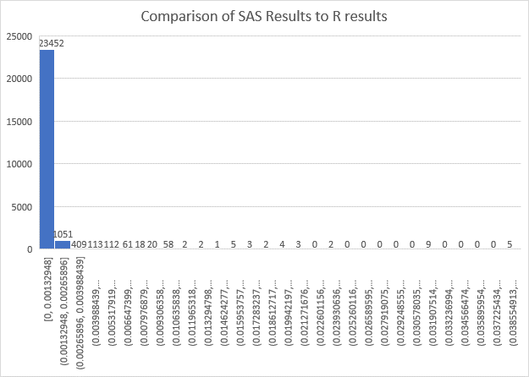

**Figure S1.** To compare the p-values, we looked at the proportional differences. These differences amounted to less than a 1% difference for all markers except for 115 (0.44% of data). The most significantly impacted proportions were in some of the most differentiated regions, where the p-value given by SAS and R respectively were 1.80E-07 and 1.73E-07 (3.9% difference). Given the small difference and the fact that in no case did any locus change from being statistically significant to not or vice versa, we conclude that these disagreements are unimportant.

** A** **B**

**Figure S2.** Scatter plot of the single model results (-LogP) versus the matching multi-model results (line represents equality) for the MegaMUGA SNP chip data from Xu and Garland (2017) (A) and the WGS SNP data (B). No major differences were found for loci with small p-values (top right of graph).