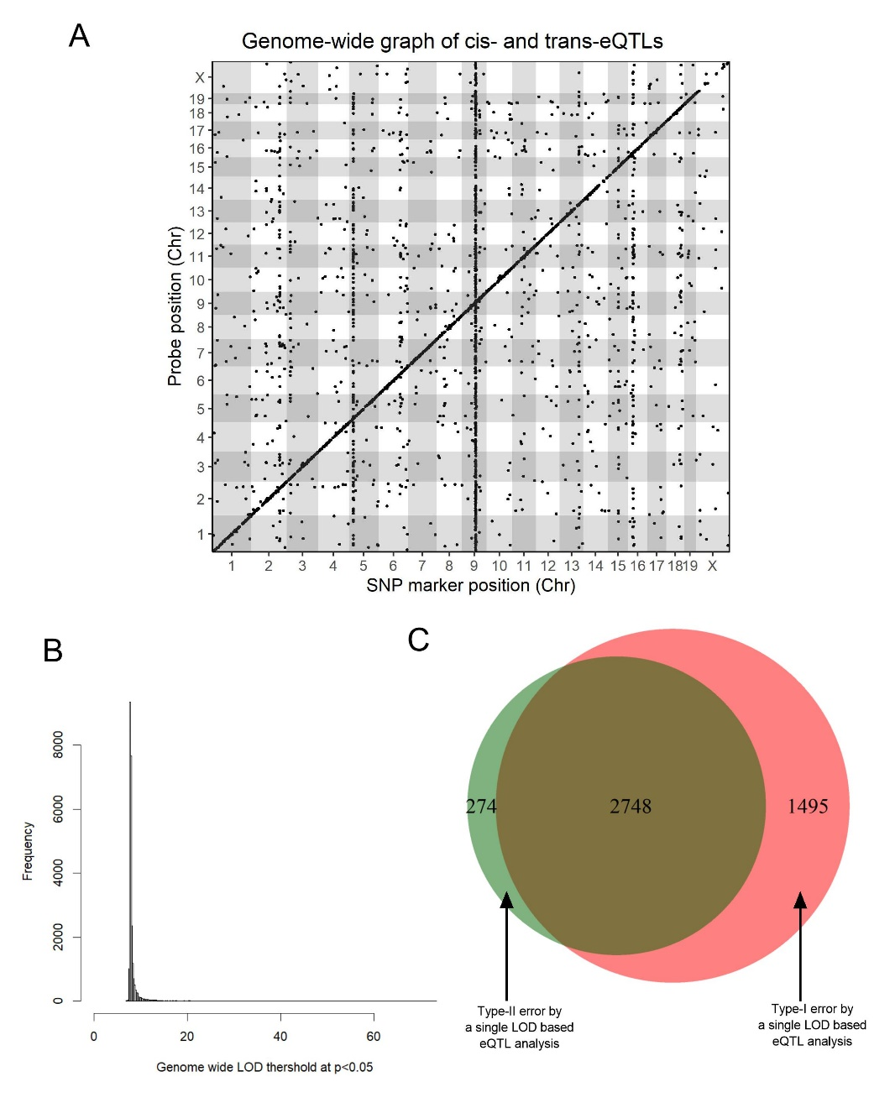

Figure S1: A single LOD threshold based eQTL might lead to higher Type-I and Type-II errors. (A) The positions of the significant eQTLs based on single LOD threshold (median LOD threshold = 7.65 (25th = 7.77 and 75th = 8.40) calculated form randomly selected 1000 probesets) are plotted against the locations of the corresponding transcript (y-axis) along with the genome (x-axis). Cis-eQTL, occurring within a 4-Mb (peak SNP within ± 2Mb of the probe position) genomic window, are located at the diagonal, all other dots represent trans-regulated genes. (B) Frequency of the genome-wide LOD thresholds at p<0.05 for individual probset on all probes on the microarray for all probes. (C) Venn diagram showing, overlap between significant (p<0.05) eQTLs and conventional single LOD based eQTLs, Type-I (an eQTL with LOD score higher than 7.65 but lower than its own LOD threshold at p<0.05), and Type-II (an eQTL with LOD scored less than 7.65 but higher than its own true LOD threshold at p<0.05) error generated by the single LOD based analysis.
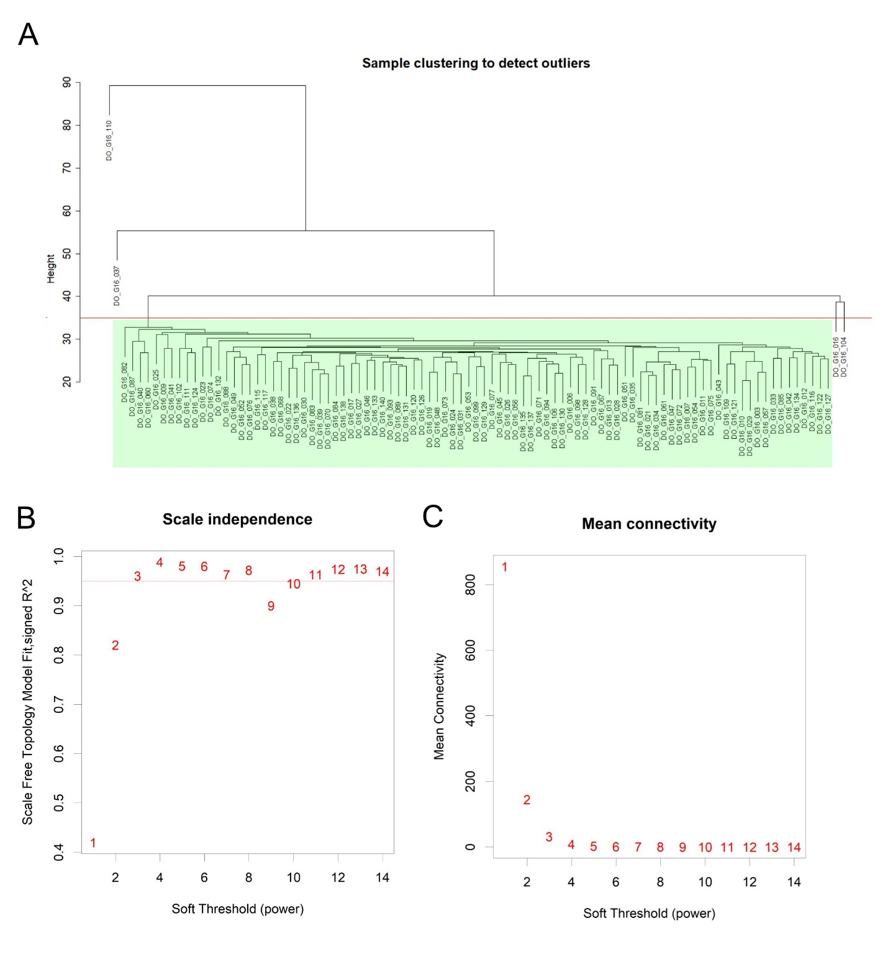

Figure S2: (A) Samples were clustered based on the kidney gene expression levels to determine the outliers. The horizontal red line indicates the chosen cut height for the sample tree to determine the outliers. Out of 95 samples, 91 samples clustered together (light green shaded) and was included in the downstream analysis. (B) The effect of different power value on the scale-free topology of co-expression of the gene expression levels. (C) The effect of different power value on the mean connectivity degree of co-expression modules of the kidney gene expression levels.
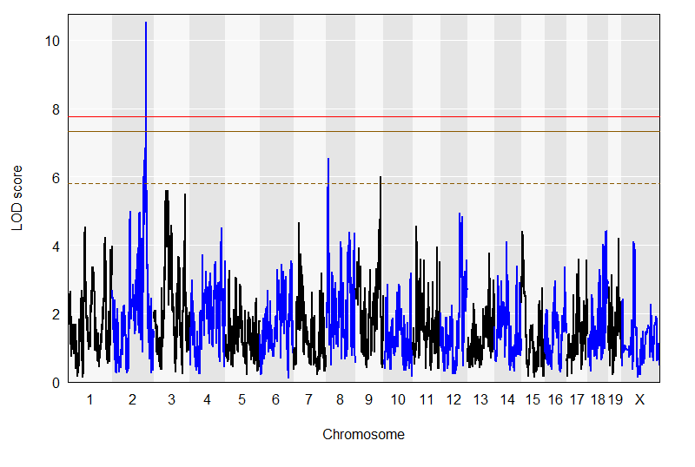
Figure S3: Genome scan of plasma CysC level with adjusting with body weight as an additive covariate in the model. Red, solid golden, and broken golden lines show permutation-derived (N = 1000) significance thresholds at P < 0.05, p<0.10, and P<0.63, respectively.

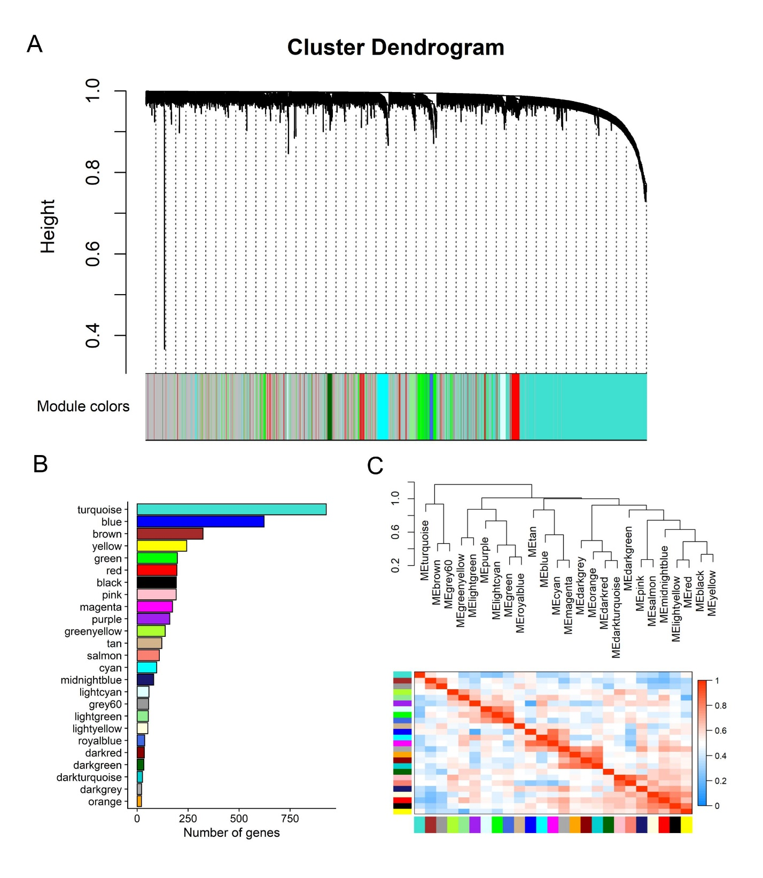Figure S4: (A) WGCNA-module analysis of the kidney gene expression level and identified modules. (B) Number of genes in each of the gene-modules. (C) Heatmap represents the intermodule eigengenes correlation and a hierarchical clustering dendrogram of the eigengenes.

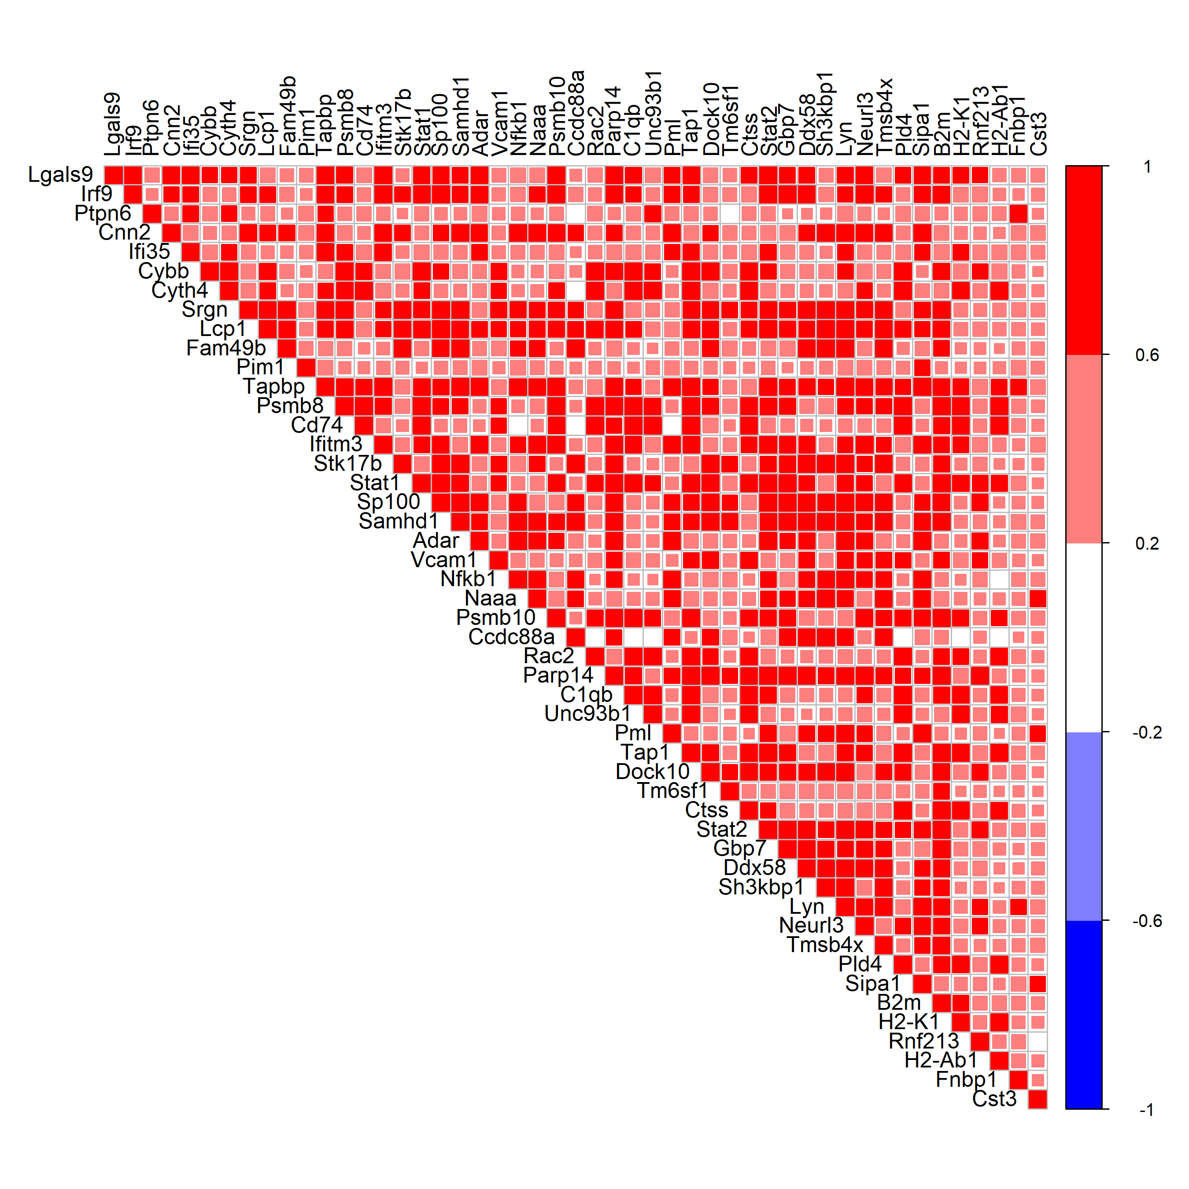
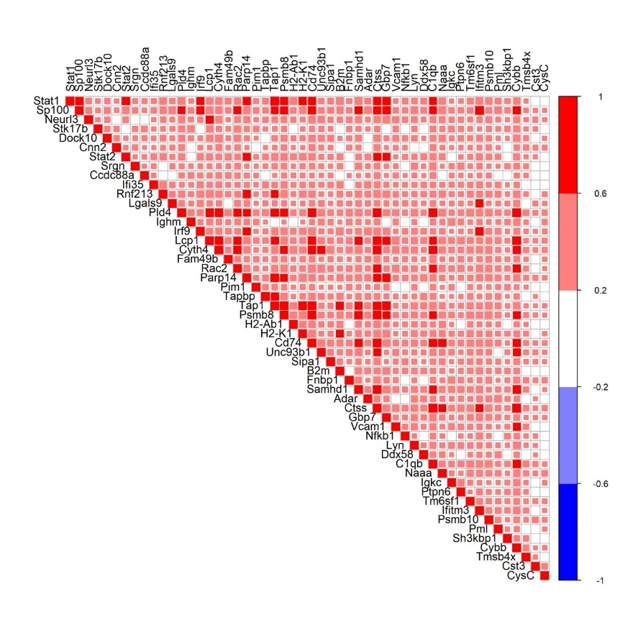
A
B

Figure S5: (A) among top 50 hubgenes in brown module, Cst3 expression and plasma CysC level in DO-microarray data. (B) among top 50 hub genes in brown module, Cst3 expression and plasma CysC level in publicly available DO-RNASeq data (GEO: GSE121330). White square means non-significant (p≥0.05) correlation.

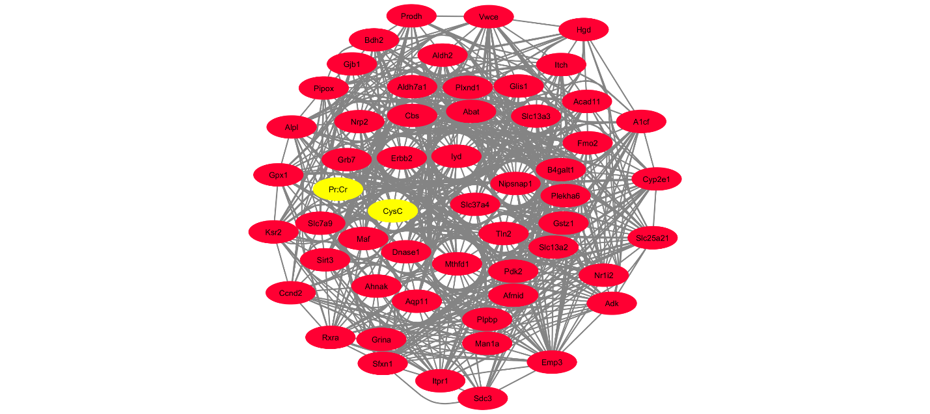

Figure S6: Cytoscape network visualization of to 50 hubgenes in the red module and their relationship with plasma CysC and urinary total protein: creatinine. The red nodes denote hubgenes in the module and the yellow nodes denote CysC and urinary total protein: creatinine.

