SUPPLEMENTAL MATERIALS

SUPPLEMENTAL METHODS

We selected plausible combinations of μ, F, and H for wYak at low and high altitude based on our mathematical analyses (Table S5) to illustrate how stochasticity contributes to variation in wYak frequencies at infection equilibria ($\hat{p}$). This included a set of plausible parameters for wYak at low altitude ($\hat{p}$ = 0.8, μ = 0.038, $s_{h}$ = 0.16, F = 1.05), high altitude ($\hat{p}$ = 0.84, μ = 0.087, $s_{h}$ = 0.20, F = 1.55), and a second set for high altitude with the anomalous YAK05b trap removed ($\hat{p}$ = 0.97, μ = 0.036, $s_{h}$ = 0.45, F = 1.47; see Results).

Monte Carlo simulations with 10,000 replicates of population events were enacted using functions in the PopTools package (Hood 2011) and the following parameters described in Kriesner and Hoffmann (2018): (1) the number of reproductively successful females in each cohort (N_{CS♀}) where cohort is based on infection status, random binomial with n = total number of females comprising cohort (N_{C♀}) and p = 0.91, (2) the number of ova produced for each cohort, N_{CS♀}× F × ω, where ω = normally distributed random variable with mean = 24.4 and σ = 17.5/$\sqrt{N_{CS♀}}$, (3) the number of uninfected ova produced by infected mothers per cohort, random binomial with n = total number of ova produced per cohort and p = μ, and (4) the number of uninfected ova fertilized by sperm from wYak-infected males and rendered inviable due to CI, random binomial with n = number of uninfected ova arising per cohort and p = $s_{h}$. For the number of reproductively successful females and the number of ova produced for each cohort (parameters 1 and 2 above), values for p, mean of the normal distribution, and σ are based on fecundity data obtained previously using D. yakuba of varying infection status from Cooper et al. (2017). Here, p was calculated as the mean proportion of mated females in 24 hours, and the mean and σ were calculated from the daily number of eggs laid in the intraspecific D. yakuba fecundity experiments described in Cooper et al. (2017). All other parameters were set to the defaults described in Kriesner and Hoffmann (2018), including the number of viable ova per cohort that survive to adulthood, the number of successful male matings for each new cohort, and the number of reproductively successful females in each new cohort that mated with males of each infection type. All other relevant information can be found in the main text.

SUPPLEMENTAL FIGURES

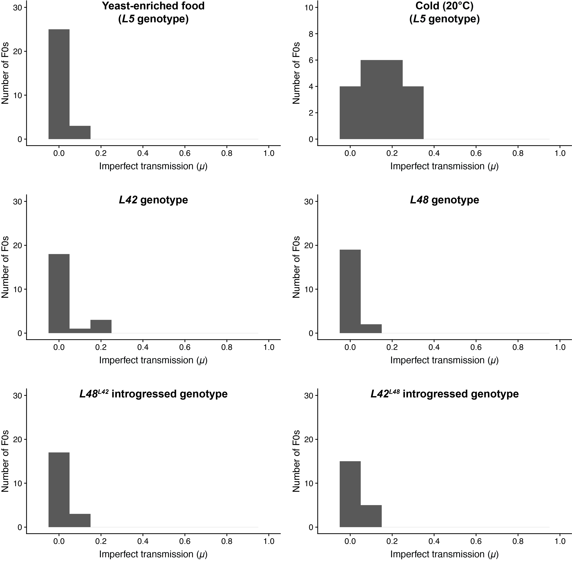

SUPPLEMENTAL FIGURE S1. Histogram of μ in laboratory experiments using the D. yakuba isofemale line L5 and reciprocally introgressed genotypes (L42, L48, L48^{L42}, L42^{L48}).

SUPPLEMENTAL FIGURE S2. Left) Differences in allele frequencies between the genomes of D. yakuba from low and high altitudes on São Tomé. Histogram (gray) shows the full distribution of differences in allele frequencies between low and high altitude populations. The mean difference (0.0027) is shown with a vertical red line. This distribution overlaps the histogram of data simulated with an equivalent standard deviation and mean 0 (blue). Right) Sliding window average differences across each chromosome.

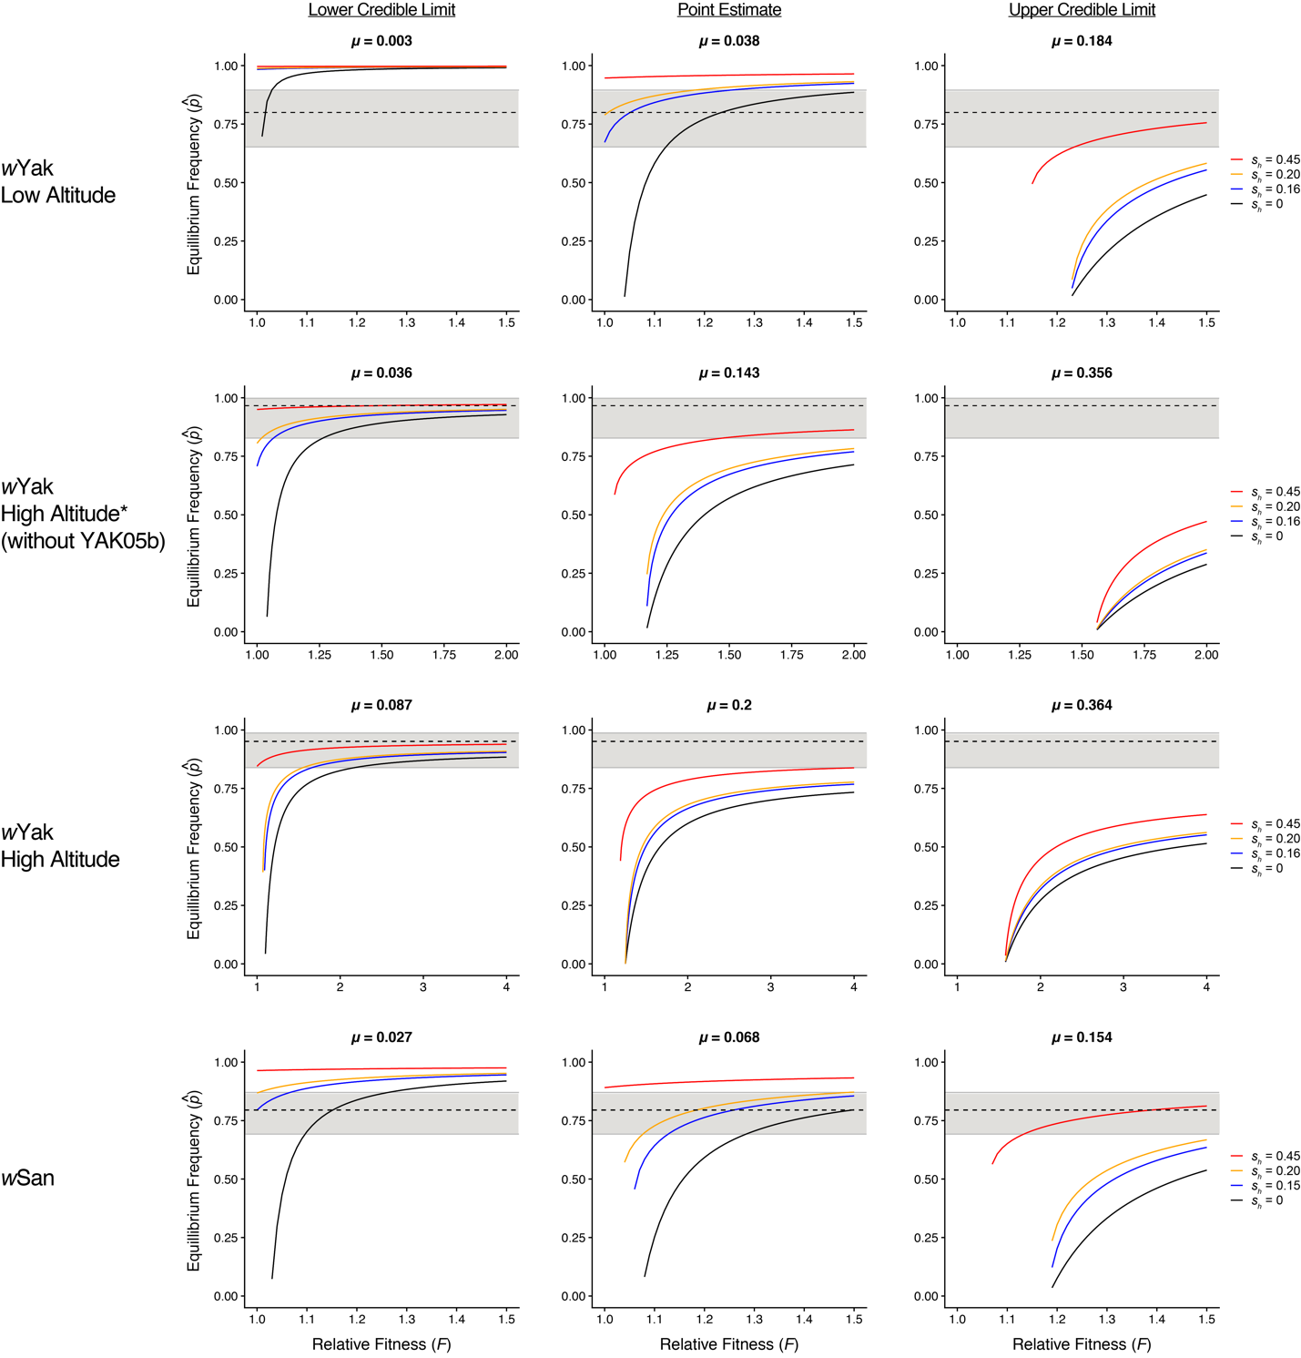

SUPPLEMENTAL FIGURE S3. Equilibrium infection frequencies for wYak and wSan plotted against a range of F values, assuming our field estimates of μ (± credible intervals). The dotted lines indicate observed infection frequencies, and the gray areas denote 95% binomial confidence intervals. Plotted black lines denote no CI ($s_{h}$ = 0), followed by laboratory estimates of weak CI in blue for wYak ($s_{h}$ = 0.16) and wSan ($s_{h}$ = 0.15) (Cooper et al. 2017), moderate CI in orange ($s_{h}$ = 0.20), and strong CI in red ($s_{h}$ = 0.45). Each row presents results for specific Wolbachia and regions. Plots are arranged in columns by the lower credible limit, point estimate, and upper credible limit of μ for each group. The asterisk signifies that the YAK05b trapping site was removed from the high altitude wYak dataset due to an anomalously high value of μ. The full range of parameter estimates are shown in Table S5.
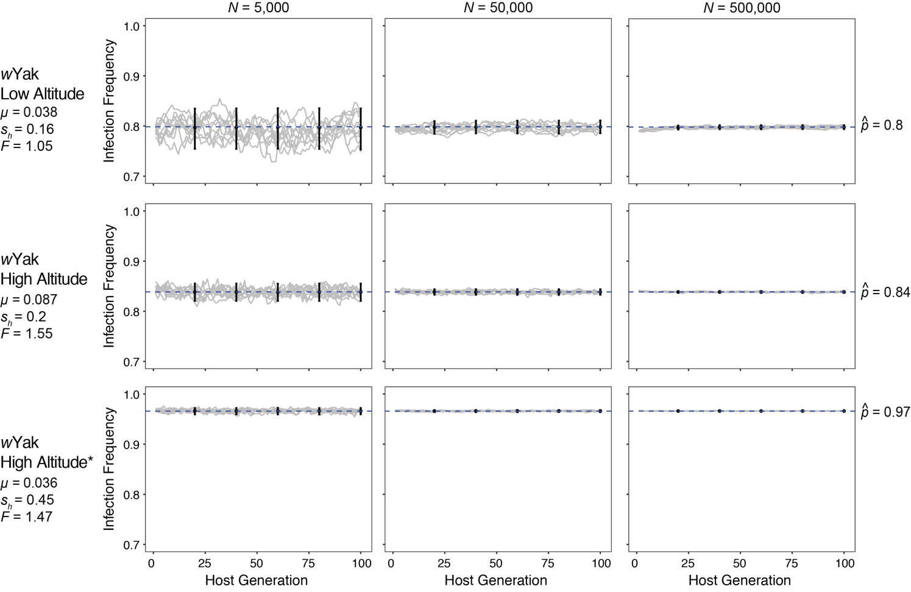
SUPPLEMENTAL FIGURE S4. Stochastic model outcomes for wYak frequencies in host populations at infection equilibrium ($\hat{p}$). Infection dynamics over 100 host generation (10 random trials each) are shown with the mean of Monte Carlo simulations (10,000 replicates) and associated 95% confidence intervals sampled every 20 host generations. Infection equilibria predicted by Equation 2 for each region are shown with a blue dashed line. Models incorporate field estimates of p and μ and a range of $s_{h}$ and F values (see Table S5). The asterisk signifies that the YAK05b trapping site was removed from the high altitude wYak dataset due to an anomalously high value of μ. For each region, separate models were run assuming a host census population size (N) of 5,000, 50,000, and 500,000.

SUPPLEMENTAL TABLE S1. Estimates of infection frequencies (p) and imperfect maternal transmission (μ) for individual trapping sites. Sample sizes (N), infection frequencies (p) with exact 95% binomial confidence intervals, mean number of F1 offspring per family (Mean N F1s), and weighted mean imperfect transmission (μ) are shown for each trapping site. 95% BC_{a} confidence intervals were not calculated for μ due to inadequate sample sizes at some individual trapping sites.

Species | Grouping | Latitude | Longitude | Elevation | Bioclim Annual Mean Temperature (°C) | N | N infected | p  [Confidence Interval] | Mean N F1s | μ
D. yakuba | Low Altitude
 | YAK02 | 0.304 | 6.646 | 590 | 20.9 | 40 | 32 | 0.800 [0.652, 0.895] | 9.9 | 0.038
 | High Altitude
 | YAK04 | 0.290 | 6.630 | 900 | 20.6 | 27 | 26 | 0.963 [0.817, 0.998] | 10.6 | 0.148
 | YAK05 | 0.289 | 6.616 | 1096 | 17.8 | 2 | 2 | 1.000 [0.342, 1.000] | 8.5 | 0.059
 | YAK05b | 0.290 | 6.616 | 1104 | 17.8 | 12 | 11 | 0.917 [0.646, 0.996] | 9.7 | 0.354
D. santomea | Site 1
 | CAR01 | 0.277 | 6.588 | 1184 | 17.8 | 3 | 2 | 0.667 [0.208, 0.983] | 14.3 | 0.133
 | CAR02 | 0.277 | 6.588 | 1216 | 17.8 | 3 | 3 | 1.000 [0.439, 1.000] | 5.0 | 0.000
 | CAR03 | 0.277 | 6.586 | 1261 | 17.8 | 3 | 2 | 0.667 [0.208, 0.983] | 6.0 | 0.308
 | CAR04 | 0.279 | 6.587 | 1347 | 17.8 | 4 | 2 | 0.500 [0.150, 0.850] | 8.0 | 0.000
 | CAR05 | 0.279 | 6.589 | 1340 | 17.8 | 11 | 10 | 0.909 [0.623, 0.995] | 11.9 | 0.130
 | Site 2
 | CAR07 | 0.279 | 6.594 | 1414 | 17.8 | 9 | 8 | 0.889 [0.565, 0.994] | 9.1 | 0.000
 | CAR09 | 0.281 | 6.595 | 1399 | 17.8 | 8 | 5 | 0.625 [0.306, 0.863] | 8.3 | 0.000
 | CAR10 | 0.282 | 6.596 | 1411 | 17.8 | 16 | 12 | 0.750 [0.505, 0.898] | 8.6 | 0.000
 | TRNE01 | 0.281 | 6.592 | 1460 | 17.8 | 10 | 8 | 0.800 [0.490, 0.943] | 12.5 | 0.171
 | TRNE02 | 0.282 | 6.593 | 1464 | 17.8 | 7 | 7 | 1.000 [0.646, 1.000] | 11.4 | 0.000
 | TRNE03 | 0.283 | 6.597 | 1385 | 17.8 | 4 | 3 | 0.750 [0.301, 0.987] | 8.8 | 0.033

SUPPLEMETNAL TABLE S2. Sampling information for isofemale lines used in laboratory experiments.

Line | Year | Latitude | Longitude | Altitude (m)
L5 | 2013 | 3.3436 | 8.656 | 1,356
L42 | 2009 | 0.2914 | 6.6214 | 1,100
L48 | 2009 | 0.2914 | 6.6214 | 1,100

SUPPLEMENTAL TABLE S3. Imperfect wYak maternal transmission in the laboratory. The number of sublines (N), mean number of F1 offspring per subline (Mean N F1s), weighted mean imperfect transmission (μ), and 95% BC_{a} confidence intervals are shown for each experiment.

Treatment | N | Mean N F1s | μ [Confidence Interval]
yeast-enriched food | 28 | 9.89 | 0.011 [0.004, 0.029]
cold (20°C) | 20 | 10 | 0.15 [0.109, 0.196]
host genotype L42 | 22 | 10 | 0.032 [0.009, 0.082]
host genotype L48 | 21 | 9.86 | 0.01 [0, 0.034]
reciprocal introgression L42^{L48} | 20 | 9.95 | 0.025 [0.01, 0.055]
reciprocal introgression L48^{L42} | 20 | 10 | 0.015 [0.005, 0.045]

SUPPLEMENTAL TABLE S4. Gene annotations for completely differentiated SNPs between low and high altitude populations of D. yakuba. Annotation results are shown each SNP using the D. yakuba Release 2.0 assembly and annotation on the UCSC Genome Browser.

Chromosome Arm | SNP Position | Position | Annotation Gene Symbol | Dmel Gene Symbol | Gene Name | Gene Location | Molecular Function (GO) Predictions
3L | 3668737 | <10kb upstream | CG7213 | CG7213 | NA | chr3L:3,668,973-3,672,288 | NA
 |  | <10kb upstream | CG8023 | eIF4E3 | eukaryotic translation initiation factor 4E3 | chr3L:3,673,908-3,674,928 | RNA 7-methylguanosine cap binding; RNA cap binding; contributes to translation initiation factor activity; translation initiation factor binding
3L | 5201729 | <10kb upstream | CG7471 | HDAC1 | Histone deacetylase 1 | chr3L:5,202,077-5,204,254 | histone deacetylase activity; transcription corepressor activity
 |  | <10kb upstream | CG43225 | axo | axotactin | chr3L:5,205,034-5,205,411 | serine-type endopeptidase inhibitor activity
 |  | <10kb upstream | CG13716 | NA | NA | chr3L:5,209,817-5,210,164 | NA
3L | 18327412 | 10kb intergenic | NA | NA | NA | NA | NA
3R | 16902666 | <10kb upstream | CG18765 | NA | NA | chr3R:16,904,248-16,905,597 | NA
 |  | <10kb upstream | CG6908 | NA | NA | chr3R:16,906,043-16,907,540 | NA
 |  | <10kb upstream | CG6834 | NA | NA | chr3R:16,907,939-16,911,105 | NA
 |  | <10kb upstream | CG6830 | NA | NA | chr3R:16,911,662-16,914,246 | NA
3R | 16902675 | <10kb upstream | CG18765 | NA | NA | chr3R:16,904,248-16,905,597 | NA
 |  | <10kb upstream | CG6908 | NA | NA | chr3R:16,906,043-16,907,540 | NA
 |  | <10kb upstream | CG6834 | NA | NA | chr3R:16,907,939-16,911,105 | NA
 |  | <10kb upstream | CG6830 | NA | NA | chr3R:16,911,662-16,914,246 | NA
X | 3902534 | <10kb upstream | CG3062 | NA | NA | chrX:3,905,462-3,906,454 | NA
 |  | <10kb upstream | CG3081 | NA | NA | chrX:3,906,928-3,908,664 | NA
 |  | <10kb upstream | CG3346 | pon | partner of numb | chrX:3,909,330-3,911,475 | NA
 |  | <10kb upstream | CG12179 | NA | NA | chrX:3,912,017-3,915,981 | NA
X | 5614370 | 10kb intergenic | NA | NA | NA | NA | NA
X | 8177508 | <10kb upstream | CG18319 | ban | bendless | chrX:8,186,055-8,186,507 | ubiquitin conjugating enzyme activity

SUPPLEMENTAL TABLE S5. Values of F required to explain estimates of p (± credible intervals) given our field estimates of μ (± credible intervals) and a range of CI strength. Estimates were calculated using equation 2. Estimates of infection frequencies (p) and weighted mean imperfect transmission (μ) are shown for wYak at low and high altitude sites and for the pooled sample of wSan. For each grouping, we evaluated parameter space across the full credible interval of p and μ (lower limit, point estimate, and upper limit). Cells labeled NA indicate bistable equilibria where F(1 – μ) < 1, which we consider unlikely because they preclude Wolbachia spread at low frequency (counter to observations in nature; see Methods). Values of F > 1.5 are considered biologically unrealistic and have not been observed in any system (see Meany et al. 2019). F values in bold identify parameter combinations used the stochastic models adapted from Kriesner and Hoffmann (2018) (Figure S4, Table S7).

wYak | p value | p | μ Value | μ | No CI  ($s_{h}$ = 0) | Weak Lab CI  ($s_{h}$ = 0.16) | Moderate CI  ($s_{h}$ = 0.20) | Strong CI  ($s_{h}$ = 0.45)
Low Altitude | Lower Limit | 0.652 | Lower Limit | 0.003 | 1.01 | NA | NA | NA
 |  |  | Point Estimate | 0.038 | 1.12 | NA | NA | NA
 |  |  | Upper Limit | 0.184 | 2.12 | 1.77 | 1.68 | 1.23
 | Point Estimate | 0.8 | Lower Limit | 0.003 | 1.02 | NA | NA | NA
 |  |  | Point Estimate | 0.038 | 1.23 | 1.05 | 1.01 | NA
 |  |  | Upper Limit | 0.184 | >4 | >4 | >4 | 1.86
 | Upper Limit | 0.895 | Lower Limit | 0.003 | 1.03 | NA | NA | NA
 |  |  | Point Estimate | 0.038 | 1.57 | 1.25 | 1.18 | NA
 |  |  | Upper Limit | 0.184 | >4 | >4 | >4 | >4
High Altitude* (without YAK05b) | Lower Limit | 0.828 | Lower Limit | 0.036 | 1.26 | 1.07 | 1.02 | NA
 |  |  | Point Estimate | 0.143 | >4 | 3.34 | 2.95 | 1.48
 |  |  | Upper Limit | 0.356 | >4 | >4 | >4 | >4
 | Point Estimate | 0.966 | Lower Limit | 0.036 | >4 | >4 | >4 | 1.47
 |  |  | Point Estimate | 0.143 | >4 | >4 | >4 | >4
 |  |  | Upper Limit | 0.356 | >4 | >4 | >4 | >4
 | Upper Limit | 0.998 | Lower Limit | 0.036 | >4 | >4 | >4 | >4
 |  |  | Point Estimate | 0.143 | >4 | >4 | >4 | >4
 |  |  | Upper Limit | 0.356 | >4 | >4 | >4 | >4
High Altitude | Lower Limit | 0.839 | Lower Limit | 0.087 | 2.18 | 1.66 | 1.55 | NA
 |  |  | Point Estimate | 0.2 | >4 | >4 | >4 | >4
 |  |  | Upper Limit | 0.364 | >4 | >4 | >4 | >4
 | Point Estimate | 0.951 | Lower Limit | 0.087 | >4 | >4 | >4 | >4
 |  |  | Point Estimate | 0.2 | >4 | >4 | >4 | >4
 |  |  | Upper Limit | 0.364 | >4 | >4 | >4 | >4
 | Upper Limit | 0.987 | Lower Limit | 0.087 | >4 | >4 | >4 | >4
 |  |  | Point Estimate | 0.2 | >4 | >4 | >4 | >4
 |  |  | Upper Limit | 0.364 | >4 | >4 | >4 | >4
wSan | p value | p | μ Estimate | μ | No CI  ($s_{h}$ = 0) | Weak Lab CI  ($s_{h}$ = 0.15) | Moderate CI  ($s_{h}$ = 0.20) | Strong CI  ($s_{h}$ = 0.45)
Pooled | Lower Limit | 0.692 | Lower Limit | 0.027 | 1.1 | NA | NA | NA
 |  |  | Point Estimate | 0.068 | 1.28 | 1.13 | 1.08 | NA
 |  |  | Upper Limit | 0.154 | 2 | 1.67 | 1.57 | 1.13
 | Point Estimate | 0.795 | Lower Limit | 0.027 | 1.15 | NA | NA | NA
 |  |  | Point Estimate | 0.068 | 1.5 | 1.26 | 1.18 | NA
 |  |  | Upper Limit | 0.154 | >4 | 2.75 | 2.45 | 1.39
 | Upper Limit | 0.87 | Lower Limit | 0.027 | 1.26 | 1.07 | NA | NA
 |  |  | Point Estimate | 0.068 | 2.1 | 1.62 | 1.49 | NA
 |  |  | Upper Limit | 0.154 | >4 | >4 | >4 | 2.78

SUPPLEMENTAL TABLE S6. Exploration of parameter space assuming wYak μ in the current generation may not reflect μ in the previous generation. We conservatively considered the full range of wYak μ point estimates (0.038–0.354) across all D. yakuba trapping sites on São Tomé in our 2018 sample (Table S1), which exceeds seasonal variation of wRi μ observed in a population of D. simulans in Ivanhoe, CA (Turelli and Hoffmann 1995). We assume that any between-host-generation variation in μ within a region is unlikely to exceed the full range of μ point estimates across all trapping sites (Table S1). Values of F required to explain estimates of p (± credible intervals) for each group were calculated using equation 2. Cells labeled NA indicate bistable equilibria where F(1 – μ) < 1, which we consider unlikely because they preclude Wolbachia spread at low frequency (counter to observations in nature; see Methods). Values of F > 1.5 are considered biologically unrealistic and have not been observed in any system (see Meany et al. 2019).

wYak | p value | p | μ Value | μ | No CI  ($s_{h}$ = 0) | Weak Lab CI  ($s_{h}$ = 0.16) | Moderate CI  ($s_{h}$ = 0.20) | Strong CI  ($s_{h}$ = 0.45)
Low Altitude | Lower Limit | 0.652 | Lowest Observed | 0.038 | 1.12 | NA | NA | NA
 |  |  | Highest Observed | 0.354 | >4 | >4 | >4 | 3.98
 | Point Estimate | 0.8 | Lowest Observed | 0.038 | 1.23 | 1.05 | 1.01 | NA
 |  |  | Highest Observed | 0.354 | >4 | >4 | >4 | >4
 | Upper Limit | 0.895 | Lowest Observed | 0.038 | 1.57 | 1.25 | 1.18 | NA
 |  |  | Highest Observed | 0.354 | >4 | >4 | >4 | >4
High Altitude* (without YAK05b) | Lower Limit | 0.828 | Lowest Observed | 0.038 | 1.28 | 1.08 | 1.03 | NA
 |  |  | Highest Observed | 0.354 | >4 | >4 | >4 | >4
 | Point Estimate | 0.966 | Lowest Observed | 0.038 | >4 | >4 | >4 | 1.61
 |  |  | Highest Observed | 0.354 | >4 | >4 | >4 | >4
 | Upper Limit | 0.998 | Lowest Observed | 0.038 | >4 | >4 | >4 | >4
 |  |  | Highest Observed | 0.354 | >4 | >4 | >4 | >4
High Altitude | Lower Limit | 0.839 | Lowest Observed | 0.038 | 1.31 | 1.1 | 1.04 | NA
 |  |  | Highest Observed | 0.354 | >4 | >4 | >4 | >4
 | Point Estimate | 0.951 | Lowest Observed | 0.038 | >4 | 2.52 | 2.22 | 1.06
 |  |  | Highest Observed | 0.354 | >4 | >4 | >4 | >4
 | Upper Limit | 0.987 | Lowest Observed | 0.038 | >4 | >4 | >4 | >4
 |  |  | Highest Observed | 0.354 | >4 | >4 | >4 | >4

SUPPLEMENTAL TABLE S7. Stochastic model outcomes for wYak frequencies in populations at infection equilibrium ($\hat{p}$). Models assume field estimates of $\hat{p}$ and μ and plausible values of $s_{h}$ and F for each region (see Table S5). The asterisk signifies that the YAK05b trapping site was removed from the high altitude wYak dataset due to an anomalously high value of μ. For each region, separate models were run assuming a host census population size (N) of 5,000, 50,000, and 500,000. Infection dynamics over 100 host generation are shown with the mean infection frequencies (p), variance, and associated 95% confidence intervals from the Monte Carlo simulations (10,000 replicates).

wYak Region | $$\hat{p}$$ | μ | $$s_{h}$$ | F | N | Host Generation | Mean p | Variance | Lower CI | Upper CI
Low Altitude | 0.789 | 0.038 | 0.16 | 1.05 | 5,000 | 20 | 0.7971 | 4.18E-04 | 0.7544 | 0.8348
 |  |  |  |  |  | 40 | 0.7974 | 4.32E-04 | 0.7544 | 0.8352
 |  |  |  |  |  | 60 | 0.7977 | 4.16E-04 | 0.7548 | 0.8354
 |  |  |  |  |  | 80 | 0.7974 | 4.30E-04 | 0.7544 | 0.8354
 |  |  |  |  |  | 100 | 0.7973 | 4.33E-04 | 0.7530 | 0.8350
 |  |  |  |  | 50,000 | 20 | 0.7975 | 4.18E-05 | 0.7845 | 0.8099
 |  |  |  |  |  | 40 | 0.7982 | 4.17E-05 | 0.7854 | 0.8107
 |  |  |  |  |  | 60 | 0.7982 | 4.21E-05 | 0.7853 | 0.8106
 |  |  |  |  |  | 80 | 0.7982 | 4.19E-05 | 0.7851 | 0.8107
 |  |  |  |  |  | 100 | 0.7984 | 4.20E-05 | 0.7856 | 0.8110
 |  |  |  |  | 500,000 | 20 | 0.7975 | 4.22E-06 | 0.7935 | 0.8015
 |  |  |  |  |  | 40 | 0.7983 | 4.18E-06 | 0.7942 | 0.8023
 |  |  |  |  |  | 60 | 0.7984 | 4.22E-06 | 0.7943 | 0.8024
 |  |  |  |  |  | 80 | 0.7984 | 4.08E-06 | 0.7944 | 0.8024
 |  |  |  |  |  | 100 | 0.7984 | 4.09E-06 | 0.7945 | 0.8024
High Altitude | 0.839 | 0.087 | 0.2 | 1.55 | 5,000 | 20 | 0.8384 | 7.74E-05 | 0.8208 | 0.8554
 |  |  |  |  |  | 40 | 0.8384 | 7.61E-05 | 0.8206 | 0.8552
 |  |  |  |  |  | 60 | 0.8382 | 7.81E-05 | 0.8206 | 0.8550
 |  |  |  |  |  | 80 | 0.8384 | 7.90E-05 | 0.8206 | 0.8554
 |  |  |  |  |  | 100 | 0.8385 | 7.79E-05 | 0.8208 | 0.8552
 |  |  |  |  | 50,000 | 20 | 0.8386 | 7.83E-06 | 0.8331 | 0.8440
 |  |  |  |  |  | 40 | 0.8385 | 7.70E-06 | 0.8330 | 0.8440
 |  |  |  |  |  | 60 | 0.8385 | 7.55E-06 | 0.8331 | 0.8439
 |  |  |  |  |  | 80 | 0.8385 | 7.85E-06 | 0.8330 | 0.8439
 |  |  |  |  |  | 100 | 0.8386 | 7.66E-06 | 0.8331 | 0.8440
 |  |  |  |  | 500,000 | 20 | 0.8385 | 7.46E-07 | 0.8368 | 0.8402
 |  |  |  |  |  | 40 | 0.8385 | 7.72E-07 | 0.8368 | 0.8403
 |  |  |  |  |  | 60 | 0.8385 | 7.67E-07 | 0.8368 | 0.8402
 |  |  |  |  |  | 80 | 0.8385 | 7.60E-07 | 0.8368 | 0.8402
 |  |  |  |  |  | 100 | 0.8385 | 7.88E-07 | 0.8368 | 0.8403
High Altitude* | 0.966 | 0.036 | 0.45 | 1.47 | 5,000 | 20 | 0.9660 | 1.09E-05 | 0.9594 | 0.9722
 |  |  |  |  |  | 40 | 0.9661 | 1.06E-05 | 0.9596 | 0.9722
 |  |  |  |  |  | 60 | 0.9661 | 1.07E-05 | 0.9594 | 0.9724
 |  |  |  |  |  | 80 | 0.9660 | 1.12E-05 | 0.9592 | 0.9722
 |  |  |  |  |  | 100 | 0.9661 | 1.04E-05 | 0.9596 | 0.9722
 |  |  |  |  | 50,000 | 20 | 0.9661 | 1.06E-06 | 0.9640 | 0.9680
 |  |  |  |  |  | 40 | 0.9661 | 1.08E-06 | 0.9640 | 0.9681
 |  |  |  |  |  | 60 | 0.9661 | 1.10E-06 | 0.9640 | 0.9681
 |  |  |  |  |  | 80 | 0.9661 | 1.07E-06 | 0.9640 | 0.9681
 |  |  |  |  |  | 100 | 0.9661 | 1.09E-06 | 0.9640 | 0.9681
 |  |  |  |  | 500,000 | 20 | 0.9661 | 1.08E-07 | 0.9654 | 0.9667
 |  |  |  |  |  | 40 | 0.9661 | 1.06E-07 | 0.9654 | 0.9667
 |  |  |  |  |  | 60 | 0.9661 | 1.07E-07 | 0.9654 | 0.9667
 |  |  |  |  |  | 80 | 0.9661 | 1.07E-07 | 0.9654 | 0.9667
 |  |  |  |  |  | 100 | 0.9661 | 1.09E-07 | 0.9654 | 0.9667

SUPPLEMENTAL TABLE S8. Estimates of imperfect maternal transmission from wild-caught females. Estimates of μ and 95% confidence intervals (when provided) are shown from previous work. See citations for specific details on μ estimation for each study.

Species | Strain | μ [Confidence Interval] | Citation
D. melanogaster | wMel | 0.026 [0.008, 0.059] | Hoffmann et al. (1998)
D. melanogaster | wMel | 0.11 [0.07, 0.17] | Olsen et al. (2001)
D. simulans | wRi | 0.007 | Hoffmann et al. (1990)
D. simulans | wRi | 0.047 [0.026, 0.080] | Turelli & Hoffmann (1995)
D. simulans | wRi | 0.048 [0.016, 0.116] | Carrington et al. (2011)
D. simulans | wRi | 0.026 [0.004, 0.057] | Kriesner et al. (2013)
D. simulans | wAu | 0.023 [0.003, 0.049] | Kriesner et al. (2013)
D. innubila | “strain A” | 0.031 [0.021, 0.041] | Dyer & Jaenike (2004)
D. suzukii | wSuz | 0.14 [0.04, 27] | Hamm et al. (2014)
Culex pipiens | wPip | 0.014 [0.008, 0.025] | Rasgon & Scott (2003)

