Supplementary Figures.
Figure S1. Comparison between the closed gaps identified by minimap2 and MUMmer4 on one individual (NA24385).

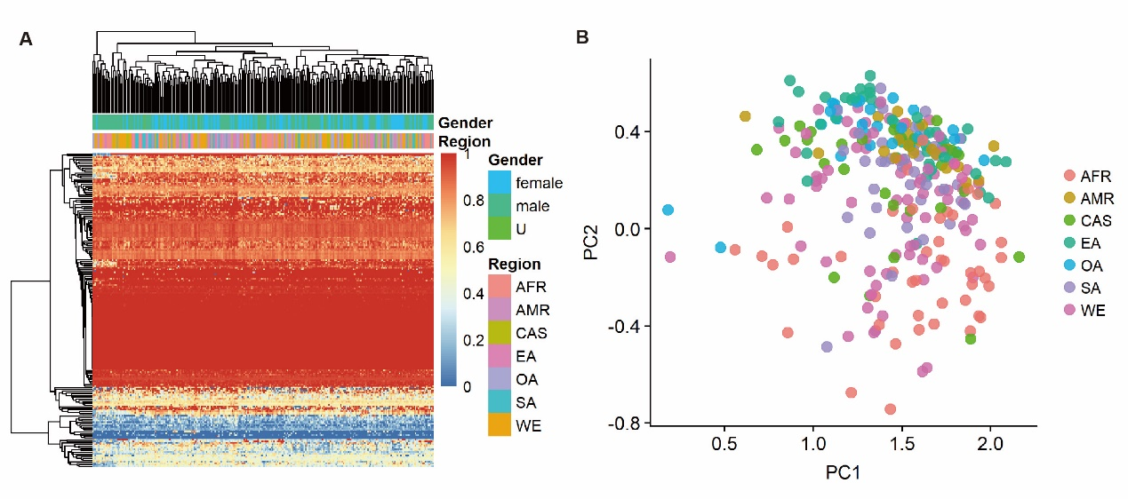
Figure S2. Non-redundant gap-closing sequences covered by unmapped reads from 279 samples. (A) Heatmap showing breadth of coverage information of non-redundant sequences not in chromosome Y by unmapped reads from 279 samples. Horizontal axis represents the 279 samples. Vertical axis represents non-redundant gap-closing sequences; (B) The first two principal components based on breadth of coverage matric of the gap-closing sequences with a population-specific pattern among 279 samples from different regions.

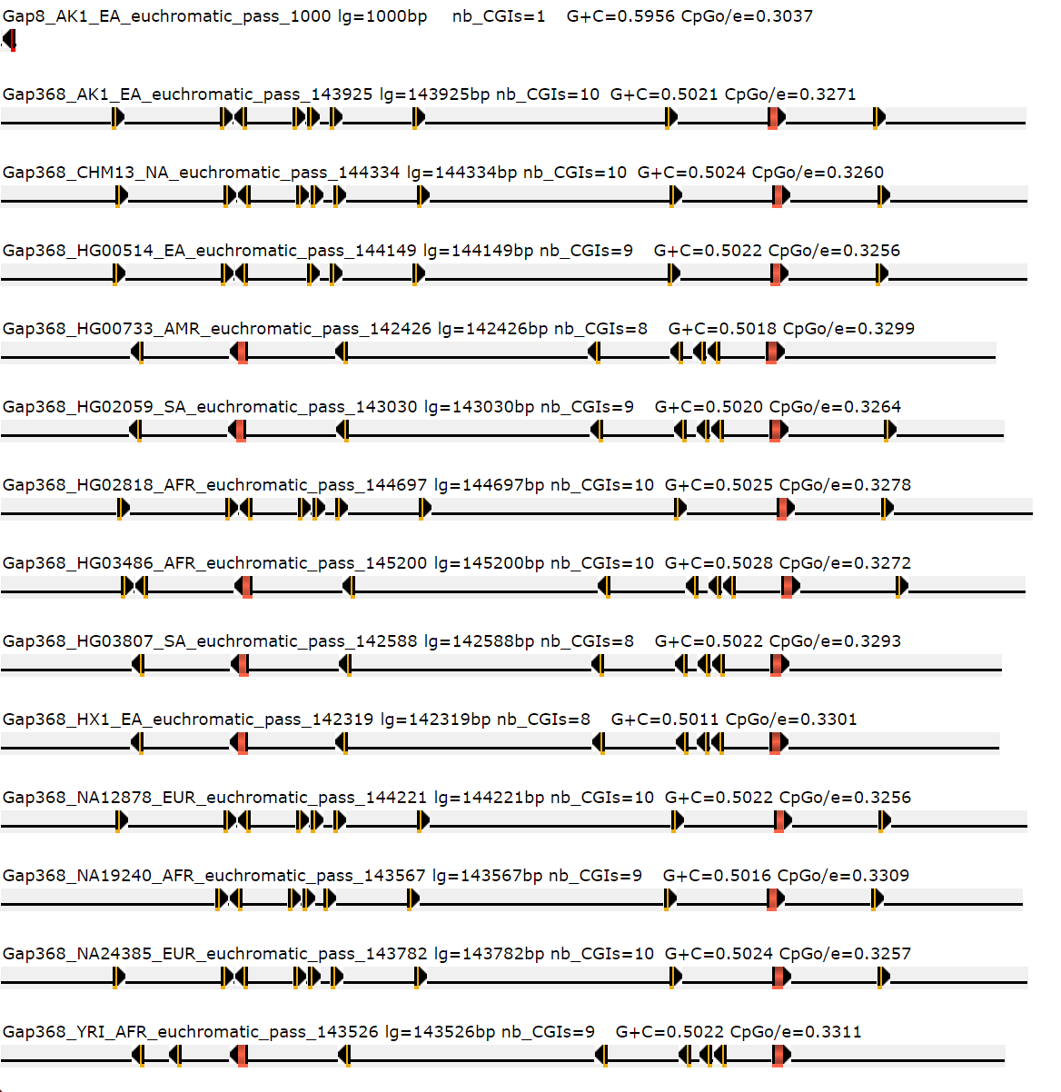Figure S3. Promoter regions associated with CpG islands predicted by CpGProD in non-reference gap-closing sequences.

