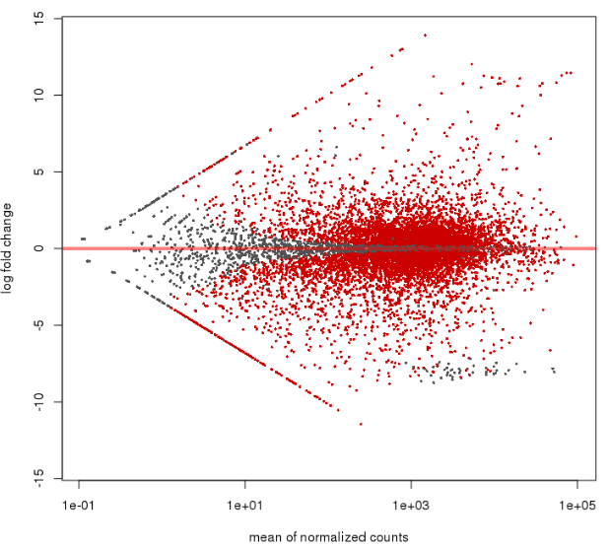
Figure S1. MA-plot of RNA-Seq data of Metarhizium anisopliae (ESALQ4676) blastospores vs. hyphae. This graphic was generated by the plotMA function in DESeq2. Each dot is represented by one gene.The data represents all four biological samples of blastospores and hyphae.

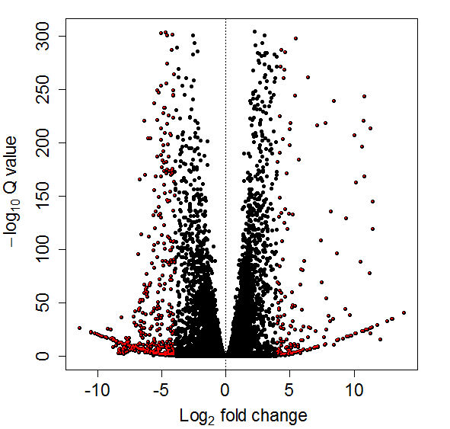
Figure S2. Volcano plot of RNA-Seq data of Metarhizium anisopliae (ESALQ4676) blastospores vs. hyphae. Each dot is represented by one gene. The red points indicate genes of interest that display large-magnitude fold-changes (x-axis) and high statistical significance (-log₁₀ of pvalue, y-axis). The data represents all four biological samples of blastospores and hyphae.

