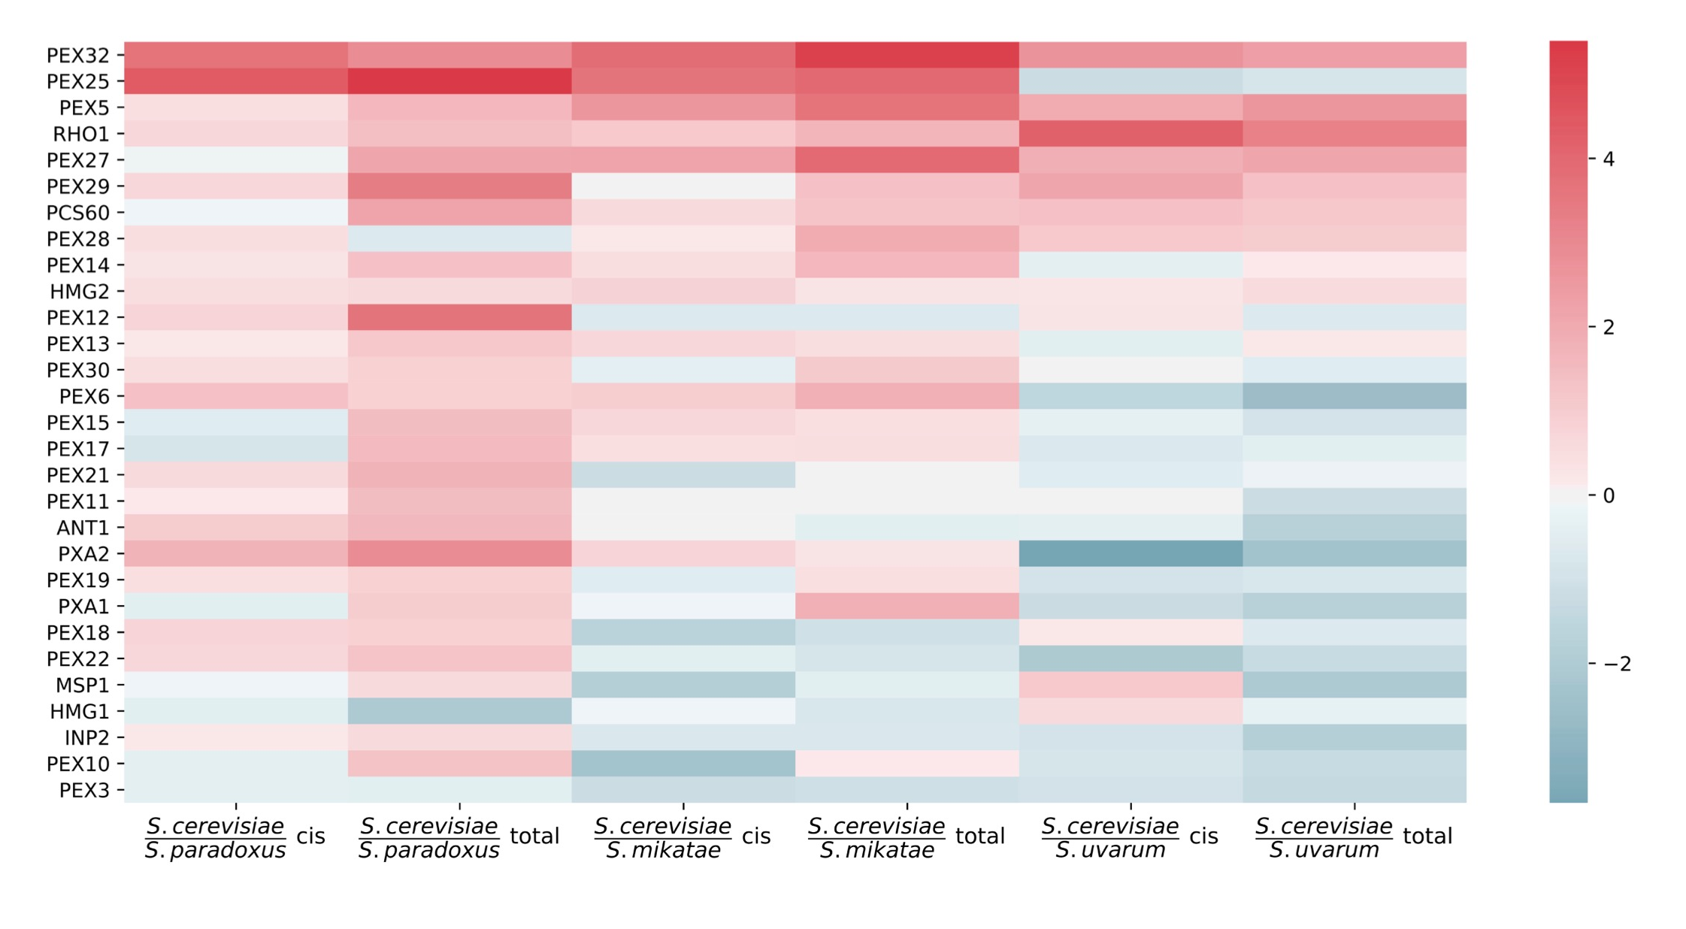Figure S2: Expression divergence across Saccharomyces sensu stricto in peroxisome membrane genes. Data are as in Figure 2 of the main text, except that comparisons of S. cerevisiae with S. mikatae and with S. uvarum are also shown.

