A.
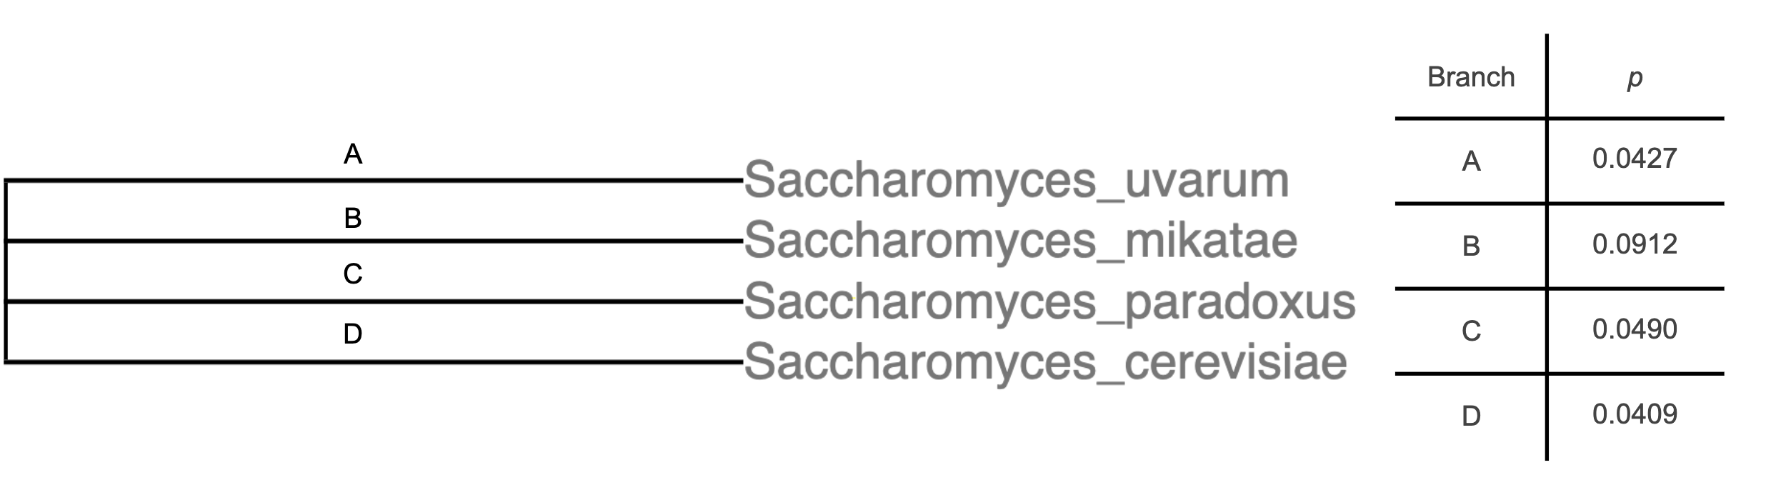
B.
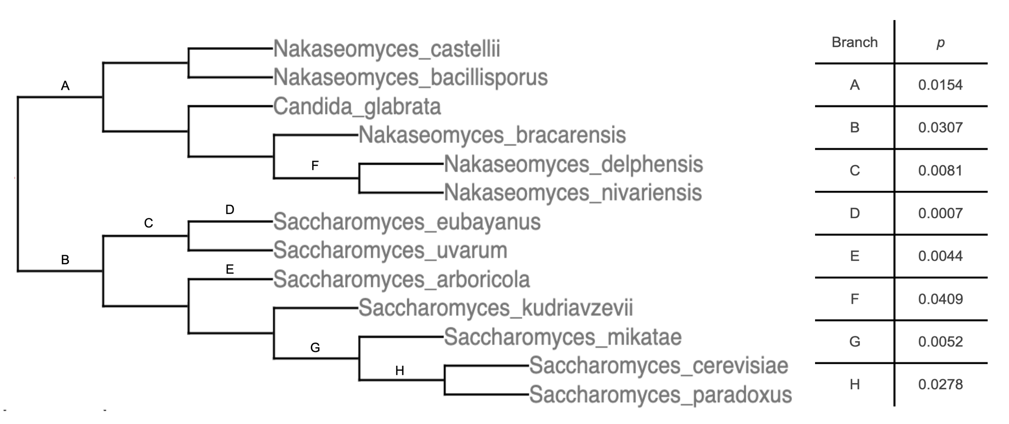
Figure S1: Phylogenetic analysis of peroxisomal membrane genes. (A) Each cell on the right reports the resampling-based significance values from a test for elevated branch length in the genes of GO:0005778, for the branch labeled at left. (B) Data are as in (A), except that a wider range of species was analyzed and only branches where p < 0.05 are reported.

