Supplemental Figures

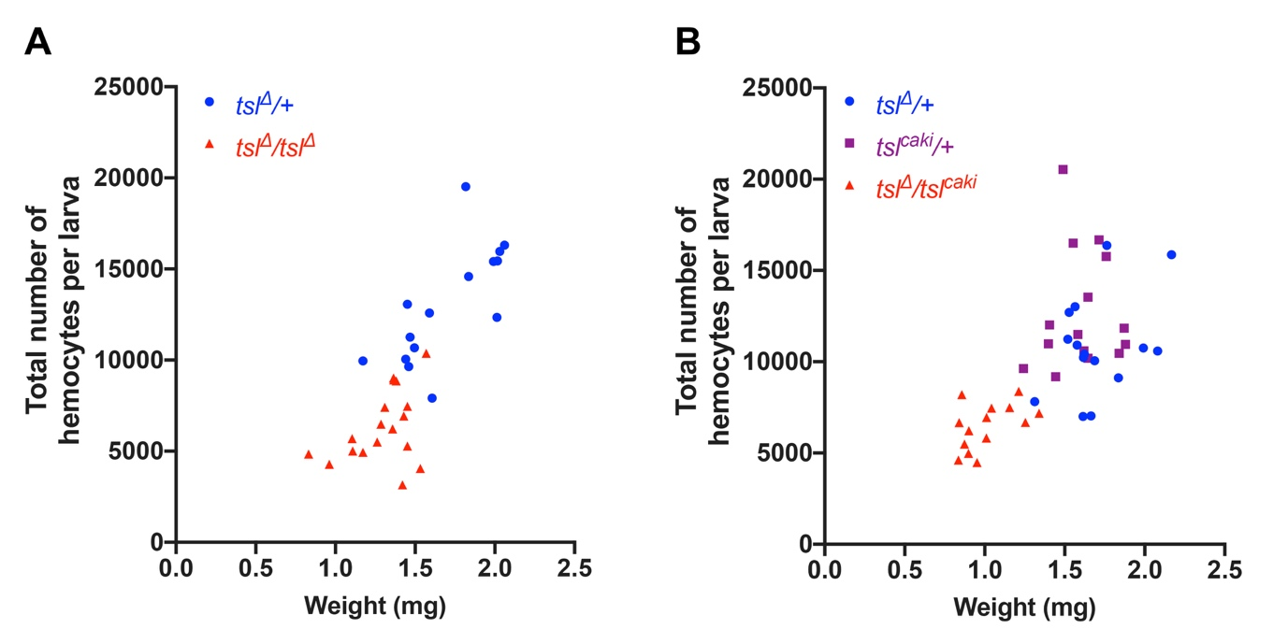
Figure S1. Untransformed data relating to Figure 3.
(A) Quantification of weight and total hemocyte number (hmlΔ-dsRed) in individual wandering tsl^{Δ}/tsl^{Δ} and tsl^{Δ}/+ larvae. Untransformed data from Figure 3A. (B) Quantification of weight and total hemocyte number (hmlΔ-dsRed) in individual wandering tsl^{Δ}/+, tsl^{caki}/+ and tsl^{Δ}/tsl^{caki} larvae. Untransformed data from Figure 3C.

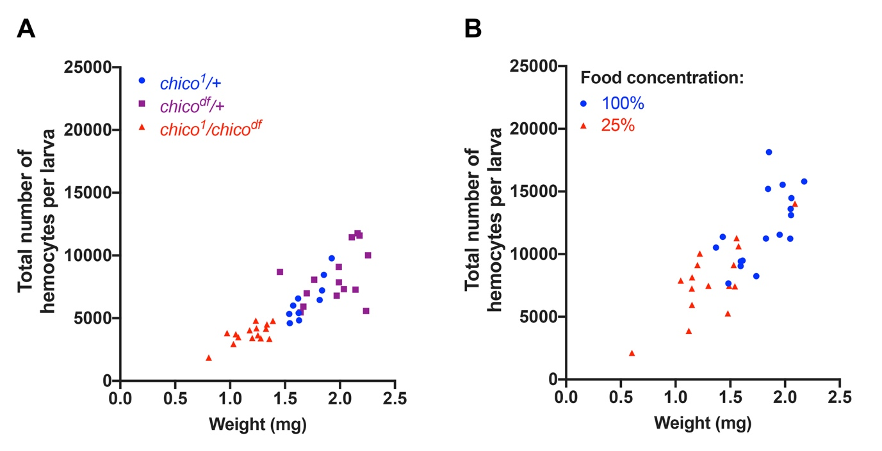
Figure S2. Untransformed data relating to Figure 4.
(A) Quantification of weight and total hemocyte number (hmlΔ-GAL4>UAS-GFP) in individual wandering chico¹/+, chico^{df}/+and chico¹/chico^{df} larvae. Untransformed data from Figure 4C. (B) Quantification of weight and total hemocyte number (hmlΔ-dsRed) in individual wandering larvae raised on a standard (100%) or diluted (25%) diet. Untransformed data from Figure 4F.

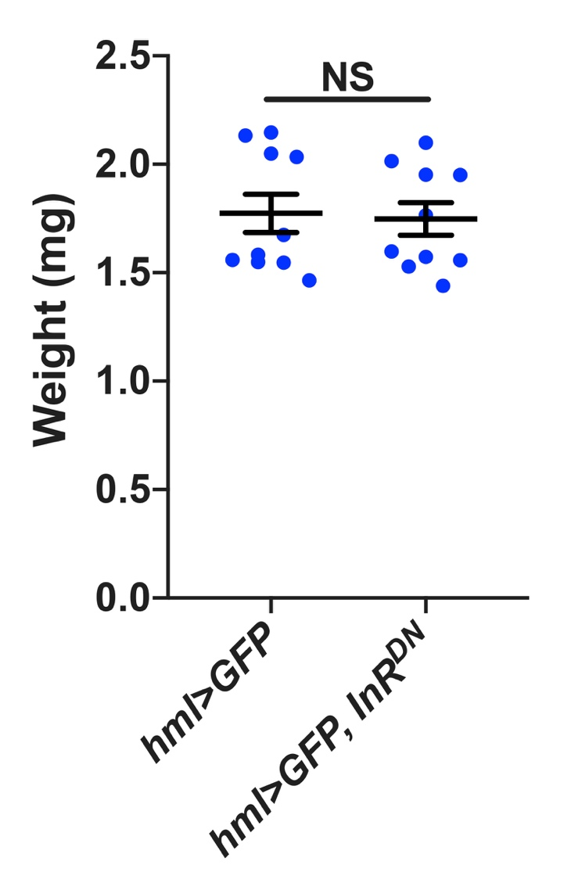
Figure S3. Expression of InR^{DN} in larval hemocytes has no effect on body size.
Wandering hml>GFP, InR^{DN} larvae are similar in size to hml>GFP controls (p=0.739). NS, not significant, Mann-Whitney test. Data points are individual larvae (n=10) with the means ±1 standard error indicated.

