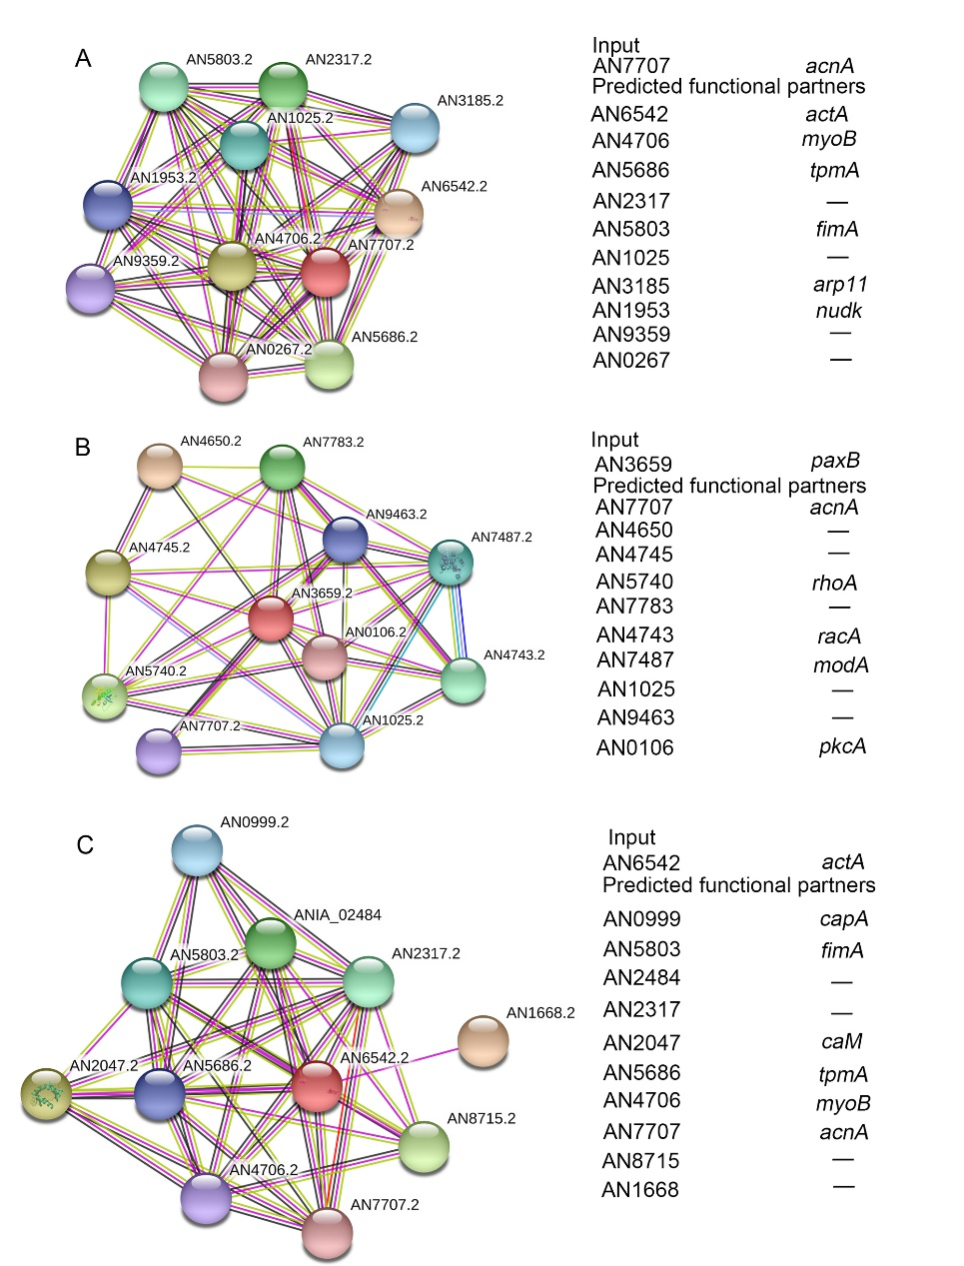
Figure S7. Bioinformatic analysis of the potential interacting proteins of (A) α-actinin AcnA, (B) PaxB and (C) Actin ActA via a software-STRING.

