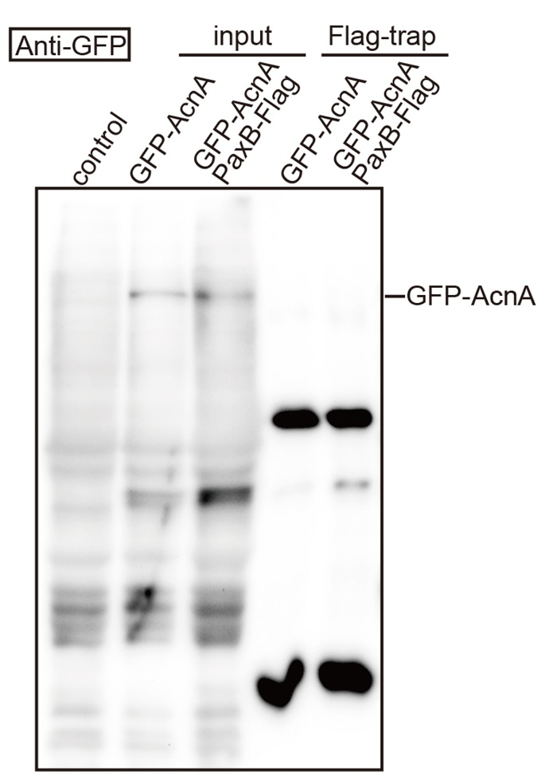
Figure S6. Co-IP assay for α-actinin and PaxB.

