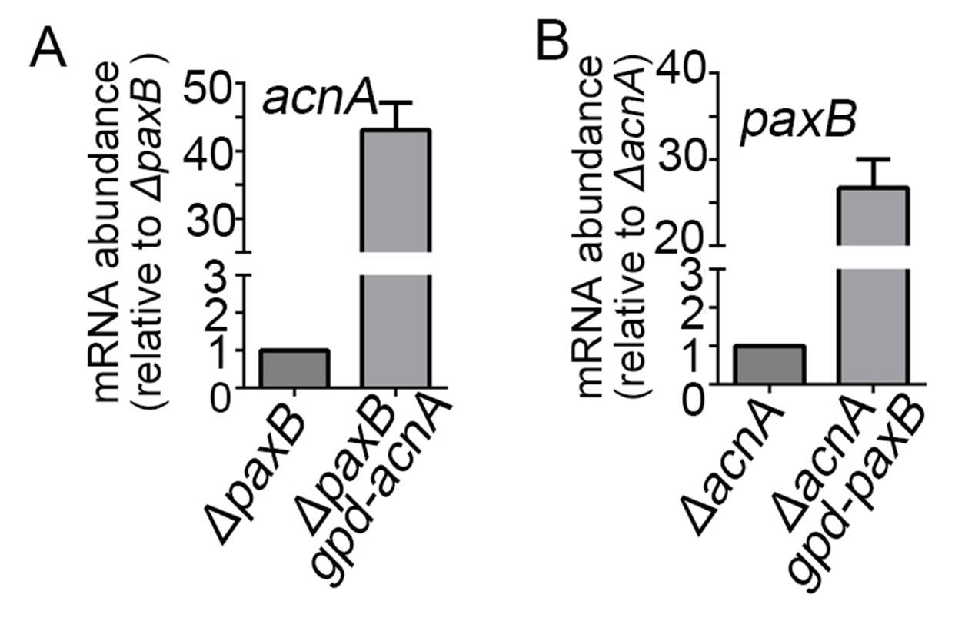
Figure S5. Verification of the construction of overexpressed strains. The detection of the mRNA expression levels of (A) acnA and (B) paxB in the related strains via real-time PCR.

