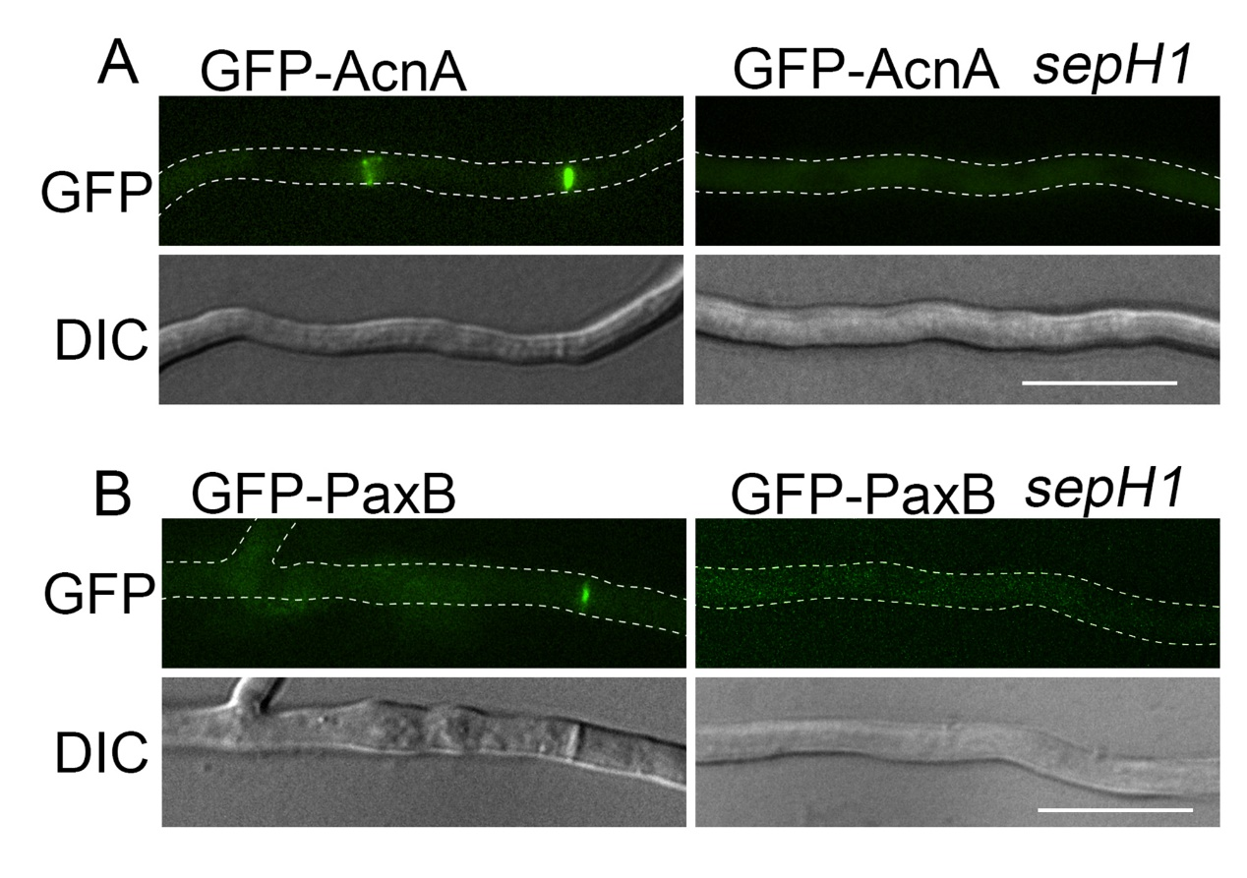
Figure S4. The SIN was required for the localization of α-actinin and PaxB. (A) Localization of GFP-α-actinin and (B) GFP-PaxB visualized via differential interference contrast (DIC) in the wild-type (WJ02 and AAV98) and sepH1 (ZXB11 and ZXB12) strains cultured in the liquid minimal PGR medium at 42°C for 20 h. Bars, 10 µm.

