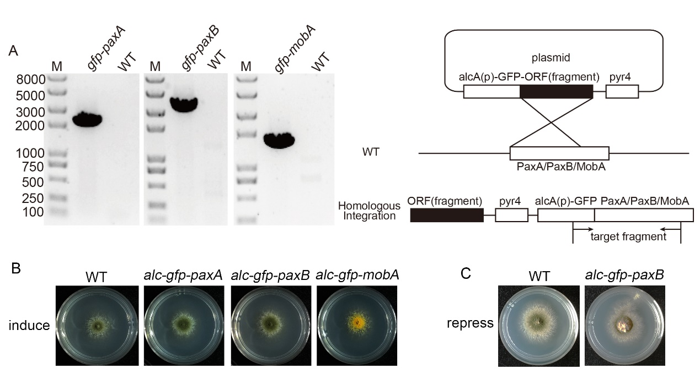
Figure S2. Verification of related GFP-labeling strains. (A) The diagnostic PCR of the GFP-labeling strains compared to the wild-type strain. (B) Colony morphologies of the wild type (TN02A7) and GFP-labeling strains AAV97, AAV98 and WR01 cultured on induced medium PGRUU at 37°C for 2 days. (C) Colony morphologies of the wild type (TN02A7) and the GFP-labeling strain AAV98 cultured on the repressed medium PDRUU at 37°C for 2 days.

