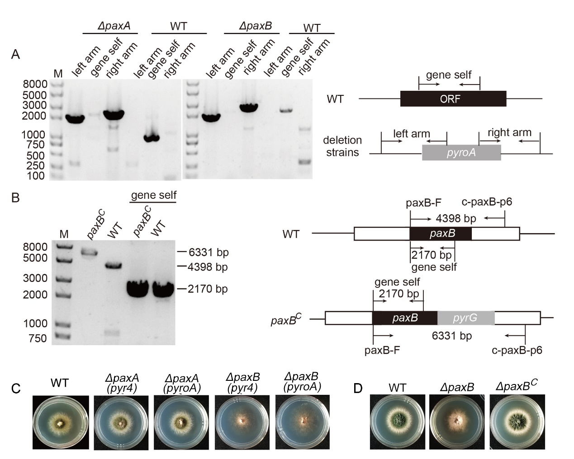
Figure S1. Verification of related deletion strains and complementary strain. (A) The diagnostic PCR of the deletion strains and (B) the complementation strain (ZXB13). (C) Colony morphologies of the wild-type (TN02A7), ΔpaxA (AAV126 and AAV156) and ΔpaxB (AAV127 and AAV157) strains cultured on PDRUU at 37°C for 2 days. (D) Colony morphologies of the wild-type (TN02A7), and ΔpaxB (AAV127) complementary (ZXB13) strains cultured on YUU at 37°C for 2 days.

