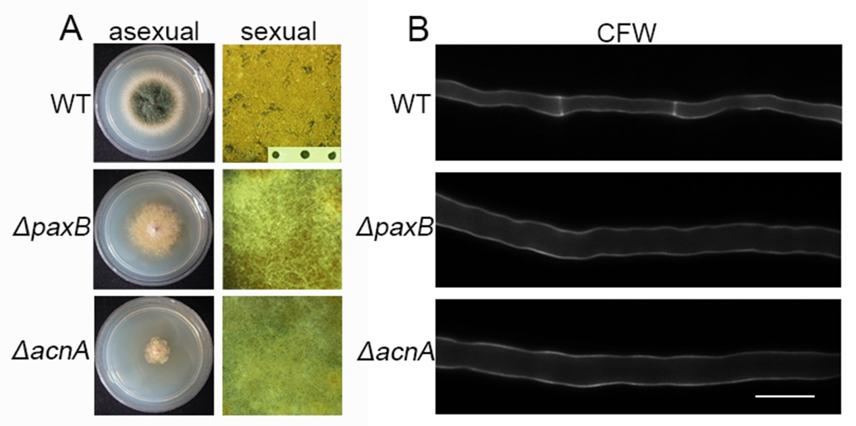
Figure S3. PaxB and α-actinin were required for asexual and sexual reproduction and septation. (A) Colony morphologies of the wild-type (TN02A7), ΔacnA (WJ03) and ΔpaxB (AAV127) strains grown on rich YUU medium at 37°C for 2.5 days. (B) Comparisons of cleistothecium development having ascospores or not during self-fertilization in the wild-type (R21) strain and the ΔacnA (WJ03) and the ΔpaxB (AAV127) mutants. (C) Septa comparison in hyphal cells stained with CFW in the indicated strains cultured in liquid rich YUU media at 37°C for 20 h. Bars, 10 µm.

