Figure S1
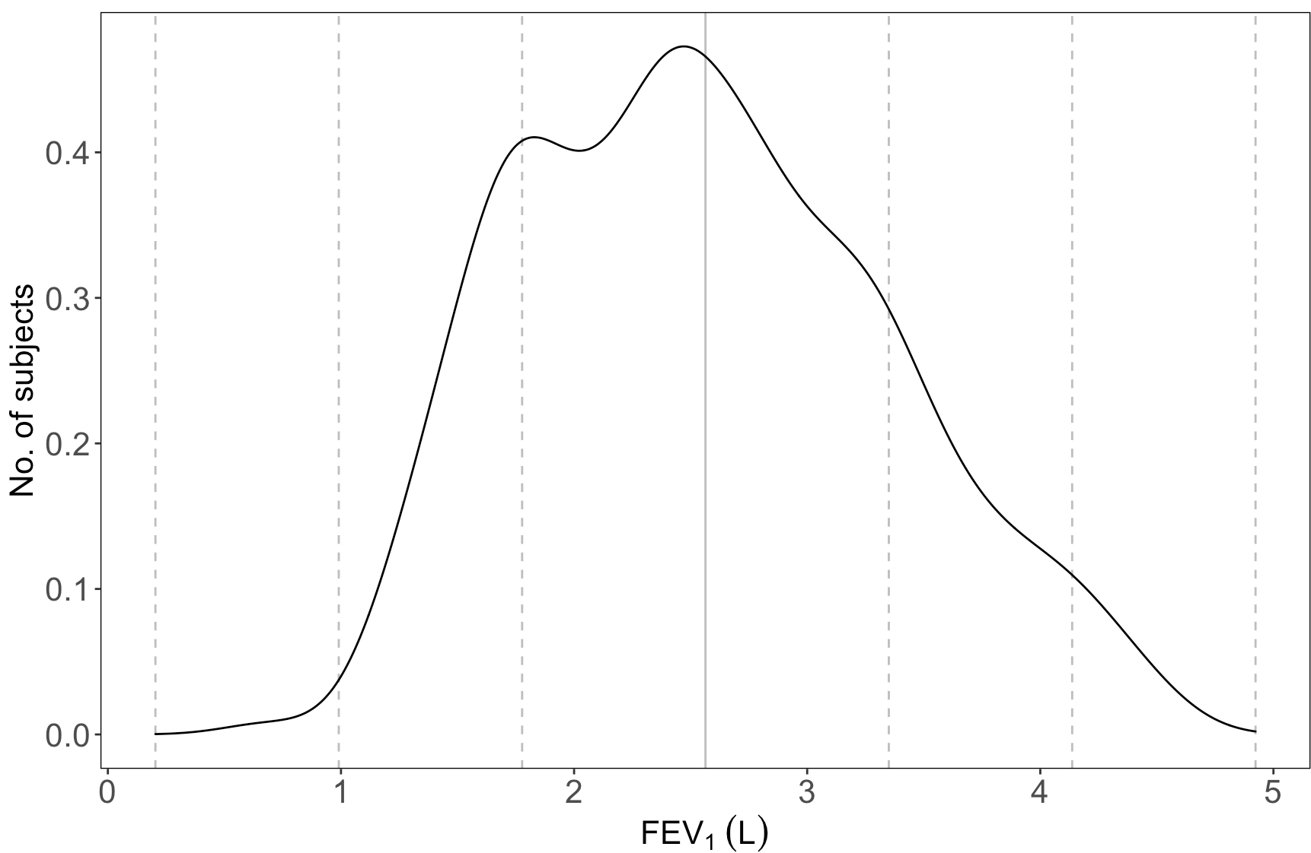
Figure S1. Density distribution of FEV₁ in 867 African American children with asthma. The vertical solid line represents the mean of 2.56L and dashed lines away from the mean represents 1 to 3 standard deviations (0.79L), respectively.

Figure S2
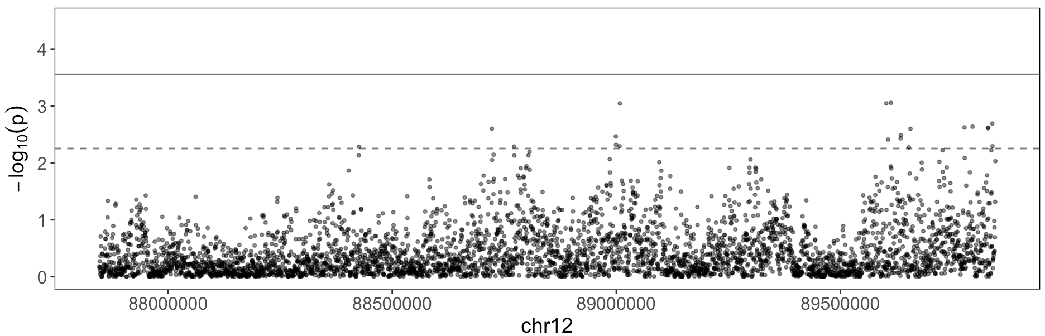
Figure S2. Region-based FEV₁* association analysis using all common and rare variants in 1kb sliding windows. *FEV₁.res.rnorm was used as the phenotype for the association analysis. Solid and dashed horizontal line indicates Bonferroni-adjusted statistical significance level of p = 2.80 x 10⁻⁴ and suggestive significance level of p = 5.60 x 10⁻³.

Figure S3.
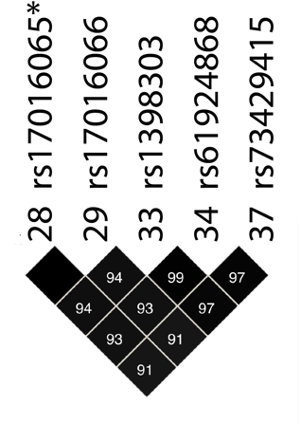
Figure S3. Five KITLG eQTLs are in high linkage disequilibrium. Numbers and different shades of black in the LD plot represent LD in R². One of the independent signals identified in the conditional analysis is marked with *. Marker numbers (28, 29, 33, 34 and 37) correspond to those used in Figure 2.

