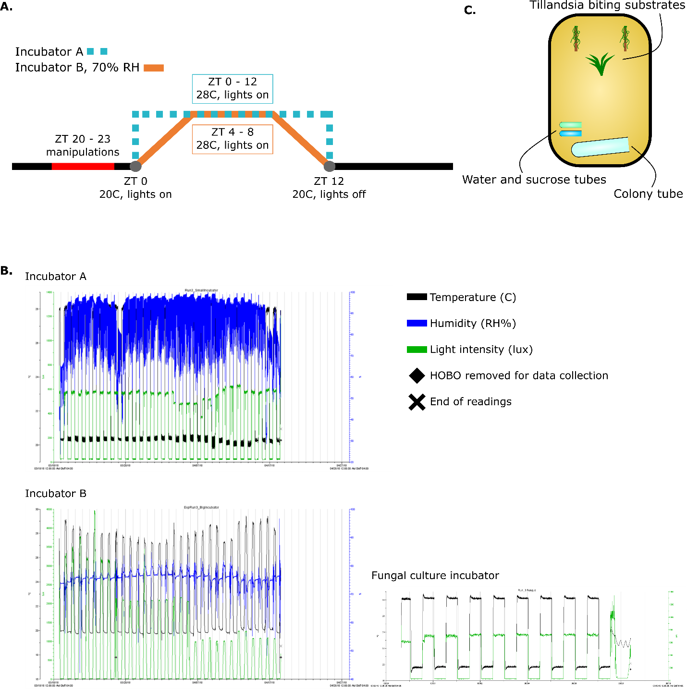

Figure S1. Climate and housing conditions during the infection experiment. (A.) Incubator climate cycle settings. Incubator B included a constant humidity at 70% RH. (B.) Climate data for the duration of the experiment from incubator A, B, and the incubator used to culture fungi. (C.) Schematic of ant infection experiment enclosure, 33 cm x 22 cm.

