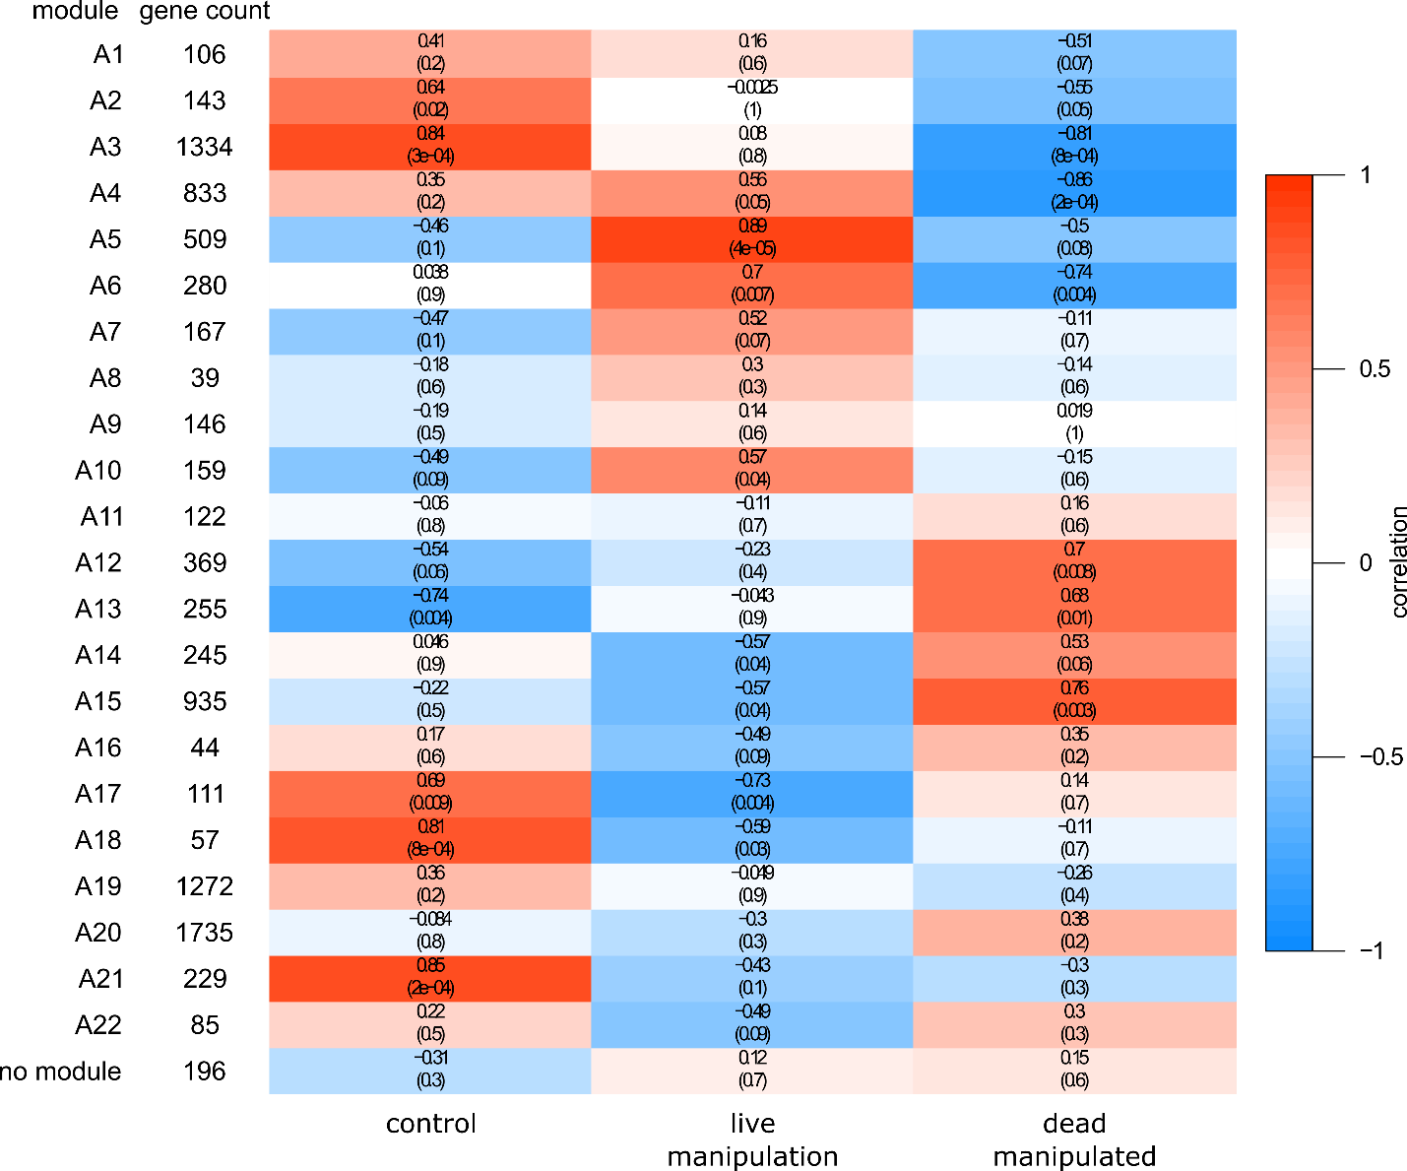

Figure S3. WGCNA of ant normalized gene expression data correlated to sample type. Correlation values are the top value in each cell, the p-values are in parentheses below.

