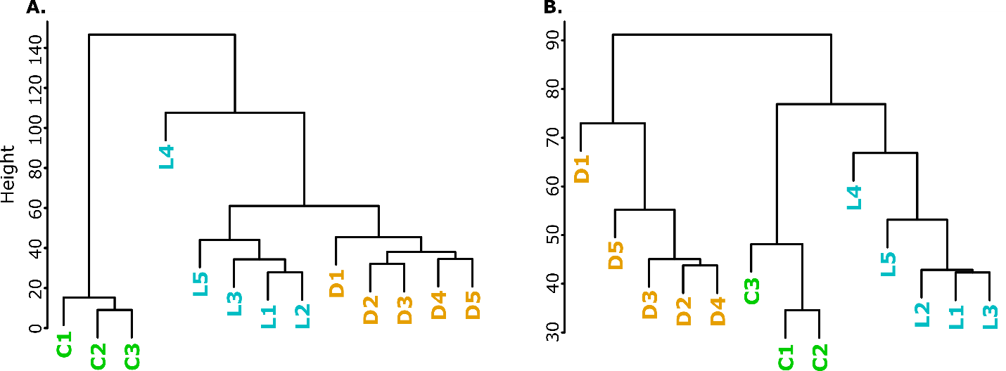

Figure S2. Unsupervised dendrogram clustering of biological replicates based on normalized gene expression levels (RPKM). Control (green, C1 – C3), live manipulation (blue, L1 – L5), and dead manipulated (orange, D1 – D5) samples largely cluster into their defined biological groups. (A.) Dendrogram of O. camponoti-floridani transcriptome data. The clustering of replicates indicates that fungi that actively interact with their host have more similar gene expression profiles to each other than to fungal growth under pre-infection conditions. (B.) Dendrogram of C. floridanus transcriptome data. The clustering of replicates indicates that living ants, whether healthy or manipulated, are more similar to each other than to recently expired ants after manipulation.

