Loss of N-glycanase 1 alters transcriptional and translational regulation in K562 cell lines

William F. Mueller *,†, Petra Jakob*,†, Han Sun‡, Sandra Clauder-Münster*, Sonja Ghidelli-Disse§, Diana Ordonez*, Markus Boesche§, Marcus Bantscheff§, Paul Collier*, Bettina Haase*, Vladimir Benes*, Malte Paulsen*, Peter Sehr*, Joe Lewis*, Gerard Drewes3, Lars M. Steinmetz*,*,‡

\**European Molecular Biology Labs, Genome Biology Unit, Heidelberg, Germany*

*Meyerhofstrasse 1, Heidelberg, Germany, 69117*

[william.mueller@embl.de](mailto:1william.mueller@embl.de); *lars.steinmetz@embl.de

‡*Stanford University, Stanford, USA*

*Stanford, CA, 94305*

§*Cellzome GmbH, a GlaxoSmithKline Company*

*Meyerhofstrasse 1, Heidelberg, Germany, 69117*

†*These authors contributed equally*

**Corresponding author:**

Lars M. Steinmetz, *European Molecular Biology Labs, Genome Biology Unit*

*Meyerhofstrasse 1, Heidelberg, Germany, 69117*

*Phone: +49 6221 3889*

lars.steinmetz@embl.de

**Description of Supplementary Material:**

File S1 – Contains the supplementary figures and discussion as referenced in the main text of Mueller et al, 2020.

File S2 – A ZIP file containing the raw data for the expression proteomics of the K562 cell lines used in the paper.

File S3 – A ZIP file containing the raw data for the TPP of the K562 cell lines used in the paper as output from the TPP R package.

Table S1 – Differentially expressed transcripts in NGLY1 KD K562 cells.

Table S2 - Differentially expressed proteins in NGLY1 KD K562 cells.

1. Supplementary figures

Supplemental Figure EV1

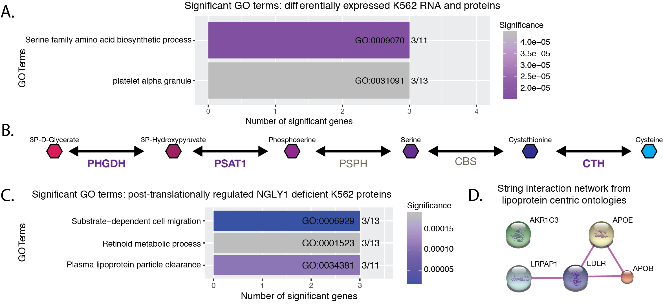

**Fig EV1: GO terms deemed significant with interesting hits, but which were underpowered based on the number of genes.** (**A**) GO analysis of genes found to be differentially expressed at both the transcript and protein level. (**B**) Representation of the cysteine biosynthetic pathway. The genes found by GO analysis from (A) are highlighted in bold. (**C**) GO analysis of post-translationally regulated proteins found five proteins involved in lipid metabolism to be significant. (**D**) STRING interaction network (protein-protein interactions only) of the proteins identified in (C).

Supplemental Figure EV2

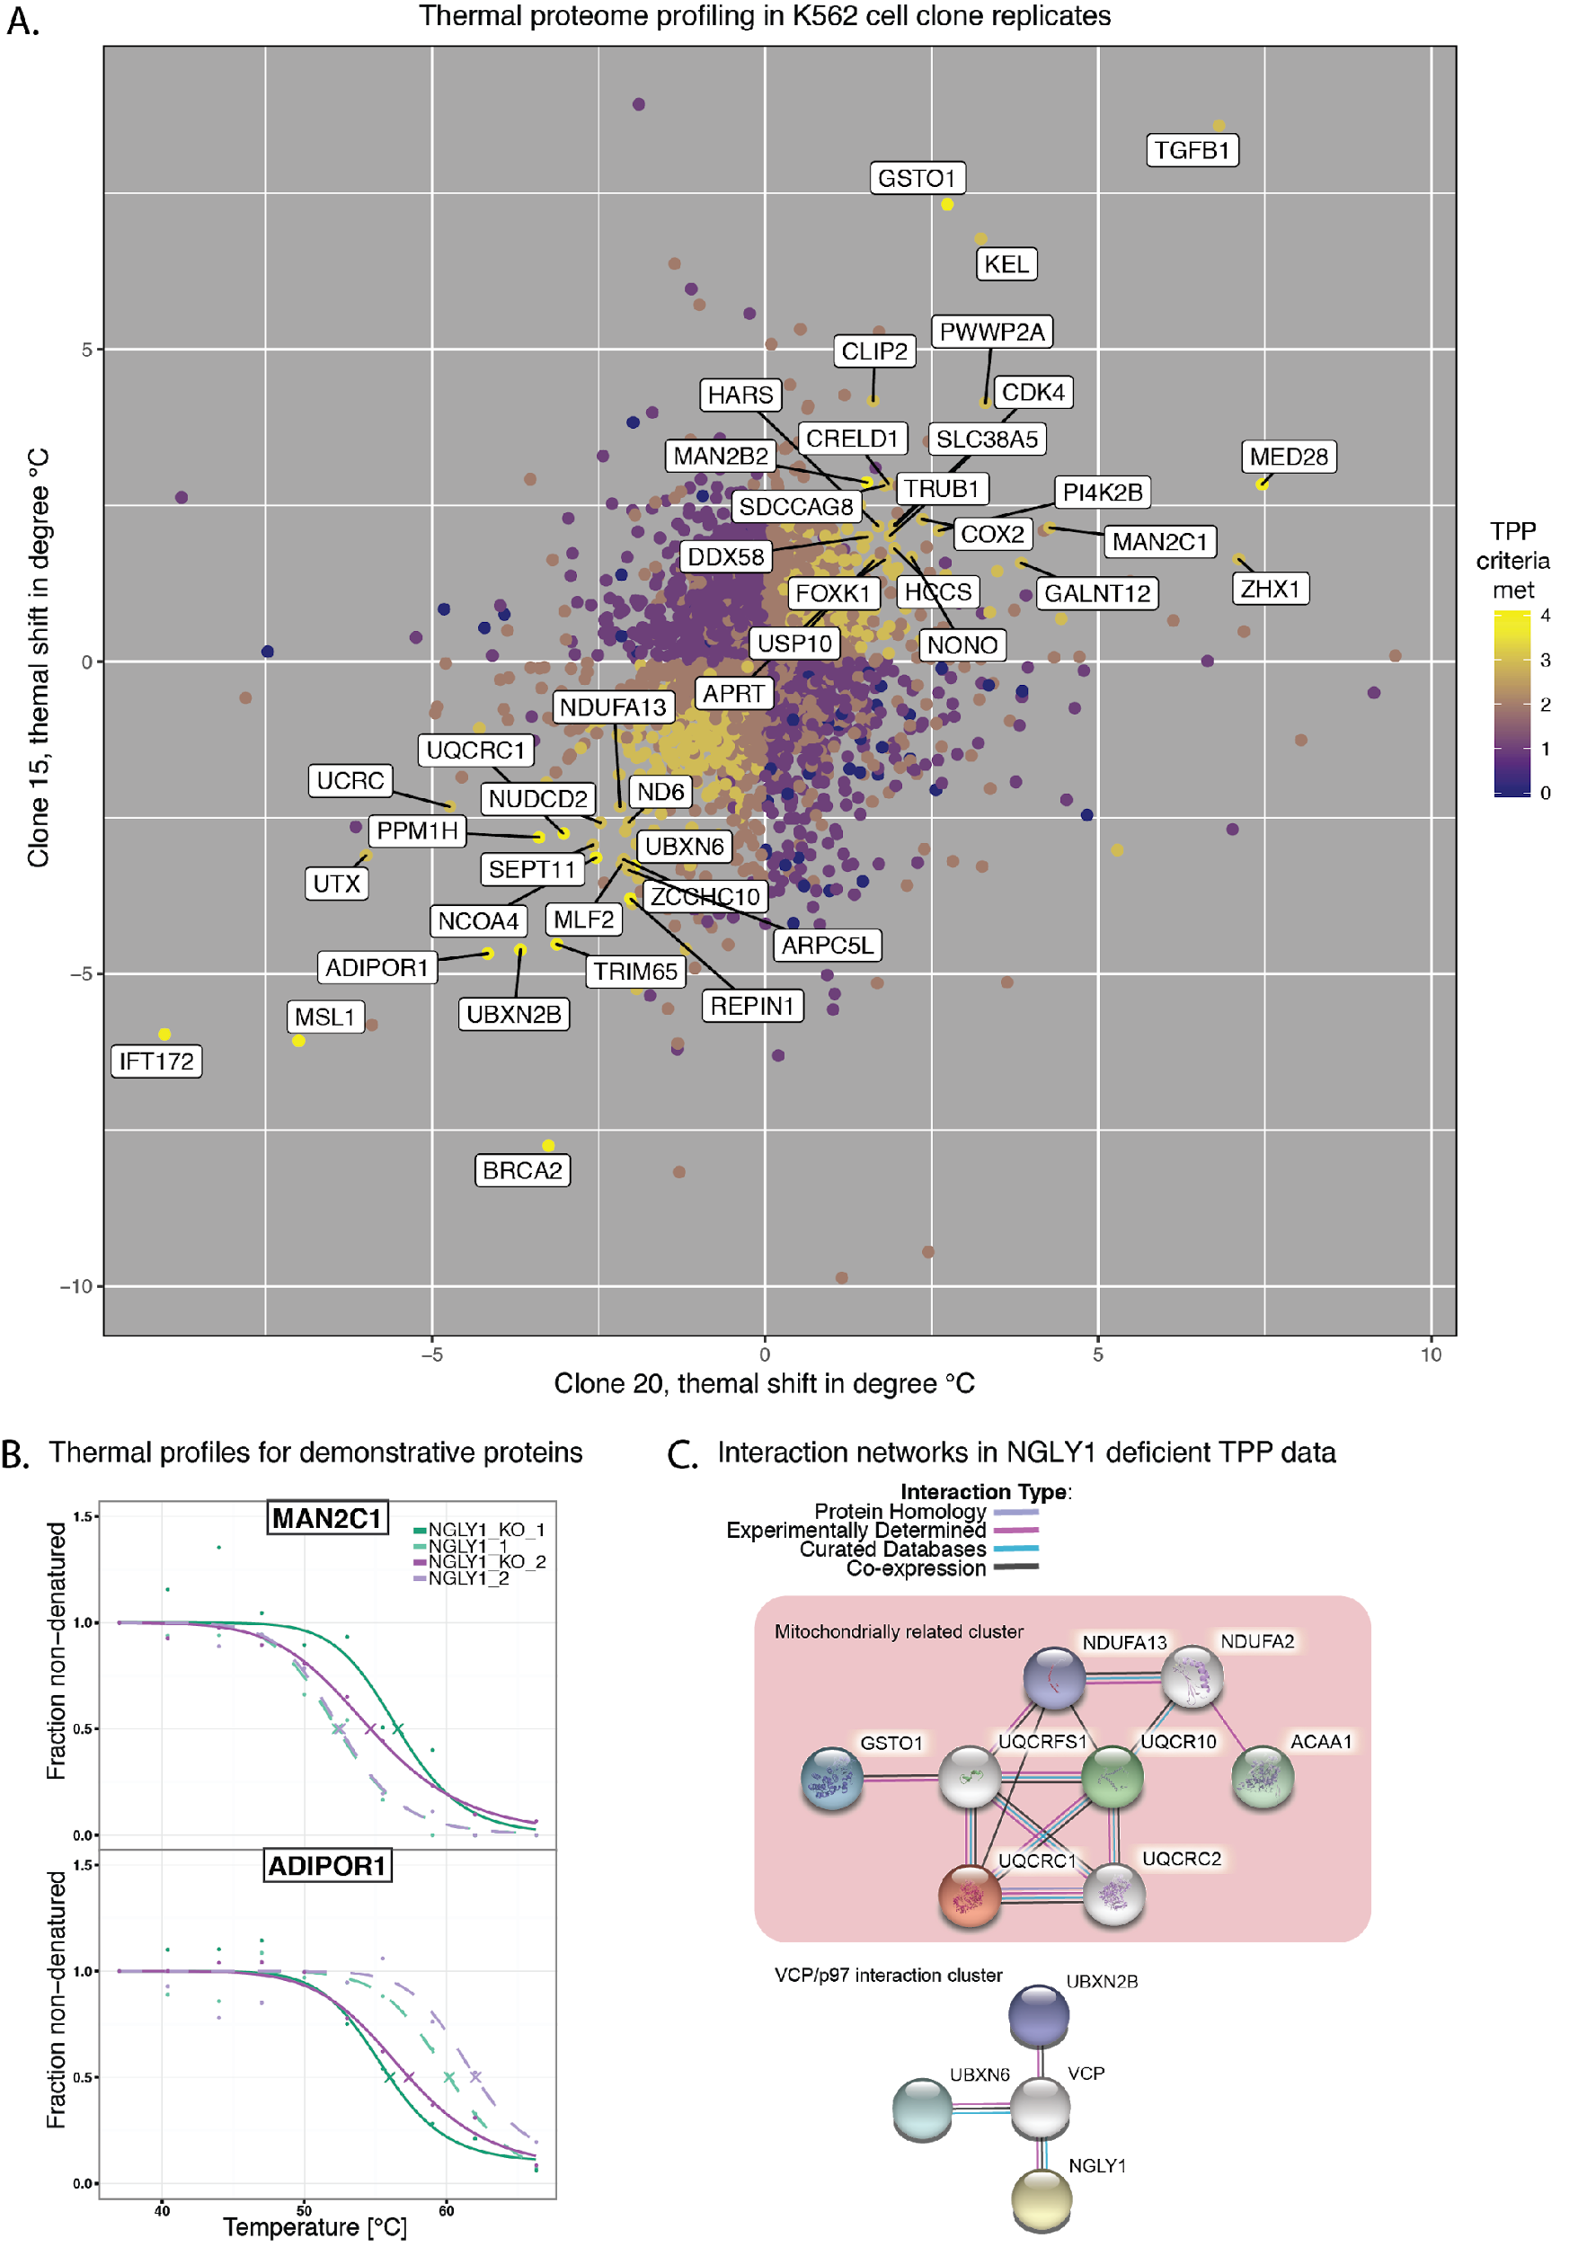

**Fig EV2: TPP analysis of NGLY1-deficient K562 cell line total protein.** (**A**) Change in thermal stability for each clone was plotted and each protein that was identified in both analyses was color coded for the criteria met for quality and differential thermal stability from the WT cells. The top list of thermally shifted proteins is highlighted on the graph. (**B**) Exemplary thermal shift profiles for MAN2C1 (increased stability) and ADIPOR1 (decreased stability) (**C**) STRING interaction network for proteins with shifts in thermal stability. Colored nodes represent proteins detected as thermally shifted with the exception of NGLY1 which was colored to highlight its network proximity. Grey/silver nodes are interacting proteins that were not detected as significant in our TPP analysis. Data for our TPP analysis is provided in supplemental file S4

Supplemental Figure EV3

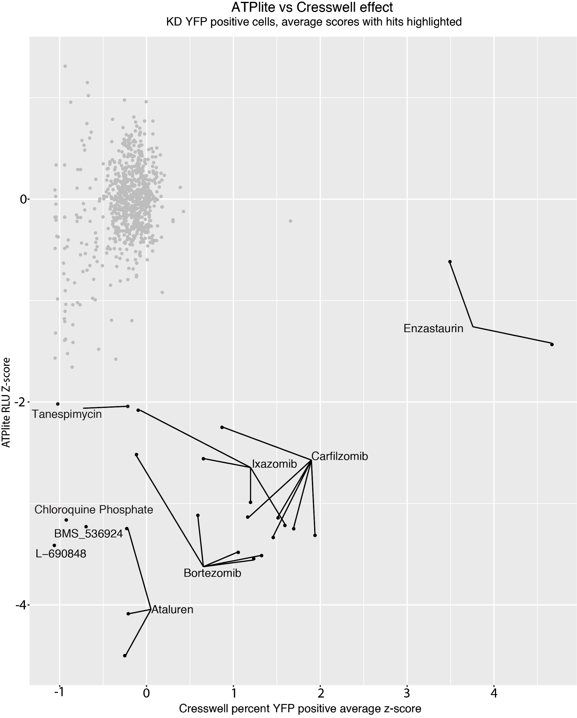

**Fig EV3: Treatment of NGLY1-deficient K562 cells with 48 compounds, plotted by assay and concentration to visualize compounds that were not toxic but activated ddVenus fluorescence.** Each point represents a single concentration, and compounds are identified by name if they decreased ATPlite signal by more than 50% or if they increased ddVenus signal to the level of the NGLY1 KD line control.

Supplemental Figure EV4

Dose Response and Cell Viability Curves for Hits from the 48 Compound Screen



**Fig EV4: Treatment of ddVenus expressing WT and NGLY1-deficient K562 cells with 6 compounds.** Percent inhibition of ddVenus signal and % luciferase signal were determined and plotted to assess the reproducibility of the inhibitory effect of the hit compounds Antimycin A, AZD-8055 (AZD), CA-074, NVP-BEZ 235 (NVP), PAC-1, Parthenolide, and Rotenone.

**Supplementary Figure EV1 Discussion**

Gene ontology (GO), Gene Set Enrichment Analysis (GSEA), and KEGG pathway analysis were limited by the small number of similarly regulated genes but revealed 3 other important genes in the serine/cysteine biosynthetic pathway were downregulated (PHGDH, PSAT1, and CTH, Supplemental Fig 1).

While transcriptional changes can account for changes on the protein level, increases or decreases in transcription can be buffered so that there is no effect on protein expression. We looked for specific processes that would be buffered in this manner by analyzing the transcripts that were differentially expressed but had no significant change in protein expression (1265 genes, Fig 3). The dual oxidase genes (responsible for the production of reactive oxygen species) are all up regulated in the NGLY1 KD cells (increased from almost no detection) but are not detected on the protein level [(Donkó *et al*. 2005)](https://paperpile.com/c/0RJ1kf/wOBW). LRRK2, a kinase highly associated with Parkinson’s disease, is also upregulated in this category [(Cookson 2010)](https://paperpile.com/c/0RJ1kf/J5ag).

A more direct readout of NGLY1 effect may be displayed by protein analysis. We specifically looked at proteins that were significant via LC-MS/MS but were not significant in the RNA-seq to look for post-translational regulatory mechanisms at work in NGLY1 deficiency. We would expect to see targets of NGLY1 enriched in significantly upregulated proteins that have no change at the RNA level. However, no known NGLY1 target proteins were significantly upregulated. Analysis of the post-translationally regulated genes (119 proteins) showed enrichment for lipoprotein metabolism categories via GO and KEGG. Of the 5 identified proteins that were downregulated, 4 were shown to interact with each other (Supplemental Fig 1D).

**Supplementary Figure EV2 Discussion**

The upregulation of genes related to protein aggregation (*SNCA*, *FBXO2* and *LRRK*) along with the biological role for NGLY1 suggest that there may be an increase in misfolded glycoproteins in the cytoplasm of NGLY1-deficient cells. Some of NGLY1’s known targets (NFE2L1, HMGCR) take advantage of the ERAD pathway for protein processing and regulation [(Suzuki *et al*. 2016)](https://paperpile.com/c/0RJ1kf/6PVN). We attempted to determine possible NGLY1 targets, NGLY1 dependent aggregates, and other NGLY1 related changes in proteins through thermal proteome profiling (TPP). This technique’s unbiased ability to detect many protein-based changes (small chemical binding, complex formation, and post-translational modification) made it optimal for discovery in the NGLY1-deficient system. Comparing control to NGLY1-deficient K562 cells lead to the identification of 14 high confidence thermally shifted proteins and another 53 proteins that met three out of four criteria for significance but displayed acceptable variations to be considered for further analysis (Fig 4B). Of the 14 highly significant proteins, 6 are linked to NGLY1 through protein interactions, the mitochondria, and glycoside catabolism (Fig 4C). MAN2C1 is a protein downstream of NGLY1 in cytosolic glycan metabolism (Suzuki 2018). UQCRC and UQRC1 are proteins that are part of mitochondrial complex III, and NDUF is part of mitochondrial complex I [(Ott *et al*. 2007)](https://paperpile.com/c/0RJ1kf/ZwGc). Two proteins have weak evidence for interaction with NGLY1 (UBXN6 & UBXN2B), but who have strong evidence for interaction with VCP/p97 a known NGLY1 interactor (Park *et al.* 2001; Uchiyama *et al*. 2006; Christianson *et al*. 2011; Trusch *et al*. 2015; X. Zhang *et al*. 2015).

One aspect of NGLY1 biology that has not been considered to our knowledge is its role as a structural protein, tethering other ERAD proteins together [(Suzuki *et al*. 2016)](https://paperpile.com/c/0RJ1kf/6PVN). NGLY1 has multiple interaction partners, the best characterized of which are VCP/p97 and RAD23B (Park *et al.* 2001; Christianson *et al*. 2011). VCP/p97 interacts with two proteins UBXN2B and UBXN6, which were shown to have altered thermal stability profiles in our data. UBXN2B is involved in membrane fusion in ER and Golgi after mitosis, and has been shown to be a VCP/p97 activator [(Uchiyama *et al*. 2006; X. Zhang *et al*. 2015)](https://paperpile.com/c/0RJ1kf/s1vk+iGJT). UBXN6 can similarly regulate the activity of VCP/p97 [(Trusch *et al*. 2015)](https://paperpile.com/c/0RJ1kf/1TJ4). VCP/p97 cofactor association has been shown to be competitive *in vitro*, and altered cofactor binding can alter VCP/p97 substrate recognition, localization, and activity (Buchberger *et al*. 2015; Xue *et al*. 2016). Altered interaction of p97 with cofactors has been suggested to play a role in IBMPDF disorder/familiat ALS ( Watts *et al*. 2007; Fernández-Sáiz and Buchberger 2010; Mehta *et al*. 2013; Meyer and Weihl 2014). Another p97 related disorder, SCA3 has been shown to be affected by over-activity of RAD23B, another interactor of NGLY1 [(Costa *et al*. 2016; Sutton *et al*. 2017)](https://paperpile.com/c/0RJ1kf/oG0l+emtJ). It is possible NGLY1 acts as a scaffold, contributing to the maintenance and recruitment of proteins like VCP/p97 and RAD23B to the ER and directing their activity. The loss of this function could lead to differential interaction or regulation for its binding partners, contributing to the disease. Further experiments with a catalytically inactive version of NGLY1 may be able to identify particular NGLY1 deficiency phenotypes related to this possible regulatory function.

NGLY1 is also involved in the cytosolic metabolism of glycans [(Suzuki *et al*. 2016)](https://paperpile.com/c/0RJ1kf/6PVN). This pathway is shared with at least two other enzymes that act on glycoproteins or glycans freed from proteins by NGLY1, ENGase and MAN2C1 [(Suzuki *et al*. 2016)](https://paperpile.com/c/0RJ1kf/6PVN). The stabilization of MAN2C1 identified in our TPP data suggests altered regulation, alternative isoform expression, or an increase in substrate binding for MAN2C1. Decreased MAN2C1 expression has been shown to induce mitochondrial apoptosis through DDIT3 (CHOP) in an activity independent manner [(Wang and Suzuki 2013)](https://paperpile.com/c/0RJ1kf/ZtQV). MAN2C1 function and the buildup of free glycans has also been linked to CNS degradation [(Paciotti *et al*. 2014)](https://paperpile.com/c/0RJ1kf/hvDz). Even in an NGLY1-deficient background, glycosylated proteins undergo incomplete deglycosylation in the cytosol by ENGase which would provide glycan substrates for MAN2C1 [(Huang *et al*. 2015)](https://paperpile.com/c/0RJ1kf/AsjYi). It is unclear why the loss of NGLY1 would alter the thermal stability of MAN2C1.

Previous work has suggested that there is a link between NGLY1 and mitochondria (Z. Zhang and Falk 2014; Kong *et al*. 2018; Yang *et al*. 2018). Our data shows that the loss of NGLY1 alters the thermal stability of core proteins in mitochondrial complexes I and III. We also see the differential expression of multiple mitochondrial transcripts and proteins, but they do not fall into a single enriched category in our functional analyses. The link between NGLY1 and mitochondria could be through oxidative stress, and reactive oxygen species are generated by the activities of complex I and III [(Ott *et al*. 2007)](https://paperpile.com/c/0RJ1kf/ZwGc). While our data do not support a strong oxidative or mitochondrial stress response, we do observe an increase in expression of one family of oxidative stress genes on the RNA level, the DUOX genes [(Donkó *et al*. 2005)](https://paperpile.com/c/0RJ1kf/wOBW). We also observe the downregulation of multiple steps along the cysteine biosynthetic pathway. Cystine is metabolically critical for the synthesis of glutathione, which itself is important in antioxidant defense [(Lu 2009)](https://paperpile.com/c/0RJ1kf/BXeA).

NGLY1 has been suggested to deglycosylate other proteins besides NFE2L1 [(Leichner *et al*. 2009; Suzuki *et al*. 2016)](https://paperpile.com/c/0RJ1kf/sYY22+6PVN). We did not directly observe changes in the regulation of these proteins or of NFE2L1.

**Supplementary Figure EV3 Discussion**

Treatment of NGLY1 KD K562 cells with the 48 compounds did not result in the detection of compounds that increased NGLY1 activity. Due to intrinsic autofluorescence Enzastaurin was found to be a false positive. Treatment with proteasome inhibitors increased ddVenus signal slightly but decreased ATPlite signal at the same time. Due to the known processing of NFE2L1 by NGLY1 to simulate proteasome subunit transcription, and the likelihood that this is an artifact of inhibited reporter protein degradation, these were not considered viable therapeutic options.

**Supplementary Figure EV4 Discussion**

5 of the 6 compounds were available for testing post-screen. The 6th compound B02 was not available and so was dropped from follow up. We added mitochondrial targeted compounds from the screen as controls for decreased cellular viability. It is interesting to note that the compound AZD-8055, a reported mTOR kinase inhibitor, showed ddVenus signal decrease, but was toxic to the K562 cells. This suggests that other autophagy inducing compounds might have similar effects to those we observed in NVP-BEZ235.

Citations

Buchberger, A., H. Schindelin, and P. Hänzelmann, 2015 Control of p97 function by cofactor binding. FEBS Lett. 589: 2578–2589.

Christianson, J. C., J. A. Olzmann, T. A. Shaler, M. E. Sowa, E. J. Bennett *et al.*, 2011 Defining human ERAD networks through an integrative mapping strategy. Nat. Cell Biol. 14: 93–105.

Cookson, M. R., 2010 The role of leucine-rich repeat kinase 2 (LRRK2) in Parkinson’s disease. Nat. Rev. Neurosci. 11: 791–797.

Costa, M. do C., M. do Carmo Costa, N. S. Ashraf, S. Fischer, Y. Yang *et al.*, 2016 Unbiased screen identifies aripiprazole as a modulator of abundance of the polyglutamine disease protein, ataxin-3. Brain 139: 2891–2908.

Donkó, A., Z. Péterfi, A. Sum, T. Leto, and M. Geiszt, 2005 Dual oxidases. Philos. Trans. R. Soc. Lond. B Biol. Sci. 360: 2301–2308.

Fernández-Sáiz, V., and A. Buchberger, 2010 Imbalances in p97 co-factor interactions in human proteinopathy. EMBO Rep. 11: 479–485.

Huang, C., Y. Harada, A. Hosomi, Y. Masahara-Negishi, J. Seino *et al.*, 2015 Endo-β-N-acetylglucosaminidase formsN-GlcNAc protein aggregates during ER-associated degradation in Ngly1-defective cells. Proceedings of the National Academy of Sciences 112: 1398–1403.

Kong, J., M. Peng, J. Ostrovsky, Y. J. Kwon, O. Oretsky *et al.*, 2018 Mitochondrial function requires NGLY1. Mitochondrion 38: 6–16.

Leichner, G. S., R. Avner, D. Harats, and J. Roitelman, 2009 Dislocation of HMG-CoA reductase and Insig-1, two polytopic endoplasmic reticulum proteins, en route to proteasomal degradation. Mol. Biol. Cell 20: 3330–3341.

Lu, S. C., 2009 Regulation of glutathione synthesis. Mol. Aspects Med. 30: 42–59.

Mehta, S. G., M. Khare, R. Ramani, G. D. J. Watts, M. Simon *et al.*, 2013 Genotype-phenotype studies of VCP-associated inclusion body myopathy with Paget disease of bone and/or frontotemporal dementia. Clin. Genet. 83: 422–431.

Meyer, H., and C. C. Weihl, 2014 The VCP/p97 system at a glance: connecting cellular function to disease pathogenesis. Journal of Cell Science 127: 3877–3883.

Ott, M., V. Gogvadze, S. Orrenius, and B. Zhivotovsky, 2007 Mitochondria, oxidative stress and cell death. Apoptosis 12: 913–922.

Paciotti, S., E. Persichetti, K. Klein, A. Tasegian, S. Duvet *et al.*, 2014 Accumulation of free oligosaccharides and tissue damage in cytosolic α-mannosidase (Man2c1)-deficient mice. J. Biol. Chem. 289: 9611–9622.

Park, H., T. Suzuki, and W. J. Lennarz, 2001 Identification of proteins that interact with mammalian peptide:N-glycanase and implicate this hydrolase in the proteasome-dependent pathway for protein degradation. Proc. Natl. Acad. Sci. U. S. A. 98: 11163–11168.

Sutton, J. R., J. R. Blount, K. Libohova, W.-L. Tsou, G. S. Joshi *et al.*, 2017 Interaction of the polyglutamine protein ataxin-3 with Rad23 regulates toxicity in Drosophila models of Spinocerebellar Ataxia Type 3. Hum. Mol. Genet. 26: 1419–1431.

Suzuki, T., C. Huang, and H. Fujihira, 2016 The cytoplasmic peptide:N-glycanase (NGLY1) - Structure, expression and cellular functions. Gene 577: 1–7.

Trusch, F., A. Matena, M. Vuk, L. Koerver, H. Knævelsrud *et al.*, 2015 The N-terminal Region of the Ubiquitin Regulatory X (UBX) Domain-containing Protein 1 (UBXD1) Modulates Interdomain Communication within the Valosin-containing Protein p97. J. Biol. Chem. 290: 29414–29427.

Uchiyama, K., G. Totsukawa, M. Puhka, Y. Kaneko, E. Jokitalo *et al.*, 2006 p37 is a p97 adaptor required for Golgi and ER biogenesis in interphase and at the end of mitosis. Dev. Cell 11: 803–816.

Wang, L., and T. Suzuki, 2013 Dual functions for cytosolic α-mannosidase (Man2C1): its down-regulation causes mitochondria-dependent apoptosis independently of its α-mannosidase activity. J. Biol. Chem. 288: 11887–11896.

Watts, G. D. J., D. Thomasova, S. K. Ramdeen, E. C. Fulchiero, S. G. Mehta *et al.*, 2007 Novel VCP mutations in inclusion body myopathy associated with Paget disease of bone and frontotemporal dementia. Clin. Genet. 72: 420–426.

Xue, L., E. E. Blythe, E. C. Freiberger, J. L. Mamrosh, A. S. Hebert *et al.*, 2016 Valosin-containing protein (VCP)-Adaptor Interactions are Exceptionally Dynamic and Subject to Differential Modulation by a VCP Inhibitor. Mol. Cell. Proteomics 15: 2970–2986.

Yang, K., R. Huang, H. Fujihira, T. Suzuki, and N. Yan, 2018 N-glycanase NGLY1 regulates mitochondrial homeostasis and inflammation through NRF1. The Journal of Experimental Medicine 215: 2600–2616.

Zhang, Z., and M. J. Falk, 2014 Integrated transcriptome analysis across mitochondrial disease etiologies and tissues improves understanding of common cellular adaptations to respiratory chain dysfunction. Int. J. Biochem. Cell Biol. 50: 106–111.

Zhang, X., L. Gui, X. Zhang, S. L. Bulfer, V. Sanghez *et al.*, 2015 Altered cofactor regulation with disease-associated p97/VCP mutations. Proc. Natl. Acad. Sci. U. S. A. 112: E1705–14.