Supplementary Figures
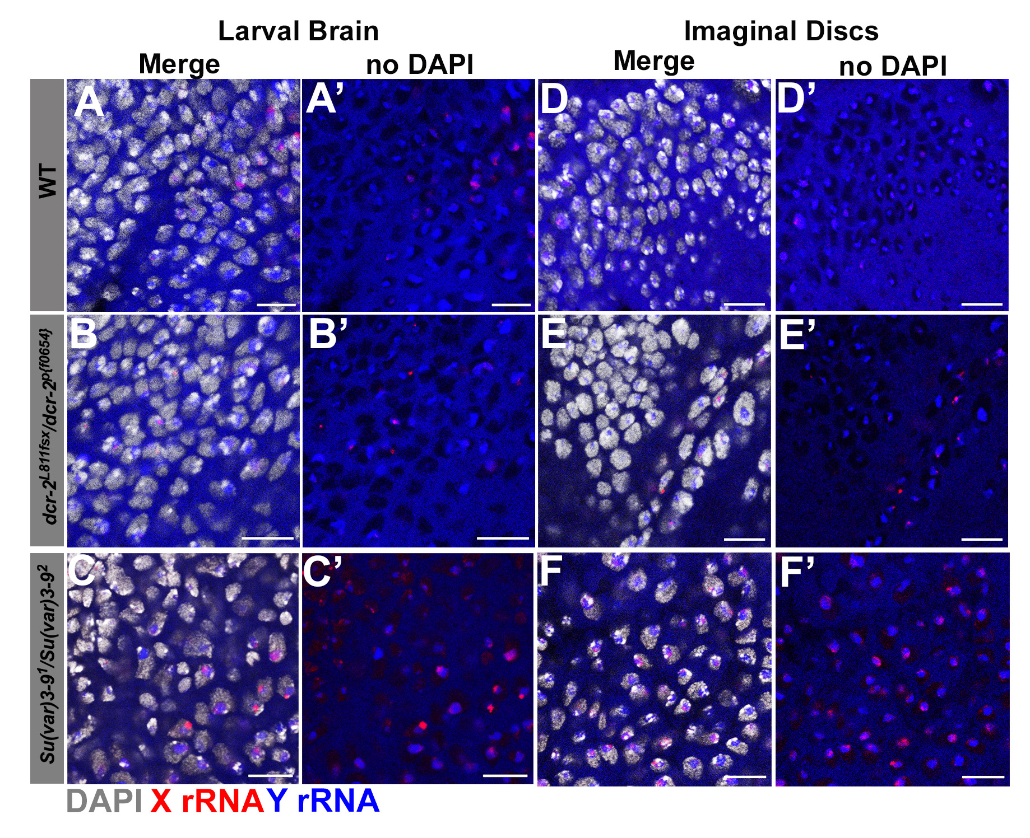
Figure S1: Heterochromatin formation aids in Y rDNA dominance in males. Representative images of larval brains from A) wild type (yw), B) dcr-2^{L811fsx}/ dcr-2^{p[f06544]} mutants, and C) Su(var)3-9¹/Su(var)3-9² mutants. Representative images of imaginal discs from D) wild type, E) dcr-2^{L811fsx}/ dcr-2^{p[f06544]} mutants, and F) Su(var)3-9¹/Su(var)3-9² mutants. Red = X rRNA, blue Y rRNA, white = DAPI. All scale bars = 10μm.

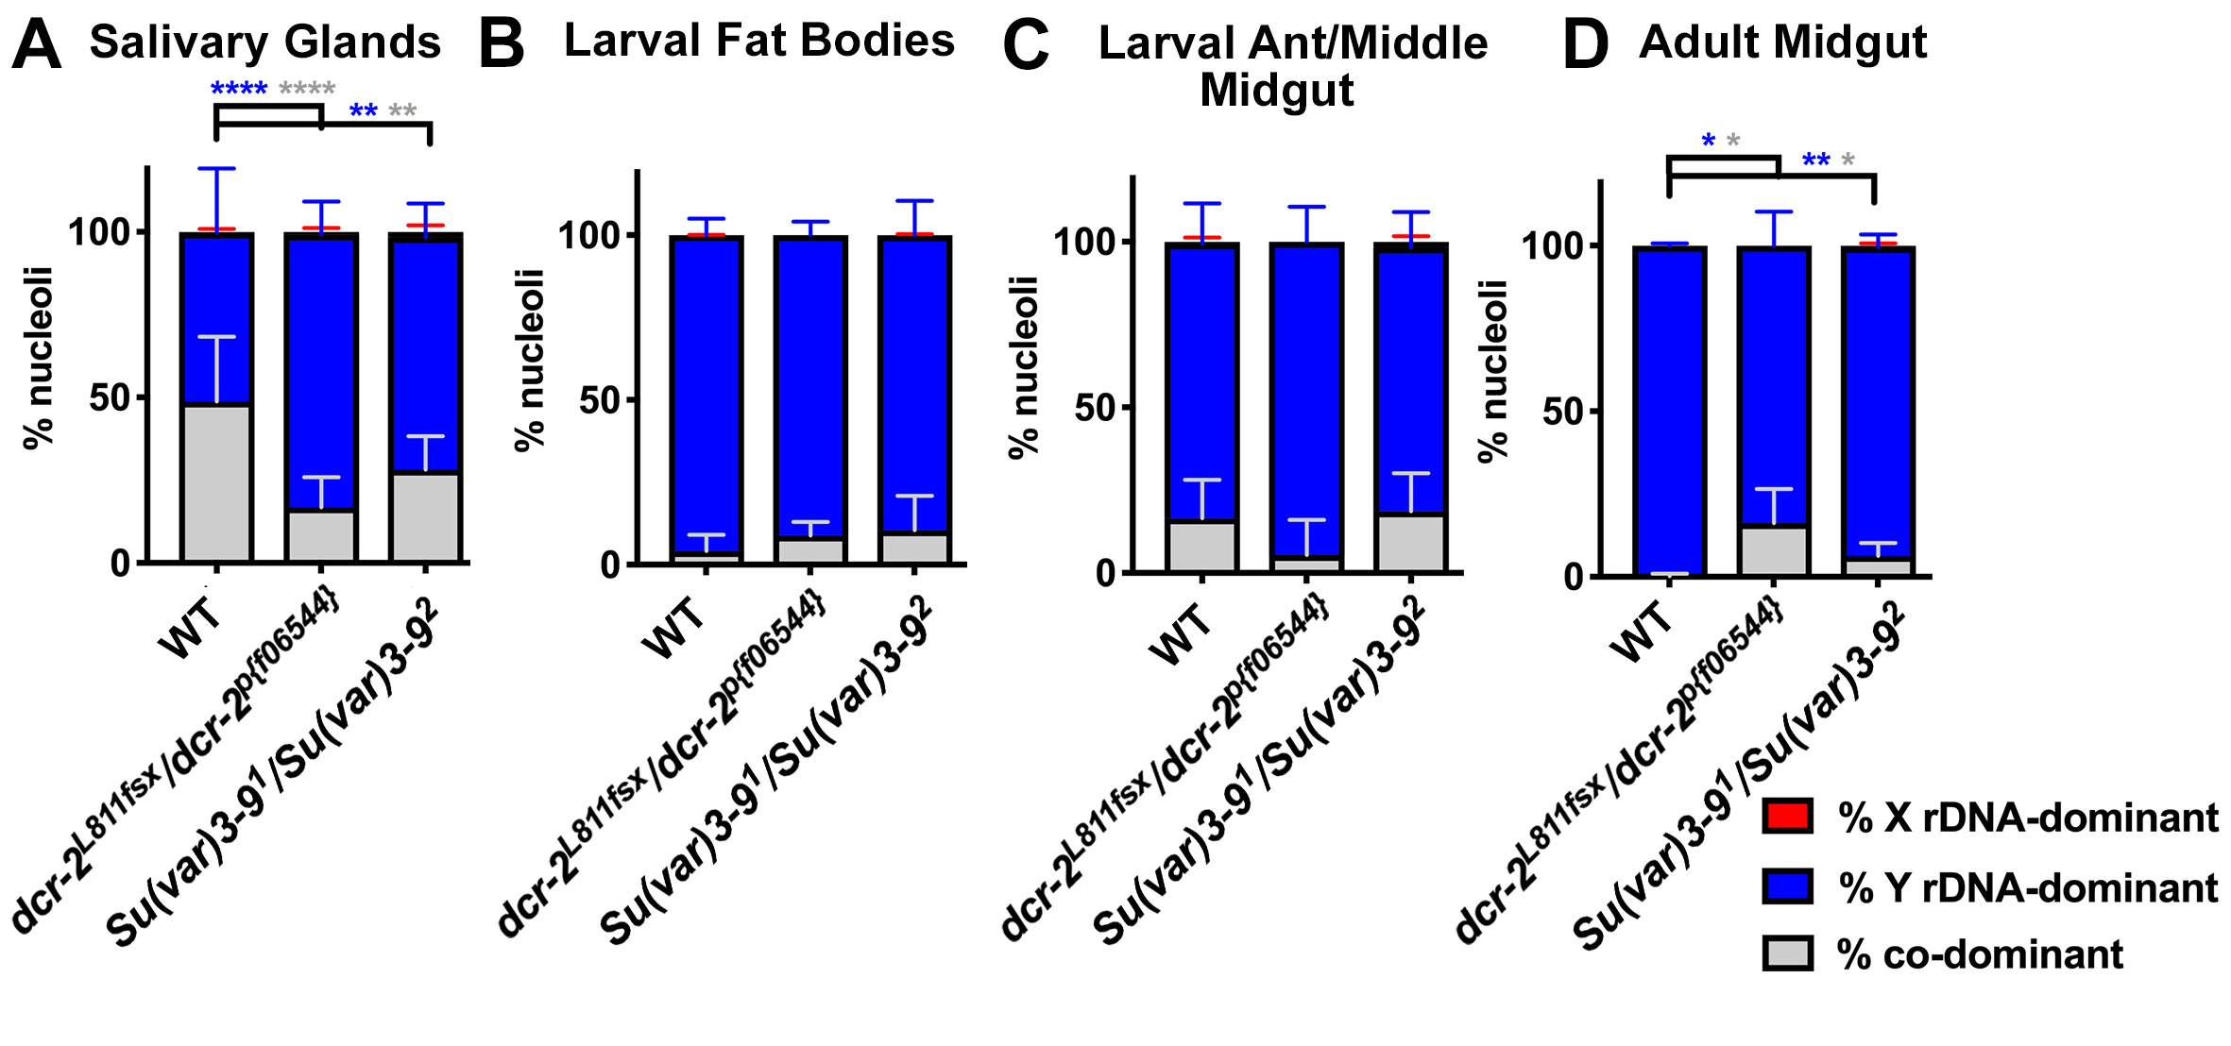
Figure S2: The state of nucleolar dominance in polyploid tissues in dcr-2 and Su(var)3-9 mutants. Quantification of nucleolar dominance in males in A) salivary glands of wild type (yw) (n = 878 cells from 15 salivary glands), dcr-2^{L811fsx}/ dcr-2^{p[f06544]}mutants (n = 373 cells from 8 salivary glands), and Su(var)3-9¹/Su(var)3-9² mutants (n = 423 cells from 11 salivary glands), B) larval fat bodies of wild type (n = 1575 cells from 17 fat bodies), dcr-2^{L811fsx}/ dcr-2^{p[f06544]} mutants (n = 320 cells from 4 fat bodies), and Su(var)3-9¹/Su(var)3-9² mutants (n = 351 cells from 7 fat bodies), C) larval anterior/middle midgut enterocytes of wild type (n = 181 cells from 6 guts), dcr-2^{L811fsx}/ dcr-2^{p[f06544]}mutants (n = 150 cells from 5 guts), and Su(var)3-9¹/Su(var)3-9² mutants (n = 172 cells from 5 guts), and D) adult anterior midgut enterocytes of wild type (n = 922 cells from 7 guts), dcr-2^{L811fsx}/ dcr-2^{p[f06544]} mutants (n = 614 cells from 6 guts), and Su(var)3-9¹/Su(var)3-9² mutants (n = 476 cells from 6 guts). Red = % X rDNA-dominant, blue = % Y rDNA-dominant, grey = % co-dominant nuclei. p-values calculated using Welch’s unpaired, unequal variances t-test using n = number of tissues. (no star) = not significant, * = < 0.05, ** = < 0.01, **** = < 0.0001. Colors of asterisks correspond to colors of bars for which p-values were calculated (e.g. blue asterisk for Y rDNA-dominant p-values).

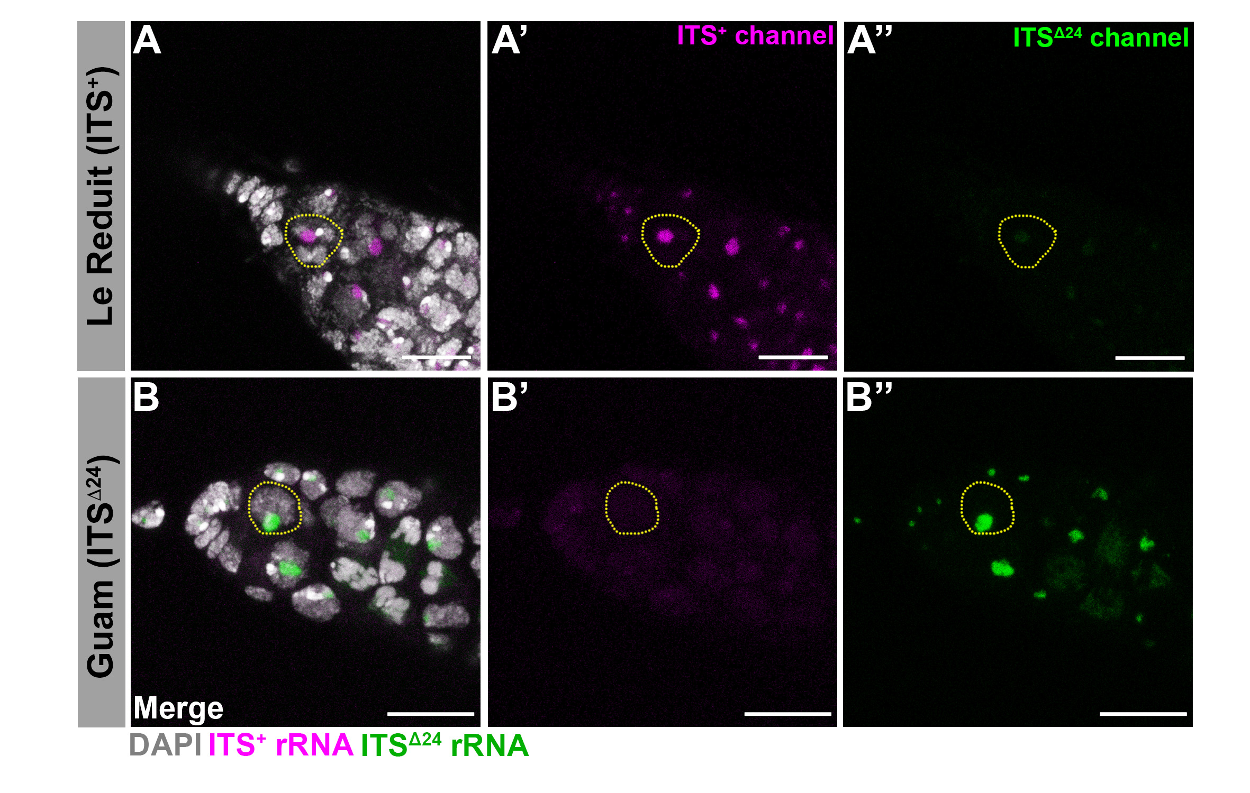
Figure S3: ITS probes that differentially identify distinct X rDNA variants. A) Representative images of germarium from Le Réduit, A’) ITS⁺ channel only, A’’) ITS^{Δ24} channel only, and B) Guam D. melanogaster strains, B’) ITS⁺ channel only, B’’) ITS^{Δ24} channel only. All scale bars = 10μm. Magenta = ITS⁺ rDNA transcript, green = ITS^{Δ24} rDNA transcript, white = DAPI. Yellow circles to denote an example of a germline stem cell (GSC).

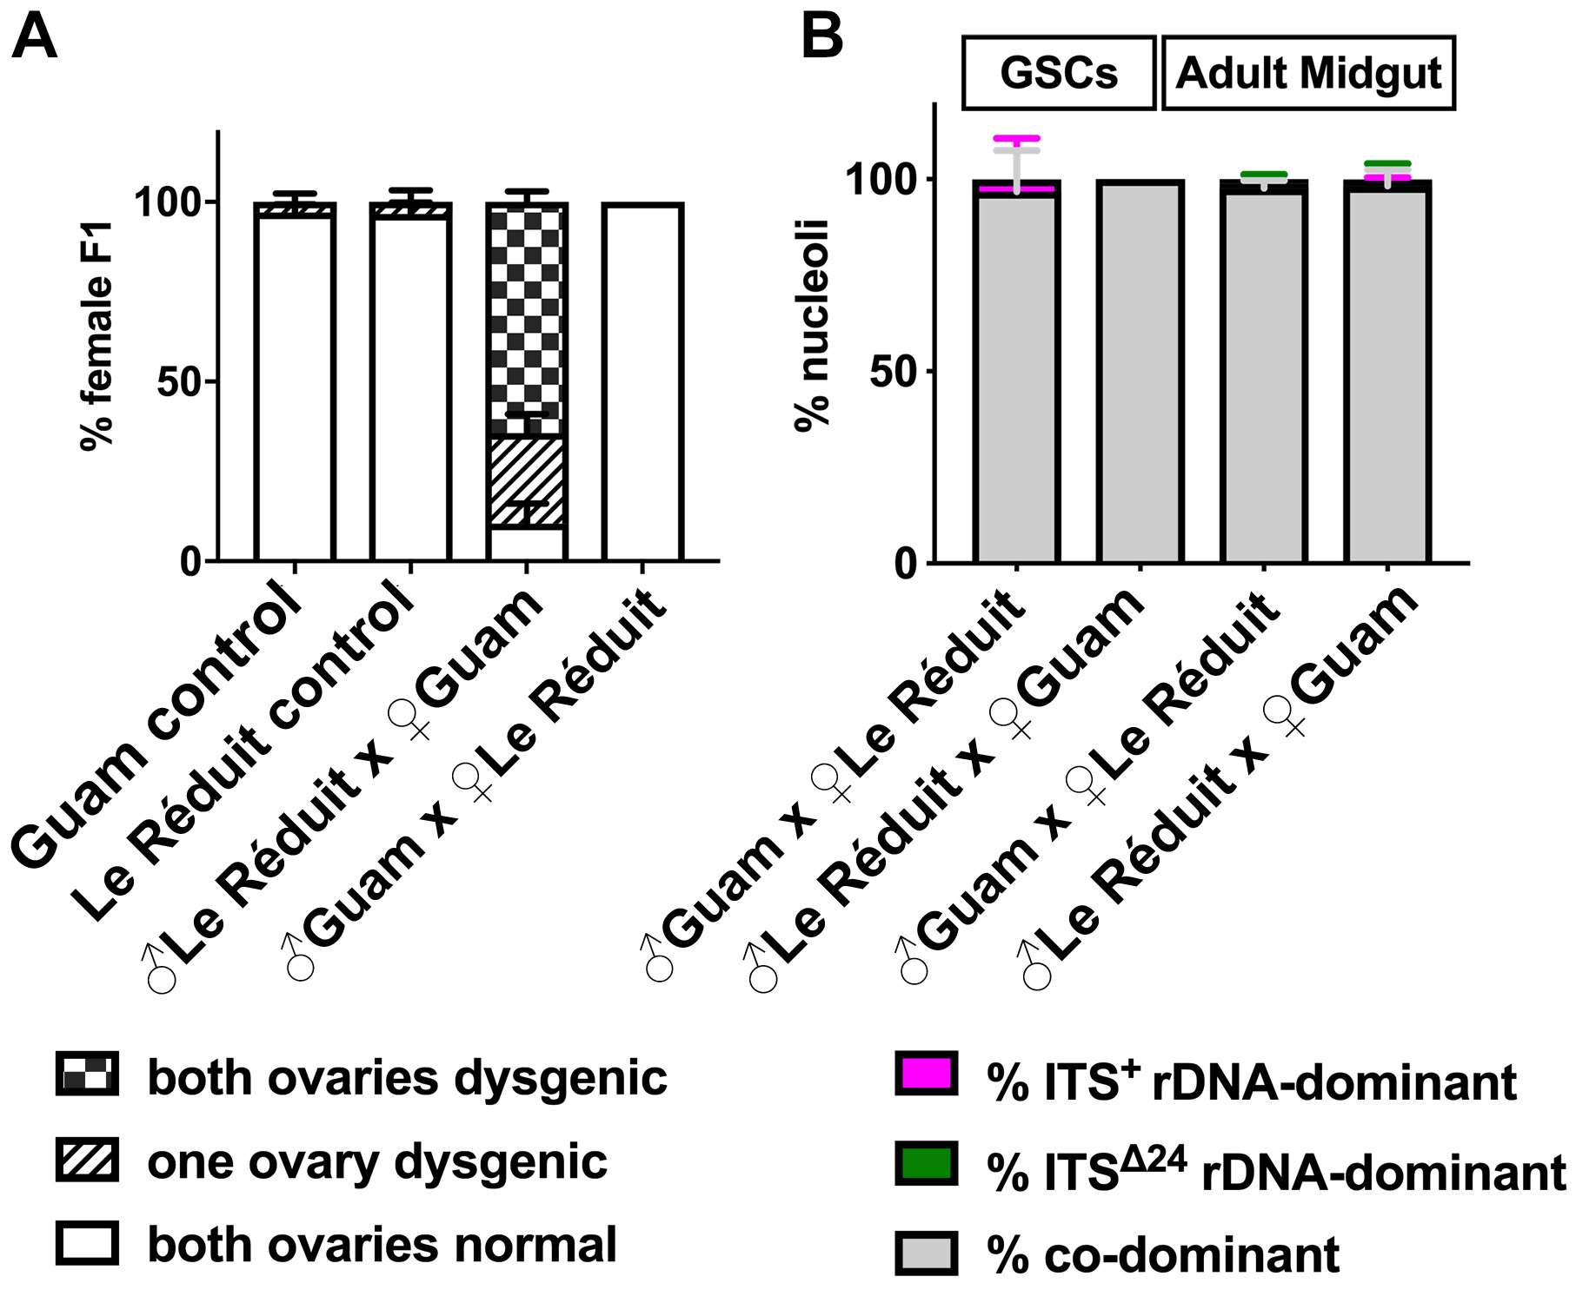
Figure S4: Two X chromosomes (ITS⁺ vs. ITS^{Δ24} variants) exhibit co-dominance irrespective of parental origins. A) Quantification of hybrid dysgenesis in the crosses of ♂Guam x ♀Guam controls (n = 104 females from 4 vials), ♂Le Réduit x ♀Le Réduit controls (n = 185 females from 4 vials), and ♂Le Réduit x ♀Guam (n = 145 females from 3 vials), and ♂Guam x ♀Le Réduit (n = 202 females from 4 vials) performed at 25° (Engels and Preston 1979). B) Quantification of female nucleolar dominance between two X rDNA comparing both cross directions (data from Figure 4 is reproduced to show that the parental origin minimally influence the state of nucleolar dominance). GSCs scored: ♂Guam x ♀Le Réduit (n = 150 cells from 57 germarium),♂Le Réduit x ♀Guam (n = 107 cells from 51 germarium). Adult anterior midgut scored: ♂Guam x ♀Le Réduit (n = 904 cells from 9 guts),♂Le Réduit x ♀Guam (n = 962 cells from 9 guts).

Reference:
Engels, W. R., and C. R. Preston, 1979 Hybrid dysgenesis in Drosophila melanogaster: the biology of female and male sterility.
Genetics 92: 161–174.

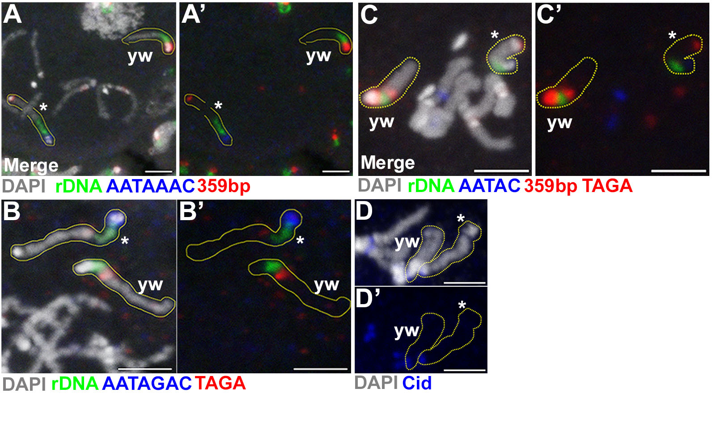
Figure S5: Cytological characterization of the Xbb⁻YS chromosome. DNA fluorescent in situ hybridization (FISH) on mitotic chromosome spreads from larval brains of Xbb⁻YS/X females with A) AATAAAC (blue) and 359-bp (red), A’) no DAPI. B) AATAGAC (blue) and TAGA (red), B’) no DAPI. C) AATAC (blue), TAGA, and 359-bp, C’) no DAPI. D) Immunofluorescence (IF) of centromeric protein Cid (blue) on mitotic chromosome spreads, D’) no DAPI. Xbb⁻YS (*) and wild type X (wt), both outlined in yellow. White = DAPI. All scale bars = 3μm.

