Supplemental Material

Supplemental Figure 1
Confirmation of amplicon size selection. Representative bioanalyzer trace showing the size distribution of the size selected final, Ta subfamily-enriched L1Hs-amplified sequencing library for an individual sample. Size selected amplicon products were distributed between 200-1000 base pairs (bp, x-axis). Y-axis is arbitrary florescent units (FU).
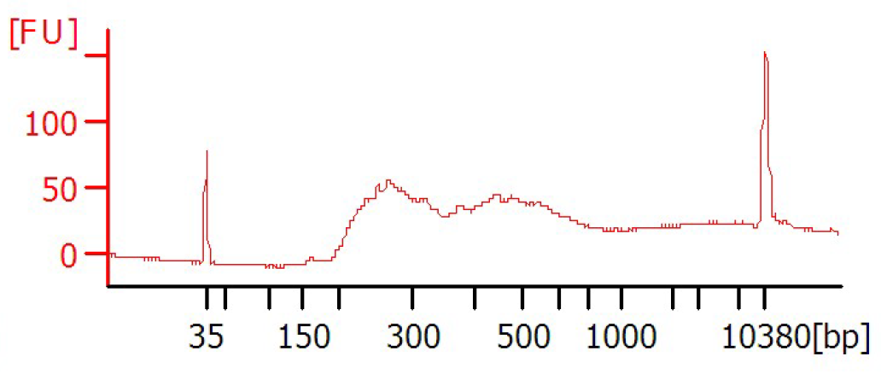

Supplemental Oligomers

L1HsACA primer
GGGAGATATACCTAATGCTAGATGACACA

Double stranded T-Linker
AGATGTGAGAAAGGGATGTGCTGCGAGAAGGCTAG/Phos/5’
TCTACACTCTTTCCCTACACGACGCTCTTCCGATC*T

T-linker bottom strand primer
TCTACACTCTTTCCCTACACGACGCTCTTCCGATCT

Seq2-L1HsG primer
GTGACTGGAGTTCAGACGTGTGCTCTTCCGATCTGCACATGTACCCTAAAACTTAG

Adapt2-Seq1
AATGATACGGCGACCACCGAGATCTACACTCTTTCCCTACACGACGCTCTTCCGATCT

Adapt1-Barcode-Seq2 - Index 1
CAAGCAGAAGACGGCATACGAGATACATCGGTGACTGGAGTTCAGACGTGTGCTCTTCCGATC*T

Adapt1-Barcode-Seq2 - Index 2
CAAGCAGAAGACGGCATACGAGATTGGTCAGTGACTGGAGTTCAGACGTGTGCTCTTCCGATC*T

Adapt1-Barcode-Seq2 - Index 3
CAAGCAGAAGACGGCATACGAGATCACTGTGTGACTGGAGTTCAGACGTGTGCTCTTCCGATC*T

Adapt1-Barcode-Seq2 - Index 4
CAAGCAGAAGACGGCATACGAGATATTGGCGTGACTGGAGTTCAGACGTGTGCTCTTCCGATC*T

Adapt1-Barcode-Seq2 - Index 5
CAAGCAGAAGACGGCATACGAGATGATCTGGTGACTGGAGTTCAGACGTGTGCTCTTCCGATC*T

Adapt1-Barcode-Seq2 - Index 6
CAAGCAGAAGACGGCATACGAGATTACAAGGTGACTGGAGTTCAGACGTGTGCTCTTCCGATC*T

* denotes a phosphorothioate bond and highlighting denotes barcode sequence

