Supplementary Figures
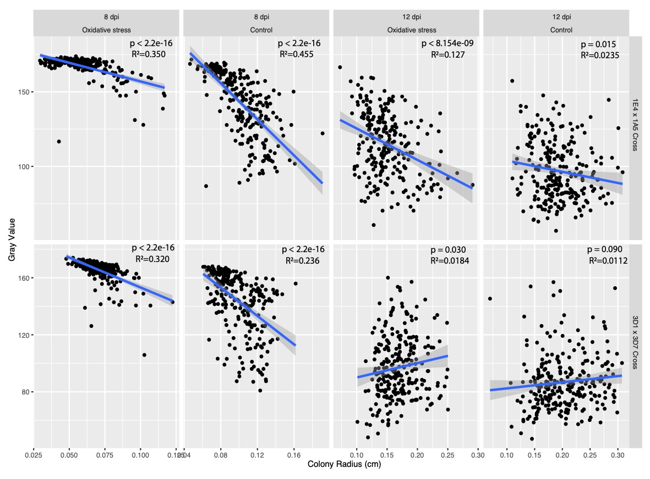
Figure S1. Correlations between absolute melanization and absolute growth at 8 and 12 dpi in the two crosses.

Figure S2. Progenies showing extreme colony growth in hydrogen peroxide at 8 dpi in 1E4 x 1A5 cross. Shown are the eight strains with the lowest growth and eight strains with the highest growth in the entire population of offspring.

Figure S3. Progenies showing extreme relative growth at 8 dpi in the 3D1 x 3D7 cross. Shown are the eight strains with the lowest relative growth values and eight strains with the highest relative growth values in the entire population of offspring. The genotype for each strain at the SNP marker with the highest LOD in chromosome 10 QTL is listed below the image of each strain. The genotypes in red indicate the missing information for those strains at this marker, which were inferred from genotypes of surrounded markers.
Figure S4. In planta expression profile of genes related to the oxidative stress response. (A) Infected leaves at 3, 7, 11, 14 and 21 dpi (images from Palma-Guerrero et al. 2016). (B) Expression profiles of selected genes at the five time points corresponding to (A). Red dots mark the highest expression levels for each gene. Genes found within our QTL confidence intervals are highlighted in boldface type.

