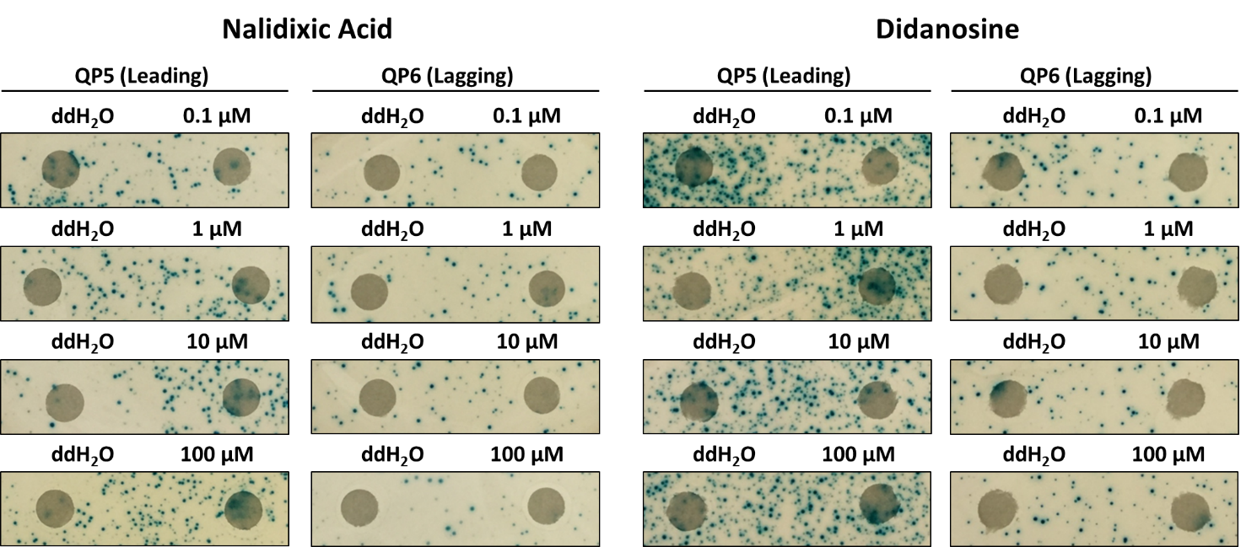
Supplementary Figure 1. No mutator effect of fresh stocks of false negatives, nalidixic acid and didanosine. The disk diffusion test for Lac reversion using QP5 and QP6 reporters on lactose X-gal papillation medium was conducted. Each disk on the right was saturated with 5 μL of specified drug at the indicated concentrations. Each control disk on the left was spotted with 5 μL of distilled water.

