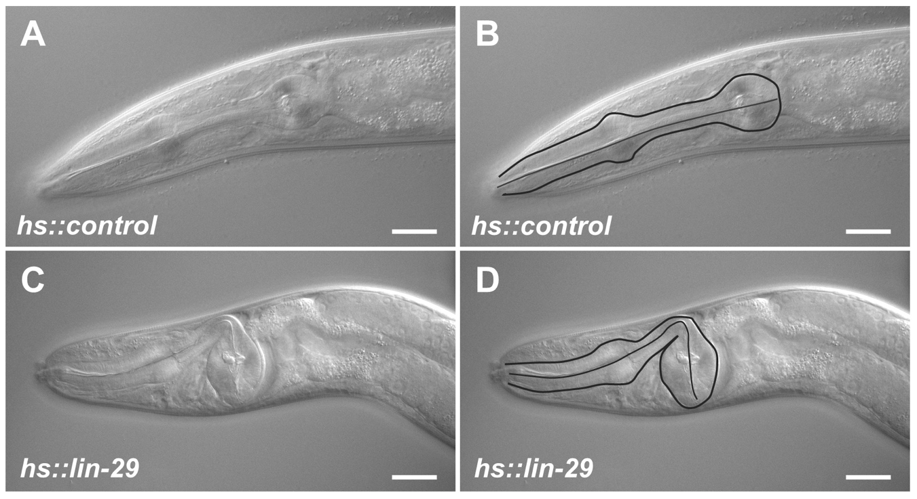

Figure S2. Small animals resulting from ectopic early expression of LIN-29 have a bent pharynx phenotype. Synchronized hs::control and hs::lin-29 L1 animals were fed at 20°C, given single heat shock pulses in the L2 and L4 stages and allowed to grow to adulthood. The head regions of a wild type hs::control adult (A) and a Small hs::lin-29 adult (C) are shown. In (B) and (D) the same animals are shown with the outline of the pharynx drawn in. Scale bar: 20µm.

