Supplementary Material

“A high-quality genome assembly from short and long reads for the non-biting midge Chironomus riparius (Diptera)”
Hanno Schmidt, Sören Lukas Hellmann, Ann-Marie Waldvogel, Barbara Feldmeyer, Thomas Hankeln, Markus Pfenninger

Supplementary Methods S1: Estimation of the recombination rate
Short read sequence data from twenty unrelated female individuals (datasets 27-46 from Supplementary Table S1, published in (Waldvogel et al. 2018)) from five populations across Europe (MF = Rhône-Alpes, MG = Hessen, NMF = Lorraine, SI = Piemonte, SS = Andalucia) was used to generate a set of single nucleotide polymorphisms (SNP) for the analyses. Sampling locations and quality processing of the reads are described in (Oppold et al. 2017).
Reads were aligned to the genome described in this study using bwa mem algorithm from BWA v0.7.13-r1126 (Li and Durbin 2009; Li 2013) with standard parameters. PCR duplicate reads were marked with the MarkDuplicatesWithMateCigar algorithm from Picard tools v2.6.0 (http://broadinstitute.github.io/picard/). Afterwards, realignment around indels was performed with the IndelRealigner algorithm from the Genome Analysis Toolkit v3.6-0-g89b7209 (GATK; (McKenna et al. 2010)), followed by recalibration of bases. For the latter we applied the UnifiedGenotyper algorithm from GATK to identify an initial SNP set, searched for shared SNPs in all resulting VCF files with the isec algorithm from Bcftools v1.3.1 (Li et al. 2009) and finally recalibrated bases with the BaseRecalibrator algorithm from GATK.
The final SNPs were called on the recalibrated BAM files again using the UnifiedGenotyper algorithm from GATK with stand_call_conf=40 and stand_emit_conf=15. Phasing of haplotypes was performed scaffold-wise with SHAPEIT2 v2.r837 (Delaneau et al. 2013) using only diallelic SNPs. We converted the output from SHAPEIT2 to VCF files and extracted input files for LDhelmet with VCFtools (http://vcftools.sourceforge.net) and the --ldhelmet option.
Recombination rates were estimated by applying a reversible jump Markov Chain Monte Carlo mechanism (rjMCMC) implemented in the program LDhelmet v1.7 (Chan et al. 2012) individually for each scaffold. LDhelmet is a derivative of LDhat (Auton et al. 2012), especially modified to fit genomic characteristics that differ from hominids to Drosophila (for example higher SNP density). Since we anticipate similar patterns in Chironomus, we chose LDhelmet and mainly followed the parameter recommendations of the authors.
Using the information from the SNPS and POS files from the VCFtools’ output we generated FASTA files for every population and every scaffold individually, ending up with 3,220 input files (5 populations * 644 scaffolds), containing 25,760 haplotype blocks (3,220 files * 4 individuals * 2 haplotypes), representing 99 % of the genome assembly. Data preparation for the main run in LDhelmet included creation of haplotype configuration files with the find_confs command on a window size of 50 SNPs as recommended by the authors, as well as likelihood lookup tables and Padé coefficients. For these calculations we used population-specific mutation rates theta (θ = 4N_{e}μ) that were individually derived from Pool-Seq data of the same five populations (Waldvogel et al. 2018) and calculated with PoPoolation v1.2.2 (Kofler et al. 2011). Theta values are: θ_{MF} = 0.01236, θ_{MG} = 0.01134, θ_{NMF} = 0.01446, θ_{SI} = 0.01029 and θ_{SS} = 0.01021. Default values were applied to all other parameters.
The ultimate LDhelmet analysis with the rjmcmc command was run for each scaffold with a block penalty of 50.0 (as recommended; parameter of negligible influence on results (Heil et al. 2015)) and a window size of 50 SNPs (as in the data preparation). We used a burn-in of 1,000,000 iterations and subsequently ran the Markov chain for 10,000,000 iterations (in addition to the burn-in). Results were extracted from the binary output via the post_to_text command of LDhelmet.
To allow for a comparison of recombination rates between chromosomes, a number of scaffolds was correlated to their physical chromosomes by fluorescence-in-situ-hybridization (data not shown) applying protocols described previously (Hankeln and Schmidt 1987; Schmidt et al. 1988).

Supplementary Methods S2: Genome annotation
The draft genome, the reference transcriptome described in the main text and the GFF file from a BUSCO run were uploaded to the Augustus v3.2.3 training (Stanke et al. 2008) at the University of Greifswald webserver (http://bioinf.uni-greifswald.de/webaugustus/training/create; accessed on 2017-02-24). This output then served as input for the first round of MAKER2. MAKER2 can work much more accurate when provided with genome-specific gene models at the beginning. Therefore we ran CEGMA v2.5 (Parra et al. 2007) on the draft genome and converted the output to a hidden Markov model using scripts from the SNAP gene finder v2006-07-28 (Korf 2004). Additionally, we created another hidden Markov model by running GeneMark v4.32 (Lomsadze et al. 2014) with min_contig set to 20,000 on the draft genome.
The first round of MAKER2 annotation was then run using MPICH2 v3.2 (https://www.mpich.org/) parallelization with the described transcriptome, SNAP, GeneMark and Augustus models, our custom repeat library plus the SwissProt database (as at 13.1.2016) as input. The MAKER2 pipeline was run with the programs Augustus v3.2.1, BLAST v2.2.28+ (Altschul et al. 1990), Repeatmasker v4.0.6 (Smit et al. 2013-2015), SNAP v2006-07-28 (Korf 2004), GeneMark v4.32 (Lomsadze et al. 2014) and Exonerate v2.2.0 (Slater and Birney 2005). We applied default parameters with only max_dna_len set to 500,000 to prevent loss of gene parts from genes with larger introns, min_protein set to 10 to receive as much potential protein sequences as possible and fix_nucleotides set as flag to allow for non-ACGT-characters in the genome file. The gff files of MAKER2’s output were merged to a single file using gff3_merge from the MAKER2 distribution. Afterwards this gff file was converted to a hidden Markov model using SNAP scripts as described above for CEGMA with only the cegma2zff script being replaced by maker2zff. The information from the first MAKER2 run was also used for retraining the gene model in Augustus. The genome.ann file was first retransformed to gff and modified to match the gff format and then fed into the autoAug.pl script from Augustus v3.2.1 for retraining the EST-based gene models. The second round of the MAKER2 pipeline was then started with the same settings and input files as described above but with the updated Augustus and SNAP gene models and the parameters min_protein set to 30 and alt_splice on. Afterwards, a third round of the MAKER2 pipeline was run exactly as the second one, including another re-training of the Augustus gene model with autoAug.pl and again updating the SNAP gene model. From the resulting output of MAKER2’s third round we merged all gff files with gff3_merge as described above and renamed the included gene tracks to ensure easier handling. To allow for assigning putative gene functions to the annotated gene tracks, we gathered all predicted proteins from the MAKER2 output folder, performed BLASTP searches against the SwissProt database (as at 13.1.2016) and then added the best BLAST hits to the accordant gene tracks.
To evaluate the reliability of the annotation produced by MAKER2, we used another annotation pipeline, BRAKER v2.1.0 (Hoff et al. 2015), to fully annotate C. riparius’ genome sequence again. The completeness of the gene space was then checked by BUSCO searches on the coding genes’ protein sequences of both annotations. These were compared to a BUSCO search on the genome sequence itself. Most notably, the annotations of both pipelines contain almost the same number of genes that are complete and single copy (MAKER2 83.6%, BRAKER 83.9%; Supplementary Figure S3). One problem in MAKER2’s results was the formation of chimeric genes that occurred by concatenating neighboring genes (data not shown). On the other hand, BRAKER seemed to be quite aggressive in annotating, since it had fewer missing genes (MAKER2 9.2%, BRAKER 3.7%), but more duplicated ones (MAKER2 1.5%, BRAKER 9.1%), with the latter also being related to BRAKER’s potentially useful tendency to call several transcript variants of a gene. BRAKER’s aggressiveness is also demonstrated by the total number of genes found by the pipeline – with 18,690, the gene count is 40% higher than MAKER2’s result on C. riparius’ genome, and also higher than in any other chironomid genome or the Drosophila melanogaster reference genome (Table 2). Overall, results between the two pipelines were similar enough to not question their reliability, but the differences present were too ambiguous to make a clear judgement.

Supplementary Tables
Supplementary Table S1 – Sequence data used in the study
dataset  ID | used in part | sequencing technology | read length (bp) | number of raw reads | accession number | publication
01 | genome assembly | PacBio RS II | up to 48,745 | 1,155,855 | ERR2696325 | this study
02 | genome assembly | Illumina paired end | 100 | 29,136,088 | SAMEA4560833 | (Oppold et al. 2017)
03 | genome assembly | Illumina paired end | 100 | 167,264,372 | SAMEA4560834 | (Oppold et al. 2017)
04 | genome assembly | Illumina paired end (MiSeq) | 300 | 58,447,092 | SAMEA4560835 | (Oppold et al. 2017)
05 | genome assembly + scaffolding | Illumina mate-pair | 100  (3 kb insert size) | 48,853,530 | SAMEA4560836 | (Oppold et al. 2017)
06 | genome assembly + scaffolding | Illumina mate-pair | 100  (6 kb insert size) | 47,978,148 | SAMEA4560837 | (Oppold et al. 2017)
07 | error correction | Illumina paired end | 150 | 29,694,824 | PRJEB18039 | (Oppold and Pfenninger 2017)
08 | error correction | Illumina paired end | 150 | 34,118,424 | PRJEB18039 | (Oppold and Pfenninger 2017)
09 | error correction | Illumina paired end | 150 | 35,803,108 | PRJEB18039 | (Oppold and Pfenninger 2017)
10 | error correction | Illumina paired end | 150 | 38,534,360 | PRJEB18039 | (Oppold and Pfenninger 2017)
11 | error correction | Illumina paired end | 150 | 39,512,980 | PRJEB18039 | (Oppold and Pfenninger 2017)
12 | annotation (transcriptome) | 454 Roche | up to 679 | 430,916 | SRR834592 | (Schmidt et al. 2013)
13 | annotation (transcriptome) | 454 Roche | up to 914 | 456,584 | SRR834593 | (Schmidt et al. 2013)
14 | annotation (transcriptome) | 454 Roche | up to 690 | 1,549,146 | SRR496839 | (Marinković et al. 2012)
15 | annotation (transcriptome) | 454 Roche | up to 606 | 4,041 | SRX022389 | (Nair et al. 2011)
16 | annotation (transcriptome) | 454 Roche | up to 679 | 138,103 | SRR1049908
17 | annotation (transcriptome) | 454 Roche | up to 802 | 266,129 | SRR1049909
18 | annotation (transcriptome) | 454 Roche | up to 600 | 189,271 | SRR1049910
19 | annotation (transcriptome) | 454 Roche | up to 662 | 235,202 | SRR1049911
20 | annotation (transcriptome) | Illumina paired end | 100 | 6,863,480 | SRR1028867 | (Klomp et al. 2015)
21 | annotation (transcriptome) | Illumina paired end | 100 | 10,222,374 | SRR1032319 | (Klomp et al. 2015)
22 | annotation (transcriptome) | Illumina paired end | 100 | 9,684,342 | SRR1032320 | (Klomp et al. 2015)
23 | annotation (transcriptome) | Illumina paired end | 100 | 9,305,342 | SRR1032321 | (Klomp et al. 2015)
24 | annotation (transcriptome) | Illumina paired end | 100 | 10,861,756 | SRR1032322 | (Klomp et al. 2015)
25 | annotation (transcriptome) | Illumina paired end | 100 | 10,783,776 | SRR1032323 | (Klomp et al. 2015)
26 | annotation (transcriptome) | Illumina paired end |  |  | unpublished | 1KITE project
27 | annotation (transcriptome) | Illumina paired end | 100 | 105,429,480 | ERS1472439 | (Oppold et al. 2017)
28 | annotation (transcriptome) | Illumina paired end | 100 | 197,899,590 | ERS1472440 | (Oppold et al. 2017)
29 | annotation (transcriptome) | Illumina paired end | 100 | 34,987,537 | ERS1472441 | (Oppold et al. 2017)
30 | annotation (transcriptome) | Illumina paired end | 100 | 46,557,991 | ERS1472442 | (Oppold et al. 2017)
31  MF1 | recombination rate | Illumina paired end | 150 | 36,869,618 | ERR2528543 | (Waldvogel et al. 2018)
32  MF2 | recombination rate | Illumina paired end | 150 | 30,387,616 | ERR2528544 | (Waldvogel et al. 2018)
33  MF3 | recombination rate | Illumina paired end | 150 | 32,170,704 | ERR2528545 | (Waldvogel et al. 2018)
34  MF4 | recombination rate | Illumina paired end | 150 | 32,312,656 | ERR2528546 | (Waldvogel et al. 2018)
35  MG2 | recombination rate | Illumina paired end | 150 | 29,057,938 | ERR2528547 | (Waldvogel et al. 2018)
36  MG3 | recombination rate | Illumina paired end | 150 | 28,788,518 | ERR2528548 | (Waldvogel et al. 2018)
37  MG4 | recombination rate | Illumina paired end | 150 | 27,094,554 | ERR2528549 | (Waldvogel et al. 2018)
38  MG5 | recombination rate | Illumina paired end | 150 | 34,100,258 | ERR2528550 | (Waldvogel et al. 2018)
39  NMF1 | recombination rate | Illumina paired end | 150 | 38,469,060 | ERR2528551 | (Waldvogel et al. 2018)
40  NMF2 | recombination rate | Illumina paired end | 150 | 32,269,454 | ERR2528552 | (Waldvogel et al. 2018)
41  NMF3 | recombination rate | Illumina paired end | 150 | 29,389,106 | ERR2528553 | (Waldvogel et al. 2018)
42  NMF4 | recombination rate | Illumina paired end | 150 | 26,446,596 | ERR2528554 | (Waldvogel et al. 2018)
43  SI1 | recombination rate | Illumina paired end | 150 | 37,946,848 | ERR2528555 | (Waldvogel et al. 2018)
44  SI2 | recombination rate | Illumina paired end | 150 | 42,327,576 | ERR2528556 | (Waldvogel et al. 2018)
45  SI3 | recombination rate | Illumina paired end | 150 | 32,922,356 | ERR2528557 | (Waldvogel et al. 2018)
46  SI4 | recombination rate | Illumina paired end | 150 | 30,872,238 | ERR2528558 | (Waldvogel et al. 2018)
47  SS1 | recombination rate | Illumina paired end | 150 | 31,078,600 | ERR2528559 | (Waldvogel et al. 2018)
48  SS2 | recombination rate | Illumina paired end | 150 | 39,785,504 | ERR2528560 | (Waldvogel et al. 2018)
49  SS3 | recombination rate | Illumina paired end | 150 | 36,018,158 | ERR2528561 | (Waldvogel et al. 2018)
50  SS4 | recombination rate | Illumina paired end | 150 | 28,776,202 | ERR2528562 | (Waldvogel et al. 2018)

Supplementary Table S2 – Statistics for the PacBio-only assembly with Canu
number of sequences | 8,488
total sequence length (bp) | 229,089,447
average sequence length (bp) | 26,990
longest sequence (bp) | 1,085,725
N50 | 56,198

Supplementary Table S3 – Back-mapping of reads used to obtain the assembly onto the draft genome
Only intact pairs after all quality processing steps were mapped.
dataset ID | mapped read pairs | % mapped read pairs
02 | 6,363,845 | 96.9
03 | 42,770,555 | 98.1
04 | 25,635,946 | 99.5
05 | 13,462,849 | 93.3
06 | 18,452,418 | 92.2

Supplementary Table S4 – Annotation of the mitochondrial genome
The annotation was generated by MITOS and manually curated afterwards.
Gene name | Start | Stop | Strand
trnI(gat) | 1 | 68 | +
trnQ(ttg) | 82 | 150 | -
trnM(cat) | 159 | 227 | +
nad2 | 249 | 1154 | +
trnW(tca) | 1256 | 1323 | +
trnC(gca) | 1323 | 1391 | -
trnY(gta) | 1398 | 1463 | -
cox1 | 1474 | 2988 | +
trnL2(taa) | 3028 | 3093 | +
cox2 | 3105 | 3785 | +
trnK(ctt) | 3802 | 3873 | +
trnD(gtc) | 3880 | 3948 | +
atp8 | 3949 | 4125 | +
atp6 | 4125 | 4790 | +
cox3 | 4837 | 5616 | +
trnG(tcc) | 5639 | 5704 | +
nad3 | 5705 | 6049 | +
trnA(tgc) | 6060 | 6125 | +
trnR(tcg) | 6138 | 6204 | +
trnN(gtt) | 6205 | 6272 | +
trnS1(gct) | 6273 | 6339 | +
trnE(ttc) | 6347 | 6415 | +
trnF(gaa) | 6432 | 6498 | -
nad5 | 6522 | 8222 | -
trnH(gtg) | 8247 | 8313 | -
nad4 | 8335 | 9657 | -
nad4l | 9654 | 9935 | -
trnT(tgt) | 9949 | 10014 | +
trnP(tgg) | 10015 | 10081 | -
nad6-0 | 10104 | 10613 | +
cob | 10642 | 11754 | +
trnS2(tga) | 11793 | 11860 | +
nad1 | 11902 | 12801 | -
trnL1(tag) | 12826 | 12892 | -
rrnL | 12888 | 14267 | -
trnV(tac) | 14266 | 14337 | -
rrnS | 14337 | 15138 | -
nad6-1 | 15140 | 15280 | +

Supplementary Figures
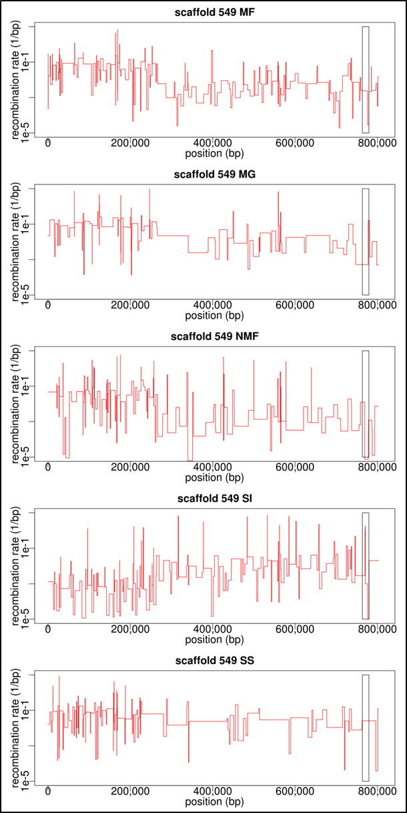
Supplementary Figure S1 – Recombination rates in the scaffold containing the sex-determining region
Scaffold 549 of the draft genome contains a part of the putative sex-determining region of C. riparius. The grey box to the right marks the position of gene CpY, a gene associated with sex-determination in chironomids. The SDR-specific calculations were done on the last 600,000 bp of the scaffold. Population codes are MF = Rhône-Alpes, MG = Hessen, NMF = Lorraine, SI = Piemonte, SS = Andalucia.

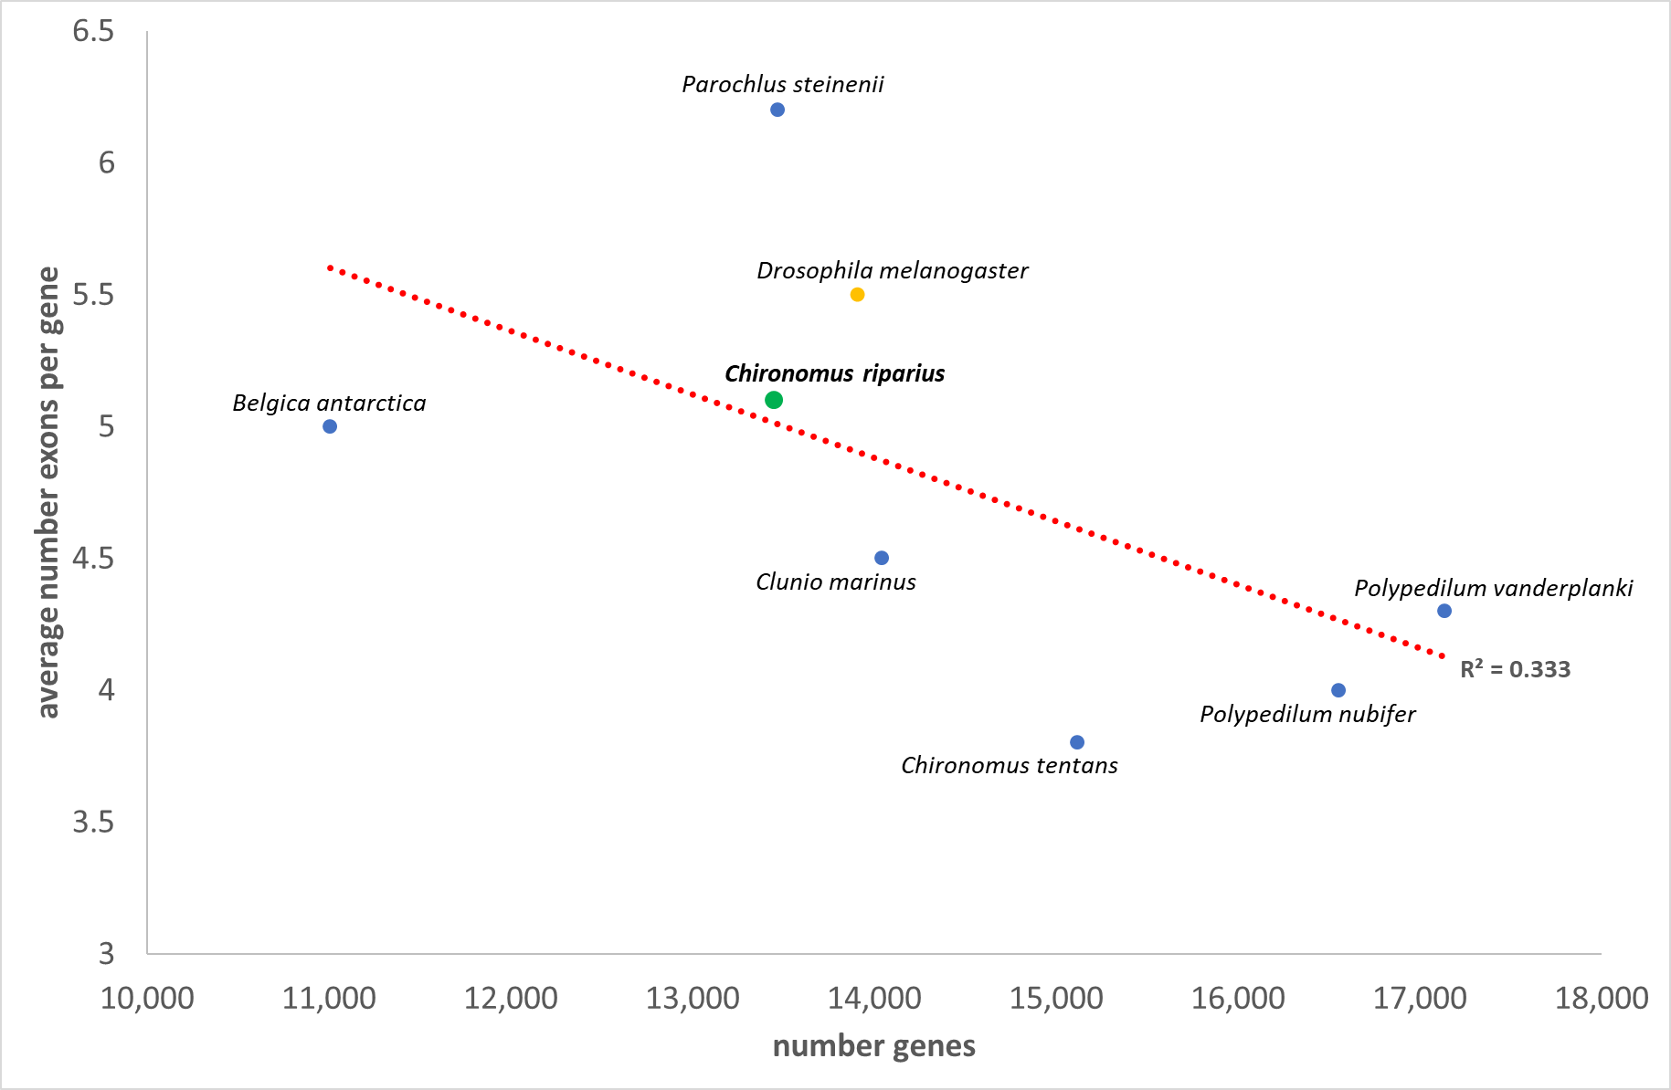
Supplementary Figure S2 – Correlation between number of genes and exons
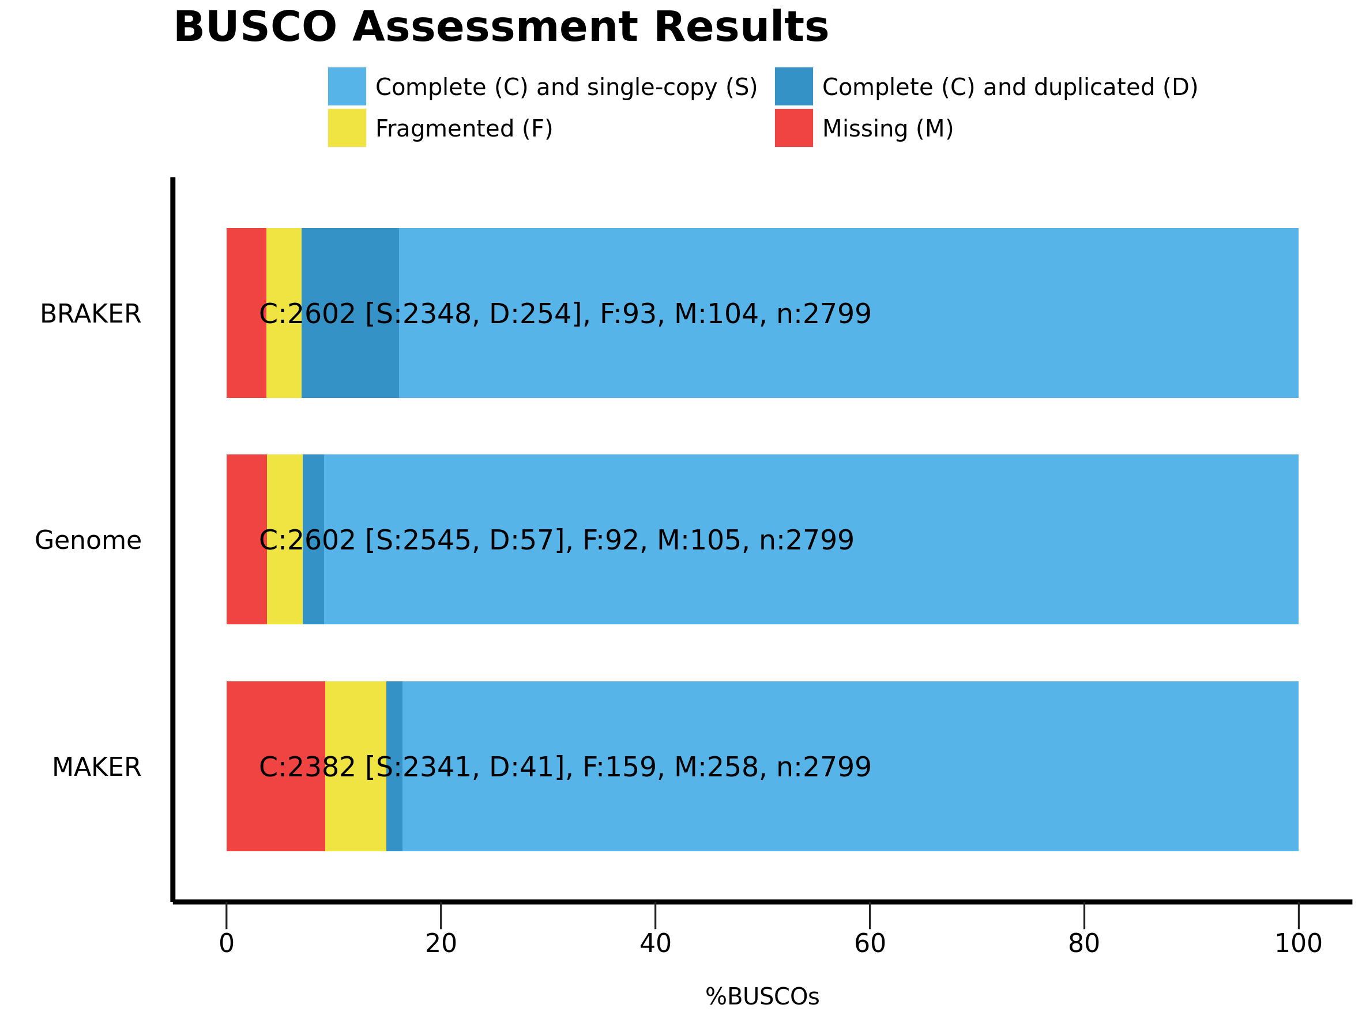
Supplementary Figure S3 – Comparison of the annotations with MAKER and BRAKER
“Genome” refers to a BUSCO search on the actual genome sequence, whereas the two other runs were performed on the protein-coding genes’ sequences output by the two annotation pipelines. C = complete, S = single-copy, D = duplicated, F = fragmented, M = missing.
References
Altschul, S.F., W. Gish, W. Miller, E.W. Myers, and D.J. Lipman, 1990 Basic local alignment search tool. Journal of Molecular Biology 215 (3):403-410.
Auton, A., A. Fledel-Alon, S. Pfeifer, O. Venn, L. Ségurel et al., 2012 A fine-scale chimpanzee genetic map from population sequencing. Science 336 (6078):193-198.
Chan, A.H., P.A. Jenkins, and Y.S. Song, 2012 Genome-wide fine-scale recombination rate variation in Drosophila melanogaster. PLoS Genetics 8 (12):e1003090.
Delaneau, O., J.-F. Zagury, and J. Marchini, 2013 Improved whole-chromosome phasing for disease and population genetic studies. Nature Methods 10 (1):5-6.
Hankeln, T., and E. Schmidt, 1987 Cotransposition of a highly repetitive DNA element with flanking sequences in the genome of the midge Chironomus thummi. Journal of Molecular Evolution 26 (4):311-319.
Heil, C.S.S., C. Ellison, M. Dubin, and M.A. Noor, 2015 Recombining without hotspots: A comprehensive evolutionary portrait of recombination in two closely related species of Drosophila. Genome Biology and Evolution 7 (10):2829-2842.
Hoff, K.J., S. Lange, A. Lomsadze, M. Borodovsky, and M. Stanke, 2015 BRAKER1: Unsupervised RNA-Seq-Based Genome Annotation with GeneMark-ET and AUGUSTUS. Bioinformatics:btv661.
Klomp, J., D. Athy, C.W. Kwan, N.I. Bloch, T. Sandmann et al., 2015 A cysteine-clamp gene drives embryo polarity in the midge Chironomus. Science 348 (6238):1040-1042.
Kofler, R., P. Orozco-terWengel, N. De Maio, R.V. Pandey, V. Nolte et al., 2011 PoPoolation: a toolbox for population genetic analysis of next generation sequencing data from pooled individuals. PLoS One 6 (1):e15925.
Korf, I., 2004 Gene finding in novel genomes. BMC Bioinformatics 5 (1):1.
Li, H., 2013 Aligning sequence reads, clone sequences and assembly contigs with BWA-MEM. arXiv preprint arXiv:1303.3997.
Li, H., and R. Durbin, 2009 Fast and accurate short read alignment with Burrows-Wheeler transform. Bioinformatics 25 (14):1754-1760.
Li, H., B. Handsaker, A. Wysoker, T. Fennell, J. Ruan et al., 2009 The sequence alignment/map format and SAMtools. Bioinformatics 25 (16):2078-2079.
Lomsadze, A., P.D. Burns, and M. Borodovsky, 2014 Integration of mapped RNA-Seq reads into automatic training of eukaryotic gene finding algorithm. Nucleic Acids Research 42 (15):e119-e119.
Marinković, M., W.C. de Leeuw, M. de Jong, M.H.S. Kraak, W. Admiraal et al., 2012 Combining Next-Generation Sequencing and Microarray Technology into a Transcriptomics Approach for the Non-Model Organism Chironomus riparius. PLoS One 7 (10):e48096.
McKenna, A., M. Hanna, E. Banks, A. Sivachenko, K. Cibulskis et al., 2010 The Genome Analysis Toolkit: a MapReduce framework for analyzing next-generation DNA sequencing data. Genome Research 20:1297-1303.
Nair, P.M.G., S.Y. Park, and J. Choi, 2011 Analyses of Expressed Sequence Tags from Chironomus riparius Using Pyrosequencing : Molecular Ecotoxicology Perspective. Environmental Health and Toxicology 26.
Oppold, A.-M., and M. Pfenninger, 2017 Direct estimation of the spontaneous mutation rate by short-term mutation accumulation lines in Chironomus riparius. Evolution Letters 1 (2):86-92.
Oppold, A.-M., H. Schmidt, M. Rose, S.L. Hellmann, F. Dolze et al., 2017 Chironomus riparius (Diptera) genome sequencing reveals the impact of minisatellite transposable elements on population divergence. Molecular Ecology 26 (12):3256-3275.
Parra, G., K. Bradnam, and I. Korf, 2007 CEGMA: a pipeline to accurately annotate core genes in eukaryotic genomes. Bioinformatics 23 (9):1061-1067.
Schmidt, E.R., H.G. Keyl, and T. Hankeln, 1988 In situ localization of two haemoglobin gene clusters in the chromosomes of 13 species of Chironomus. Chromosoma 96 (5):353-359.
Schmidt, H., B. Greshake, B. Feldmeyer, T. Hankeln, and M. Pfenninger, 2013 Genomic basis of ecological niche divergence among cryptic sister species of non-biting midges. BMC Genomics 14 (1):384.
Slater, G.S.C., and E. Birney, 2005 Automated generation of heuristics for biological sequence comparison. BMC Bioinformatics 6 (1):31.
Smit, A., R. Hubley, and P. Green, 2013-2015 RepeatMasker Open-4.0.
Stanke, M., M. Diekhans, R. Baertsch, and D. Haussler, 2008 Using native and syntenically mapped cDNA alignments to improve de novo gene finding. Bioinformatics 24 (5):637-644.
Waldvogel, A.-M., A. Wieser, T. Schell, S. Patel, H. Schmidt et al., 2018 The genomic footprint of climate adaptation in Chironomus riparius. Molecular Ecology 27:1439-1456.

