Figure S7
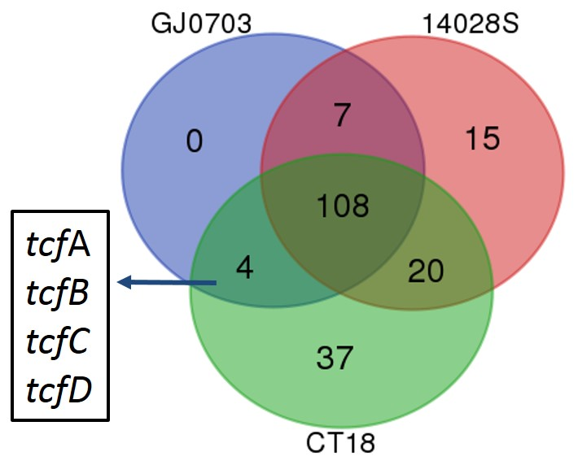

Distribution of orthologous virulent factors in GJ0703, CT18 and strain 14028S. The Venn diagram shows the identified virulence factor relationship amongst strains GJ0703, 14028S and CT18. Virulence factors were characterized by using BLASTp against the VFDB database with cut-offs identities >75%. Based on this scenario tcfA-D was identified as shared genes for strain CT18 and absent in strain 14028S.

