Figure S5
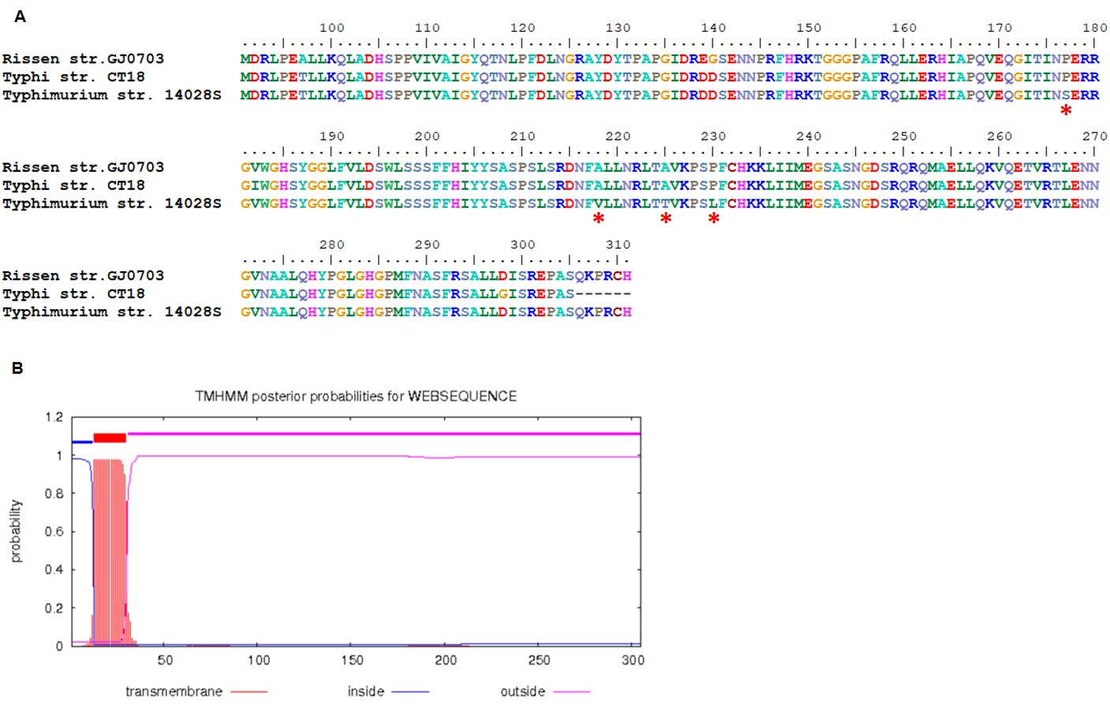

Amino acid variation in IroE. (A) Asterisks denote 4 amino acids variation in S. Rissen, S. Typhi and S. Typhimurium. The amino acid alignment was performed by BioEdit 7.0. (B) The prediction of transmembrane domains was performed resorting to Center for Biological Sequence analysis (http://www.cbs.dtu.dk/ services/TMHMM/). All the amino acid variations locate at the C-terminal outside domain and the enzyme active site of IroE were indicated in the figure.

