Figure S4
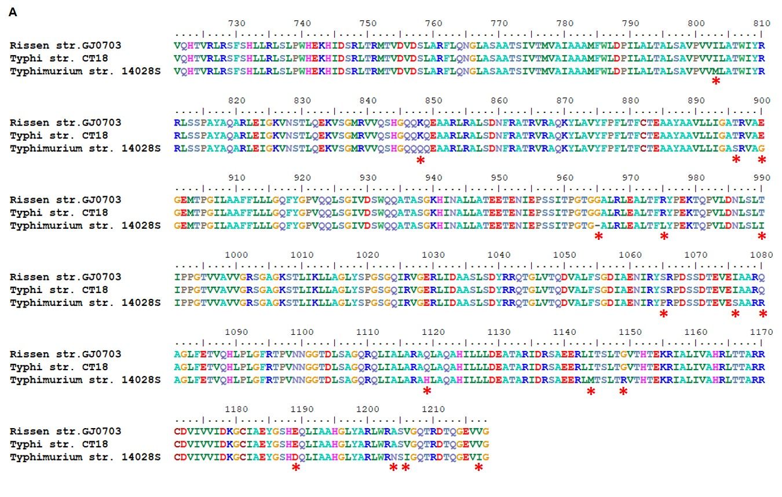
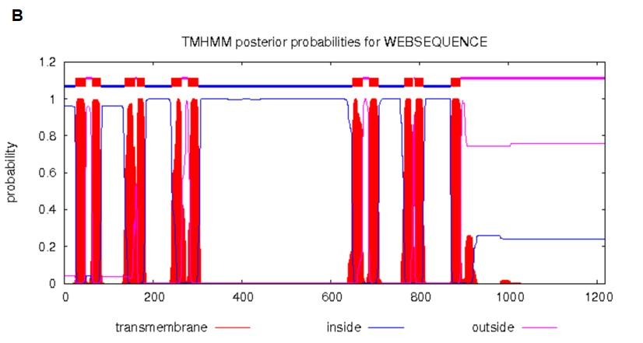

Amino acid variation in IroC. (A) Asterisks denote 15 amino acids variation in S. Rissen, S. Typhi and S. Typhimurium. The amino acid alignment was performed by BioEdit 7.0. (B) The prediction of transmembrane domains was performed resorting to Center for Biological Sequence analysis (http://www.cbs.dtu.dk/ services/TMHMM/). Most amino acid variations (13/15) concentrated at the C-terminal outside as shown in the black box.

