Figure S3
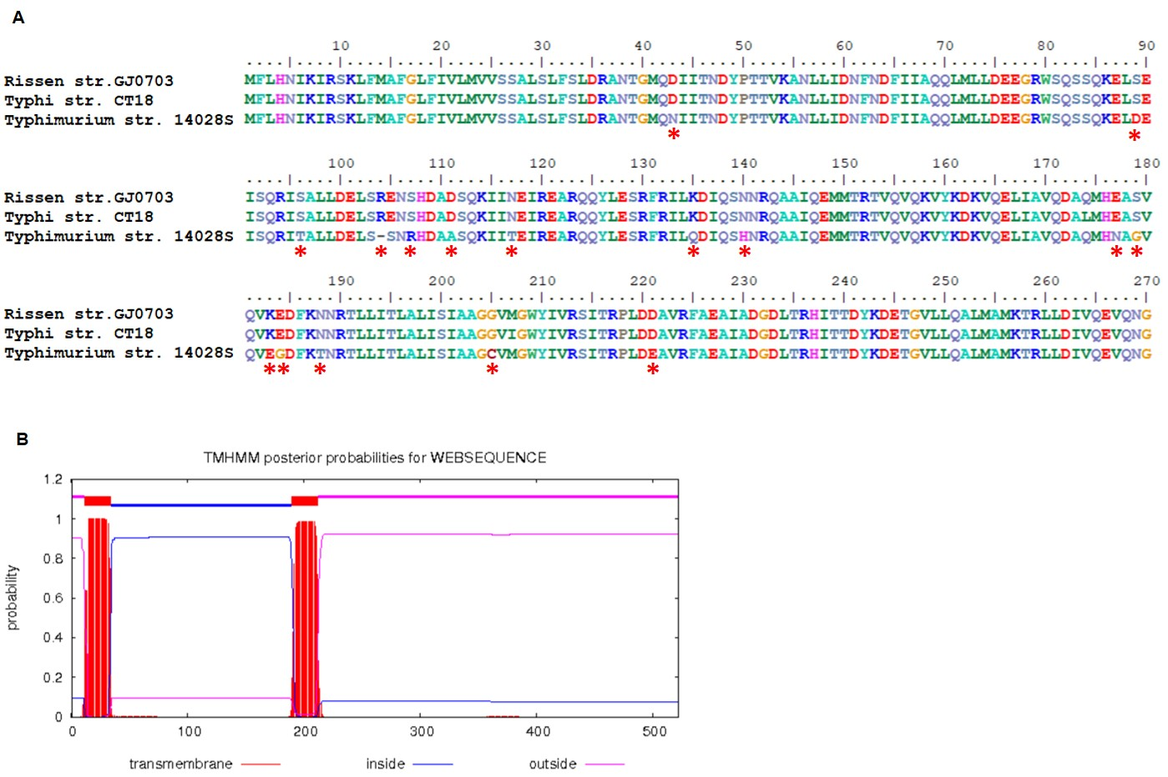

Amino acid variation in McpC. (A) Asterisks denote 16 amino acids variation in S. Rissen, S. Typhi and S. Typhimurium. The amino acid alignment was performed by BioEdit 7.0. (B) The prediction of transmembrane domains was performed resorting to Center for Biological Sequence analysis (http://www.cbs.dtu.dk/services/TMHMM/). There are 2 outside domains, 2 transmembrane domains and 1 inside domain. Most of the amino acid variations (14/16) locate in the inside domain, the ligand binding sites of McpC, as shown in the black box.

