Figure S8
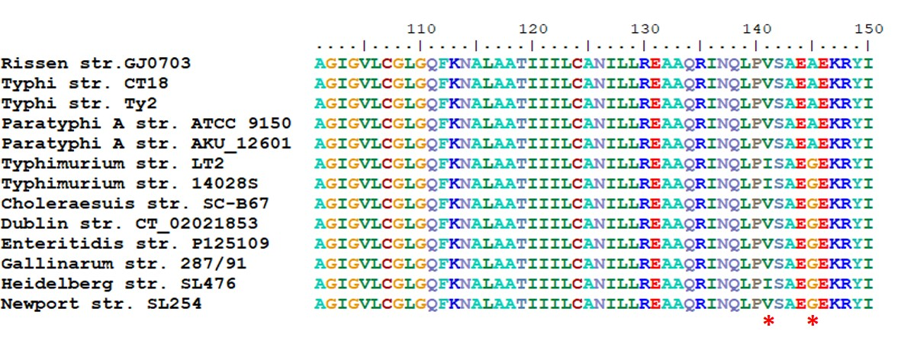
Amino acid variation in MgtC. Asterisks denote 141V and 145A in S. Rissen, S. Typhi and S. Paratyphi A. The amino acid alignment was performed with BioEdit 7.0.

