**Supplementary figures**

**Figure S1**



**Conserved and specific genes for strain GJ0703, CT18 and 14028S and COG categories of 99 genes exclusively shared by GJ0703 and CT18.** The Venn diagram shows the conservation and diversity of three strains, and the relevant pie charts present the assignments of specific or shared genes identified by using comparative genomes. COG classification was conducted by RPS-BLAST against clusters of orthologous groups (COG) database available at NCBI (ncbi.nlm.nih.gov/COG) with e-value ≤ 0.01. And COG assignment frequencies for 99 shared genes between strain CT18 and GJ0703 were indicated as well. Notably, 19% genes were assigned as the ‘mobilome, prophages and transposons’ category.

**Figure S2**



|  |  |  |
| --- | --- | --- |
| COG Assignment | Function | Number |
| D | Cell cycle control, cell division, chromosome partitioning | 3 |
| W | Extracellular structures | 9 |
| V | Defense mechanisms | 12 |
| U | Intracellular trafficking, secretion, and vesicular transport | 15 |
| Q | Secondary metabolites biosynthesis, transport and catabolism | 20 |
| I | Lipid transport and metabolism | 24 |
| F | Nucleotide transport and metabolism | 28 |
| L | Replication, recombination and repair | 29 |
| N | Cell motility | 29 |
| T | Signal transduction mechanisms | 39 |
| O | Posttranslational modification, protein turnover, chaperones | 40 |
| S | Uncharacterized protein conserved in bacteria | 42 |
| J | Translation, ribosomal structure and biogenesis | 56 |
| P | Inorganic ion transport and metabolism | 64 |
| C | Energy production and conversion | 65 |
| H | Coenzyme transport and metabolism | 66 |
| R | Predicted esterase | 66 |
| K | Transcription | 67 |
| M | Cell wall/membrane/envelope biogenesis | 81 |
| G | Carbohydrate transport and metabolism | 90 |
| E | Amino acid transport and metabolism | 95 |

**COG categories of the 928 genes carrying nsSNP variations shared by strains CT18 and GJ0703.** COG classification was conducted by RPS-BLAST against clusters of orthologous groups (COG) database available at NCBI (ncbi.nlm.nih.gov/COG) with e-value ≤ 0.01. And COG assignment frequencies and numbers of these 928 genes were indicated as well.

**Figure S3**

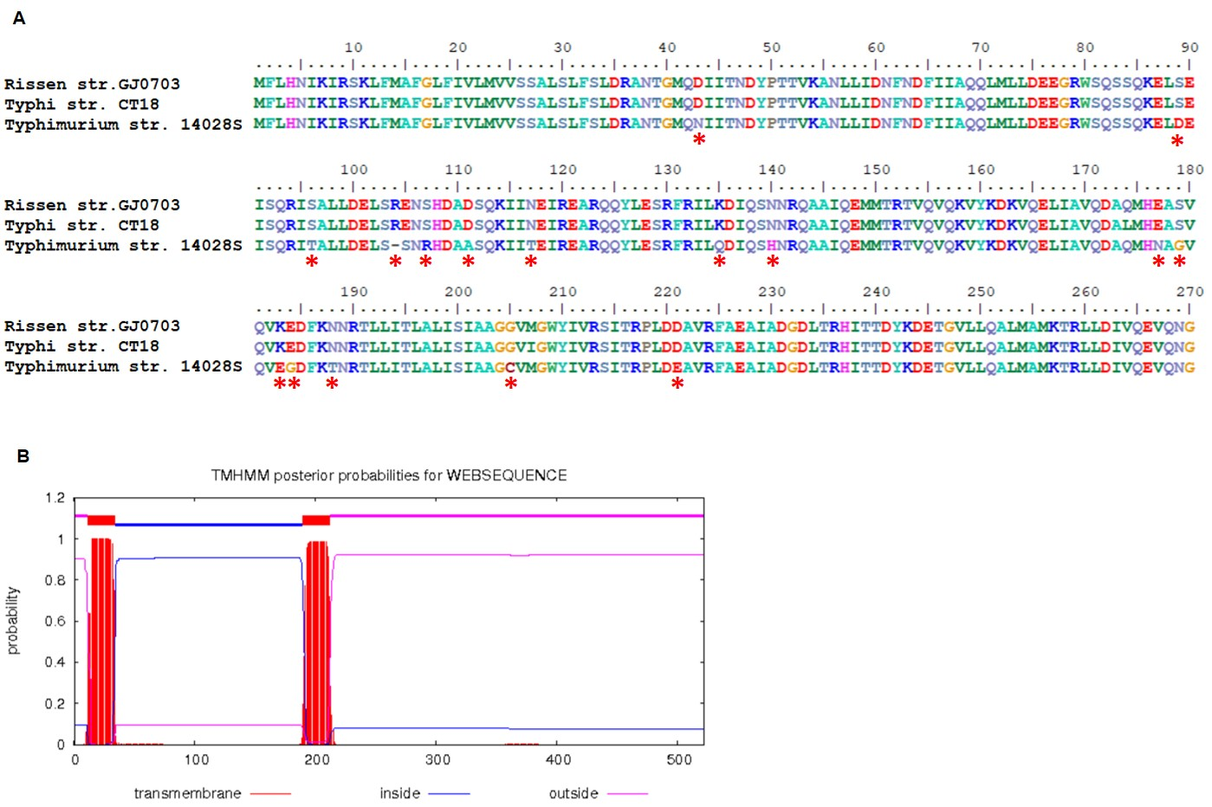

**Amino acid variation in McpC.** (A) Asterisks denote 16 amino acids variation in *S*. Rissen, S. Typhi and *S*. Typhimurium. The amino acid alignment was performed by BioEdit 7.0. (B) The prediction of transmembrane domains was performed resorting to Center for Biological Sequence analysis (http://www.cbs.dtu.dk/services/TMHMM/). There are 2 outside domains, 2 transmembrane domains and 1 inside domain. Most of the amino acid variations (14/16) locate in the inside domain, the ligand binding sites of McpC, as shown in the black box.

**Figure S4**

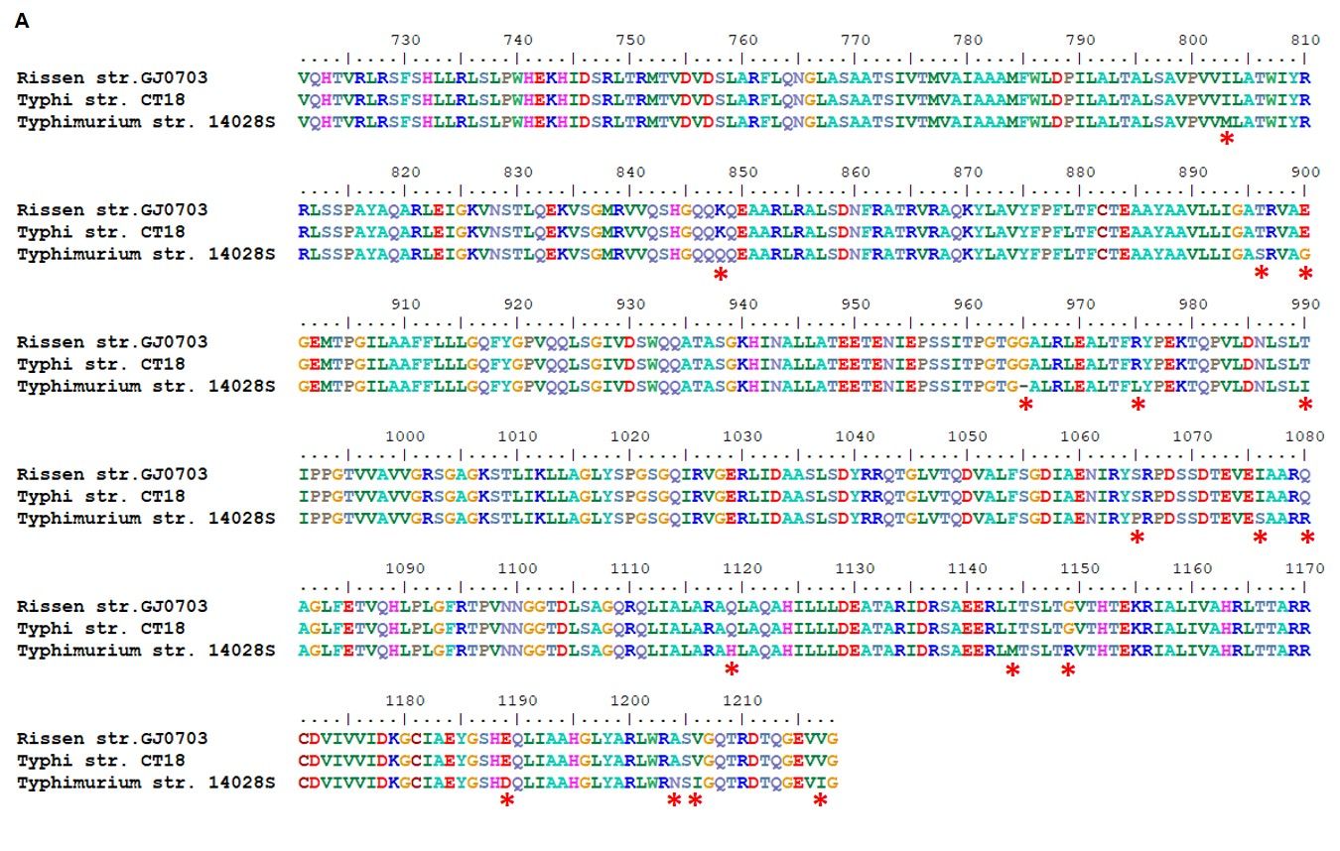

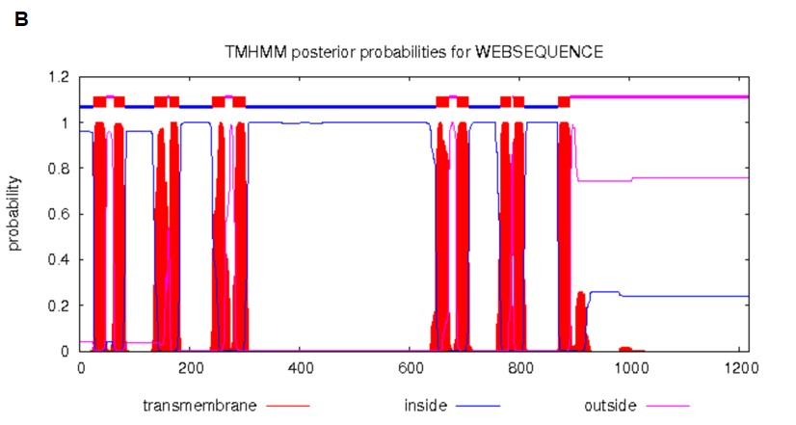

**Amino acid variation in IroC.** (A) Asterisks denote 15 amino acids variation in *S*. Rissen, S. Typhi and *S*. Typhimurium. The amino acid alignment was performed by BioEdit 7.0. (B) The prediction of transmembrane domains was performed resorting to Center for Biological Sequence analysis ([http://www.cbs.dtu.dk/ services/TMHMM/](http://www.cbs.dtu.dk/%20services/TMHMM/)). Most amino acid variations (13/15) concentrated at the C-terminal outside as shown in the black box.

**Figure S5**

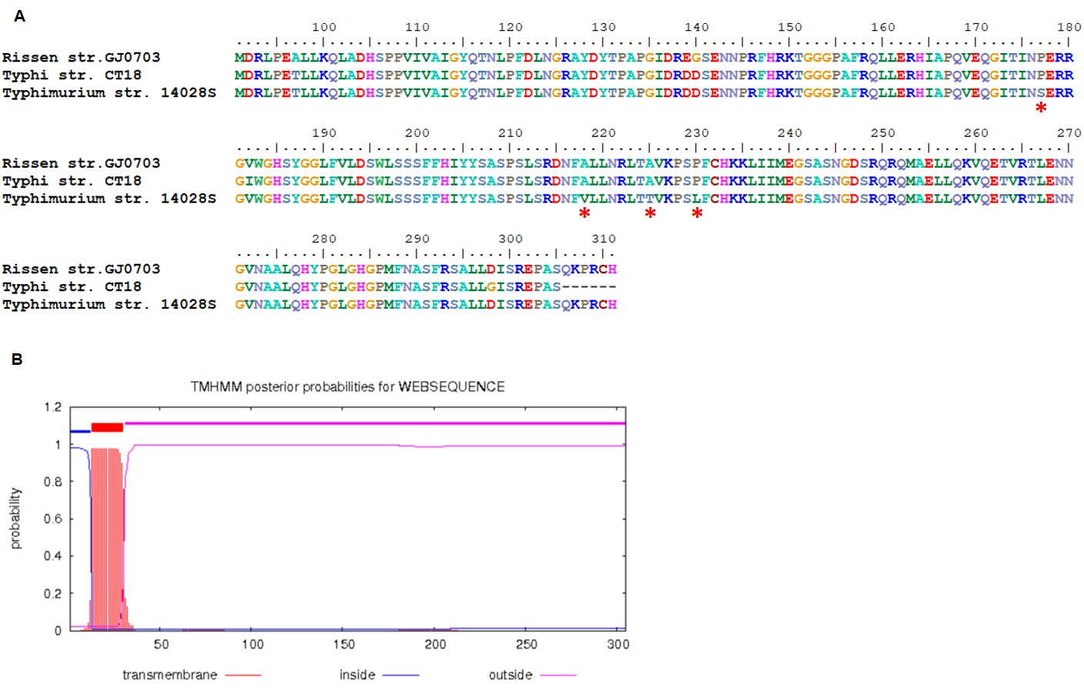

**Amino acid variation in IroE.** (A) Asterisks denote 4 amino acids variation in *S*. Rissen, S. Typhi and *S*. Typhimurium. The amino acid alignment was performed by BioEdit 7.0. (B) The prediction of transmembrane domains was performed resorting to Center for Biological Sequence analysis ([http://www.cbs.dtu.dk/ services/TMHMM/](http://www.cbs.dtu.dk/%20services/TMHMM/)). All the amino acid variations locate at the C-terminal outside domain and the enzyme active site of IroE were indicated in the figure.

**Figure S6**



**SPI-1 and SPI-2 of *S.* Rissen.** The SPI-1 (A) and SPI-2 (B) homologs of strain GJ0703 are both collinearly compared with the counterpart of genomes of Typhimurium LT2, Typhi CT18 and Typhimurium 14028S. The genes of mosaic SPI-1 and SPI-2 homologs identified in a variety of *Salmonella* genomes were color matching, and the similar gene organization of *Salmonella* pathogenicity islands carrying type III secretion system (T3SS) were characterized.

**Figure S7**

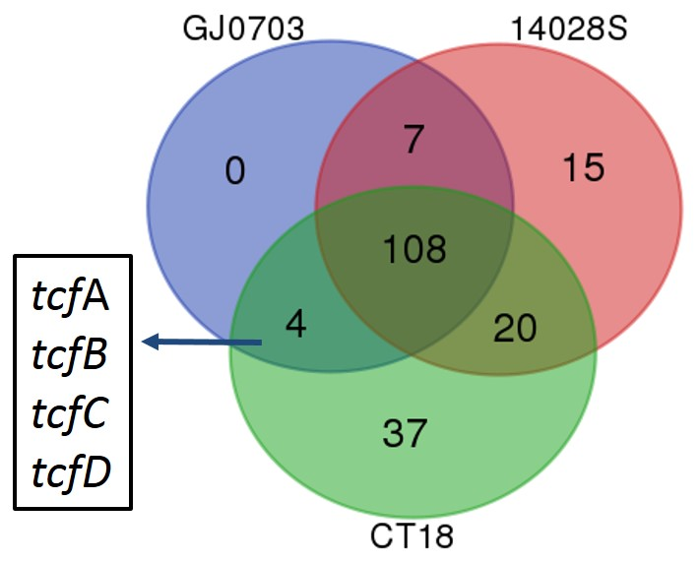

**Distribution of orthologous virulent factors in GJ0703, CT18 and strain 14028S.** The Venn diagram shows the identified virulence factor relationship amongst strains GJ0703, 14028S and CT18. Virulence factors were characterized by using BLASTp against the VFDB database with cut-offs identities >75%. Based on this scenario *tcf*A-D was identified as shared genes for strain CT18 and absent in strain 14028S.

**Figure S8**

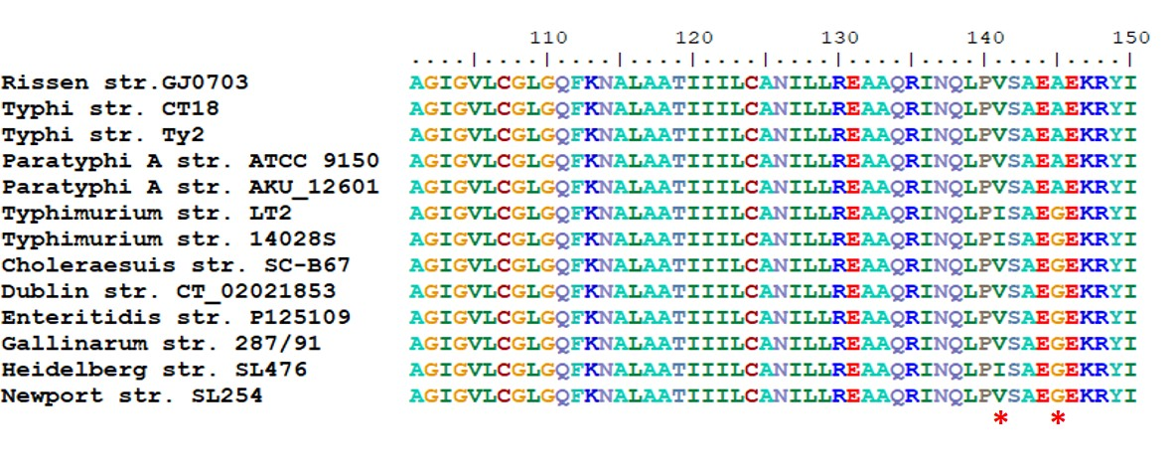

**Amino acid variation in MgtC.** Asterisks denote 141V and 145A in *S*. Rissen, S. Typhi and *S*. Paratyphi A. The amino acid alignment was performed with BioEdit 7.0.