SUPPLEMENTARY FIGURES AND TABLES

Dissecting adaptive traits with nested association mapping: Genetic architecture of inflorescence morphology in sorghum

Marcus O. Olatoye^{*,1}, Sandeep R. Marla*, Zhenbin Hu, Sophie Bouchet^{*,1}, Ramasamy Perumal*,†, and Geoffrey P. Morris^{*,3}

* Department of Agronomy, Kansas State University, Manhattan, Kansas 66506
† Kansas State University, Agricultural Research Center, Hays, Kansas 67601
¹ Current address: Department of Crop Science, University of Illinois at Urbana-Champaign, IL 61801
² Current address: GDEC, INRA, UBP, 63039, Clermont-Ferrand, France.
³ Corresponding author: gpmorris@k-state.edu
Table S1: The sorghum NAM founders, their origin, and number of RILs used for each family.

Founder | Origin | Founder Type | RILs
RTx430 | Texas A & M University | Common Parent | -
P898012 | Purdue University | Diverse Founder | 213
Ajabsido | Sudan | Diverse Founder | 214
Macia | ICRISAT | Diverse Founder | 231
SC1103 | Nigeria | Diverse Founder | 231
SC1345 | Mali | Diverse Founder | 231
SC265 | Burkina Faso | Diverse Founder | 232
SC283 | Tanzania | Diverse Founder | 223
SC35 | Ethiopia | Diverse Founder | 208
SC971 | Puerto Rico, United States | Diverse Founder | 233
Segaolane | Botswana | Diverse Founder | 204

Table S2: Within-family and across population additive effect size (AES) for QTL identified using joint linkage mapping with marker nested within family (NJL) and joint linkage with no nesting (JL).
Trait | Model | Number of QTL | Trait Mean (mm) | Range of WF-AES (mm) | Range of AP-AES (mm) | Range of PVE (%)
LBL | NJL | 14 | 85 | -30–16 | -4–2 | 0.1–2.0
LBL | JL | 21 | - | -26–19 | -12–8 | 0.6–5.0
UBL | NJL | 1 | 49 | - 29.0–0 | -4 | 3.0
UBL | JL | 17 | - | -33–5 | -11–2 | 0.6–4.0
RL | NJL | 16 | 276 | -44–52 | -10–12 | 0.1–3.0
RL | JL | 22 | - | -49.5–52 | -20–20 | 0.6–3.0
RD | NJL | 9 | 8 | -2.0–1 | -0.4–0.2 | 0.1–1.0
RD | JL | 21 | - | -2.4–1 | -0.9–1.5 | 0.2–1.0

ª Lower branch length (LBL), upper branch length (UBL), rachis length (RL), and rachis diameter (RD).
^{b} Quantitative trait loci (QTL).
^{c} Within Family Additive Effect Size (WF-AES), and Across Population Additive Effect Size (AP-AES).
^{d} Phenotypic Variation Explained (PVE).

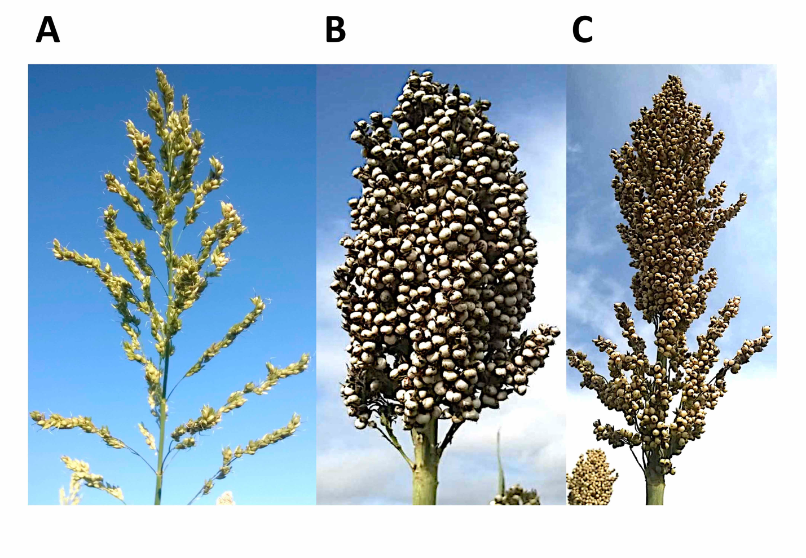
Figure S1: Examples of variation in sorghum inflorescence morphology.
(A) Open inflorescence morphology represented by SC1103 parent, (B) compact inflorescence morphology represented by Ajabsido parent, and (C) semi-compact inflorescence morphology as represented by RTx430 the common parent.
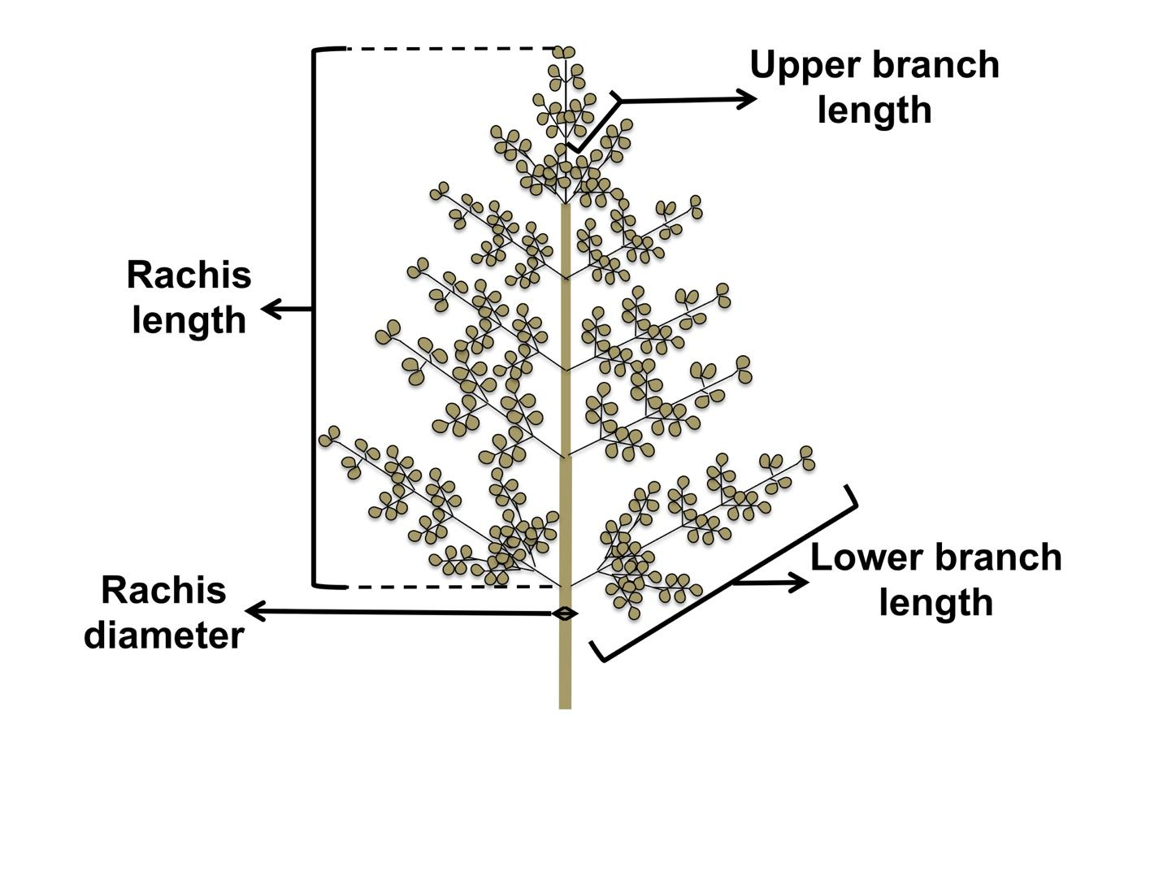
Figure S2: Sorghum inflorescence morphology traits.

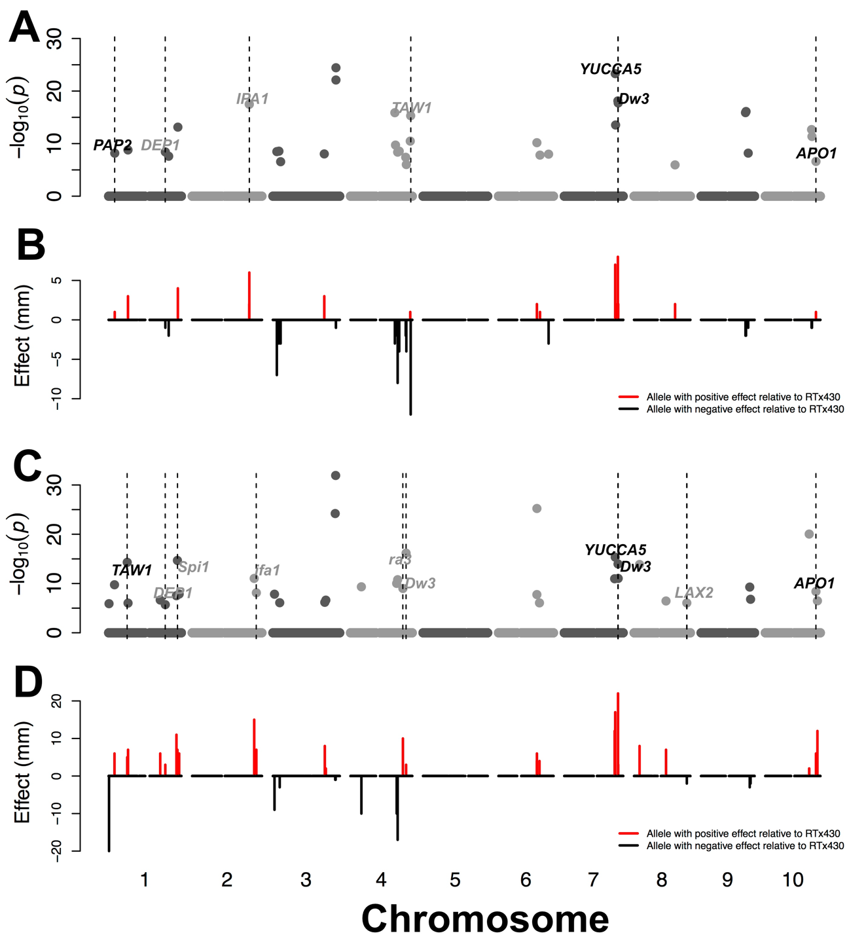
Figure S3: Details of joint linkage QTL mapping for lower branch length and rachis length.
Genome positions of loci and loci additive effect associated with lower branch length (A and B) and rachis length (C and D). A priori candidate genes that colocalize with QTL within 150 kb are noted. Black text indicates putative sorghum orthologs of a priori candidate genes while gray text indicates paralogs.

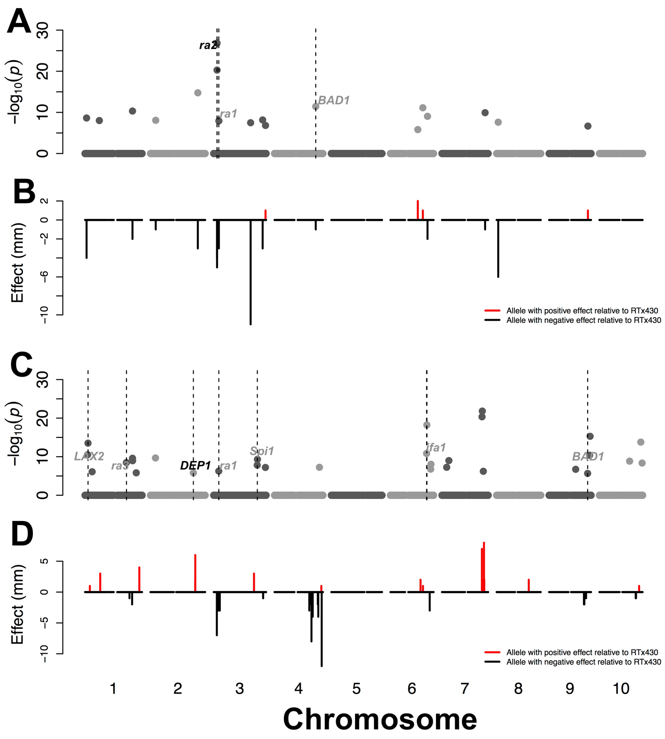

Figure S4: Details of joint linkage QTL mapping for upper branch length and rachis diameter.
Genome positions of loci and loci additive effect for upper branch length (A and B) and rachis diameter (C and D). A priori candidate genes that colocalize with QTL within 150 kb are noted. Black text indicates putative sorghum orthologs of a priori candidate genes while gray text indicates paralogs.

