Figure S1. Histogram of nuclei sizes generated from flow cytometry indicating different ploidy levels of various *Camelina* species

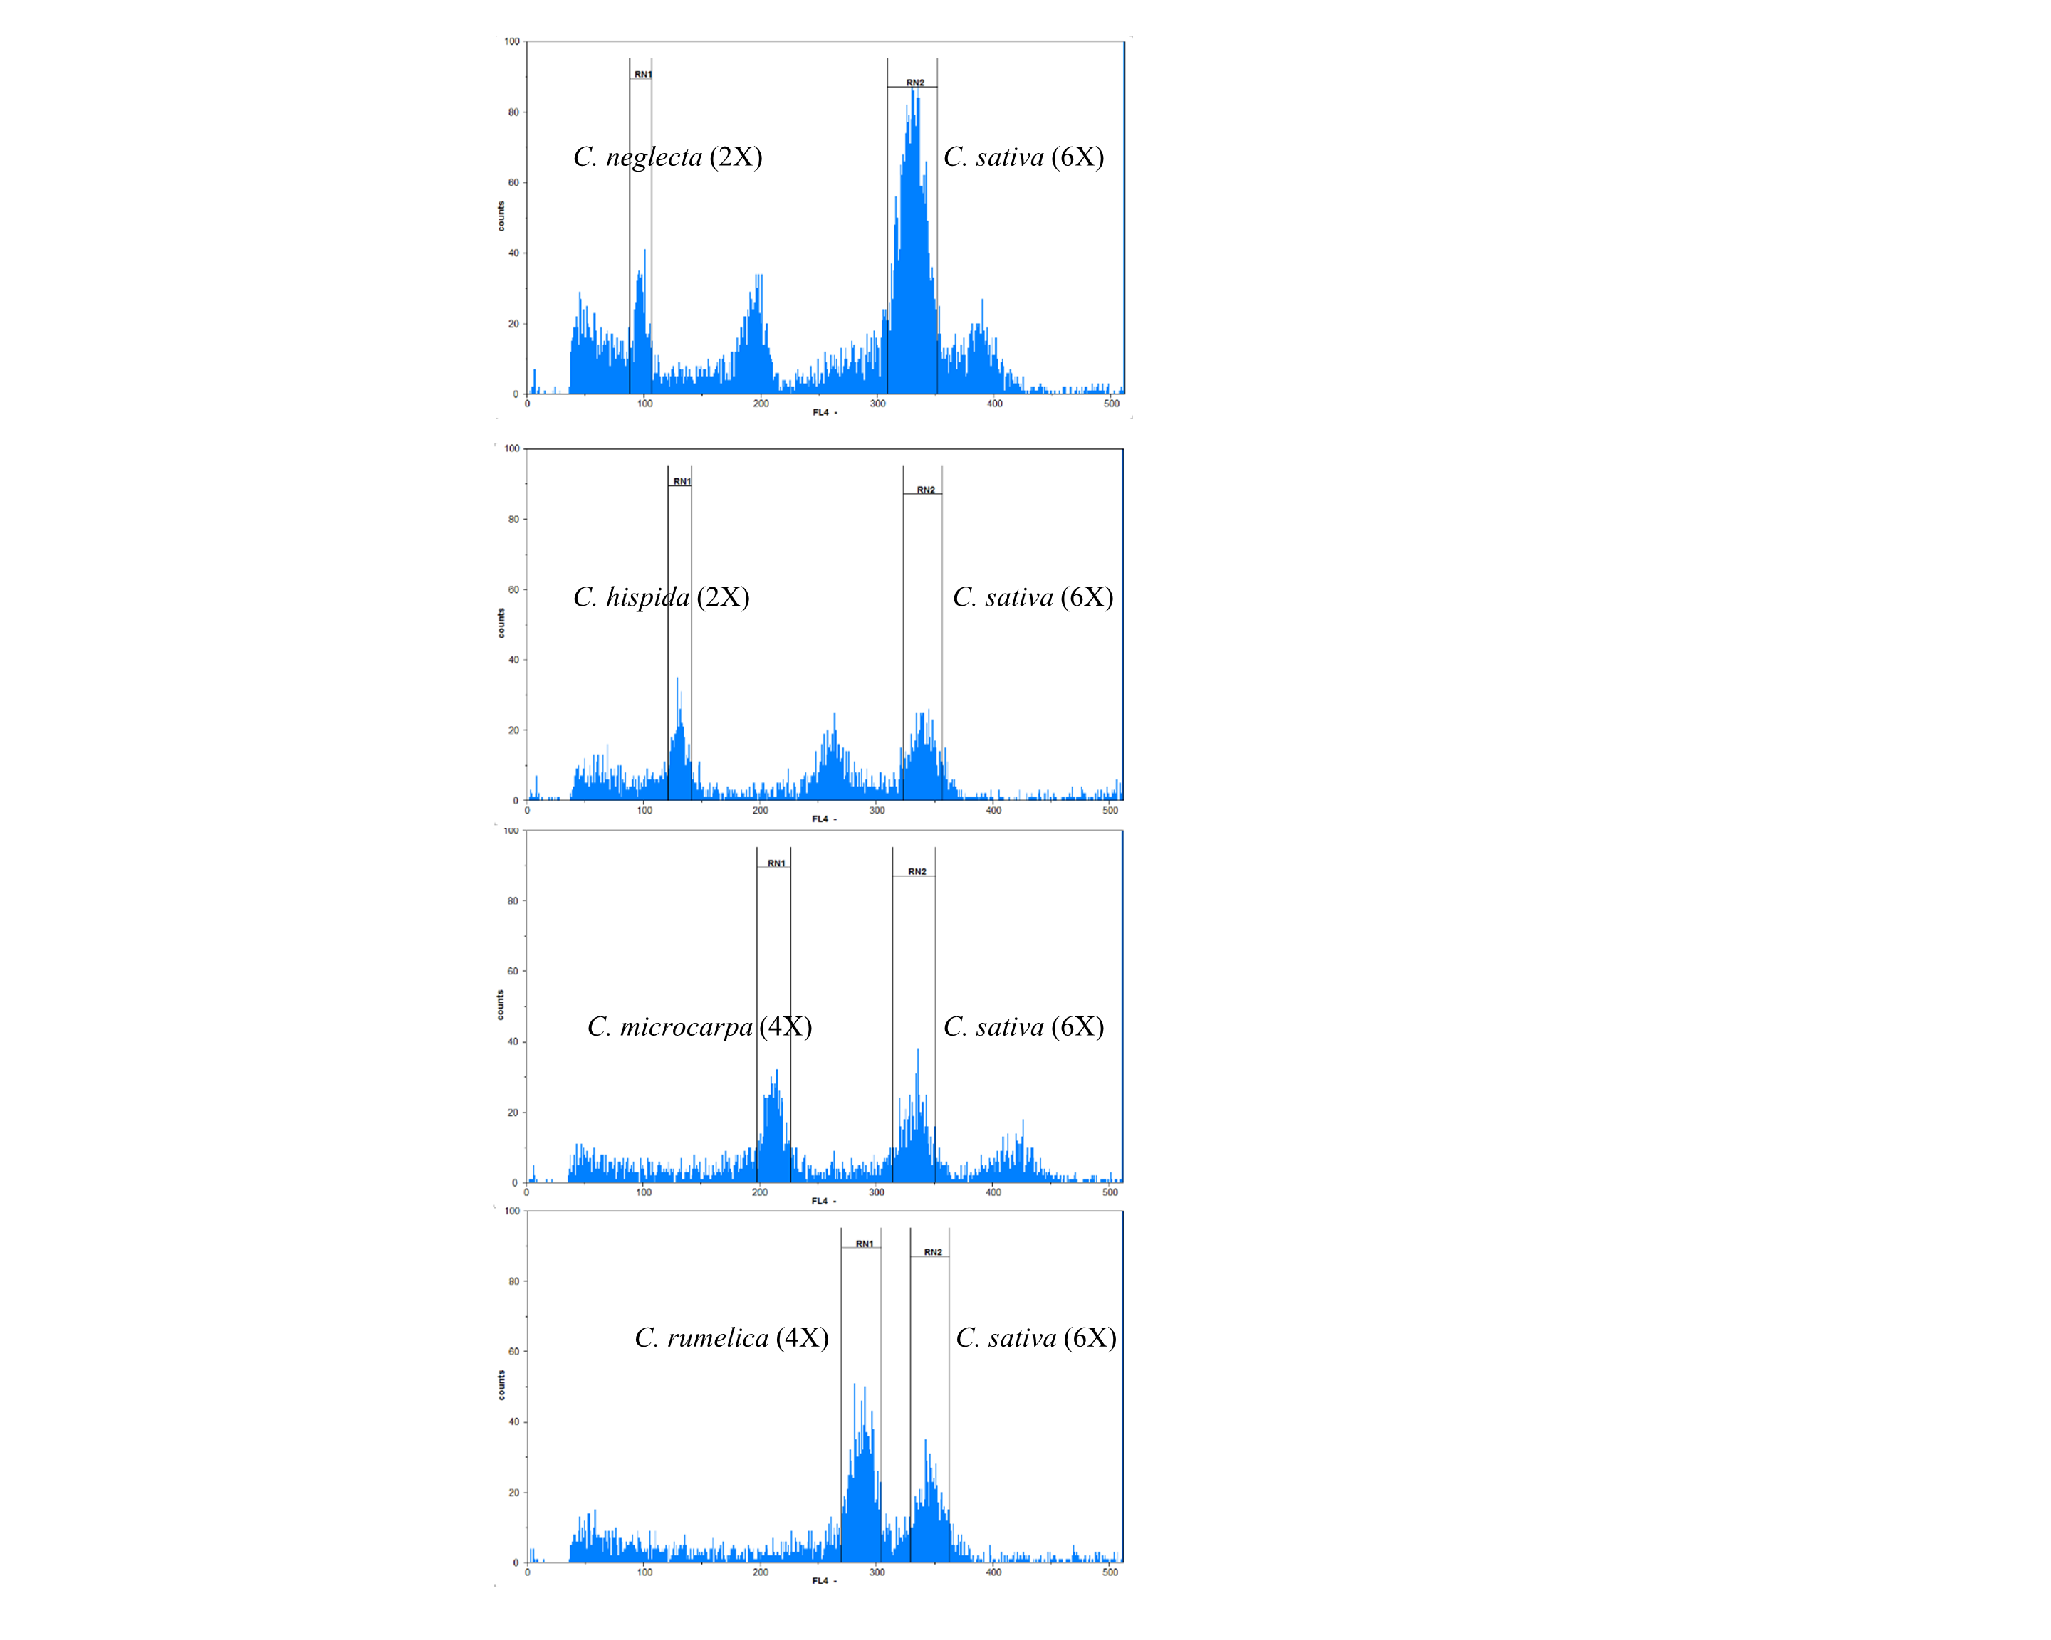

Figure S2. Number of SNPs including *indels* after filtering with 1% minor allele frequency and different level of missing percentage

### 

Figure S3. Principle coordinate analysis of 169 *Camelina* genotype with 20 chromosomes based on 1399 SNPs

C:\Users\chaudharyra\Desktop\Revision_CamelinaDiversity\RevisedFigures\PCoACs169.tif

Figure S4. DeltaK value to differentiate population structure in *Camelina* species with 20 chromosomes

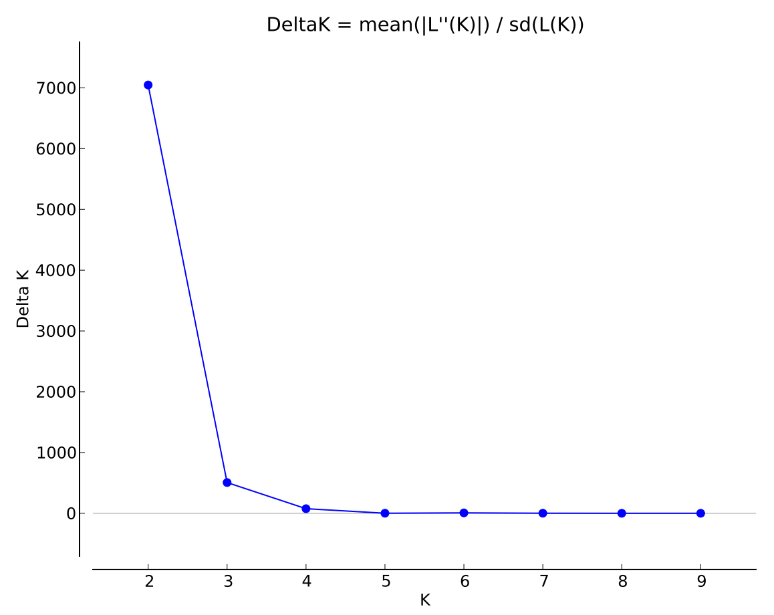

Figure S5. Molecular Phylogenetic analysis by Maximum Likelihood method among 193 *Camelina* accessions based on 4268 SNPs

