Supplementary File S8

Figure S1 – Growth and sugar utilization during serial inoculations of pooled culture during Experiment L1
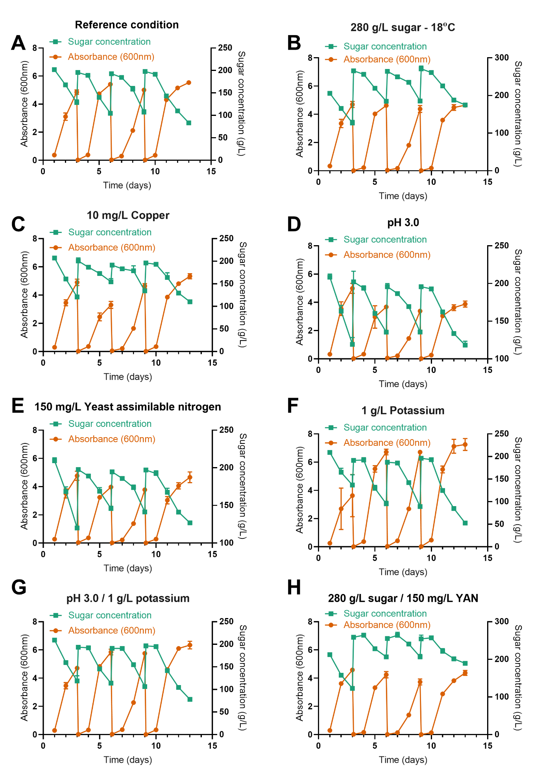

Figure S2 – Growth and sugar utilization during serial inoculations of pooled culture during Experiment L2
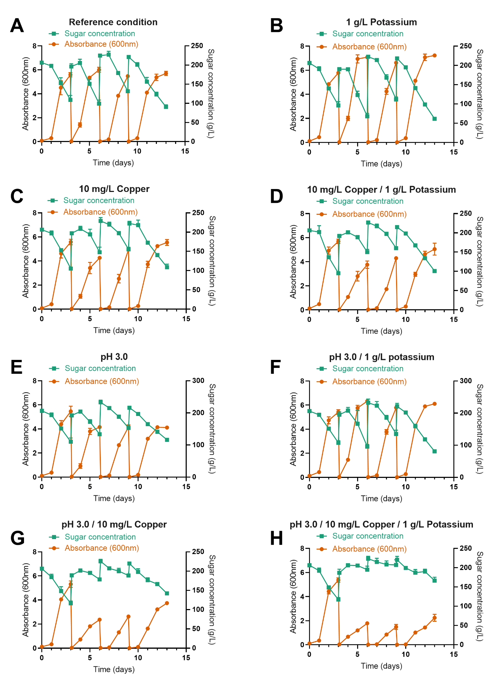

Figure S3 – Growth and sugar utilization during serial inoculations of pooled culture during Experiment L4
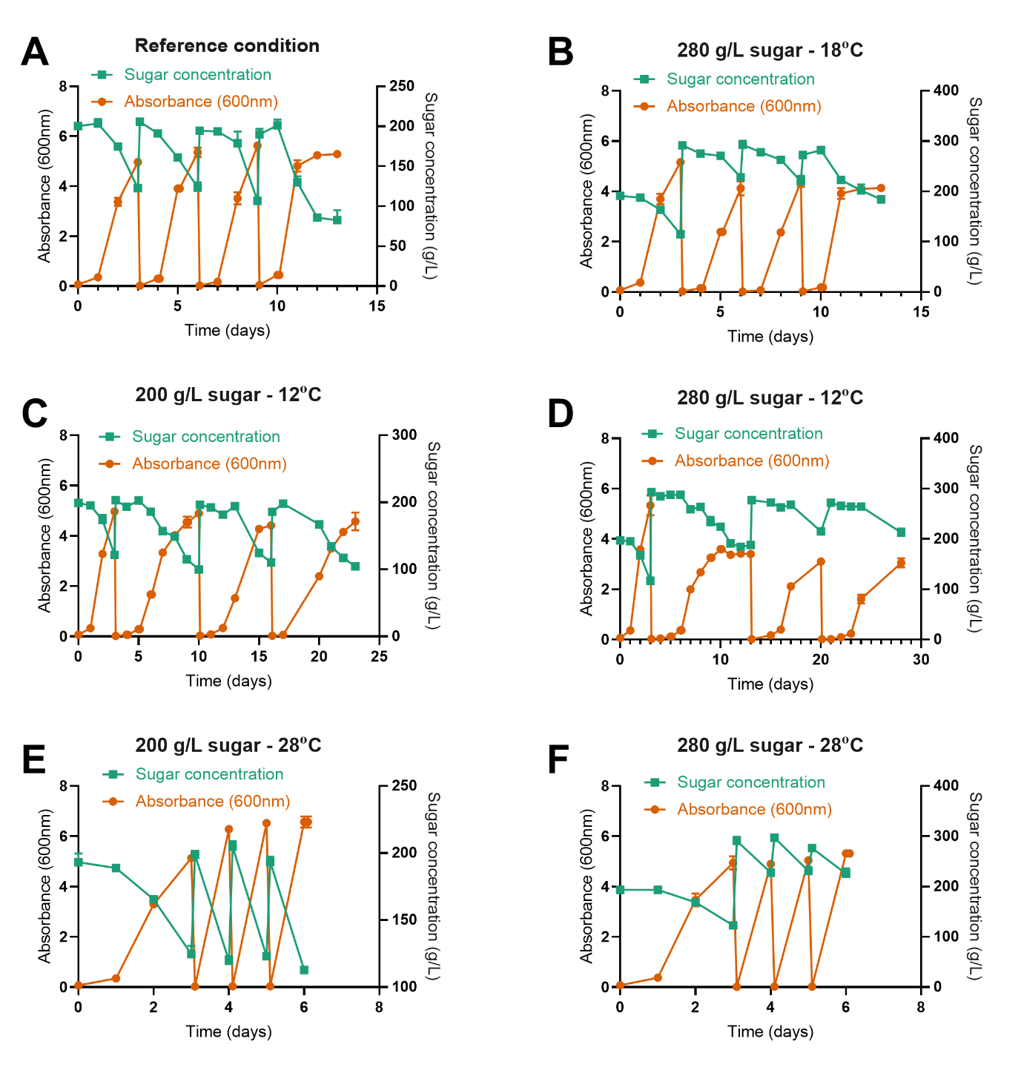

Figure S4 – Growth and sugar utilization during serial inoculations of pooled culture during Experiment L5
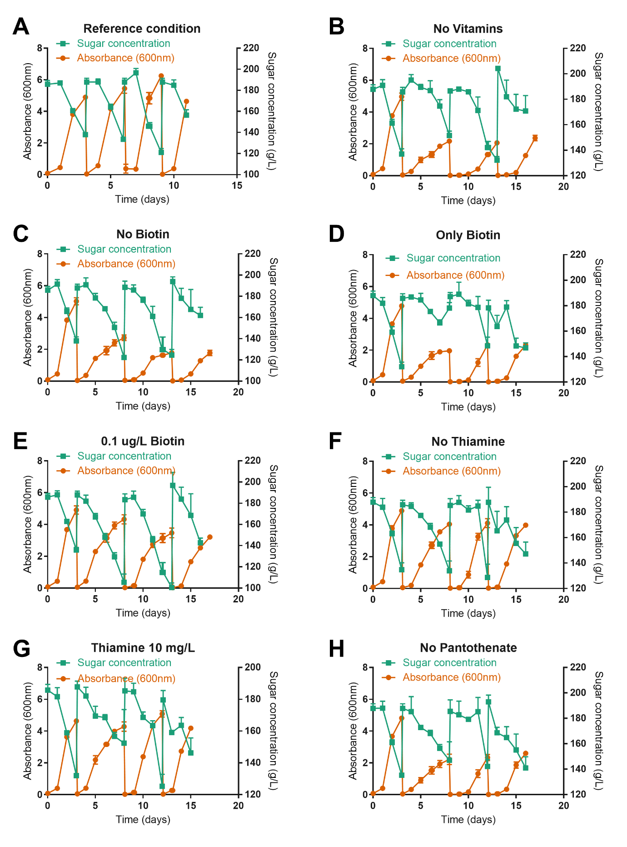

Figure S5 Growth and sugar utilization during serial inoculations of pooled culture during Experiment L6
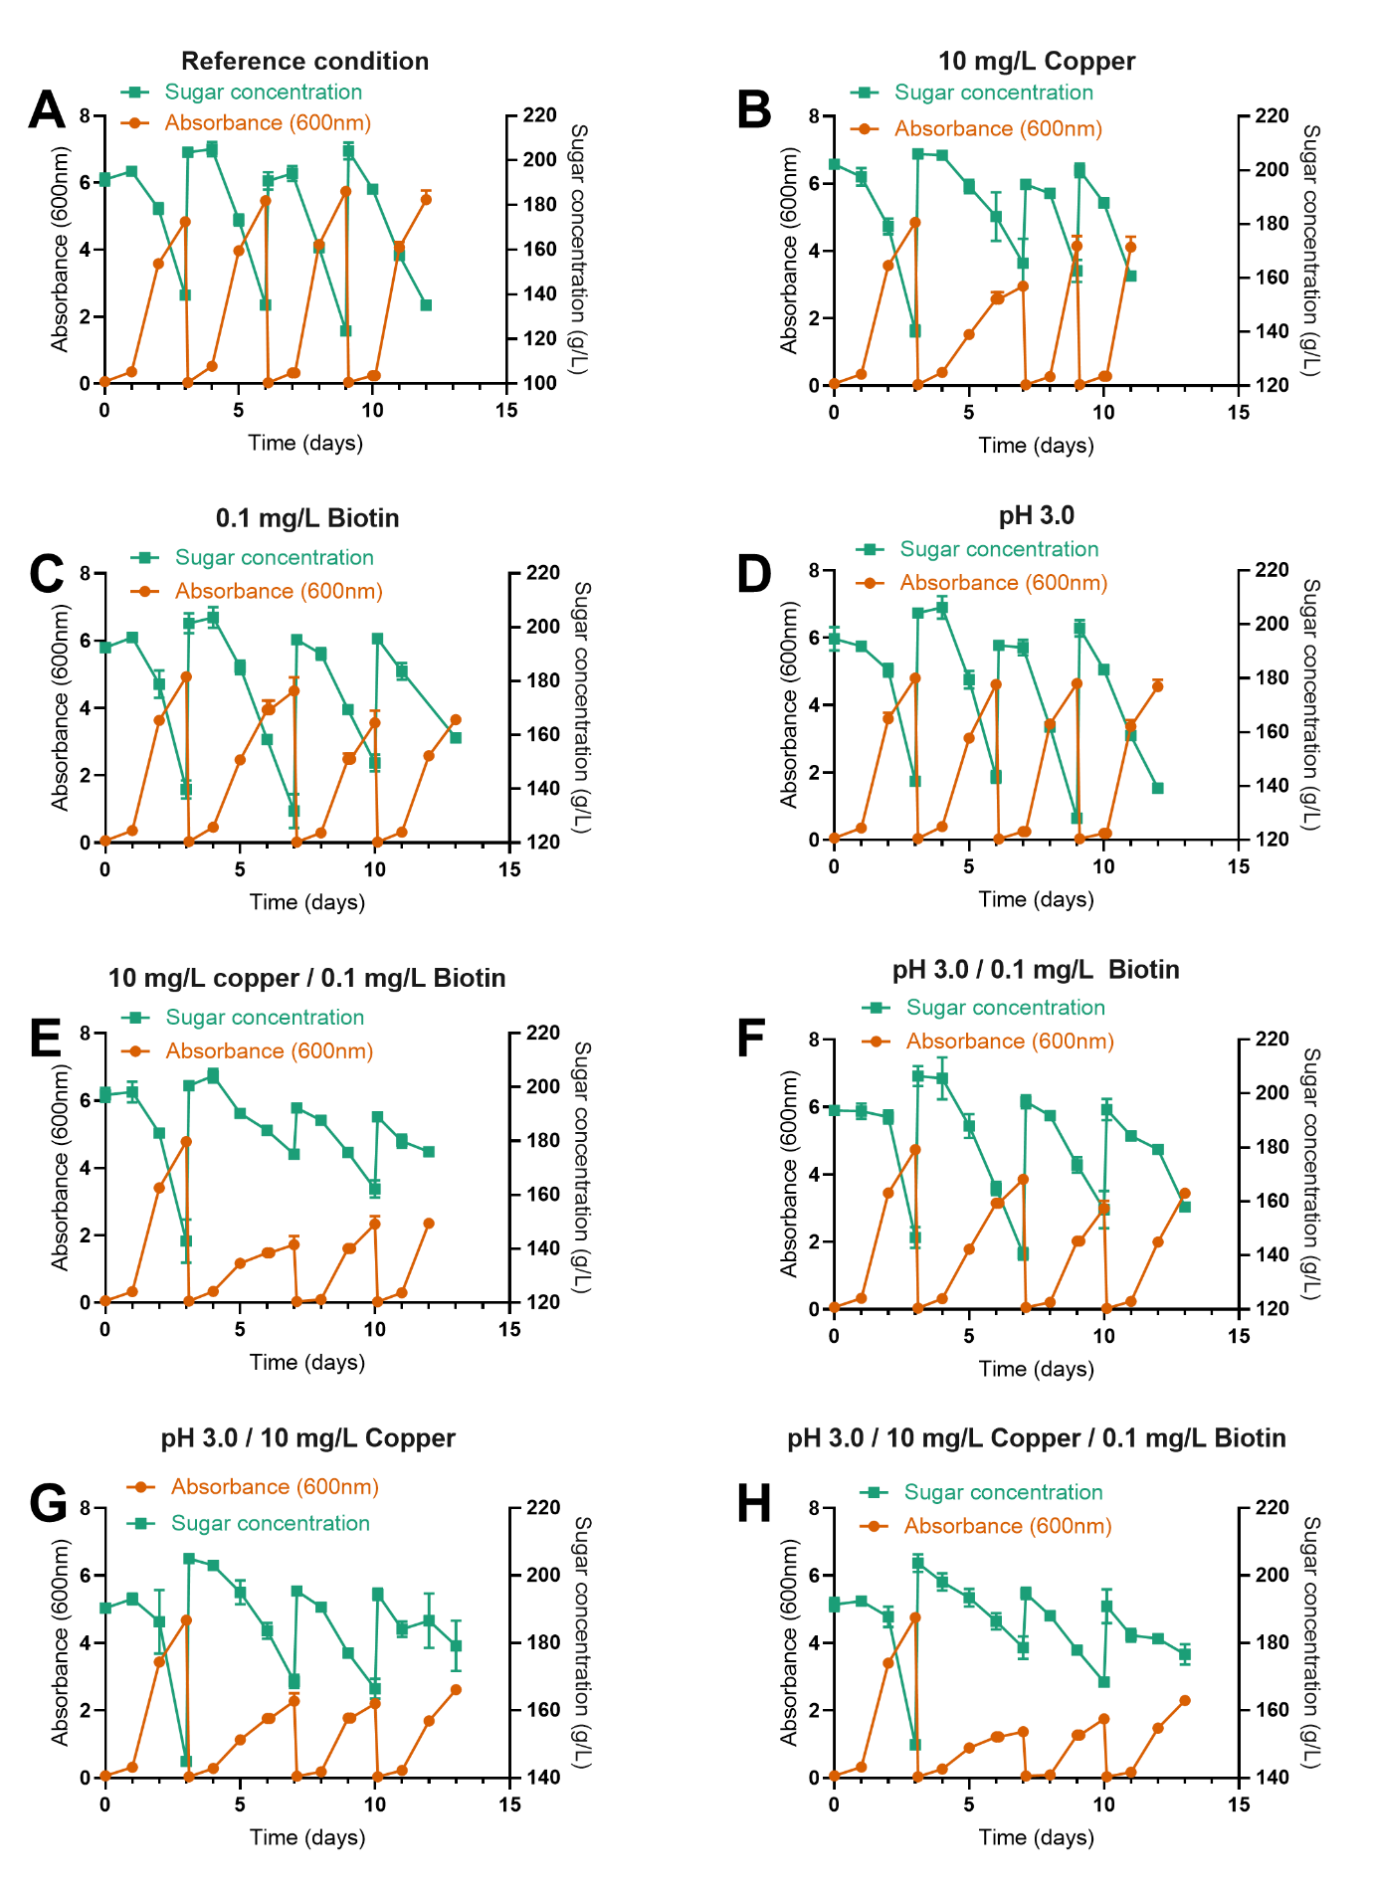

Figure S6 Growth and sugar utilization during serial inoculations of pooled culture during Experiment L7
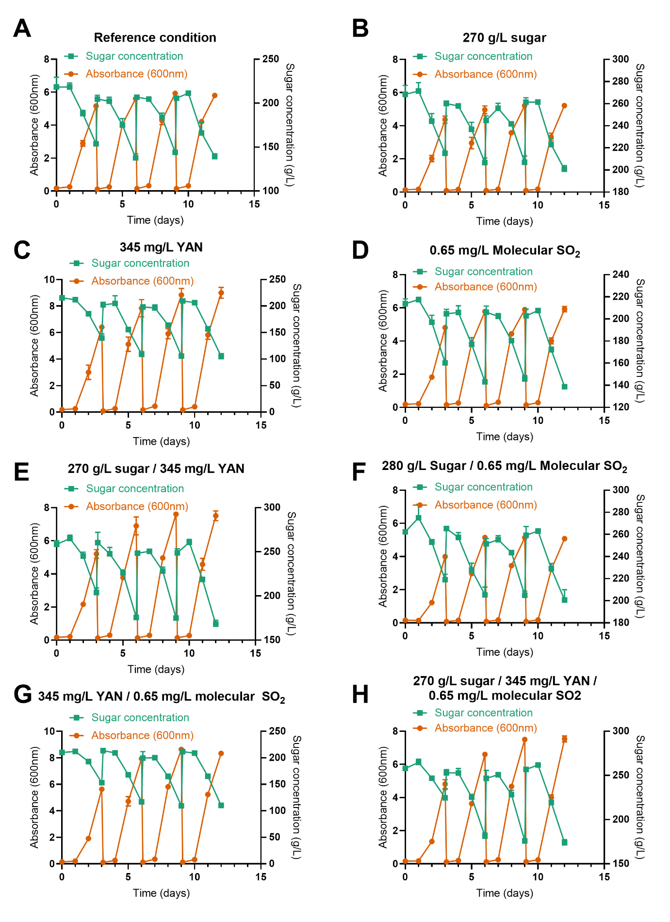

Figure S7 Growth and sugar utilization during serial inoculations of pooled culture during Experiment L8
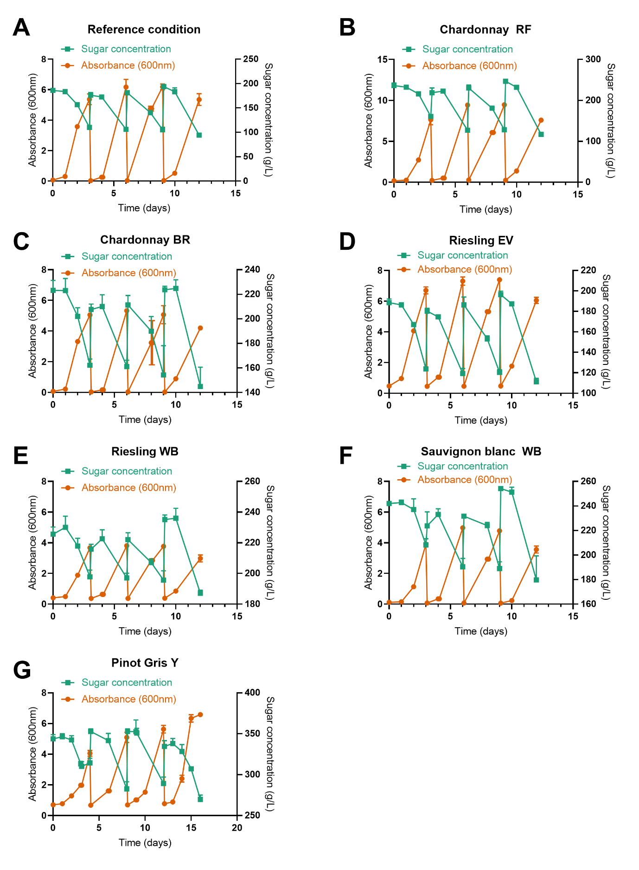

Figure S8 Growth and sugar utilization of selected strains during single inoculum fermentation of defined medium with high (10 mg/L) and low (0.035 mg/L) copper.
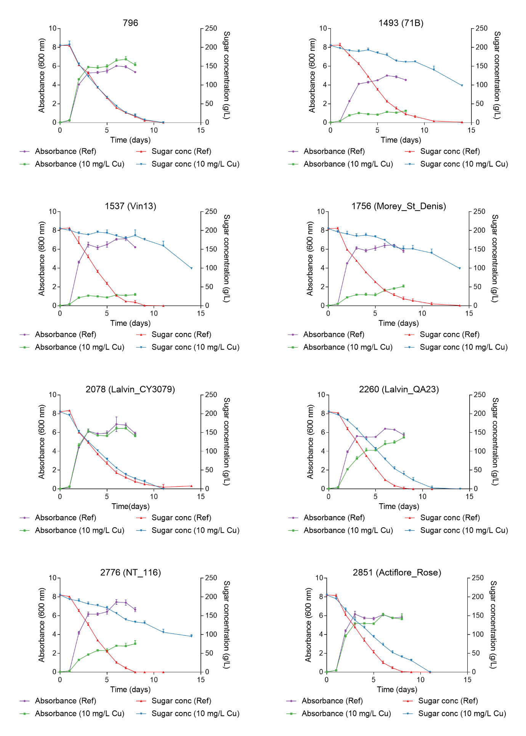

Figure S9 Relationship between absorbance and cell number for yeast strain EC1118 grown in defined medium.
A relationship between cell concentration and absorbance in defined medium was independently established using strain EC1118. Cell concentration was determined by plating and counting viable colony forming units. Absorbance was determined by at 600 nm in a DU 34 spectrophotometer (Beckman Coulter). If the absorbance value was greater than 0.5 the sample was diluted in defined medium such that the absorbance value was below 0.5. The absorbance value of the diluted sample was then multiplied by the dilution factor to give the final absorbance of the sample. The best fit regression is shown in red and asymmetrical confidence intervals are shown as dotted lines. The cell concentration (cells/ml) could be predicted from Abs (600nm, 1cm) using the following equation: Log10(cell number) = 1.011 x Log10(Abs 600nm) + 7.489, R² = 0.9943. Using this equation, cell concentrations were estimated to increase from ~ 5.9 x 10⁵ (cell conc min) to ~1.7 x 10⁸ (cell conc max) in the reference medium during a single growth phase (Abs600 0.02 to 5.42). The number of generations was calculated as follows: Log₂(cell conc max) – Log₂(cell conc min) = 8.17. Over two such cycles the number of generations is therefore = 16.

Figure S10 Correlation analysis of yeast strain fitness profiles in reference conditions.
Heat map showing changes in strain abundance (log2 fold change) between two time points during growth in media used as reference conditions (A). Fold change estimates are clustered by strain (Y-axis) and batch (X-axis). B) Exploratory analysis comparing strain performance between batches. Spearmans rank correlation coefficient (Corr) for each pair is provided in the upper figure, a pairwise dot plot in the lower figure and the distributions within each treatment by itself on the diagonal.

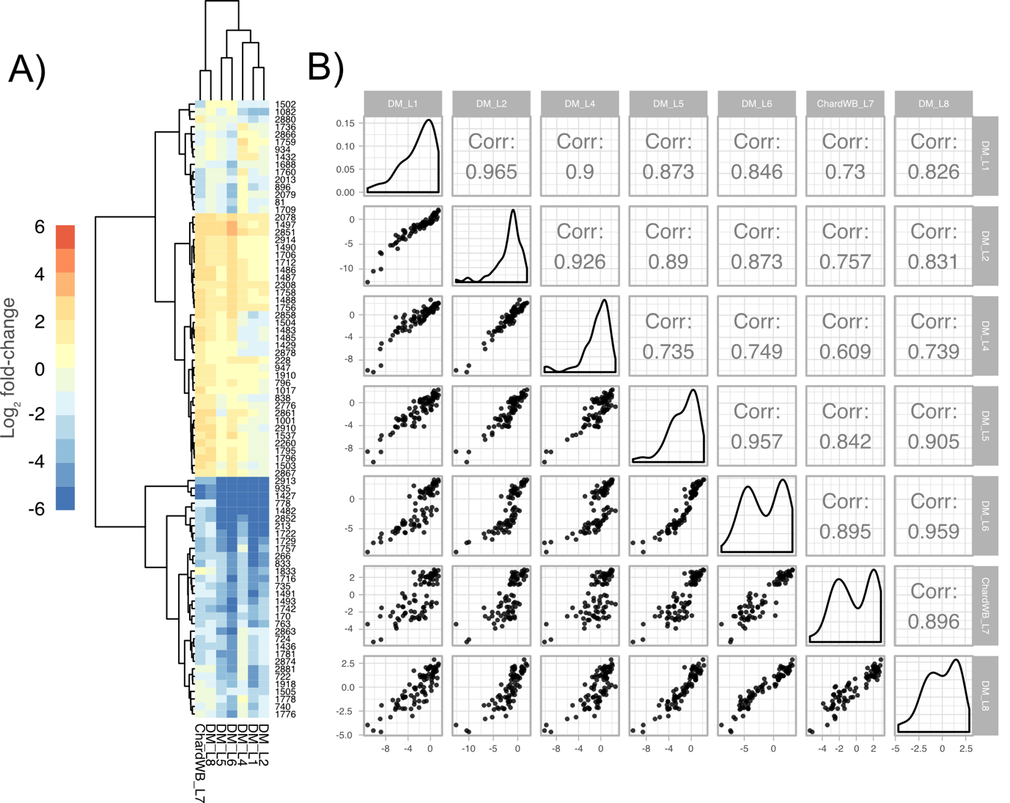

Figure S11 Multiple sequence alignment of each barcoded strain across the region into which the barcode was inserted.
The barcoded regions for each barcoded strain were amplified by PCR and sequenced (Sanger). Bases were called (Seqman Pro, DNASTAR) and consensus sequences for each strain aligned (AliView). Non-concordant bases are highlighted, and deletions are shown as a dash.
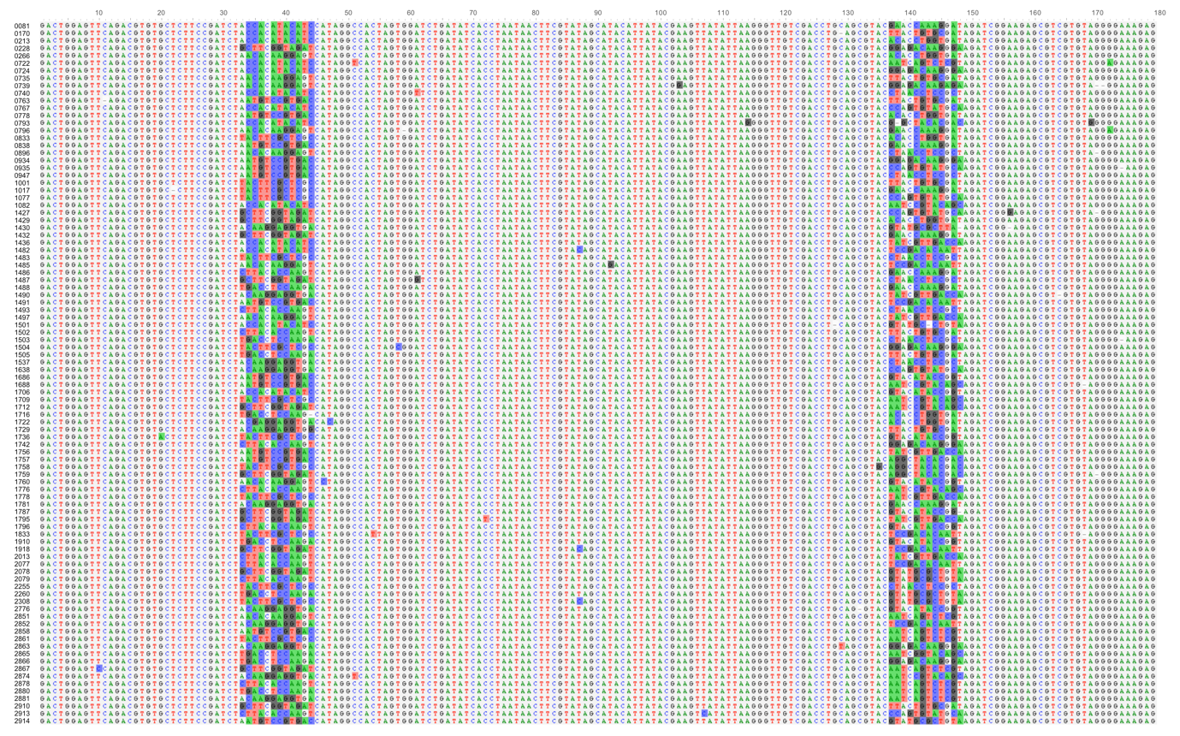

Figure S12 Comparison of absorbance (600nm) and cell number for subset of wine yeast strains.
A subset of wine yeast strains was chosen from those that were used to make up the wine yeast barcode pool. The strains were chosen based on whether their optical density at the time of producing the pool was equal to the mean absorbance ± 0.3 of all strains used to make up the pool. The mean normalized barcode counts obtained for these strains is shown in A. These wine yeast strains were grown overnight in YPD. The absorbance of the culture was recorded (600 nm) and compared to the cell concentration determined by hemocytometer count (B).
