SUPPLEMENTAL MATERIAL

Rapid degradation of C. elegans proteins at single-cell resolution with a synthetic auxin

Michael A. Q. Martinez*, Brian A. Kinney†, Taylor N. Medwig-Kinney*, Guinevere Ashley‡, James M. Ragle‡, Londen Johnson‡, Joseph Aguilera‡, Christopher M. Hammell†, Jordan D. Ward‡, David Q. Matus*

*Department of Biochemistry and Cell Biology, Stony Brook University, Stony Brook, NY 11794, USA.

†Cold Spring Harbor Laboratory, Cold Spring Harbor, NY 11724, USA.

‡Department of Molecular, Cell, and Developmental Biology, University of California-Santa Cruz, Santa Cruz, CA 95064, USA.

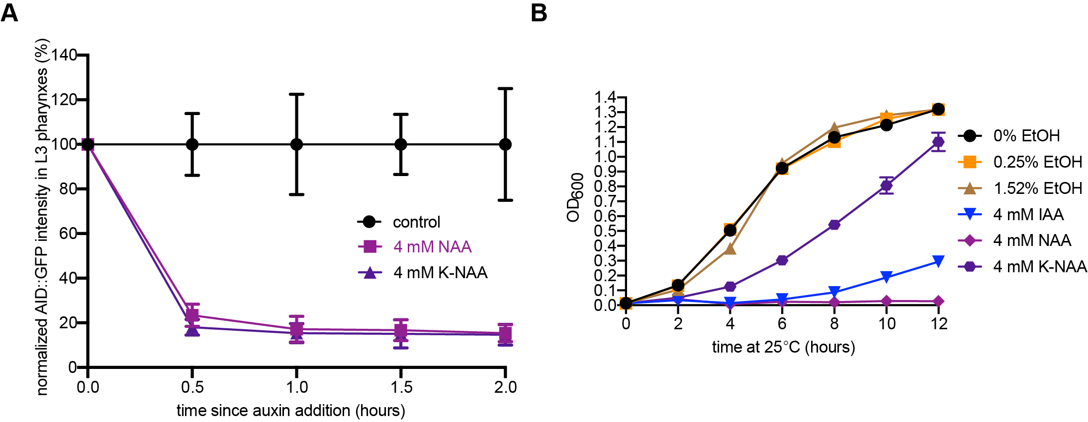

Figure S1. K-NAA degradation kinetics in the pharynx of L3 larvae and the effect of different auxins on bacterial growth. (A) Rates of degradation in a C. elegans-based microfluidics device were determined by quantifying AID::GFP levels in larval pharynxes following treatment with control, NAA, or K-NAA. Data presented as the mean±SD (n ≥ 4 animals examined for each time point). (B) OD₆₀₀ growth curves for E. coli OP50 exposed to different percentages of ethanol (0%, 0.25%, and 1.52%) and different forms of auxin (IAA, NAA, and K-NAA).
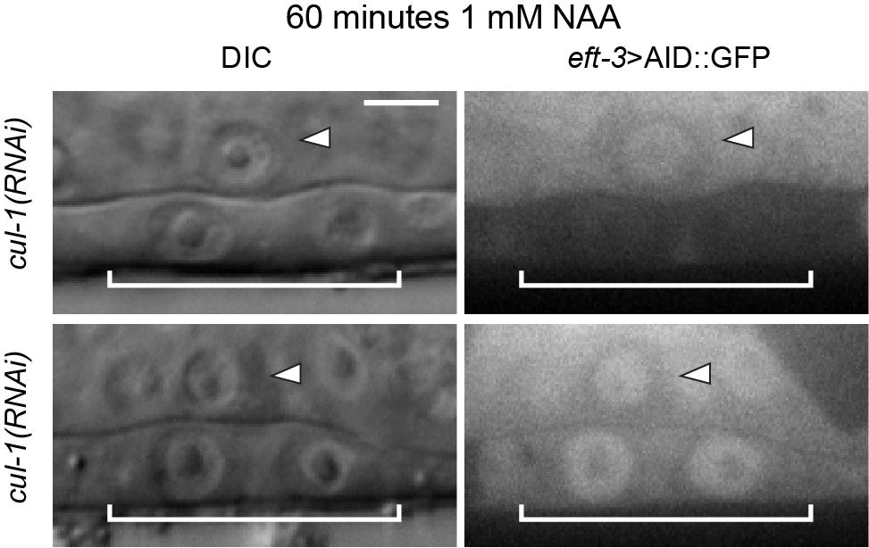

Figure S2. VPCs are variably sensitive to RNAi. DIC and corresponding GFP images of ACs (arrowheads) and underlying VPCs (brackets) from mid-L3 stage animals at the P6.p 2-cell stage, showing insensitivity to RNAi in the VPCs (top, right) as compared to sensitivity to RNAi (bottom, right). Synchronized L1 stage animals expressing eft-3>AID::GFP and eft-3>TIR1::mRuby were fed cul-1(RNAi) and treated with NAA at the P6.p 2-cell stage.

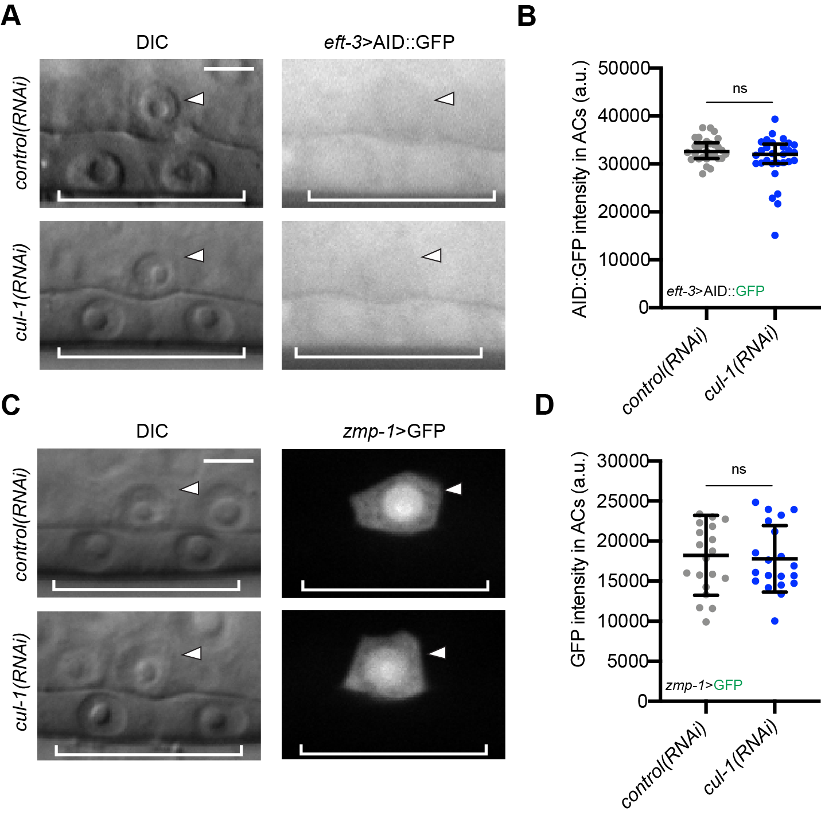
Figure S3. cul-1(RNAi) fails to increase the expression of AID-tagged transgenes in the absence of TIR1. (A) DIC and corresponding GFP images of ACs (arrowheads) and underlying VPCs (brackets) from mid-L3 stage animals at the P6.p 2-cell stage. Animals expressing eft-3>AID::GFP without TIR1::mRuby in the background were treated with cul-1(RNAi). (B) Quantification of AID::GFP in ACs. Data presented as the mean±IQR (n = 29 animals examined for each, and P = 0.1168 by a Mann Whitney U test). ns not significant. (C) DIC and corresponding GFP images of ACs (arrowheads) and underlying VPCs (brackets) from mid-L3 stage animals at the P6.p 2-cell stage. Animals expressing zmp-1>GFP without TIR1::mRuby were treated with cul-1(RNAi). (D) Quantification of GFP in ACs. Data presented as the mean±SD (n = 20 animals examined for each, and P = 0.7682 by a Student’s t-test). ns not significant.

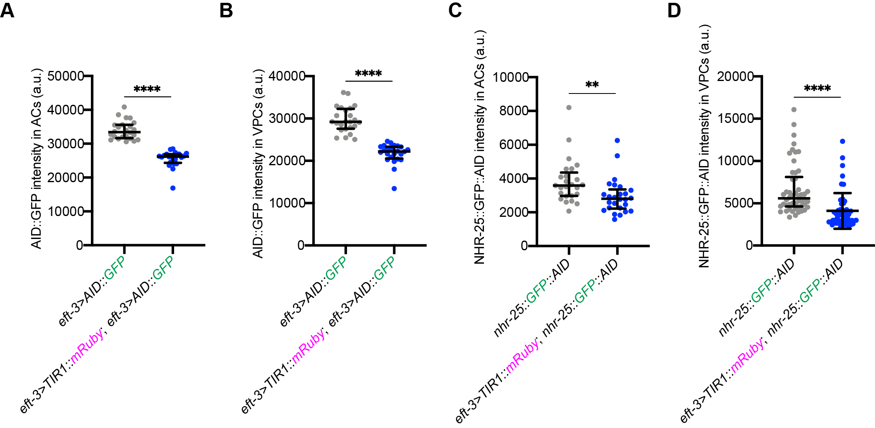

Figure S4. Auxin-independent degradation of AID::GFP and NHR-25::GFP::AID. (A, B) Quantification of AID::GFP in ACs (A) and VPCs (B) in a genetic background without and with TIR1::mRuby. Data presented as the median±IQR (n ≥ 24 animals examined for each, and P values by a Mann Whitney U test). **** P < 0.0001. (C, D) Quantification of NHR-25::GFP::AID in ACs (A) and VPCs (B) in a genetic background without and with TIR1::mRuby. Data presented as the median±IQR (n ≥ 25 animals examined for each, and P = 0.0022 and P < 0.0001, respectively by a Mann Whitney U test). ** P < 0.01, **** P < 0.0001.

