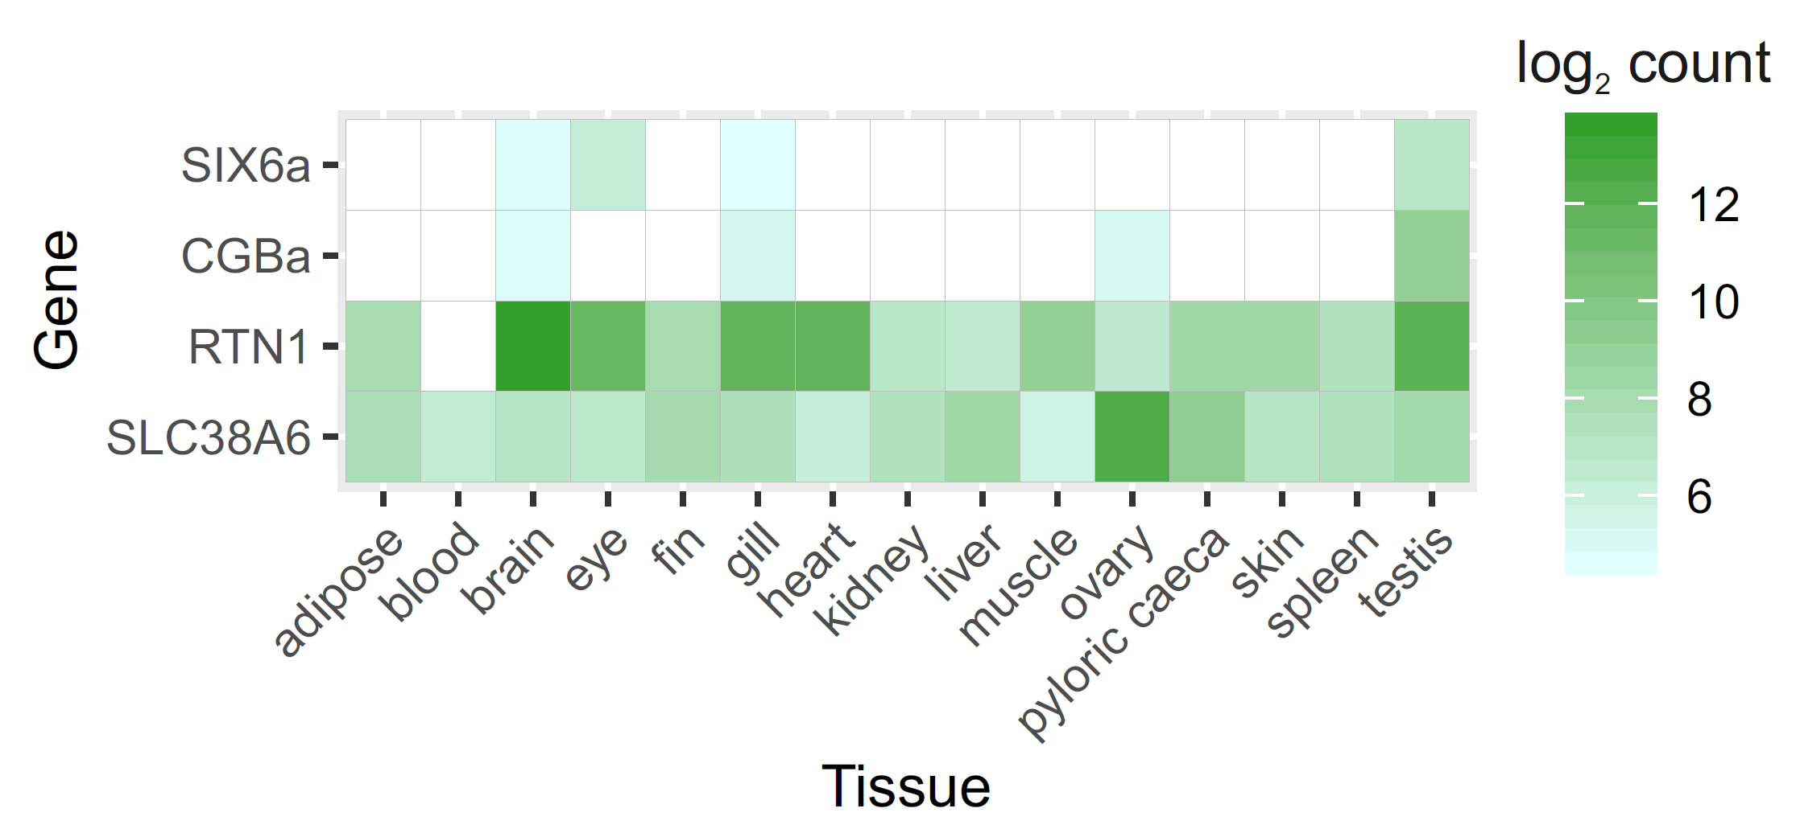

Figure S1. mRNA expression profiles of six6a-related genes in fifteen Atlantic salmon tissues. Six6a, cgba, rtn1 and slc38a6 expressed in 14 tissues of three-year old parr and blood of fry. The values were log₂-transformed and log₂(20) = 4.3 count was defined as a detection threshold below which values are shown in white. The data are represented as mean.

