**Suppl. Table S1.** Summary of RACA scaffold realignment after anchoring onto the genetic linkage map of *Oryzias melastigma*.

|  |  |  |  |
| --- | --- | --- | --- |
| **RACA Scaffold** | **Length (bp)** | **Chromosomes (Mainly involved)** | **Chromosome (partially involved)** |
| 1 | 24,725,727 | Om24 | Om08, Om01 |
| 2 | 19,886,060 | Om23 | Om08 |
| 3 | 2,342,937 | Om23 |  |
| 4 | 27,581,408 | Om22 | Om04 |
| 5 | 26,049,067 | Om21 |  |
| 6 | 2,873,080 | Om21 |  |
| 7 | 23,476,457 | Om20 |  |
| 8 | 1,709,687 | Om19 |  |
| 9 | 20,851,454 | Om19 |  |
| 10 | 23,351,003 | Om18 | Om17, Om13 |
| 11 | 20,354,890 | Om17 |  |
| 12 | 5,113,705 | Om17 |  |
| 13 | 6,052,185 | Om17 | Om07 |
| 14 | 6,452,966 | Om16 |  |
| 15 | 22,013,087 | Om16 |  |
| 16 | 28,699,589 | Om15 | Om17 |
| 17 | 27,038,434 | Om14 | Om10, Om02 |
| 18 | 1,226,830 | Om14 |  |
| 19 | 4,375,376 | Om13 | Om09 |
| 20 | 28,752,183 | Om13 | Om19, |
| 21 | 2,296,279 | Om12 |  |
| 22 | 23,737,187 | Om12 |  |
| 23 | 2,849,476 | Om11 |  |
| 24 | 16,714,535 | Om11 | Om13 |
| 25 | 6,170,691 | Om11 |  |
| 26 | 3,530,036 | Om10 |  |
| 27 | 22,715,576 | Om10 |  |
| 28 | 3,822,263 | Om09 | Om16, Om14, |
| 29 | 27,105,131 | Om09 |  |
| 30 | 23,749,461 | Om08 |  |
| 31 | 31,249,060 | Om07 | Om20, Om18, Om17, Om02 |
| 32 | 31,735,287 | Om06 | Om13 |
| 33 | 37,948,421 | Om05 | Om10, Om1, Om2 |
| 34 | 24,877,858 | Om04 | Om09, |
| 35 | 7,503,894 | Om04 | Om06 |
| 36 | 34,248,613 | Om03 | Om11, Om19, Om06 |
| 37 | 10,798,367 | Om02 | Om09, Om07 |
| 38 | 8,102,460 | Om02 | Om04, Om16 |
| 39 | 15,931,566 | Om01 | Om24, Om11 |
| 40 | 16,482,950 | Om01 |  |

**Suppl. Table S2.** Statistics of anchoring the RACA scaffolds to the genetic map using Chromonomer.

|  |  |  |
| --- | --- | --- |
| Statistics | Value |  |
| No. of scaffolds involved | 260 |  |
| No. of original scaffolds | 134 |  |
| Total length of reference genome | 779,469,774 |  |
| Length scaffolds in the map | 712,537,413 | (90.70%) |
| Length of integrated genome sequence | 787,032,520 | (90.70%) |
| Gap | 23,600 | (0.00%) |
| Length of scaffolds unplaced | 66,142,507 | (9.30%) |
| Total length | 778,703,520 | (99.90%) |

**Suppl. Table S3.** Number of genes annotated in LG-based scaffolds after anchoring process.

|  |  |  |
| --- | --- | --- |
| **Chr.** | **No. of Gene** | |
| Om01 | 1;024 |
| Om02 | 661 |
| Om03 | 1;071 |
| Om04 | 864 |
| Om05 | 1,059 |
| Om06 | 1;166 |
| Om07 | 1,213 |
| Om08 | 881 |
| Om09 | 1,216 |
| Om10 | 1;090 |
| Om11 | 937 |
| Om12 | 868 |
| Om13 | 1,124 |
| Om14 | 976 |
| Om15 | 982 |
| Om16 | 1,182 |
| Om17 | 1,059 |
| Om18 | 771 |
| Om19 | 854 |
| Om20 | 947 |
| Om21 | 1;021 |
| Om22 | 1;050 |
| Om23 | 732 |
| Om24 | 775 |
| Unanchored | 983 |
| Total | 24,506 | |

**Suppl. Table S4. LOD scores of two sex markers with others**

|  |  |  |  |  |  |  |  |  |
| --- | --- | --- | --- | --- | --- | --- | --- | --- |
| **Locus1** | **Locus2** | **RF** | **LOD** |  | **Locus1** | **Locus2** | **RF** | **LOD** |
| sex_zw | 16660 | 0.0000 | 7.42 |  | sex_xy | 17018 | 0.0000 | 17.06 |
| sex_zw | 16661 | 0.0000 | 7.08 |  | sex_xy | 17040 | 0.0000 | 16.72 |
| sex_zw | 17899 | 0.7826 | 1.79 |  | sex_xy | 17094 | 0.0702 | 11.95 |
| sex_zw | 17910 | 0.7308 | 1.37 |  | sex_xy | 17048 | 0.0577 | 11.4 |
| sex_zw | 17873 | 0.7037 | 1.1 |  | sex_xy | 16858 | 0.0702 | 11.03 |
| sex_zw | 17909 | 0.6774 | 0.92 |  | sex_xy | 18471 | 0.0702 | 10.89 |
| sex_zw | 16549 | 0.6875 | 0.83 |  | sex_xy | 16943 | 0.0566 | 10.87 |
| sex_zw | 16564 | 0.697 | 0.67 |  | sex_xy | 16992 | 0.0714 | 10.47 |
| sex_zw | 16658 | 0.6875 | 0.66 |  | sex_xy | 16660 | 0.0000 | 7.42 |
| sex_zw | 50559 | 0.697 | 0.63 |  | sex_xy | 16661 | 0.0000 | 7.08 |
| sex_zw | 18473 | 0.6875 | 0.61 |  |  |  |  |  |
| sex_zw | 16730 | 0.6774 | 0.57 |  |  |  |  |  |
| sex_zw | 50622 | 0.6774 | 0.55 |  |  |  |  |  |
| sex_zw | 50613 | 0.6875 | 0.52 |  |  |  |  |  |
| sex_zw | 50623 | 0.6667 | 0.48 |  |  |  |  |  |
| sex_zw | 50604 | 0.6875 | 0.47 |  |  |  |  |  |
| sex_zw | 17898 | 0.6538 | 0.36 |  |  |  |  |  |
| sex_zw | 18141 | 0.6563 | 0.31 |  |  |  |  |  |
| sex_zw | 18540 | 0.6563 | 0.31 |  |  |  |  |  |
| sex_zw | 50639 | 0.6452 | 0.21 |  |  |  |  |  |

**Suppl. Table S5**. Marker information significantly associated with sex in the linkage groups of Oryzias melastigma. Genome-wide tresholds of significans is 5.3 of LOD.

|  |  |  |  |  |  |  |  |  |  |  |  |  |
| --- | --- | --- | --- | --- | --- | --- | --- | --- | --- | --- | --- | --- |
| **LG-based scaffolds** | **Position (cM)** | **Locus** | **RACA scaffolds** | **LOD** | **% Expl.** |  | **LG-based scaffolds** | **Position (cM)** | **Locus** | **RACA scaffolds** | **LOD** | **% Expl.** |
| Om10 | 24.295 | 17040 | RACA27 | 34.99 | 93.8 |  | Om10 | 10.151 | 65834 | sc00206 | 7.99 | 47 |
| Om10 | 24.35 | 17018 | RACA27 | 34.98 | 93.8 |  | Om10 | 10.127 | 66725 | sc00239 | 7.98 | 46.9 |
| Om10 | 24.444 | 16718 | RACA27 | 29.07 | 90.1 |  | Om10 | 10.923 | 17164 | RACA27 | 7.94 | 46.8 |
| Om10 | 24.598 | 17048 | RACA27 | 17.78 | 75.6 |  | Om10 | 10.923 | 17198 | RACA27 | 7.94 | 46.8 |
| Om10 | 24.598 | 54652 | RACA17 | 17.78 | 75.6 |  | Om10 | 11.272 | 17179 | RACA27 | 7.94 | 46.7 |
| Om10 | 29.537 | 16660 | RACA27 | 16.87 | 73.8 |  | Om10 | 42.647 | 18421 | RACA27 | 7.77 | 46.1 |
| Om10 | 34.479 | 18471 | RACA27 | 15.97 | 71.9 |  | Om10 | 43.147 | 18427 | RACA27 | 7.77 | 46.1 |
| Om10 | 28.853 | 16858 | RACA27 | 15 | 69.6 |  | Om10 | 9.876 | 63956 | sc00152 | 7.73 | 45.9 |
| Om10 | 29.172 | 16943 | RACA27 | 14.89 | 69.3 |  | Om10 | 17.731 | 17731 | RACA27 | 7.66 | 45.6 |
| Om10 | 21.674 | 17240 | RACA27 | 14.55 | 68.5 |  | Om10 | 20.397 | 17304 | RACA27 | 7.65 | 45.5 |
| Om10 | 27.978 | 16992 | RACA27 | 14.09 | 67.3 |  | Om10 | 20.298 | 17268 | RACA27 | 7.3 | 44 |
| Om10 | 28.085 | 16980 | RACA27 | 13.48 | 65.7 |  | Om10 | 39.262 | 18400 | RACA27 | 6.92 | 42.3 |
| Om10 | 35.436 | 18313 | RACA27 | 13.16 | 64.8 |  | Om10 | 7.119 | 17664 | RACA27 | 6.82 | 41.8 |
| Om10 | 26.312 | 16866 | RACA27 | 12.62 | 63.3 |  | Om10 | 15.626 | 17378 | RACA27 | 6.78 | 41.6 |
| Om10 | 25.566 | 16993 | RACA27 | 12.55 | 63.1 |  | Om10 | 15.623 | 17420 | RACA27 | 6.76 | 41.5 |
| Om10 | 37.047 | 16522 | RACA27 | 11.76 | 60.7 |  | Om10 | 6.973 | 17796 | RACA27 | 6.61 | 40.9 |
| Om10 | 36.076 | 18285 | RACA27 | 11.65 | 60.4 |  | Om10 | 17.097 | 63076 | RACA33 | 6.56 | 40.6 |
| Om10 | 14.158 | 17207 | RACA27 | 11.45 | 59.7 |  | Om10 | 41.246 | 18271 | RACA27 | 6.44 | 40 |
| Om10 | 31.352 | 16853 | RACA27 | 11.35 | 59.4 |  | Om10 | 41.25 | 18279 | RACA27 | 6.44 | 40 |
| Om10 | 13.642 | 66750 | sc00239 | 11.04 | 58.4 |  | Om10 | 41.389 | 18372 | RACA27 | 6.44 | 40 |
| Om10 | 35.87 | 16573 | RACA27 | 10.8 | 57.6 |  | Om10 | 8.808 | 17802 | RACA27 | 6.34 | 39.5 |
| Om10 | 38.473 | 18453 | RACA27 | 9.43 | 52.7 |  | Om10 | 9.038 | 17624 | RACA27 | 6.31 | 39.4 |
| Om10 | 20.703 | 17286 | RACA27 | 8.94 | 50.8 |  | Om10 | 16.44 | 17647 | RACA27 | 6.18 | 38.8 |
| Om10 | 14.697 | 17688 | RACA27 | 8.92 | 50.7 |  | Om10 | 15.913 | 17423 | RACA27 | 6.02 | 38 |
| Om10 | 11.926 | 17384 | RACA27 | 8.83 | 50.4 |  | Om10 | 15.919 | 17443 | RACA27 | 5.93 | 37.6 |
| Om10 | 12.109 | 17182 | RACA27 | 8.83 | 50.4 |  | Om10 | 44.315 | 18106 | RACA27 | 5.88 | 37.3 |
| Om10 | 41.475 | 18441 | RACA27 | 8.82 | 50.4 |  | Om10 | 16.105 | 17571 | RACA27 | 5.58 | 35.8 |
| Om10 | 19.069 | 17190 | RACA27 | 8.27 | 48.2 |  | Om10 | 16.699 | 17558 | RACA27 | 5.5 | 35.4 |
| Om10 | 10.404 | 17797 | RACA27 | 8.11 | 47.5 |  | Om10 | 16.629 | 17617 | RACA27 | 5.37 | 34.7 |

**Suppl. Fig. S1.** Annotation pipeline of LG-based scaffolds in *Oryzias melastigma*.

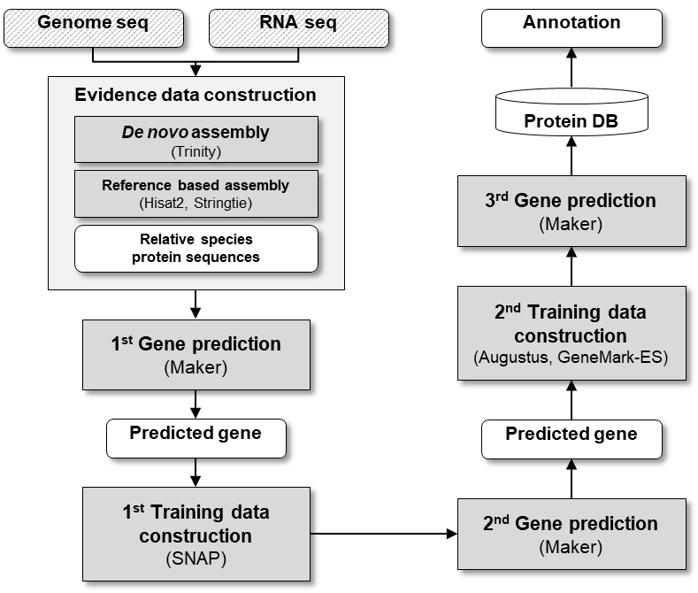

**Suppl. Fig. S2.** Relationship between the genetic map and the LG-based genome assembly in *Oryzias melastigma*. The left bar and the right bar in the pairs represent the linkage groups (Om) and LG-based scaffolds (CHRR_Om) respectively.



**Suppl. Fig. S2.** Relationship between the genetic map and the LG-based genome assembly in *Oryzias melastigma*. The left bar and the right bar in the pairs represent the linkage groups (Om) and LG-based scaffolds (CHRR_Om) respectively. (continued)



**Suppl. Fig. S3.** Comparison of sequences similarity between the LG-based scaffold in *Oryzias melastigma* and chromosomes in *Oryzias latipes*

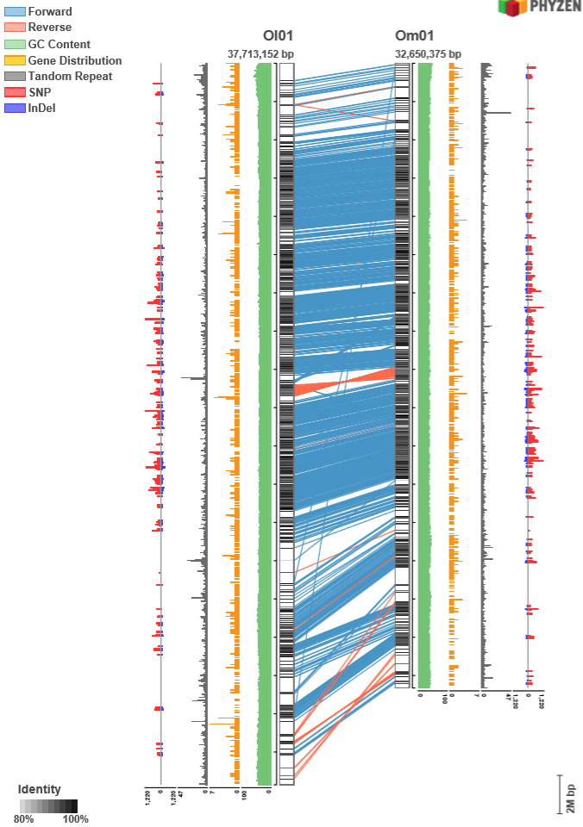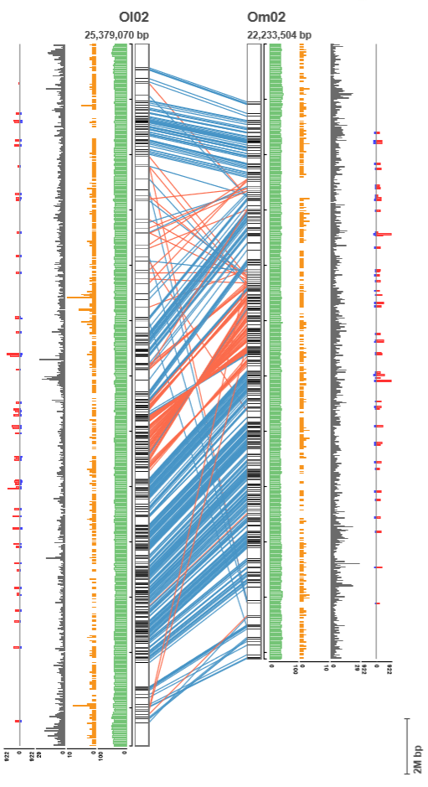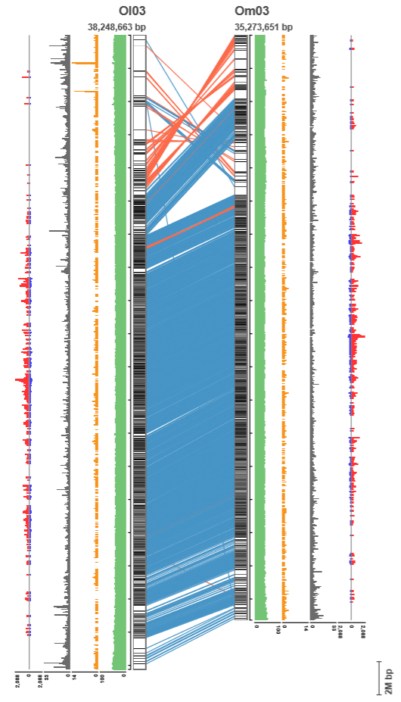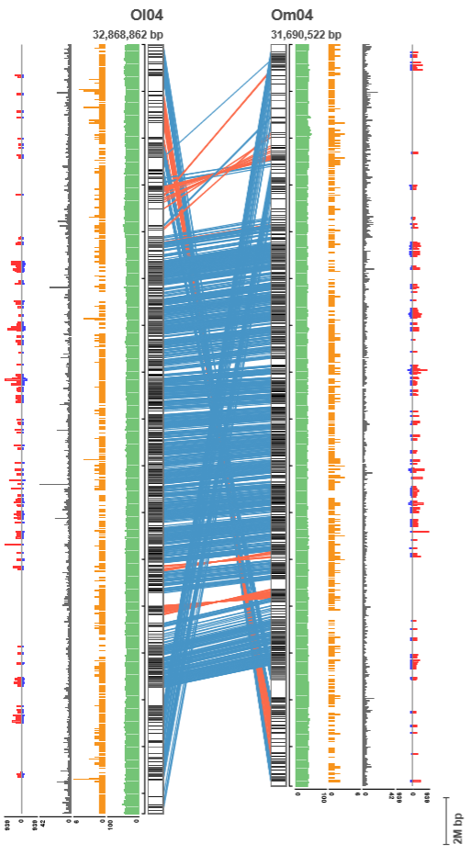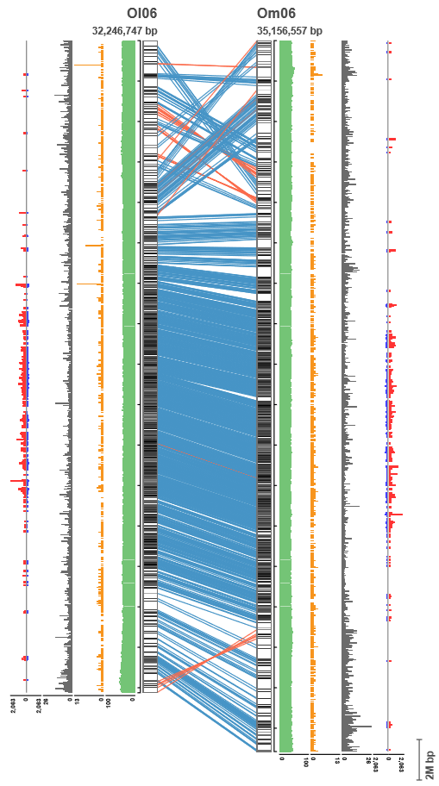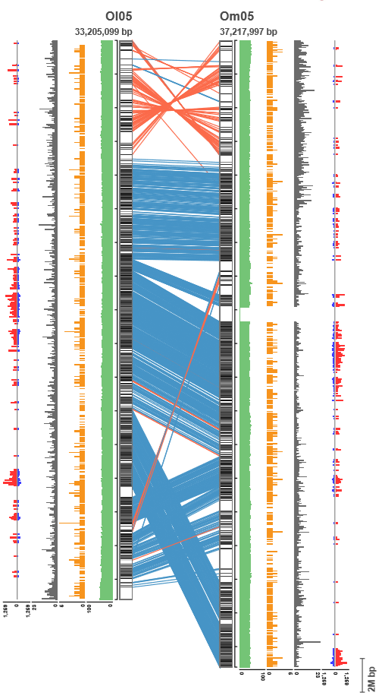

**Suppl. Fig. S3.** Comparison of sequences similarity between the LG-based scaffold in *Oryzias melastigma* and chromosomes in *Oryzias latipes* (continued)

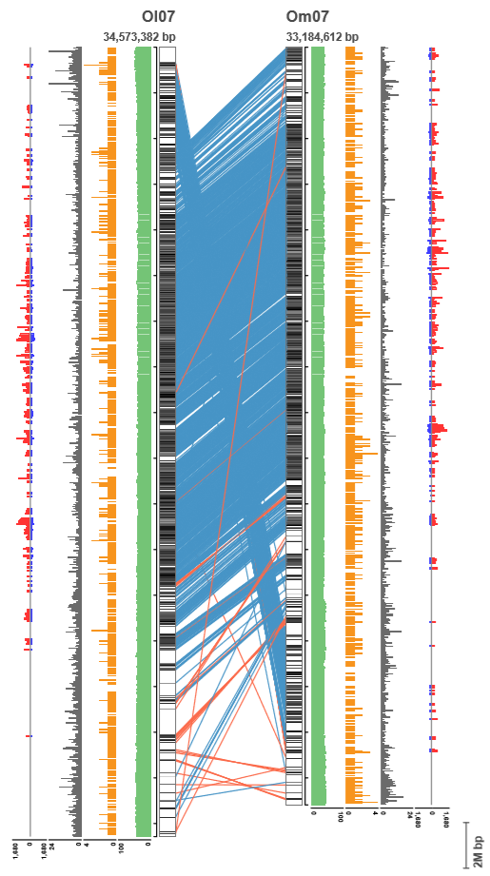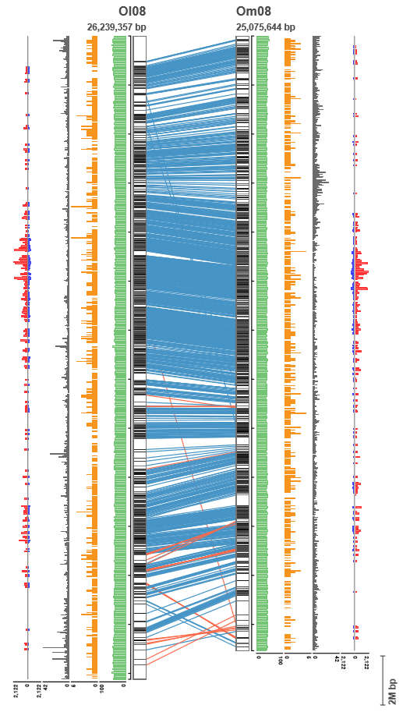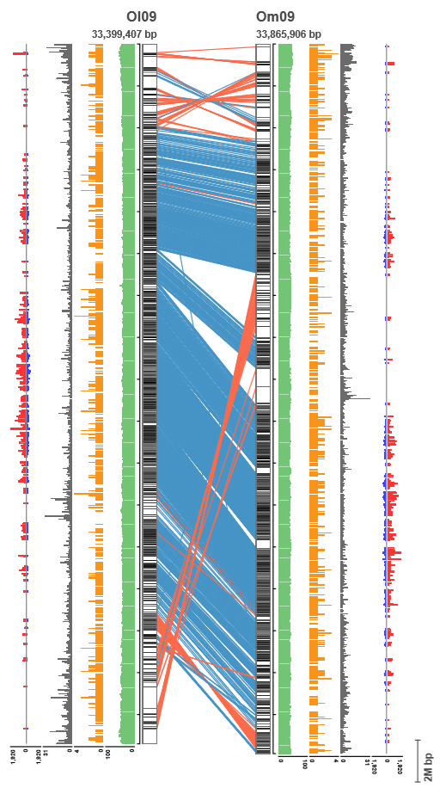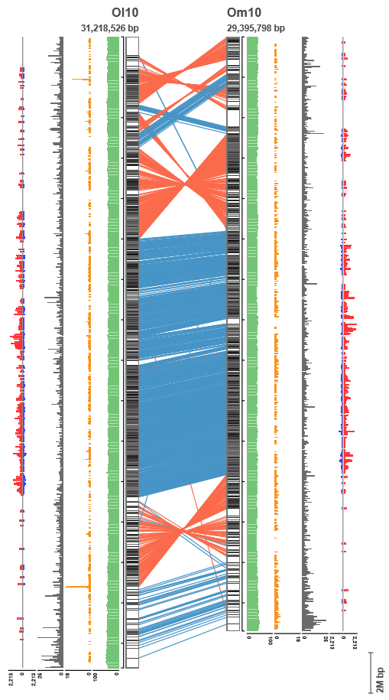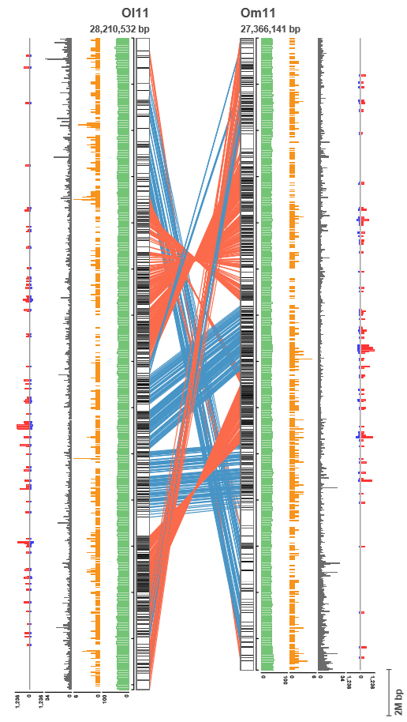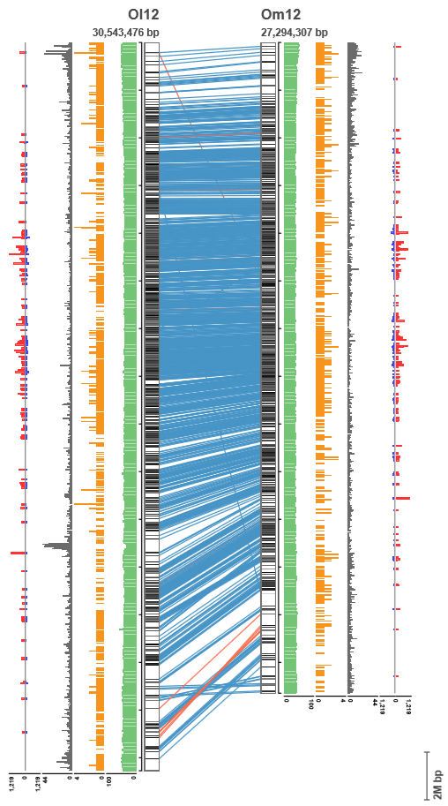

**Suppl. Fig. S3.** Comparison of sequences similarity between the LG-based scaffold in *Oryzias melastigma* and chromosomes in *Oryzias latipes* (continued)

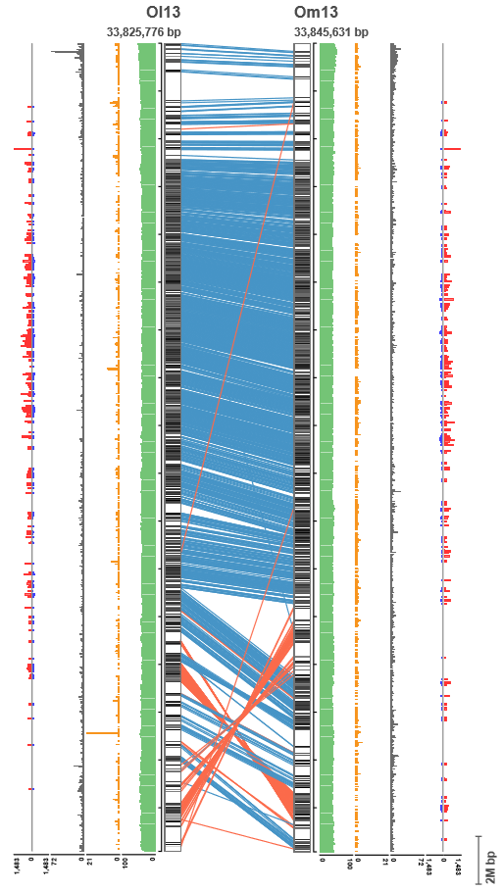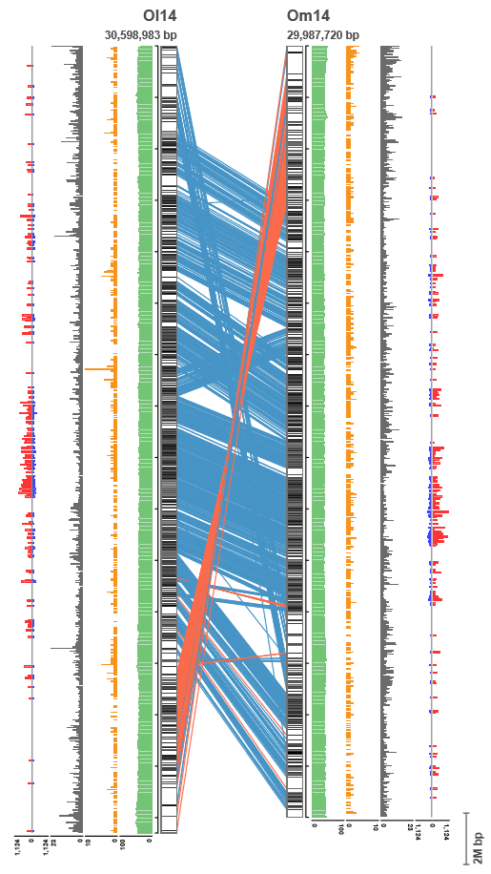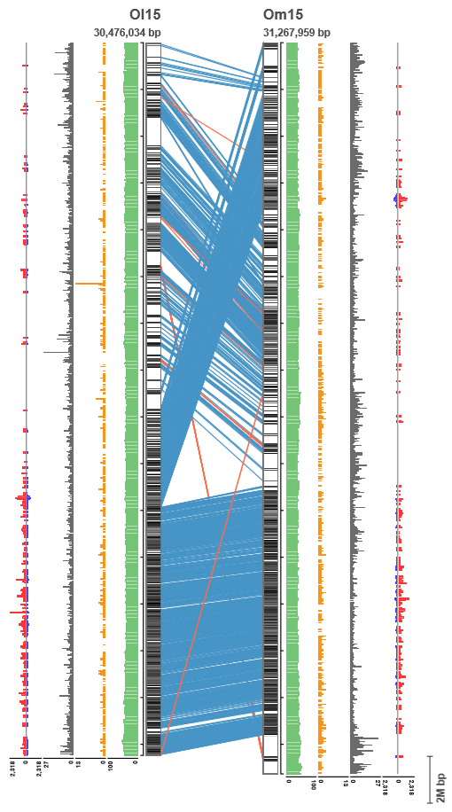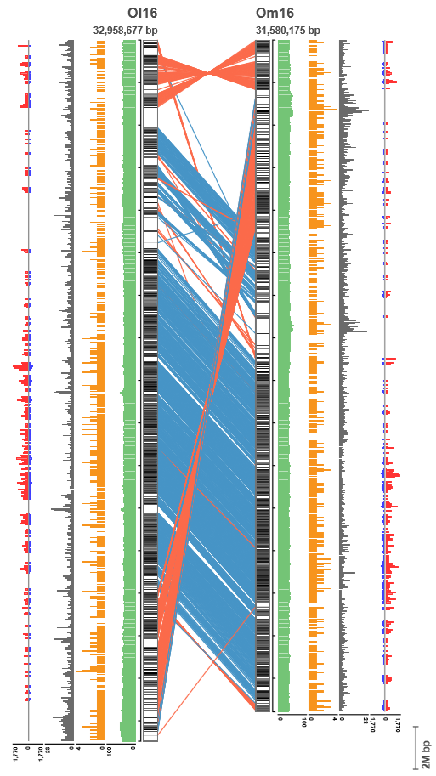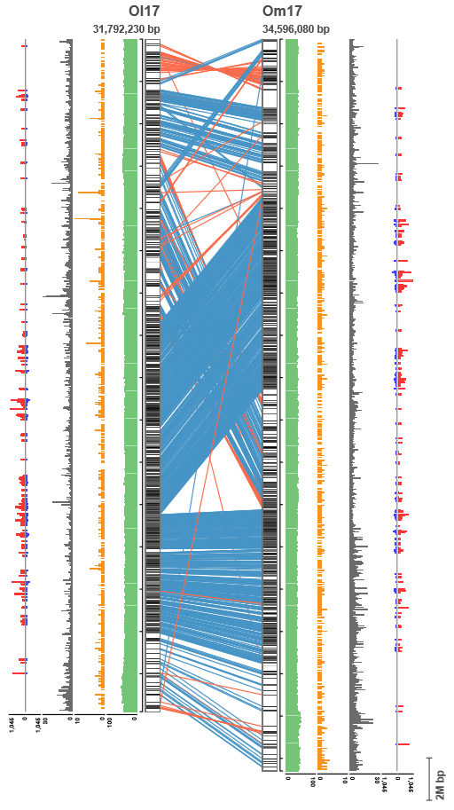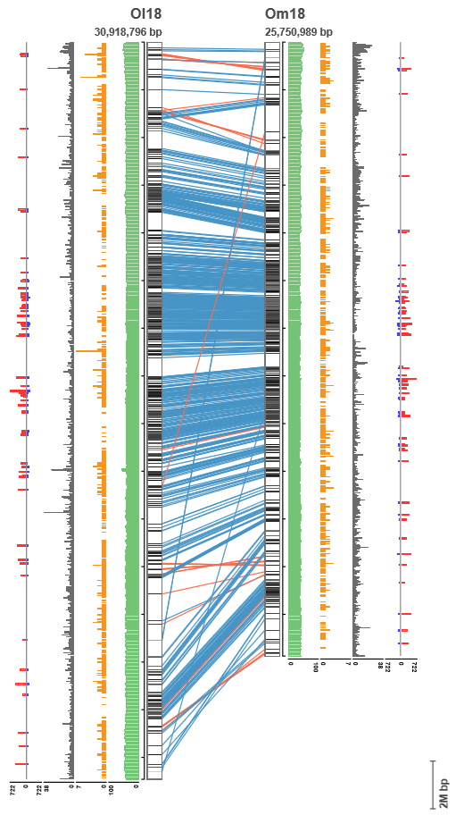

**Suppl. Fig. S3.** Comparison of sequences similarity between the LG-based scaffold in *Oryzias melastigma* and chromosomes in *Oryzias latipes* (continued)

