Supplementary Table 1. Statistics for the contig genome assembly with MEGAHIT 1.1.1 of Oreamnos americanus.

 | Short-read assembly
Total length | 2,595 Mbp
N50 / L50 | 8,423 bp / 87,093 contigs
N90 / L90 | 1,442 bp / 345,296 contigs
Total number of scaffolds | 942,462
N count | 0

Supplementary Table 2. Statistics for the contig genome assembly with Meraculous 2.0.4 of Oreamnos americanus.

 | Short-read assembly
Total length | 2,489 Mbp
N50 / L50 | 24,510 bp / 28,926 contigs
N90 / L90 | 5,851 bp / 107,981 contigs
Total number of scaffolds | 196,298
N count | 0

Supplementary Table 3. A comparison of the North American mountain goat genome assembly to a subset of wild and domestic Bovidae whole genome assemblies. *denotes that Ovis canadensis chromosome assignment is based off Ovis aries.

Species name | Common name | Assembly length (Mbp) | Scaffold N50 (bp) | Assigned to chromosomes? | Accession number
Wild
Oreamnos americanus | North American mountain goat | 2,506 | 66,617,000 | No | TBD
Bos mutus | wild yak | 2,645 | 1,407,960 | No | BosGru_v2.0 (GCA_000298355.1)
Bison bison bison | american bison | 2,954 | 6,873,254 | No | Bison_UMD1.0 (GCA_000754665.1)
Cervus elaphus hippelaphus | red deer | 3,439 | 107,358,006 | No | CerEla1.0 (GCA_002197005.1)
Odocoileus virginianus texanus | white-tailed deer | 2,381 | 850,721 | No | Ovir.te_1.0 (GCA_002102435.1)
Ovis canadensis canadensis | bighorn sheep | 2,591 | 100,190,483 | Yes* | ASM103953v1 (GCA_001039535.1)
Domestic
Bos taurus | cow | 2,716 | 103,308,737 | Yes | ARS-UCD1.2 (GCA_002263795.2)
Ovis aries | sheep | 2,619 | 100,079,507 | Yes | Oar_v3.1 (GCA_000298735.1)
Capra hircus | goat | 2,923 | 87,277,232 | Yes | ARS1 (GCA_001704415.1)
Bubalus bubalis | water buffalo | 2,656 | 117,219,835 | Yes | UOA_WB_1 (GCA_003121395.1)

Supplementary Table 4. Mapping statistics for the alignment of raw short-insert library reads to the scaffolded Oreamnos americanus genome assembly with bowtie2.

Number of reads / mates | % of total reads | Alignment
632,003,301 | 100.00% | total paired reads; of these:
86,626,312 | 13.71% | aligned concordantly >1 times
507,304,993 | 80.27% | aligned concordantly exactly 1 time
38,071,996 |  | aligned concordantly 0 times; of these:
8,071,100 | 1.28% | aligned discordantly 1 time
30,000,896 (60,001,792 mates) |  | aligned 0 times concordantly or discordantly; of these:
10,261,338 mates | 0.81% | aligned >1 times
15,681,805 mates | 1.24% | aligned exactly 1 time
34,058,649 mates | 2.69% | aligned 0 times

Supplementary Table 5. Hypergeometric test results of GO enrichment of gene families unique to Oreamnos americanus in comparison to Capra hircus, Equus cabalus, Bos taurus, Sus scrofa and Ovis aries. Only families with p-values < 0.05 are shown.

GO | Function | Type | p-value
GO:0060968 | regulation of gene silencing | biological process | 0.024
GO:0031659 | positive regulation of cyclin-dependent protein serine/threonine kinase activity involved in G1/S transition of mitotic cell cycle | biological process | 0.034
GO:0032784 | regulation of DNA-templated transcription, elongation | biological process | 0.039
GO:0032044 | DSIF complex | cellular component | 0.015
GO:0000228 | nuclear chromosome | cellular component | 0.048
GO:0003964 | RNA-directed DNA polymerase activity | molecular function | 0.015
GO:0043024 | ribosomal small subunit binding | molecular function | 0.019
GO:0000155 | phosphorelay sensor kinase activity | molecular function | 0.024
GO:0004322 | ferroxidase activity | molecular function | 0.043

Supplementary Table 6. Assembly quality metrics for the scaffolded + Chicago assembly based on FRC analysis with FRC_align with parameters set as ‘--CEstats-PE-min -50 --CEstats-PE-max 50’.

Feature | Description | Value
COMPR_PE | low CE-statistics computed on PE-reads | 681
HIGH_COV_PE | high read coverage areas (all aligned reads) | 8,988
HIGH_NORM_COV_PE | high paired-read coverage areas (only properly aligned pairs) | 5,351
HIGH_OUTIE_PE | high number of mis-oriented or too distant PE reads | 15
HIGH_SINGLE_PE | high number of PE reads with unmapped pair | 25
HIGH_SPAN_PE | high number of PE reads with pair mapped in a different contig/scaffold | 2,384
LOW_NORM_COV_PE | low paired-read coverage areas (only properly aligned pairs) | 2,437
STRECH_PE | high CE-statistics computed on PE-reads | 1,792

Supplementary Figure 1. KAT k-mer (k=27) frequency plot for the short-read assembly completed with Meraculous software.

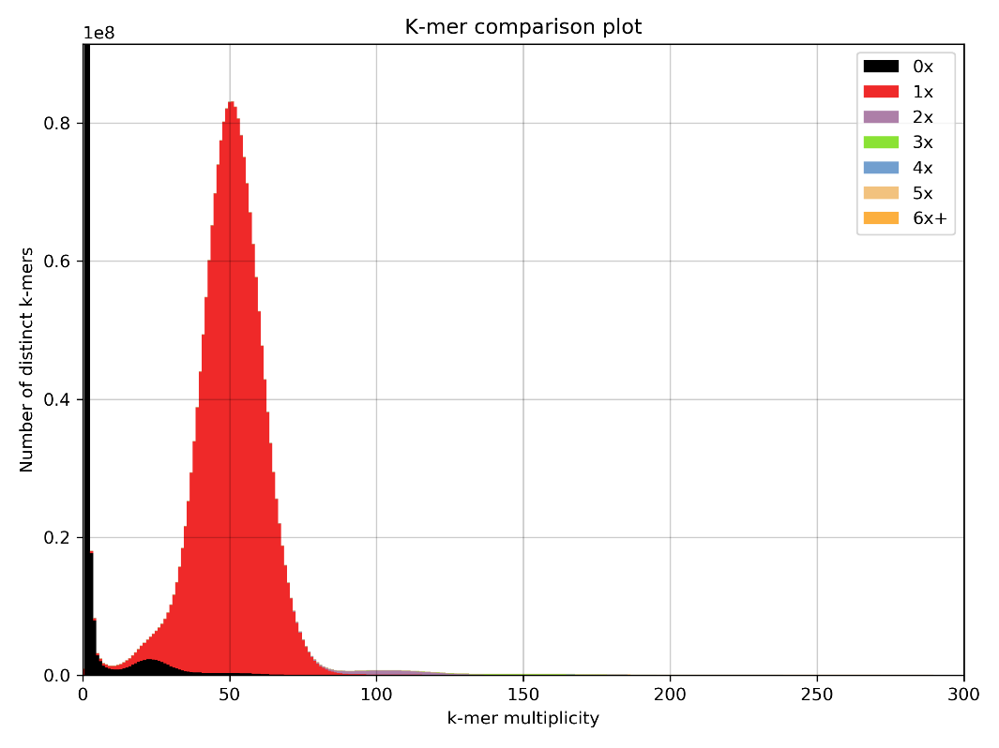

Supplementary Figure 2. KAT k-mer (k=27) frequency plot for the scaffolded + Chicago assembly.

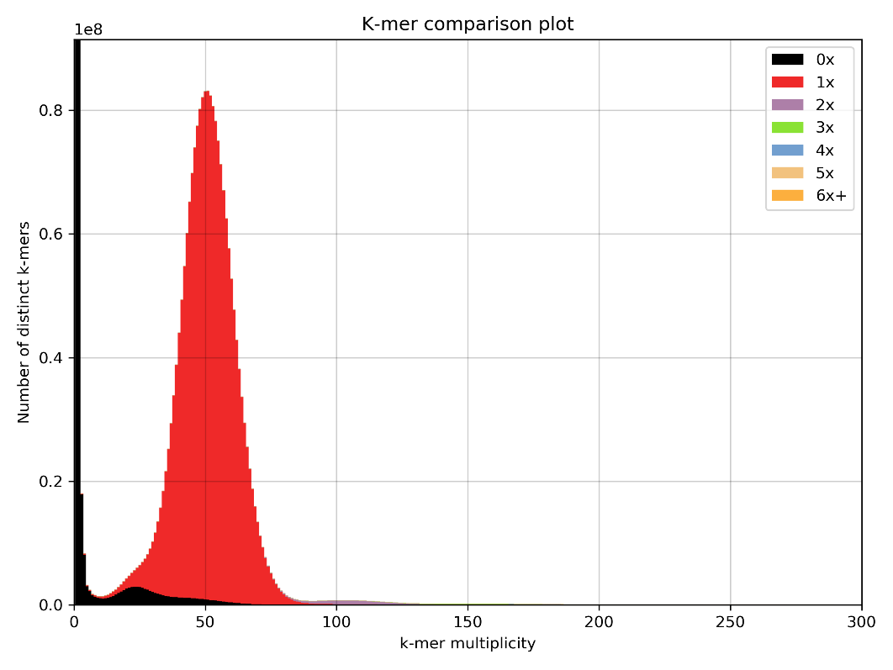

Supplementary Figure 3. The maximum likelihood phylogenetic tree for compete mitochondrial genomes of Oreamnos americanus (this study), Capra hircus (Genbank accession MK341077.1), Ovis aries (Genbank accession NC 001941.1), Bos taurus (Genbank accession GU947021.1), Sus scrofa (Genbank accession AY337045.1), Equus cabalus (Genbank accession AY584828.1) and Homo sapiens (Genbank accession GU170819.1). The tree is drawn to scale, with branch lengths measured in the number of substitutions per site. All positions containing gaps and missing data were eliminated resulting in a total of 8116 positions in the final dataset. Evolutionary analyses were conducted in MEGA7.

