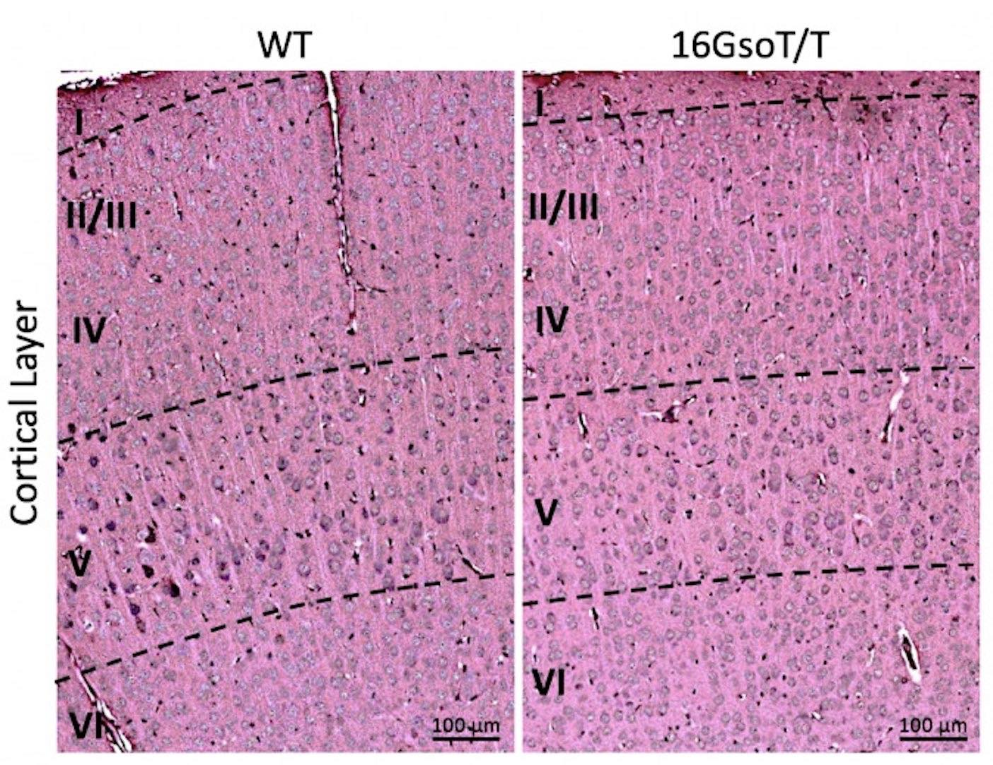
Figure S1. Cortical layers in both WT (left) and 16Gso T/T (right) at P14. H&E staining was used to identify the cortical layering in both WT and 16GsoT/T mutants. It showed 16GsoT/T mutants have normal layering and structure of cortex.

