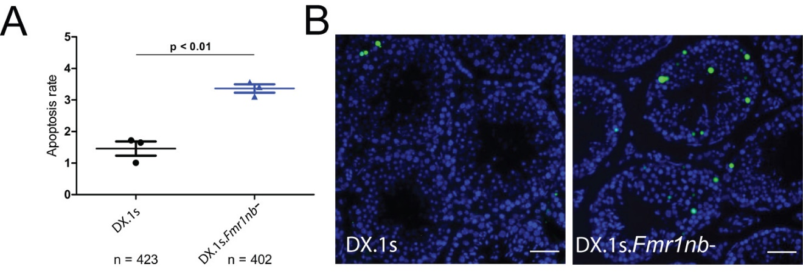

Figure S6 Apoptosis of spermatogenic cells in B6.DX1s and B6.DX.1s.Fmr1nb⁻ males. (A) Average numbers of apoptotic cells per one tubule were plotted for individual males (N=3) of both genotypes (n, total number of tubules analyzed; p<0.01). (B) Apoptotic cells were visualized by FITC fluorescence using TUNEL assay in histological sections of testis of B6.DX.1s wild type and B6.DX.1s.Fmr1nb⁻ null mutant genotypes. Scale bar, 50 μm.

