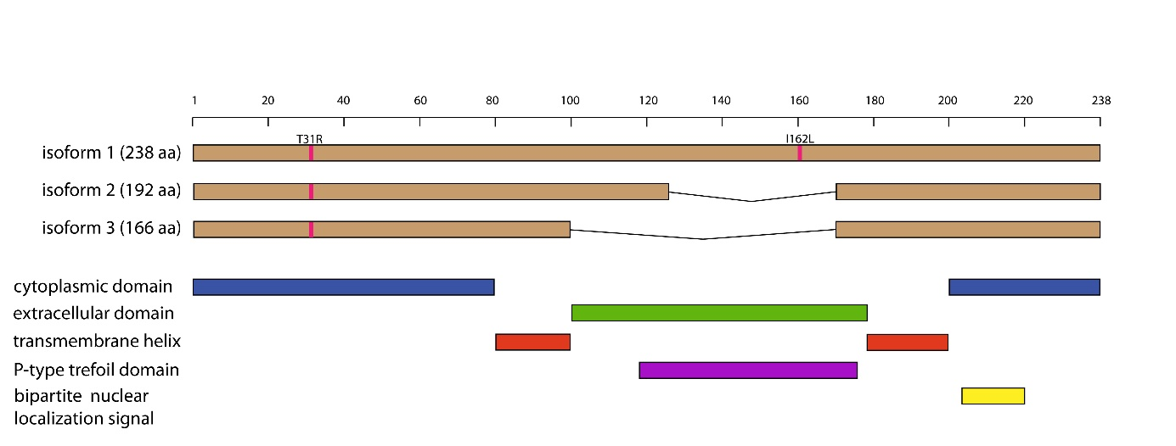

Figure S3 FMR1NB protein domains and isoforms. The predicted structure of the FMR1NB protein consists of two cytosolic N- and C-terminal domains, two transmembrane domains, and an extracellular part containing a P-type trefoil domain. Three isoforms of FMR1NB protein (Q80ZA7, UniProt) hold 238, 192 and 166 amino acids, respectively. The PWD and B6 allelic variants FMR1NB differ in two nonsynonymous substitutions: 31 Arginine^{PWD} / Threonine^{B6} and 162 Leucine^{PWD}/Isoleucine^{B6}. The polymorphic amino acids are highlighted in pink.

